 | FRAMEWORK COCOTB | CNES
Référence | 23-9482-ED_0002 | Révision | 1.1
Date d’édition | 17/11/2023
Confidentialité | NOT RESTRICTED

FRAMEWORK COCOTB
ARCHITECTURE

 | Nom | Fonction | Date | Visa
Rédigé par | Paul SUAU | FPGA Engineer | 17/11/2023
Vérifié par | Arnaud DANIEL | Technical Director | 17/11/2023
Approuvé par | Arnaud DANIEL | Technical Director | 17/11/2023

Historique du document

Révision | Date | Auteur | Description de l’évolution
1.0 | 31/10/2023 | Paul SUAU | Document creation
1.1 | 17/11/2023 | Paul SUAU | Update after first implementation

Contents

1. Applicable & reference documents 6
2. Testbench Architecture 7
3. Data structures 8
3.1. General 8
3.2. Data 8
3.2.1. Attributes 9
3.2.2. Methods 9
3.3. Stimuli 11
3.3.1. Attributes 11
3.3.2. Methods 11
3.4. Random generation 12
3.5. Parsing and Printing tests 13
3.5.1. Tests on predefined files 13
3.5.2. Error tests 13
3.5.3. Random generation Print & Parse tests 13
4. Drivers 14
4.1. AxiStreamSource 14
4.2. AxiStreamSink 14
5. Monitors 15
5.1. Stimuli & Data logging 15
5.2. AXI-Stream monitor 15
5.3. AXI / AXI-Light monitors 15
5.4. Analysis ports 16
5.5. Stimuli Loggers 16
5.5.1. Efficient Stimuli Logger 16
5.5.2. Real Time Stimuli Logger 16
6. General logs 17

Tables list

Table 1 - Applicable documents 6
Table 2 - Reference documents 6

Figures list

Figure 1 - Simple testbench example 7
Figure 2 - Data & Stimuli class diagram 8
Figure 5 - AXI Drivers class diagram 14
Figure 6 - AXI Monitors class diagram 15

Applicable & reference documents
Table 1 - Applicable documents
Name | Description | Reference
Cocotb documentation | Documentation of the cocotb framework | https://docs.cocotb.org/en/stable/
Cocotbext.axi’s README.md | Documentation of the cocotbext.axi library | README.md
JSON specification | Specification of the Json standard | https://www.json.org/json-en.html

Table 2 - Reference documents
Name | Description | Reference
Initial specifications | First specification document  Edition 1, Revision 0  Date: 25/05/2023  Authors:  - Florent MANNI  - Aurélien ODOUNDE | DTN/TVO/ET/2023-07171
Detailed specifications | Specification of Stimuli and Data file formats  Date: 30/10/2023  Author: Florent MANNI | Gitlab 30/10/2023

Testbench Architecture
The following figures illustrates the generic testbench architecture in order to verify AXI interfaces.
Figure 1 - Simple testbench example
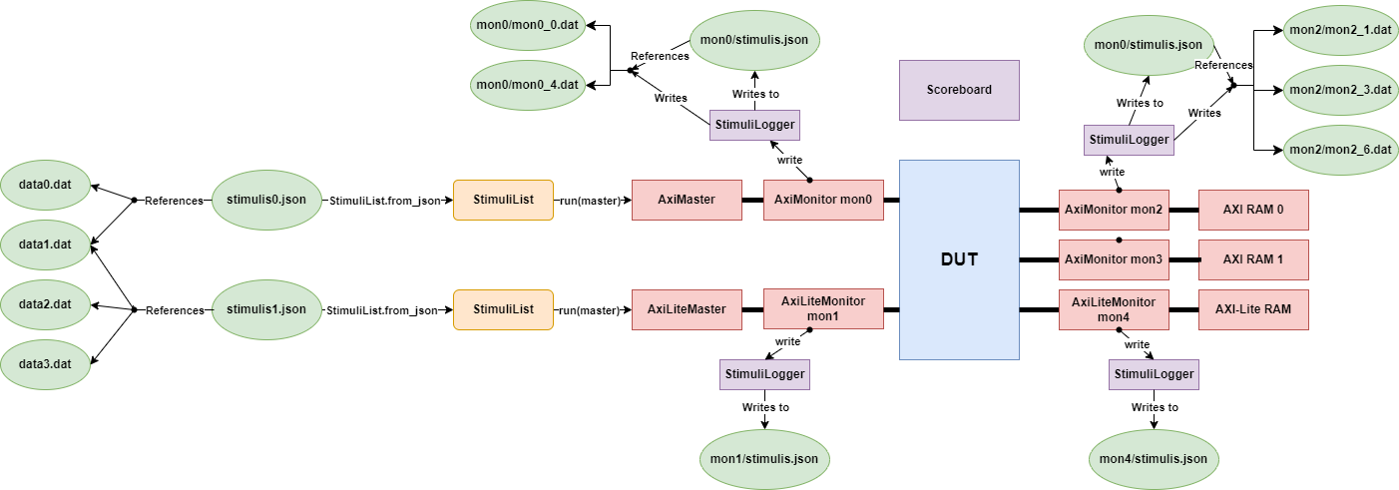
Files are in green, data structures in orange, python AXI components in red, the VHDL DUT in blue and components that receive Stimulis from monitors are in purple.
The scoreboard is connected to all monitors but it’s not represented on this example for clarity.
Notes:
- In this example, all inputs are given through files. They could also be generated randomly.
- AxiLiteMonitors don’t write .dat files because all transactions they log are unitary.

Data structures

General
The information stored in Stimuli and Data files is represented by Stimuli and Data classes in python.
These classes can be constructed:
- From a file using a class method
- Directly in Python by passing arguments to their constructors
- Randomly using a class method
Data and Stimuli classes do not represent a whole Data or Stimuli file but only a part of them.
Hence, there is a StimuliList and a DataList class to represent the files directly.
They inherit from python’s list and do not modify the “list” behaviour but add some methods to write and read Data and Stimuli files directly.
Figure 2 - Data & Stimuli class diagram
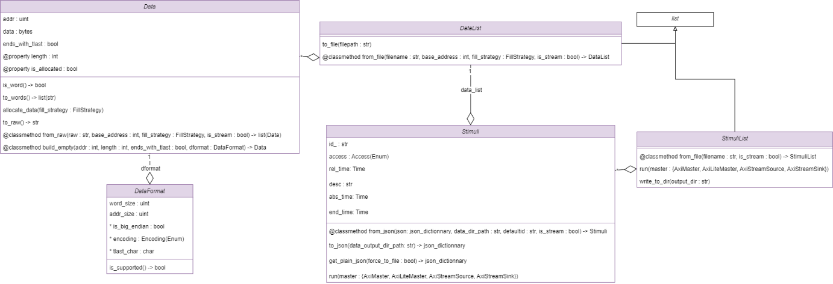
Notes:
- Read stimulis contain a single Data object which doesn’t hold any data at first (they are built using the Data.build_empty method). These data objects are filled with the requested data once it is read.
- Data, DataList, Stimuli and StimiliList all have a default generator for random generation. It’s implemented in the same file as the class, at the end as simple functions (because methods aren’t supported by functools.partial). Data has 3 default generators to generate 3 different types of data (axi/axi-lite, stream, empty).

Data
The data class represents one sequence of a Data file (without ‘!’ in the middle):
@ 0x44A20000; 0; ascii; 4; big; !;
0x12345678
123
0b110011
0x56789A; 3

DataList objects represent a list of sequences so they represent the content of a Data file.

Attributes
- Int addr: Address of the transfer
- Bytes data: Transfer data, makes sense only when allocated
- Bool ends_with_tlast: specifies if we output a tlast on the last data word for axi stream transfers.
The end of a Data must be the end of a Burst so that applies only to AXI-Stream transfers where the tlast is optional.
When parsing, we cut sequences with that define a tlast in the middle into multiple Data so that a tlast (or burst end) may only happen at the end of a Data object.
- Bool is_allocated: read only property, true if the data was allocated
- Int length: the length of the data (even when the data isn’t allocated)
- DataFormat dformat

Data Format
DataFormat is a class with that just stores values that do not affect the simulation in any way.
- Uint word_size
- Uint addr_size
- Encoding *encoding = ASCII: data encoding
- Boolean *is_big_endian = big: Endianness of data
- Char *tlast_char = ‘!’: character representing a tlast in AXI-Stream (output format specifies AXI bursts with one burst per Data object)
It’s an attribute of the Data class (and not just a parameter of the Data.to_raw() method) because that allows monitors to set the bus’s data and address size into the word_size and addr_size attributes directly so that they may be used later when printing the Data. It can also be useful to parse a Data, modify it and print it back with the same output format.
Fields noted with ‘*' are fixed for the moment (we parse them and print them but only one value is correct). The DataOutputFormat.is_supported method verifies these fields contain a supported value.

Allocation behaviour
The possibility to have Data objects that are unallocated allows to save memory. It’s used for Data objects that will be read in the future because a read Data object only needs to specify a length until the actual data is read on the bus.
This length is stored directly in the ‘data’ attribute (that is considered invalid if the Data is unallocated).
The length property allows to get the length of the data by returning the length of the data attribute when the object is ‘allocated’ (it’s a bytearray) or the length stored directly in the data attribute when it’s not allocated.

Methods
- Is_word: returns True if the data’s length is smaller than format.word_size
- To_words: returns a list of string representing all the data as words
- to_raw: returns an ascii string representing the object in the Data file format
- @classmethod from_raw: creates a Data object from an ascii string representing a Data block
- @classmethod build_empty: creates an empty Data object. This object has an address and a length but it has no data.

Stimuli
The stimuli class represents one JSON Stimuli object.
Example:
{
“Access”: “W”,
“Address”: “0x10”,
“Type”: “File”,
“Filename”: “data0.dat”,
“RelTime”: “100 ns”,
“Fill”: 0
}
StimuliList objects represent a list of Stimuli objects so they represent a stimuli.json file.

Attributes
- Str id_: The Stimuli’s ID
- Str desc: The Stimuli’s Description
- Access access: READ or WRITE
- DataList data_list: List of data objects representing the data to WRITE (input of the simulation) or the data READ (output generated during simulation)
- Time rel_time: duration between the beginning of the last stimuli and the beginning of the current one
- Time abs_time: (absolute) simulation time at which the transaction has started

Methods
- @classmethod from_json: creates a Stimuli object from a JSON object
- To_json: returns a dictionary that can be traduced to a Json object representing this object with the Stimuli format. It also writes the data_list to a file.
- Run: runs the stimuli on a master

Random generation
The random generation of Data, DataList, Stimuli and StimuliList can be done using their default_generator. They are functions that are declared in the same file as the class they generate.
They allow for random generation that’ll work for most usages but custom generators can be implemented by the user too.
These individual generators can be used together to build a function that can generate Stimulis directly with a Datalist and all with the proper constraints.
We do this by using the functools.partial function that allows us to specify the parameters to a function before calling it so it can be used directly as a generator without parameters.
```
print_hello = partial(print, "hello world")
print_hello() # -> prints "hello world"
```

This allows to combine different generators together in a hierarchical way by adding a generator argument to another generator.
```
# Building Data generator
data_gen = partial(
framework.data_default_generator,
min_addr = 0x44A20000,
max_addr = 0x44A4FFFF,
size_range = range(1, 0x20),
word_size_range = [2**i for i in range(4)]
)

# Building DataList generator using the Data generator
datalist_gen = partial(
framework.datalist_default_generator,
data_gen,
[1]
)

# Building Stimuli generator using the DataList generator
stimuli_gen = partial(
framework.stimuli_default_generator,
datalist_gen,
delay_range = range(0, framework.Time(100, 'ns').value)
)

# Building the StimuliList generator using the Stimuli Generator
stimulilist_gen = partial(
framework.stimulilist_default_generator,
stimuli_gen,
size_range = [4]
)
```
Here, data_gen, datalist_gen, stimuli_gen and stimulilist_gen are functions that take no arguments and that can be used to generate complete Data, DataList, Stimuli or StimuliList objects.
This organisation also allows to define parameters that are passed from a generator to the one below (param in function) or to a generator from the one below (return values).

Parsing and Printing tests
To test that the parsing and printing of Stimuli/StimuliList and Data/DataList objects works properly, some tests using pytest will be implemented. These tests are plain python tests that don’t use cocotb.
Parsing and printing tests will be done in 3 parts:

Tests on predefined files
These tests will be located in the tests/parsing/predefined directory.
The first part is to try to parse Data or Stimuli handwritten files to DataList or StimuliList objects.
These Data and Stimuli objects’ attributes are then printed to a file and compared to another handwritten file that respects the printing format.
The only thing these tests add compared to the Random Print & Parse tests is that the input files won’t conform to the printing format but they conform to the parsing format (that is less strict because it has degrees of freedom).
Degrees of freedom in parsing:
- have multiple spaces characters next to each other
- data/address in decimal/binary or size/word_size in hexadecimal/binary formats
- data in hexadecimal without the proper padding (word size = 2 but a data entry is 0x123 -> 0x0123)
- “Longueur” field not equal to the length of the data (smaller -> cut the data, larger -> add data)
- ‘!’ to cut axi stream or bursts in the middle of a sequence: the sequence is cut into multiple Data objects: one for every ‘!’ placed in the middle of the sequence + one for the bytes between the last ‘!’ and the end of the sequence.

Error tests
These tests will be located in the tests/parsing/errors directory.
These tests will try to parse Data or Stimuli files that aren’t valid and check that an error is thrown.
Checking that the right error is thrown is still something that has to be done manually for now.

Random generation Print & Parse tests
These tests will be located in the tests/parsing/random directory.
For these tests, we first generate a DataList as randomly as possible that we then print to a file (with all the Data files too).
We then parse these files back into a DataList and check they’re both exactly the same.

Drivers
Cocotbext.axi ‘s drivers do not support the custom Data classes so custom drivers inheriting cocotbext.axi ‘s are provided by the framework.
The following cocotbext.axi classes are extended:
- AxiLiteMaster
- AxiMaster
- AxiStreamSource
And cocotbext.axi.AxiStreamSink is reimplemented to support reads (see AxiStreamSink).
In the drawing below, orange classes are from cocotbext.axi while purple classes are the extensions implemented by the framework.
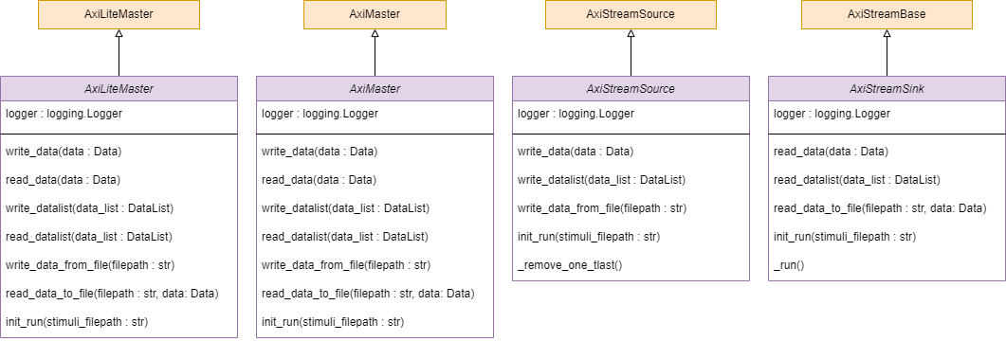
Figure 5 - AXI Drivers class diagram
The framework’s classes have the same name and should be the ones used in testbenches.
They are simple wrappers (except AxiStreamSink) that only add support for the Data objects.

AxiStreamSource
AxiStreamSource adds the possibility to write data without sending a tlast at the end. This is not supported by cocotbext.axi.AxiStreamSource and it’s implemented with the _remove_one_tlast method.
This method is launched in a new task every time a Data object that doesn’t end with a tlast is sent on a bus that has a tlast. It only waits for the next tlast and puts it back to 0 immediately after detecting it passed to 1.

AxiStreamSink
AxiStreamSink doesn’t inherit cocotbext.axi.AxiStreamSink but it inherits directly cocotbext.axi.AxiStreamBase.
This is because the AxiStreamSink given by cocotbext.axi only supports receiving frames (separated by tlast) while the behaviour required is to accept only a certain number of octets (and after they’re received, tready goes to 0).

Monitors
All the monitors will log Stimuli items (that contain a single Data item) from an AXI bus for Read and Write accesses.
In the drawing below, orange classes are from cocotbext.axi while purple classes are the extensions implemented the framework.
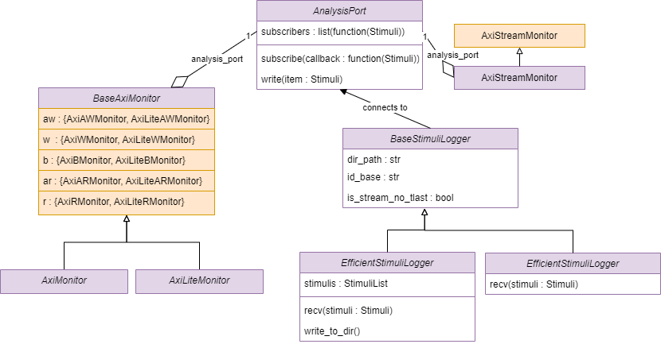
Figure 6 - AXI Monitors class diagram

Stimuli & Data logging
Monitors log only Stimulis with 1 Data item. They send these on an analysis port to which we can connect as many callbacks as we want.
The monitors see data arriving by transfers so the word_size of the data they create is the size of the bus. The same is true for the addr_size.

AXI-Stream monitor
The framework’s AXI-Stream monitor inherits from cocotbext.axi’s to log Stimuli and Data objects.
cocotbext.axi.AxiStreamMonitor (and framework.AxiStreamMonitor) log a Stimuli:
- At every transfer if the bus has no tlast signal
- At every tlast if the signal is present

AXI / AXI-Light monitors
AXI and AXI-Light monitors derive from a common BaseAxiMonitor class which contains almost all the logic.
Cocotbext.axi only provides monitors for each channel (aw, w, b, ar, r) but in order to log Stimuli and Data items, we need to monitor these 5 channels. Hence, the BaseAxiMonitor contains a cocotbext.axi monitor for each channel and uses them to build Stimuli and Data items.
Since the AXI protocol has id signals and transaction responses can arrive in a different order, we need 5 tasks (one for each channel) to monitor an AXI bus.
Note: When there are no id signals (AXI-Lite or AXI without id), we could monitor with only 2 tasks (one for writes and one for reads) because transfers are in order. For AXI4, wid doesn’t exist so we would need only 4 tasks (we could group aw and w tasks). However, the general solution allows to have a single code that works on all cases (AXI3 support wasn’t tested).

Analysis ports
Analysis ports allows to connect multiple observers on monitors. This choice was made because:
- Monitoring a bus and writing the monitored data to a file are 2 different jobs, by separating them we can have one monitor per type of bus and have the choice about which StimuliLogger we want to connect (or not connect any so the stimulis are not logged to files)
- It allows to connect other components such as a Scoreboard (or many Scoreboards) to automatically verify a DUT with random inputs.

Stimuli Loggers
StimuliLogger objects log stimulis to a directory using StimuliLogger.recv(stimuli).
This method should be connected to a monitor’s analysis port.
There are currently two types of Stimuli Logger:

Efficient Stimuli Logger
The EfficientStimuliLogger saves all stimulis in a StimuliList and writes them to files only when calling EfficientStimuliLogger.write_to_dir().
This allows to write all the files at once instead of appending new items to existing ones throughout the simulation (so in theory it’s a bit faster).
It’s also simpler to write everything at once.

Real Time Stimuli Logger
When a RealTimeStimuliLogger receives a Stimuli, it appends the JSON object to the stimulis.json file and the associated data file to the memory directly.
To stay efficient, it always keeps an open handle to the stimuli.json file.
It doesn’t support the specific format of Stimulis logged from an Axi Stream bus that has no tlast yet.

General logs
A general log is written to a “framework.log” file throughout the execution of the program.
The framework uses the logging python module to log debug, info, warning and error level messages in the same format as cocotb‘s logs.
This logger is declared in the framework’s logger.py file and can be modified to change the name of the log file or the logging level directly from user code.

End of document

