Mainscript_try2.rb – plotted with euler_try_plotter2.m
Time end = 10
Dt = 0.001
Output_num = 500

Euler_forward
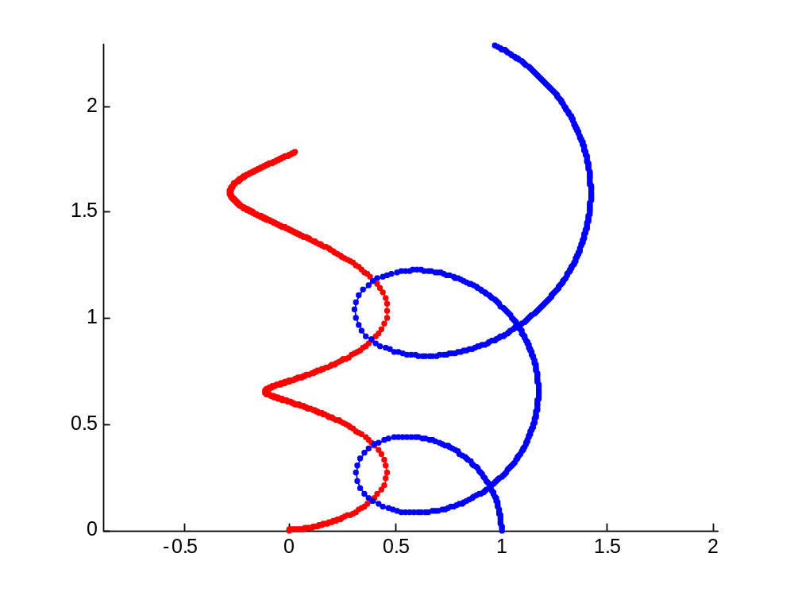

Euler Modified
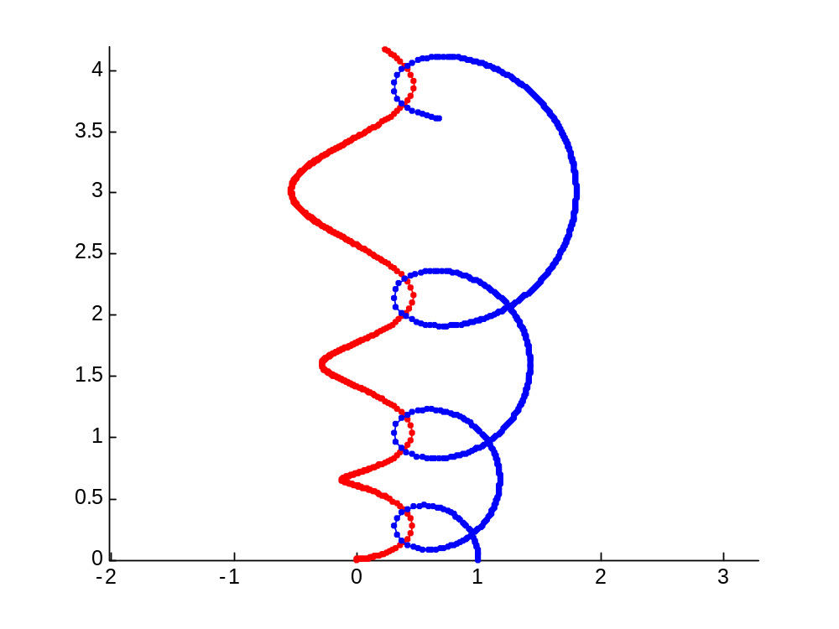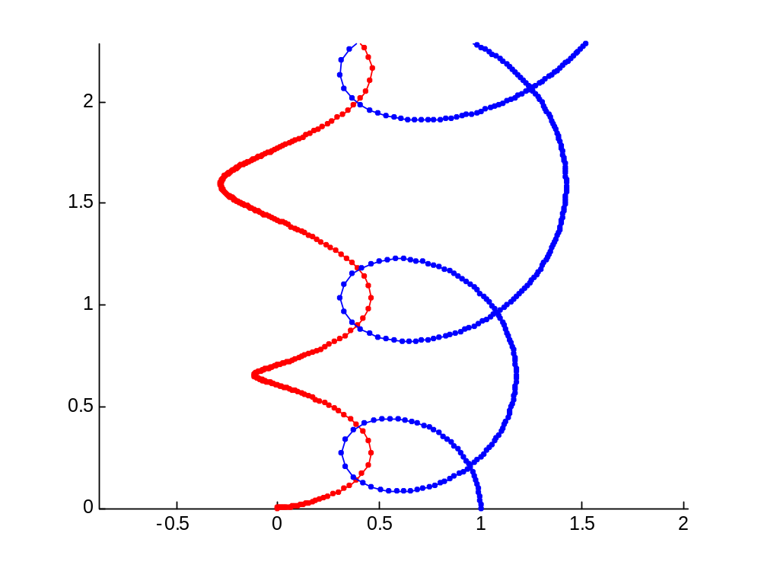
LeapFrog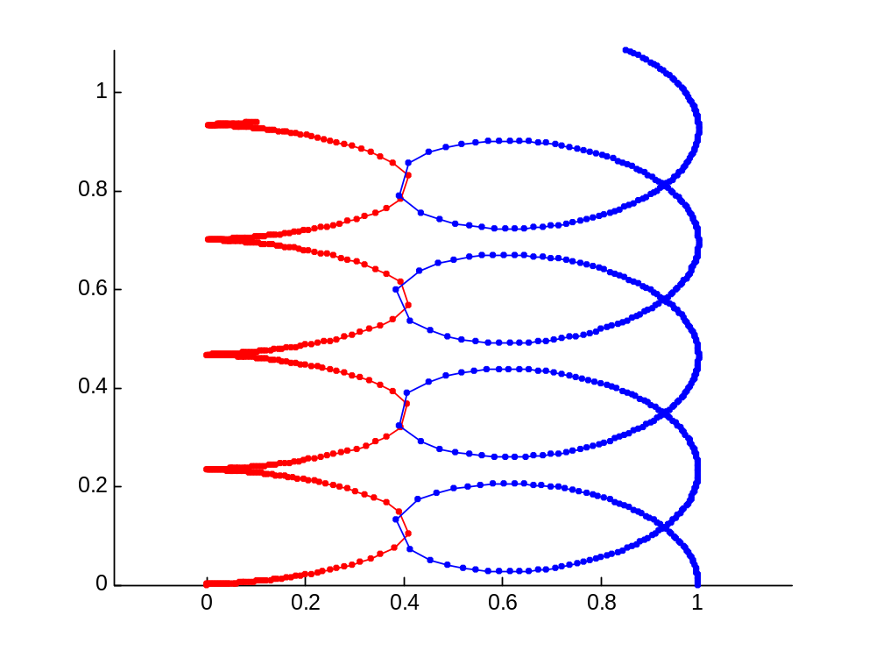
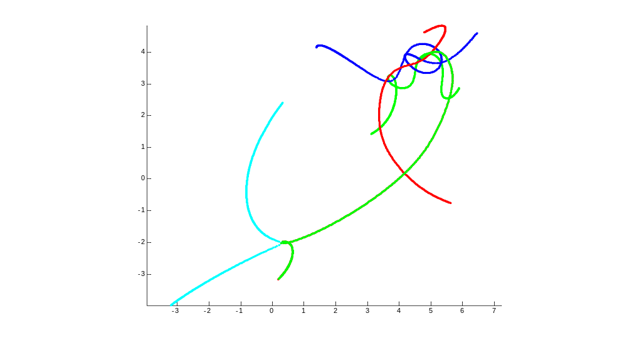5 bodies random…

