* Exception Handling
* Multithreading
* Collections
* Java 8
* Spring Core
* Spring MVC
* Spring Boot
* Spring Microservices
* Angular

Pre-requisites

* create git-hub account
* install git from : <https://git-scm.com/downloads>
* Eclipse IDE
* Java 8

Why Java?

Java is a platform independent & Object oriented language, using which you can develop any kind applications like standalone, distributed, mobile applications, you can write programs to IC’s, Cards and etc

OOPs concepts:

1. Encapsulation: private variables & public setters & getters
2. Inheritance: extends keyword
3. Polymorphism: overriding and overloading
4. Abstraction: abstract class & interface

Exception Handling:

try, catch, finally, throw & throws

Collection Framework:

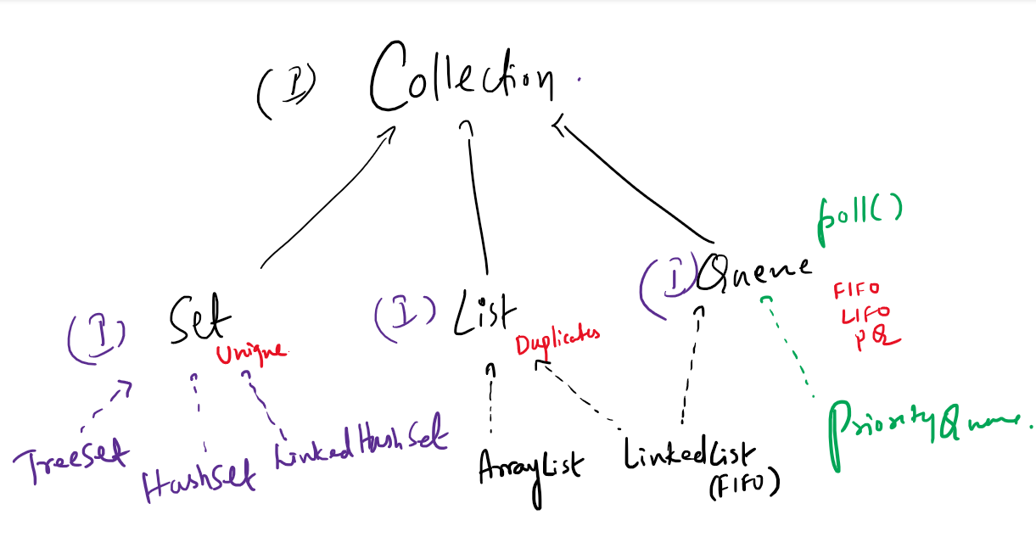

Collection has methods:

add, remove, clear, size, isEmpty, iterator,...

Set: Allows only unique elements

TreeSet: Maintains the elements in sorted order

HashSet: Maintains the elements in random order, but retrieval is faster

LinkedHashSet: Maintains the elements in insertion order

List: Allows duplicates and elements have index

ArrayList: Maintains elements in contiguous memory address, retrieval is faster but adding/removing of the elements are little slower

LinkedList: Maintains elements in non-contiguous memory address, retrieval is little slower but adding/removing of the elements are faster