MicroPeta

* [Home](https://www.micropeta.com/)
* [About](https://www.micropeta.com/about)

Docs

Micro-controllers, wireless transmission and database

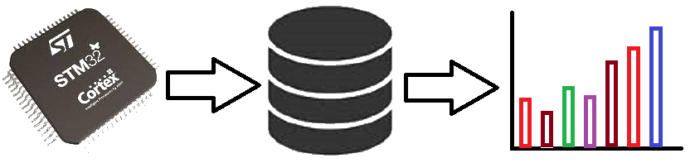

OLED with Blue Pill using STM32CubeIDE

**Prerequisites**

This project assumes you have already installed STM32CubeIDE. You need to have previously done a basic blink sketch with blue-pill using STM32CubeIDE. I have made a complete video from installing STM32CubeIDE to LED blink program. You can watch it by clicking this link. <https://www.youtube.com/watch?v=kXg467nVd_A>

**Wiring Diagram**

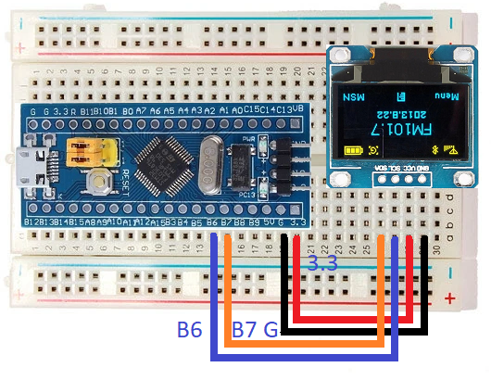

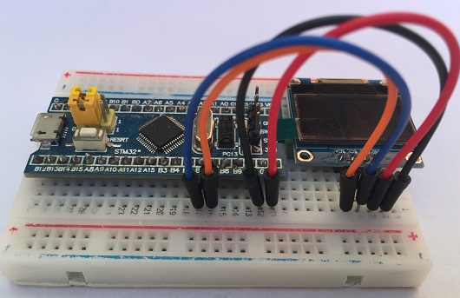

**STM32CubeIDE Settings**

Click connectivity --> Click I2C1

For I2C select I2C

Configuration --> Parameter Settings

For I2C speed select Fast Mode

**Libraries**

Inside Core/Inc Folder

[fonts.h](https://www.micropeta.com/fonts.h) [ssd1306.h](https://www.micropeta.com/ssd1306.h)

Inside Core/Src Folder

[fonts.c](https://www.micropeta.com/fonts.c) [ssd1306.c](https://www.micropeta.com/ssd1306.c)

**Additional code on top of STM32CubeIDE generated code**

/* USER CODE BEGIN Includes */

#include "fonts.h"

#include "ssd1306.h"

/* USER CODE END Includes */

/* USER CODE BEGIN 2 */

SSD1306_Init();

**char** snum[5];

SSD1306_GotoXY (0,0);

SSD1306_Puts ("NIZAR", &Font_11x18, 1);

SSD1306_GotoXY (0, 30);

SSD1306_Puts ("MOHIDEEN", &Font_11x18, 1);

SSD1306_UpdateScreen();

HAL_Delay (1000);

SSD1306_ScrollRight(0,7);

HAL_Delay(3000);

SSD1306_ScrollLeft(0,7);

HAL_Delay(3000);

SSD1306_Stopscroll();

SSD1306_Clear();

SSD1306_GotoXY (35,0);

SSD1306_Puts ("SCORE", &Font_11x18, 1);

/* USER CODE END 2 */

/* USER CODE BEGIN WHILE */

**while** (1)

{

**for** ( **int** x = 1; x <= 10000 ; x++ )

{

itoa(x, snum, 10);

SSD1306_GotoXY (0, 30);

SSD1306_Puts (" ", &Font_16x26, 1);

SSD1306_UpdateScreen();

**if**(x < 10) {

SSD1306_GotoXY (53, 30); // 1 DIGIT

}

**else** **if** (x < 100 ) {

SSD1306_GotoXY (45, 30); // 2 DIGITS

}

**else** **if** (x < 1000 ) {

SSD1306_GotoXY (37, 30); // 3 DIGITS

}

**else** {

SSD1306_GotoXY (30, 30); // 4 DIGIS

}

SSD1306_Puts (snum, &Font_16x26, 1);

SSD1306_UpdateScreen();

HAL_Delay (500);

}