README FILE

* The GPIO pin 76 is exported using echo 76 > /sys/class/gpio/export to allow access to the pin.

* The value of the GPIO pin is read using status=$(cat /sys/class/gpio/PC12/value) and stored in the status variable.

* An if statement checks if the value of status is equal to 0, indicating that the button is pressed.

* If it is, the script prints "Button pressed", "PASS"

* If not, it prints "Button not pressed", "FAIL"

TESTING SCRIPT

#! /bin/bash
echo "************************************"
echo
echo "---------BUTTON/SWITCH TEST--------"
echo
echo "***********************************"
echo

# Export GPIO pin 76
echo 76 > /sys/class/gpio/export

echo "Status of Button: "

# Read the value of the GPIO pin
status=$(cat /sys/class/gpio/PC12/value)

if [ "$status" -eq 0 ]
then
echo "Button pressed"
echo
echo "******** PASS *********"
echo
echo
else
echo "Button pressed"
echo
echo "******** FAIL *********"
echo
fi

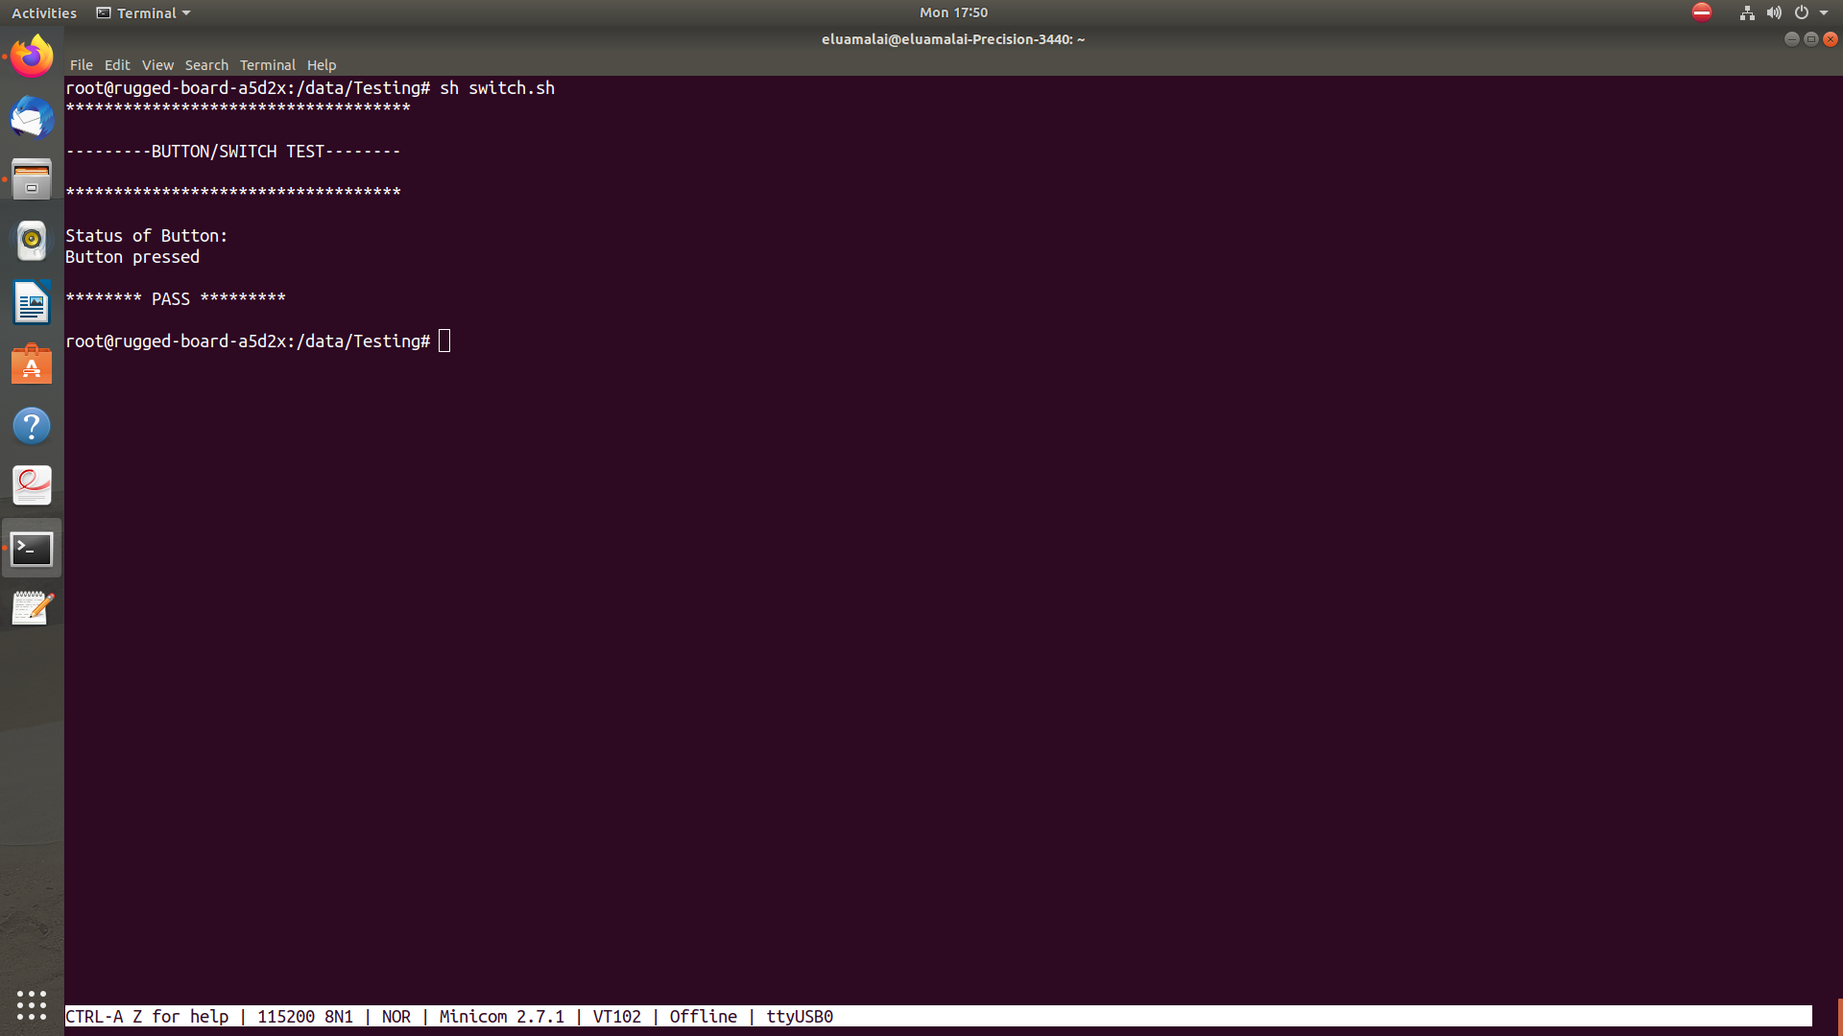
OUTPUT LOG

