READMEFILE
- The first few lines of the script print out a banner indicating that this is a test script for the GPIO pin.
- The script exports GPIO pin 84.
- The script checks if the PC20 directory exists. If it does, it prints out "GPIO Exported." If it doesn't, it prints out "GPIO Export Failed."
- The script sets the direction of the GPIO pin to "in".
- The script sleeps for 2 seconds.
- The script reads the value of the GPIO pin and stores it in the gpio5_value variable.
- The script checks if the gpio5_value is equal to 1. If it is, the script prints out "PASS." If it isn't, the script prints out "FAIL."
TESTING SCRIPT
#!/bin/bash
echo "***************************************************"
echo
echo "------------------ DIN TEST -----------------------"
echo
echo "***************************************************"
echo
echo
echo 84 > /sys/class/gpio/export
if [ -d "/sys/class/gpio/PC20" ]
then
echo "GPIO Exported"
else
echo "GPIO Export Failed"
fi
echo in > /sys/class/gpio/PC20/direction
sleep 2
gpio5_value=$(cat /sys/class/gpio/PC20/value)
if [ "$gpio5_value" == 1 ]
then
echo
echo "============= PASS ==============="
echo
else
echo
echo "============= FAIL ================"
echo
fi

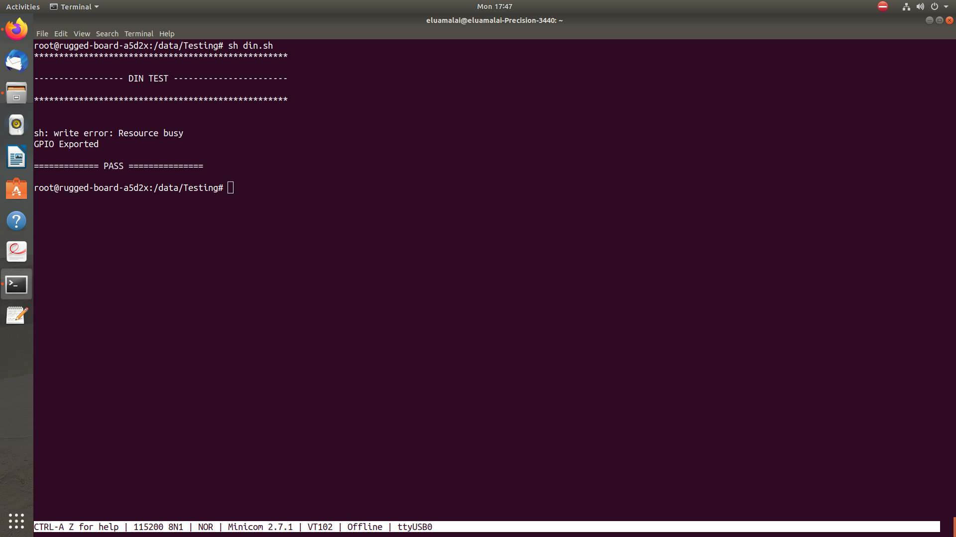
OUTPUT LOG

