README FILE
The script tries to configure the eth0 interface using the "udhcpc" command. If the configuration is successful, the script prints out "PASS" and a message indicating that the eth0 interface has been configured successfully.
- The script prints out the carrier status of the eth0 interface by reading the value of the /sys/class/net/eth0/carrier file.
- The script instructs the user to press "ctrl+c" to stop pinging and then pings "google.com" to test the Ethernet connection.
- If the configuration of the eth0 interface is not successful, the script prints out "FAIL".
TESTING SCRIPT

#!/bin/bash

echo "******************************************"
echo
echo "---------- TEST Ethernet -----------------"
echo
echo "*******************************************"

if udhcpc -i eth0 ;
then
echo
echo "============= PASS =============="
echo
echo "eth0 interface configured successfully"
echo "carrier status:"
cat /sys/class/net/eth0/carrier
echo "========= press ctrl+c to stop pinging ========"

ping google.com

else
echo "Failed to configure eth0 interface"
echo "============= FAIL =============="
echo
fi

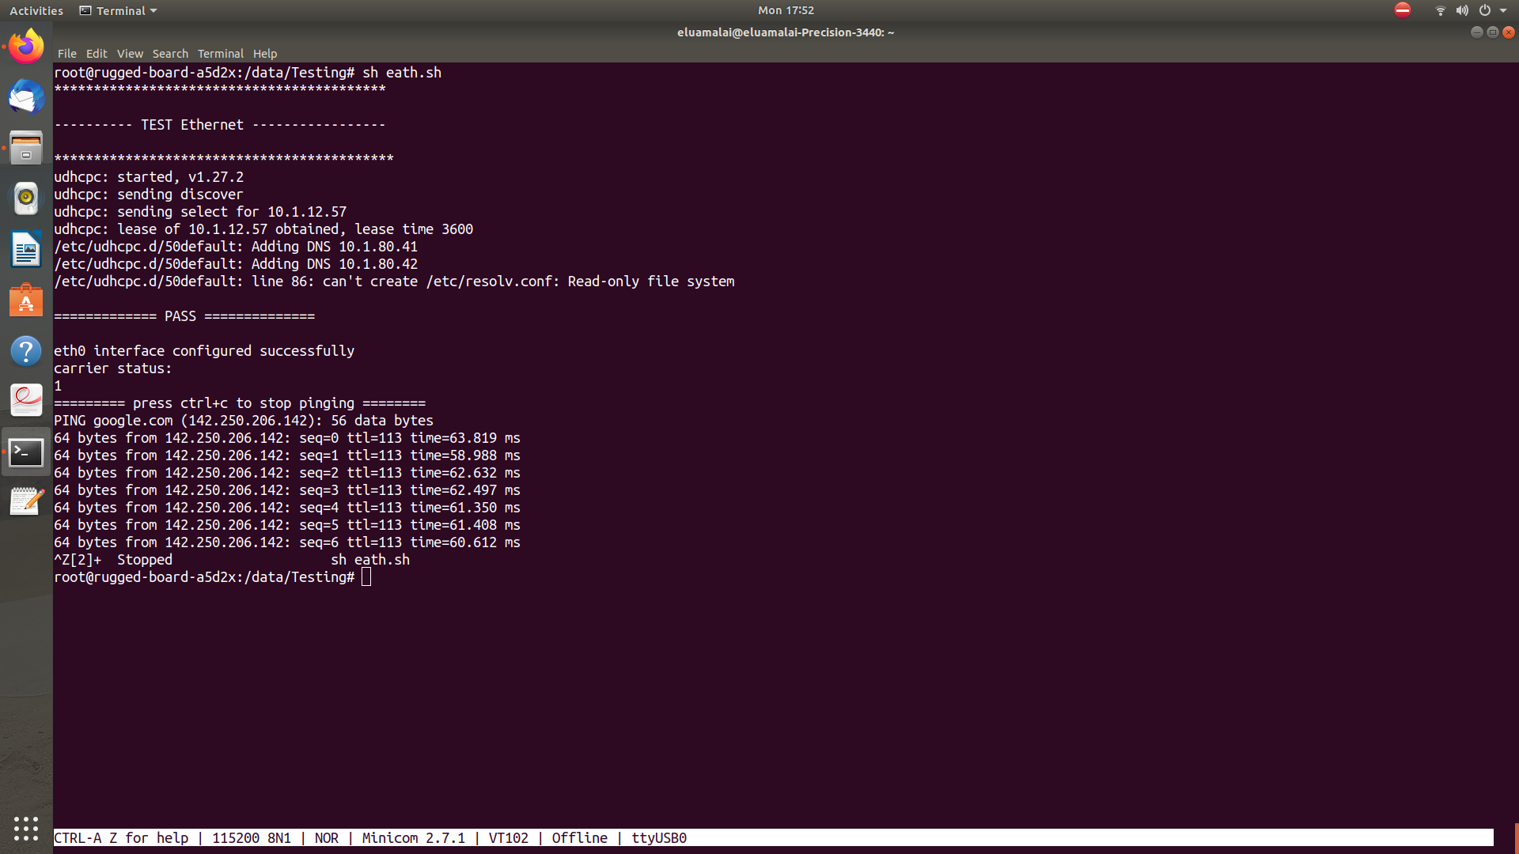
OUTPUT LOG

