README FILE
- The script uses the "i2cdetect" command to detect devices on the I2C bus. The "-y" option indicates that the user should not be prompted to confirm device connections, and the "-r 0" option specifies that the test should be run on I2C bus 0.
- The script then checks for the existence of an EEPROM (Electrically Erasable Programmable Read-Only Memory) device connected to the I2C bus using the "if [ -e /sys/class/i2c-adapter/i2c-0/0-0050/eeprom ]" condition. If the device is present, the script prints out a message indicating that it is reading the value of the EEPROM.
- If the EEPROM is present, the script reads the value of the EEPROM using the "cat" command and stores it in the "value" variable (which is currently commented out).
- The script prints out "PASS" if the EEPROM is present and the value can be read, and "FAIL" if the EEPROM is not present.
TESTING SCRIPT
#! /bin/bash
echo
echo "------------ I2C TEST ------------------"
echo
echo "****************************************"
echo

i2cdetect -y -r 0
echo "======= PERFORMING ADC TEST ===="

if [ -e /sys/class/i2c-adapter/i2c-0/0-0050/eeprom ]
then
echo "reading the value of the EEPROM"
#value=$(cat /sys/class/i2c-adapter/i2c-0/0-0050/eeprom)
#echo $value
echo
echo echo "========= PASS ================"
echo
else
echo
echo "************** FAIL **************"
echo
fi

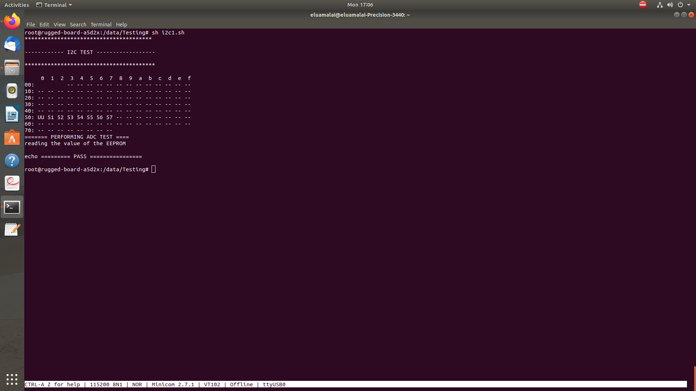
OUTPUT LOG

