README FILE
- checks whether a directory exists at "/sys/class/pwm/pwmchip0/" to determine whether the device has a PWM chip.
- If a PWM chip exists, the script proceeds with the test by exporting the PWM, setting the PWM time period to 50000, and setting the duty cycle to 2500.
- The script then waits for 3 seconds, changes the duty cycle to 1200, and enables the PWM.
- After waiting for another 3 seconds, the script checks the enable status of the PWM to determine whether the test has passed or failed.
- If a PWM chip does not exist, the script prints an error message and fails the test.

TESTING SCRIPT
#!/bin/bash
echo "*************************************"
echo
echo "------------- PWM Test---------------"
echo
echo "*************************************"
if [ -d "/sys/class/pwm/pwmchip0/" ]
then
echo "PWM Exist"
echo
echo 0 > /sys/class/pwm/pwmchip0/export
echo "PWM Test"
echo
sleep 3
echo "Setting PWM Time Period"
echo 50000 > /sys/class/pwm/pwmchip0/pwm0/period
echo
echo "Setting duty cycle"
echo 2500 > /sys/class/pwm/pwmchip0/pwm0/duty_cycle
echo
sleep 3
echo 1200 > /sys/class/pwm/pwmchip0/pwm0/duty_cycle
echo "Enabling PWM"
echo "Enabling PWM"
echo 0 > /sys/class/pwm/pwmchip0/pwm0/enable
# cat /sys/kernel/debug/pwm
echo
echo 1 > /sys/class/pwm/pwmchip0/pwm0/enable
sleep 3
echo
status=$(cat /sys/class/pwm/pwmchip0/pwm0/enable)
if [ "$status" == "1" ]
then
echo
echo "============= PASS ==============="
echo
else
echo
echo "============= FAIL ==============="
echo
fi
else
echo "No PWM chip found"
echo "============= FAIL ==============="
fi

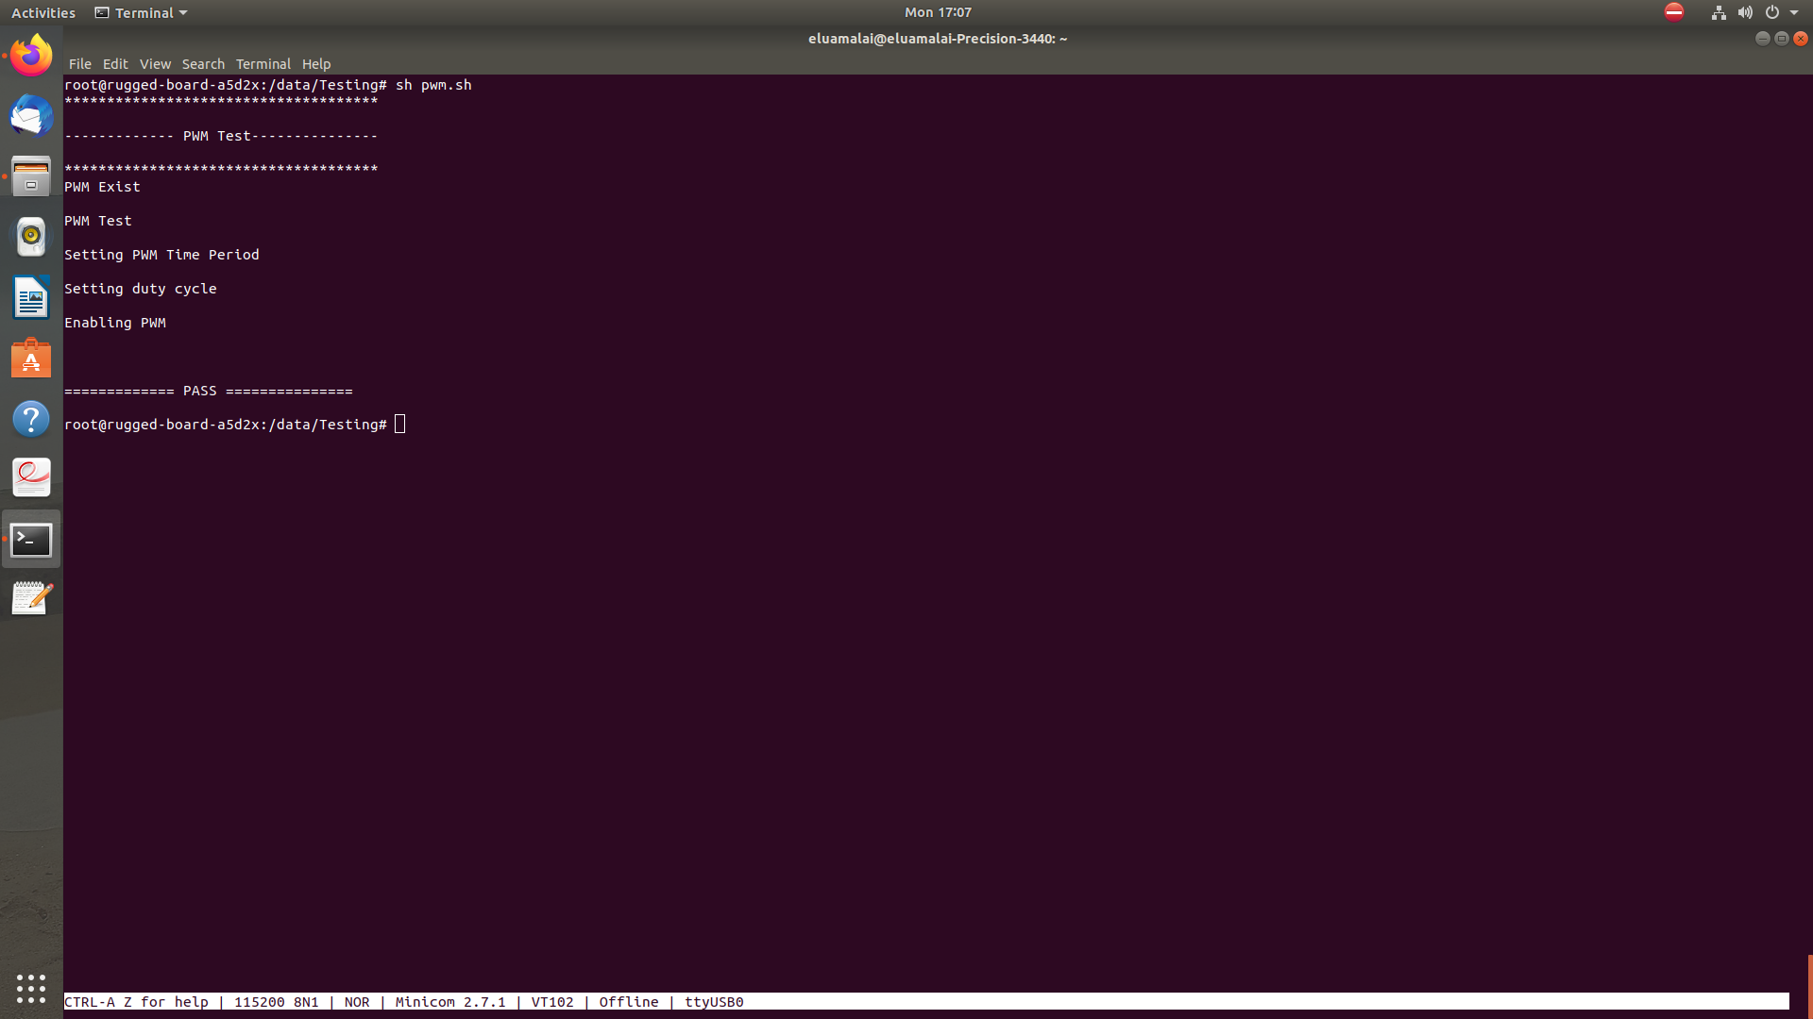
OUTPUT LOG

