README FILE

checks if the RS485 node exists at /dev/ttyS2 by checking if the file exists. If the RS485 node exists, the script prints a success message and opens a serial connection to the node using the microcom command. The user is prompted to exit the serial connection by pressing Ctrl+C.
If the RS485 node does not exist, the script prints a failure message indicating that the node was not found.

TESTING SCRIPT

#! /bin/bash
echo "***************************************************"
echo
echo "----------------- RS485 TEST ---------------------"
echo
echo "***************************************************"
echo
echo "-----checking for RS485----"
echo

if [ -e "/dev/ttyS2" ]
then
echo " RS485 Node exists"
echo
echo " ------ Performing 485-----"
echo
echo "************* PASS **************"
echo " press Ctrl+C to exit to microcom "
microcom -s 115200 /dev/ttyS2

else
echo "------ FAIL ------"
echo "RS485 Node not found"
fi

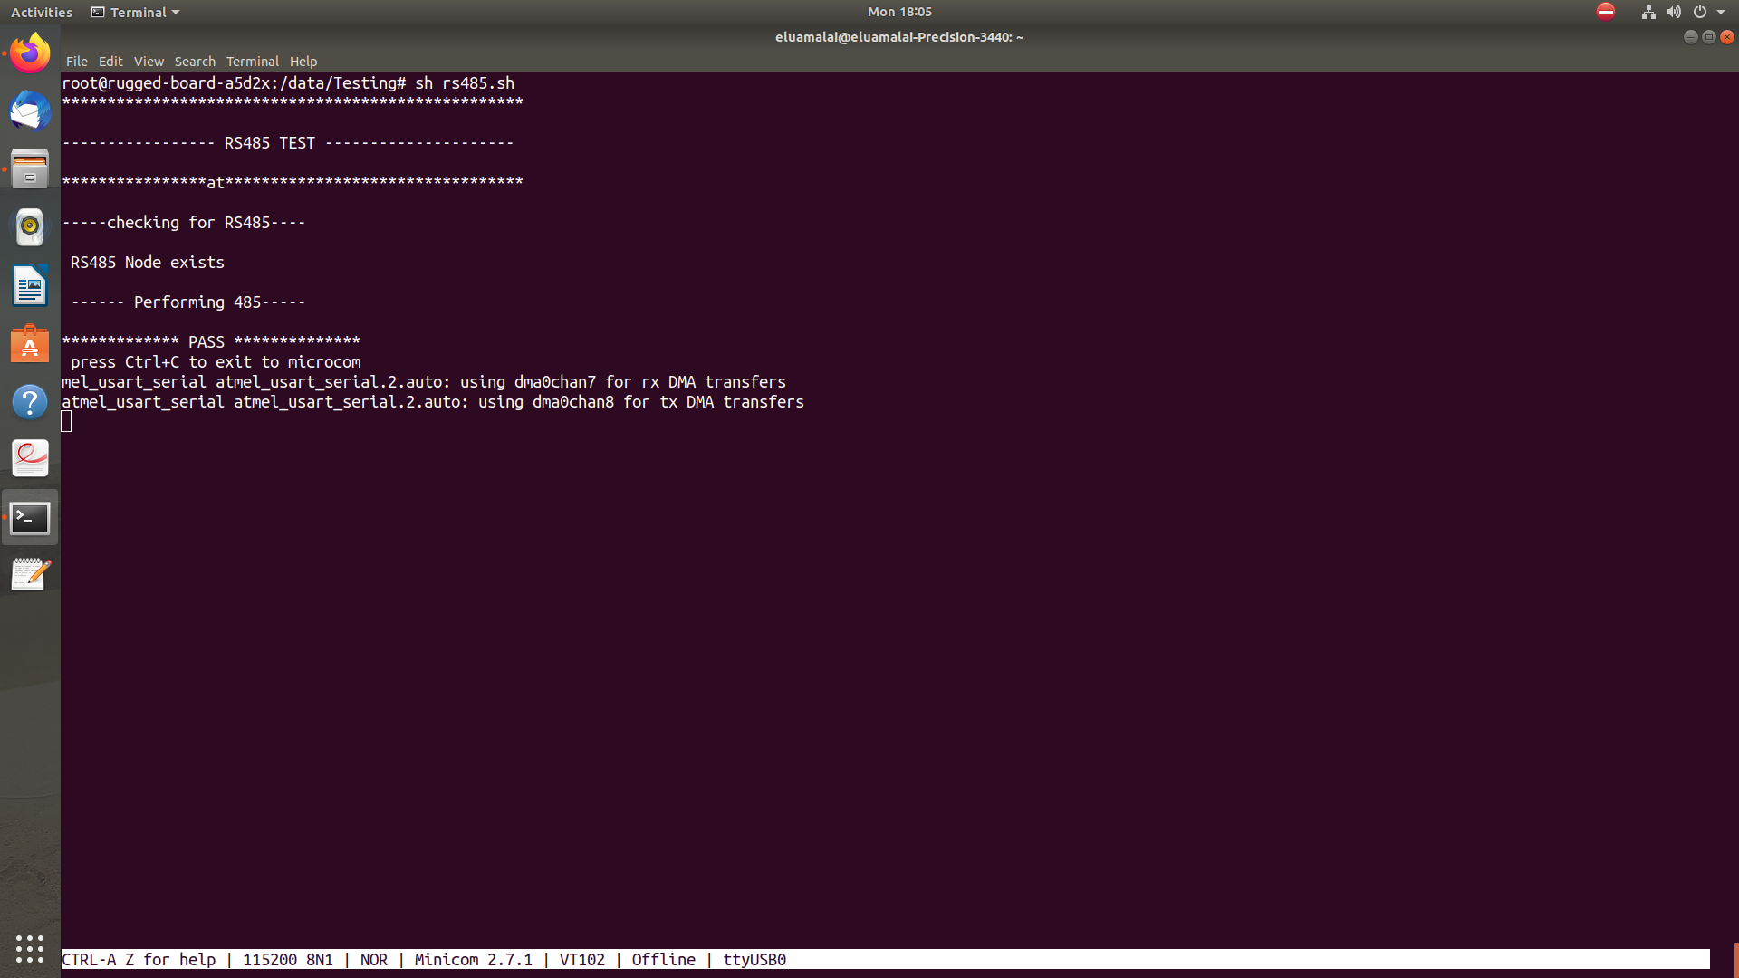
OUTPUT LOG

