README FILE
STEP1
creates an empty file named "data.txt" in the "/data/Testing" directory.
and writes the text " Welcome on phytec " to the "data.txt" file.

STEP2
checks if satement the device file "/dev/mmcblk1p2" exists or not.

STEP 3
copying file from board to sd card"

STEP 4
copying of file from board to sd card successful means PASS

STEP 5

copying of file from board to sd card Not successful means FAIL

STEP 6
SD_CARD not insert output will be "No sd card found on the board"

TESTING SCRIPT

#!/bin/sh

echo "***************************************************"
echo
echo "=============== TEST SD CARD ======================"
echo
echo "***************************************************"
touch /data/Testing/data.txt
echo " Welcome on phytec " > data.txt

if [ -e "/dev/mmcblk1p2" ]
then
echo "SD card found on the board"
echo "---------mounting the sd card--------"
mount /dev/mmcblk1p2 /mnt/
cd /mnt/
echo "copying file from board to sd card"
cp /data/Testing/data.txt /mnt/
if [ -e "/mnt/data.txt" ]
then
echo "copying of file from board to sd card successful"
echo "*************PASS**********"
else
echo "file not copied to sd card"
echo "**********FAIL*************"
fi
else
echo "No sd card found on the board"
fi

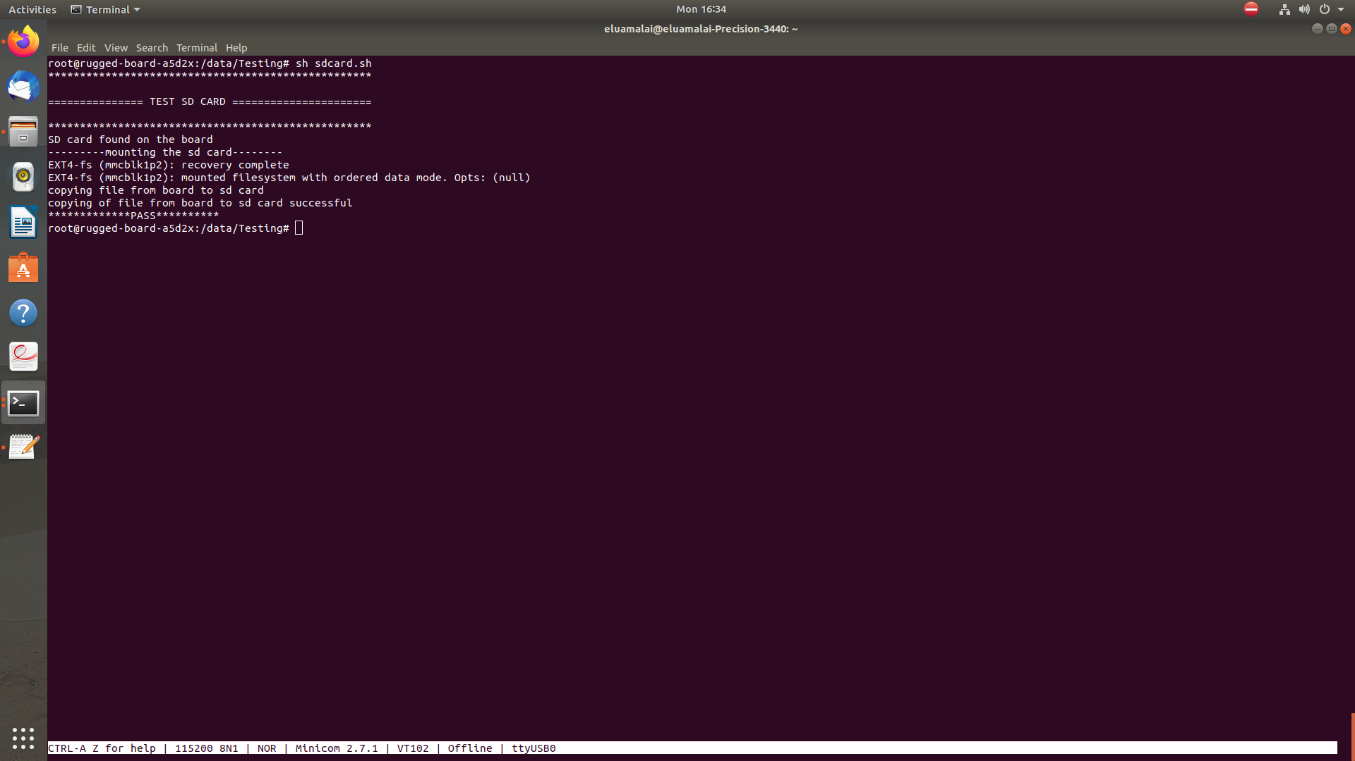
OUTPUT LOG

