RAEDME FILE

- Checks if the /dev/ttyS2 file exists. If it does, it proceeds with the test; otherwise, it displays a failure message and exits.
- If /dev/ttyS2 exists, it displays a success message and proceeds to perform the RS485 test.
- It launches the microcom tool with a baud rate of 115200 and specifies the /dev/ttyS2 device file as the communication interface.
- The script then waits for the user to terminate microcom using the Ctrl+C key combination.
- Once microcom is terminated, the script exits

TESTING SCRIPT
#! /bin/bash
echo "******************************"
echo
echo "------ TEST USART ------------"
echo
echo "******************************"
if [ -e "/dev/ttyS1" ]
then
echo "ADC NODE EXIST"
echo
echo "------------ performing UART Test ------- "
echo
echo "--------------------- PASS ----------------"
echo
else
echo "USART Node NOT Found "
echo "--------------------- FAIL ----------------"
fi

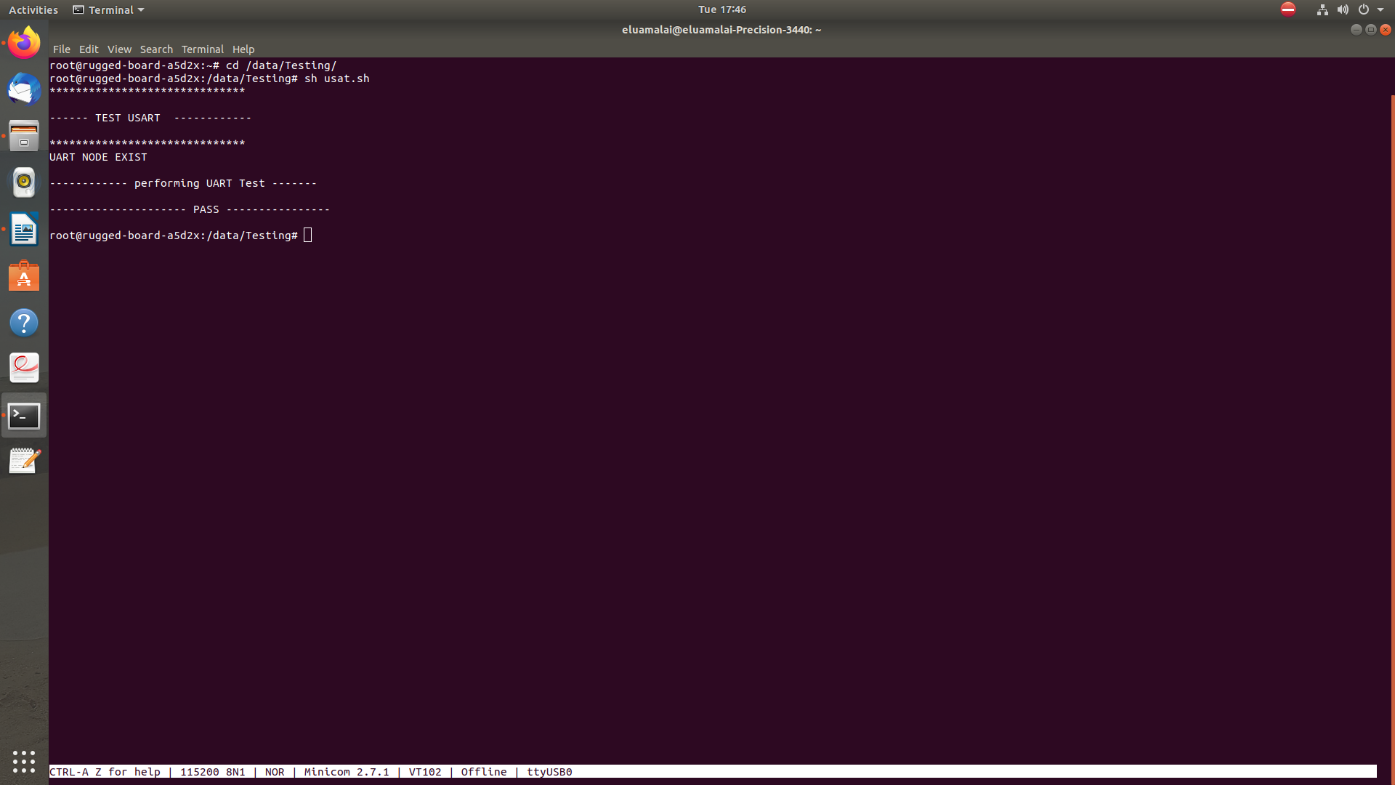
OUTPUT LOG

