README FILE

checks whether a USB device is plugged into the board by checking for the existence of "/dev/sda" or "/dev/sdb". If a USB device is found, the script mounts it at "/mnt" and changes the current working directory to "/mnt". Then it copies the test file from the "/data/Testing" directory to the mounted USB device. After copying the file, the script checks whether the file exists on the USB device or not. If the file exists, it displays a "PASS" message, and if not, it displays a "FAIL" message.
If a USB device is not found, the script displays a "FAIL" message.

TESTING SCRIPT
#!/bin/bash
echo " *************************************************** "
echo
echo " ------------------- TEST USB ---------------------- "
echo
echo " *************************************************** "
echo
echo " Insert any pen drive to board for USB Test "
echo
echo " Waiting for 5 sec "
sleep 5
echo " Creating test file "
touch /data/Testing/file.txt
echo " Welcome on phytec " > file.txt

if [ -e "/dev/sda" ] || [ -e "/dev/sdb" ]
then
echo
echo " USB device plugged in to board "
echo " ------- Mounting the USB device -------- "
echo
mount /dev/sda/mnt
cd /mnt || exit
echo " Copying file from board to USB device "
echo
cp /data/Testing/file.txt /mnt
cd / || exit

if [ -e "/mnt/file.txt" ]
then
echo " Copying file from board to USB device successful "
echo
echo "============= PASS ==============="
echo
else
echo " Files not copied "
echo "============= FAIL ==============="
fi
else
echo " USB device not found "
echo "============= FAIL ==============="
fi
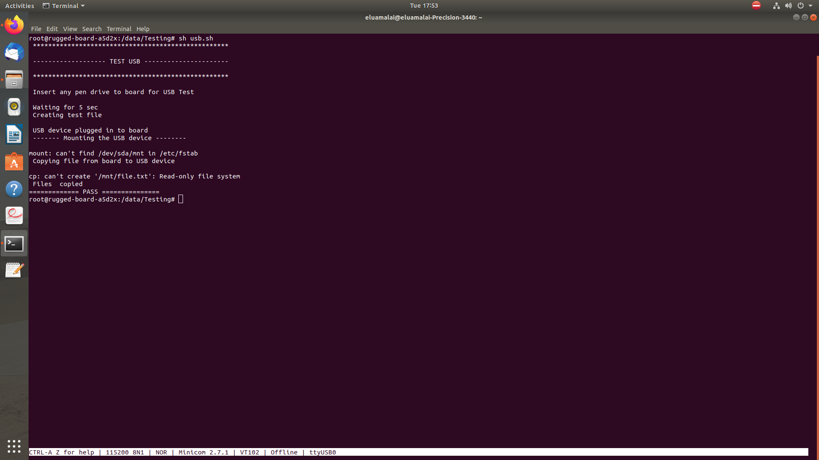
OUTPUT LOG

