README FILE

* IF Statement check the set of files or directories avalaiable or not

* Read the value of the set of files or directories

* Directories avaliable condition pass

* Directories Not avaliable condition "ADC NODE NOT FOUND"

TESTING SCRIPT

#! /bin/bash
echo "*********************************"
echo
echo "---------- TEST ADC -----------"
echo
echo "*********************************"

if [ -e /sys/bus/iio/devices/iio\:device0/in_voltage12_raw ]
then
echo "ADC NODE EXISTS"
var=$(cat /sys/bus/iio/devices/iio\:device0/in_voltage12_raw)
echo "======= PERFORMING ADC TEST ===="
echo $var
echo
echo "========= PASS ================"
echo
else
echo "ADC NODE NOT FOUND"
fi

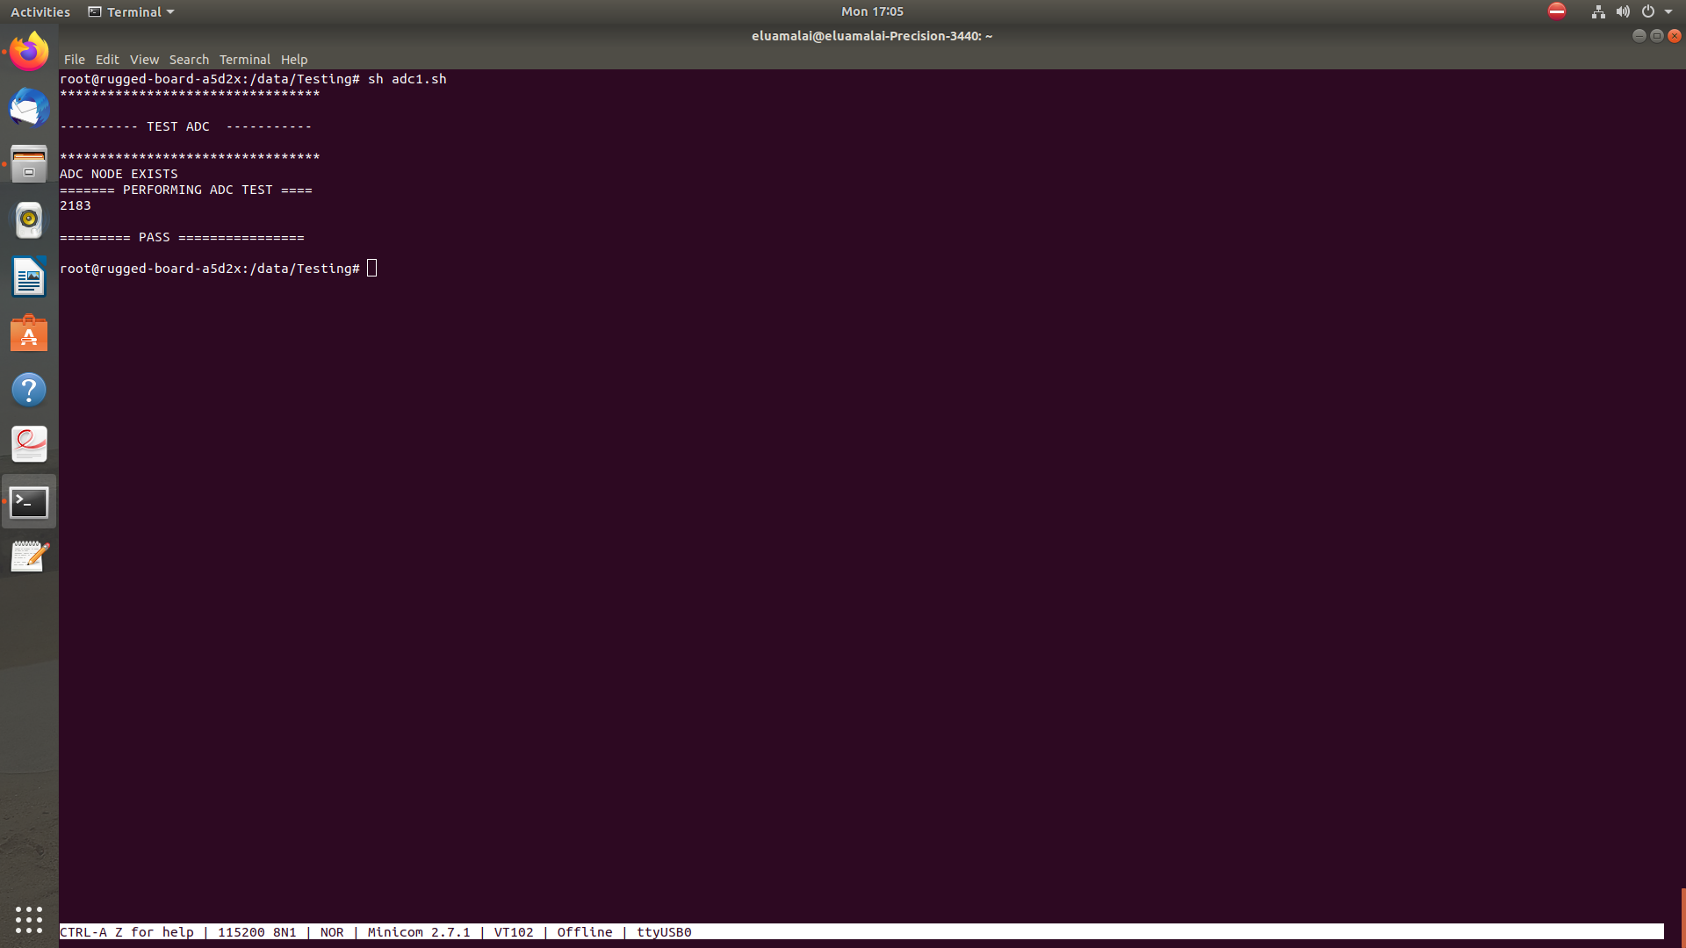
OUTPUT LOG

