**GUI Element 1: Start Screen**

**The client enter any key to start and sends them to the loading screen**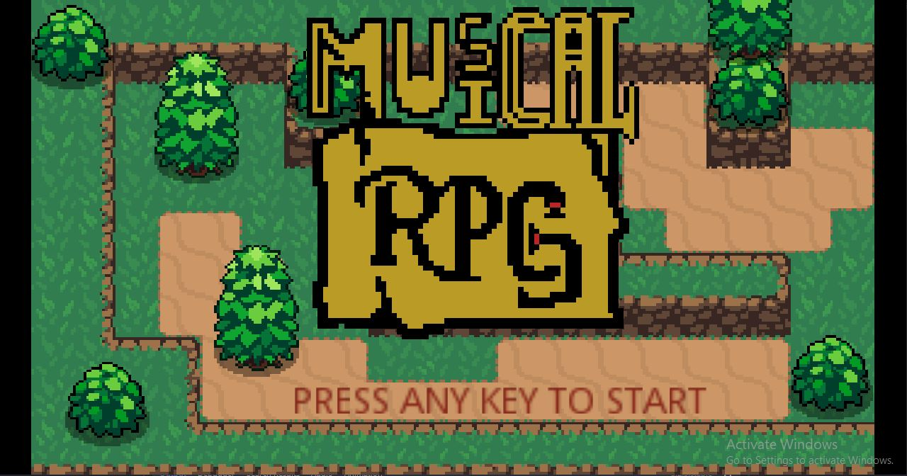

**GUI Element 2: Loading Screen**

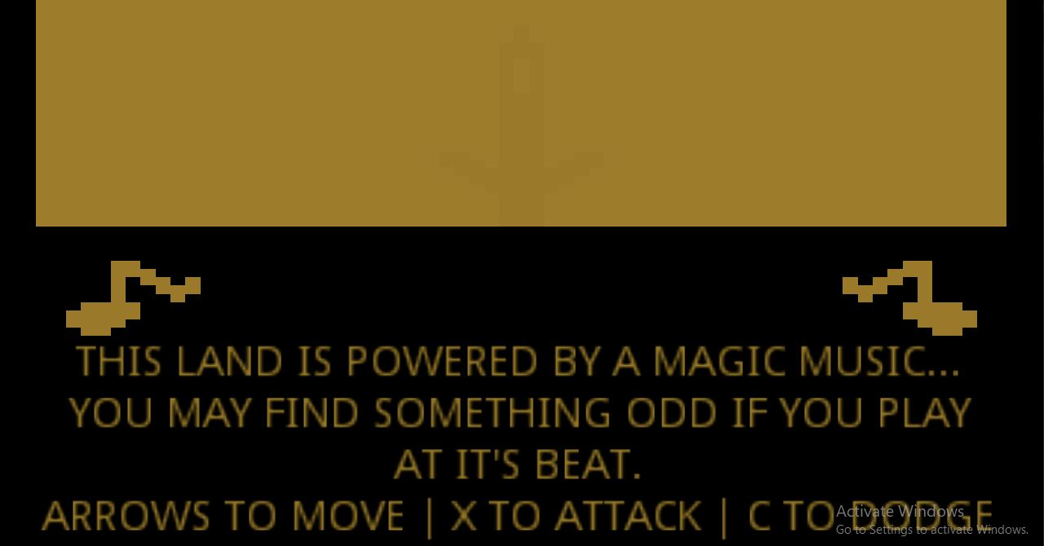

**This screen is designed to give the client knowledge about the input they may take**

**GUI Element 3: World/Forest Scene**

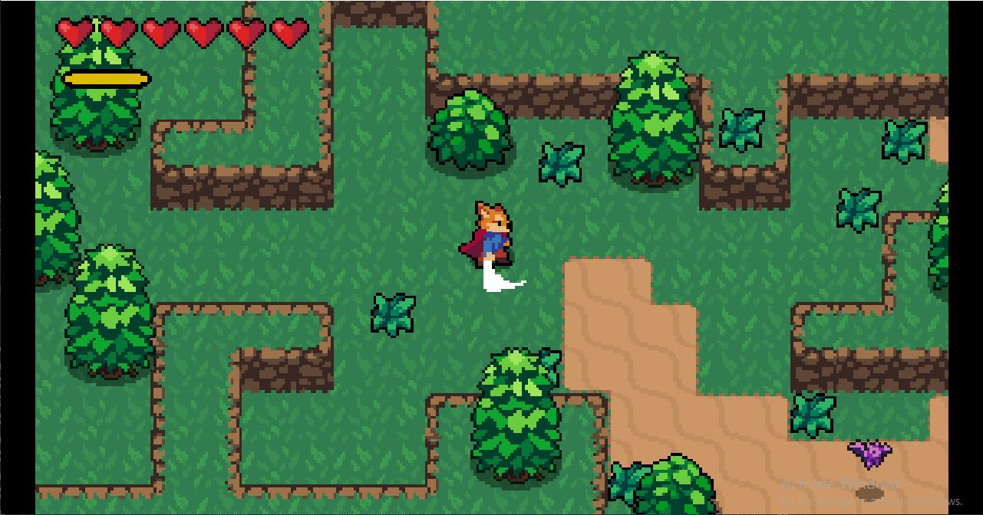

**This is the environment that the player is to interact with, 2 GUI items are displayed:**

Hearts - Amount of hit the Player body can take | Beat Meter - Glows when damage increase

**GUI Element 4: Game/Simulation Over Scene**

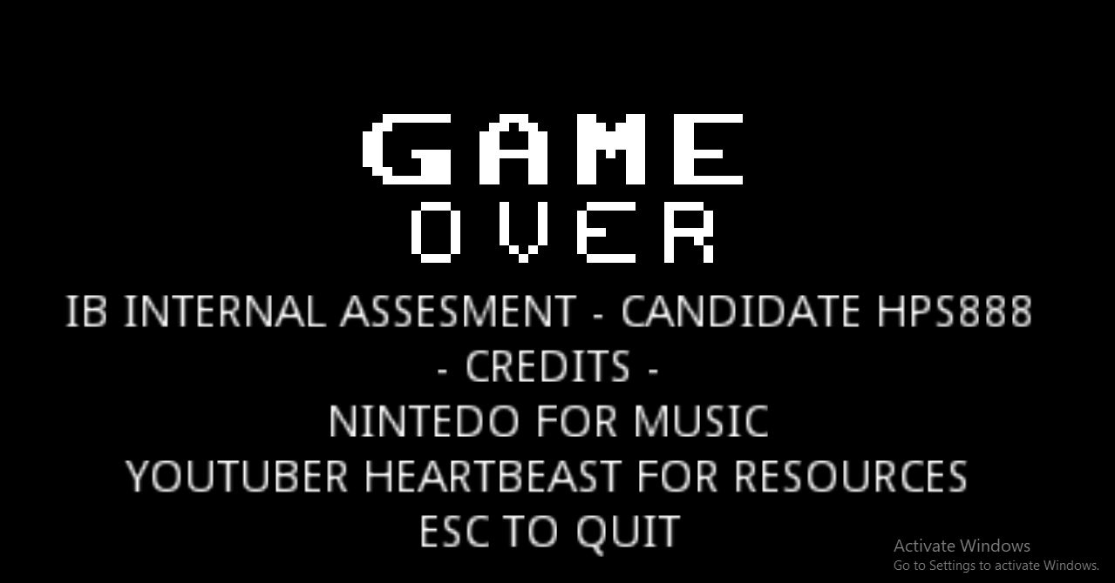

**This gives the client the credits to the developer, resource provider, and a way to exit**

# Flowchart - World

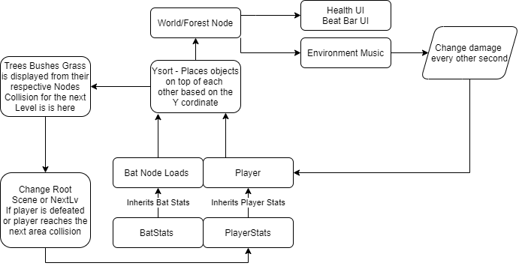

# Flowchart - Player

# Flowchart - Bat

# UML - World

# UML - Forest