**Ethical Hacking**   
**Assignment 3**

**Abdullah Raheel**

**18K-0170**

Fig 1.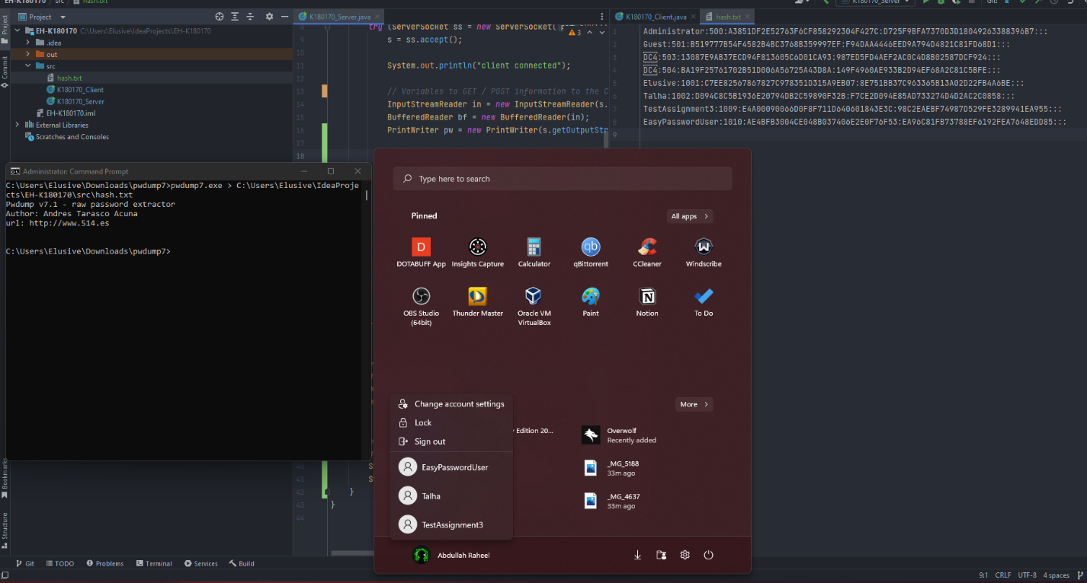

Users on Windows and dumping their passwords in Fig1. We can see their hashed Password in the hash.txt file we created inside our **src** code folder.

Fig 2.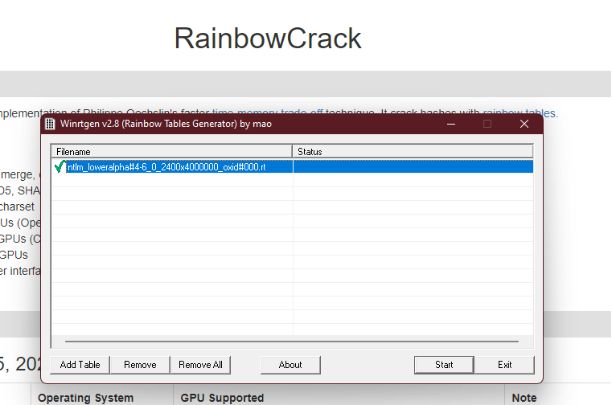

Using Winrtgen to generate a Rainbow table in Fig 2.

Fig 3.

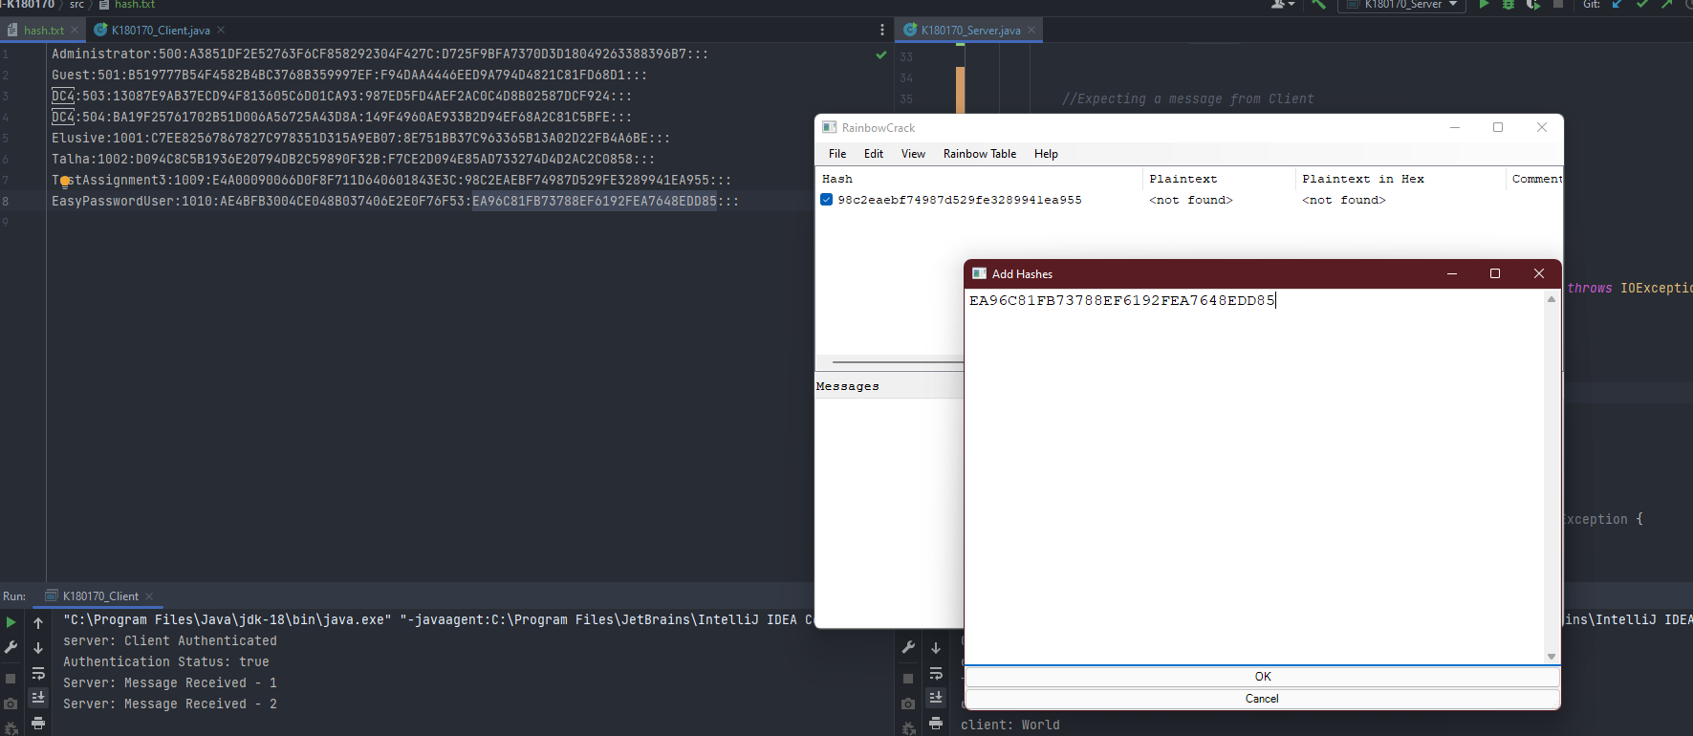  
  
Adding Hashes of the users we want to find the passwords for in Rainbow crack and also Adding the Rainbow table in Fig 3.

Fig 4.

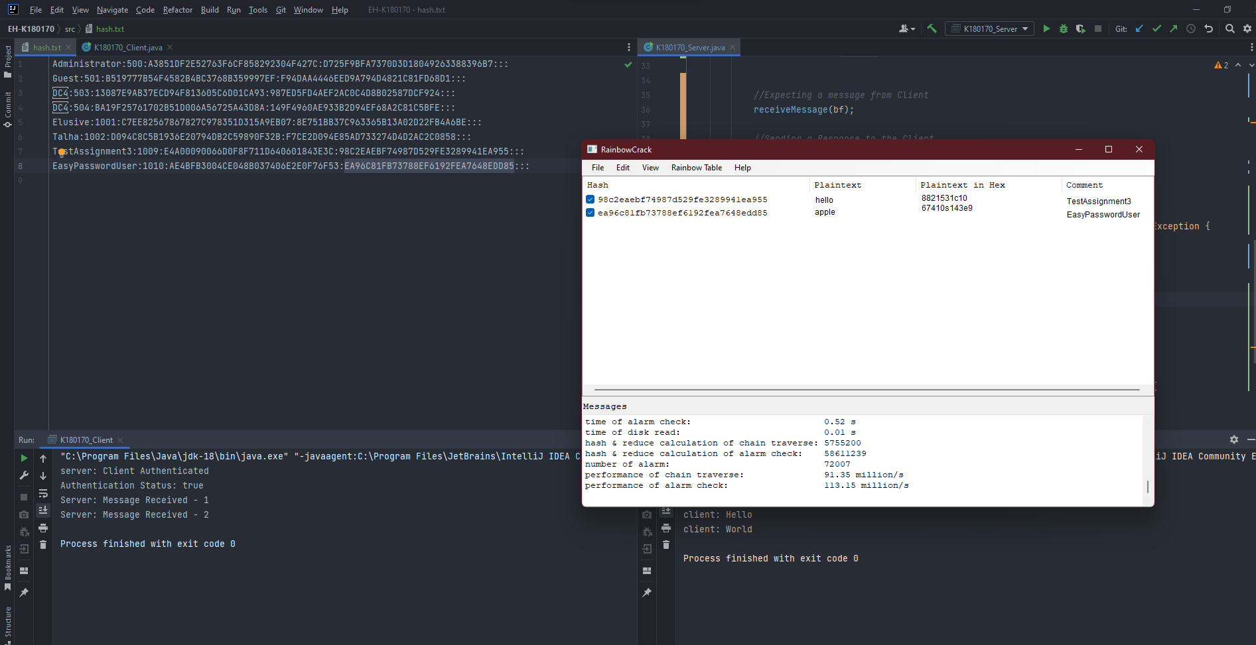

We crack the password of these users as we can see in Fig 4.

Fig 5.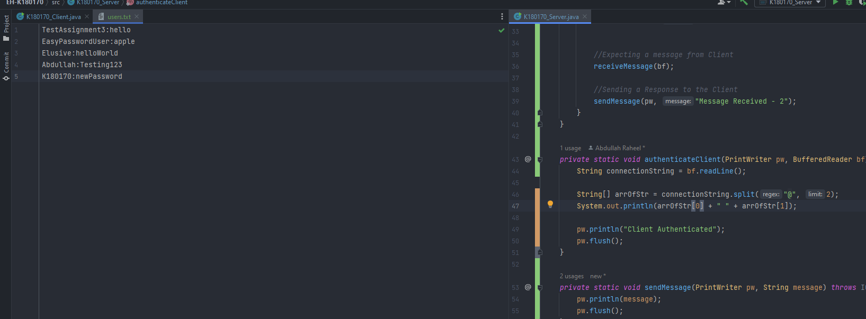

We Create a file(DB) with all valid users and their passwords we got in Fig 4. This new file can be seen in Fig 5.

Fig 6.

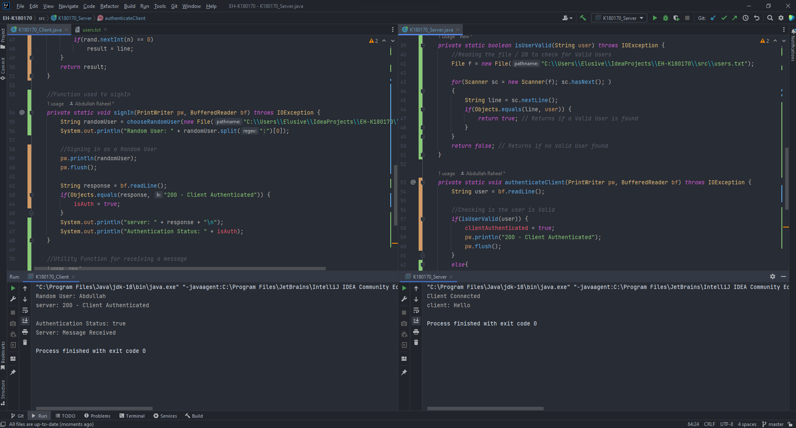

In Fig 6 each user is selected at **random** and authenticated against the server. If the user is authenticated successfully the server, then sends a message.

Fig 7.

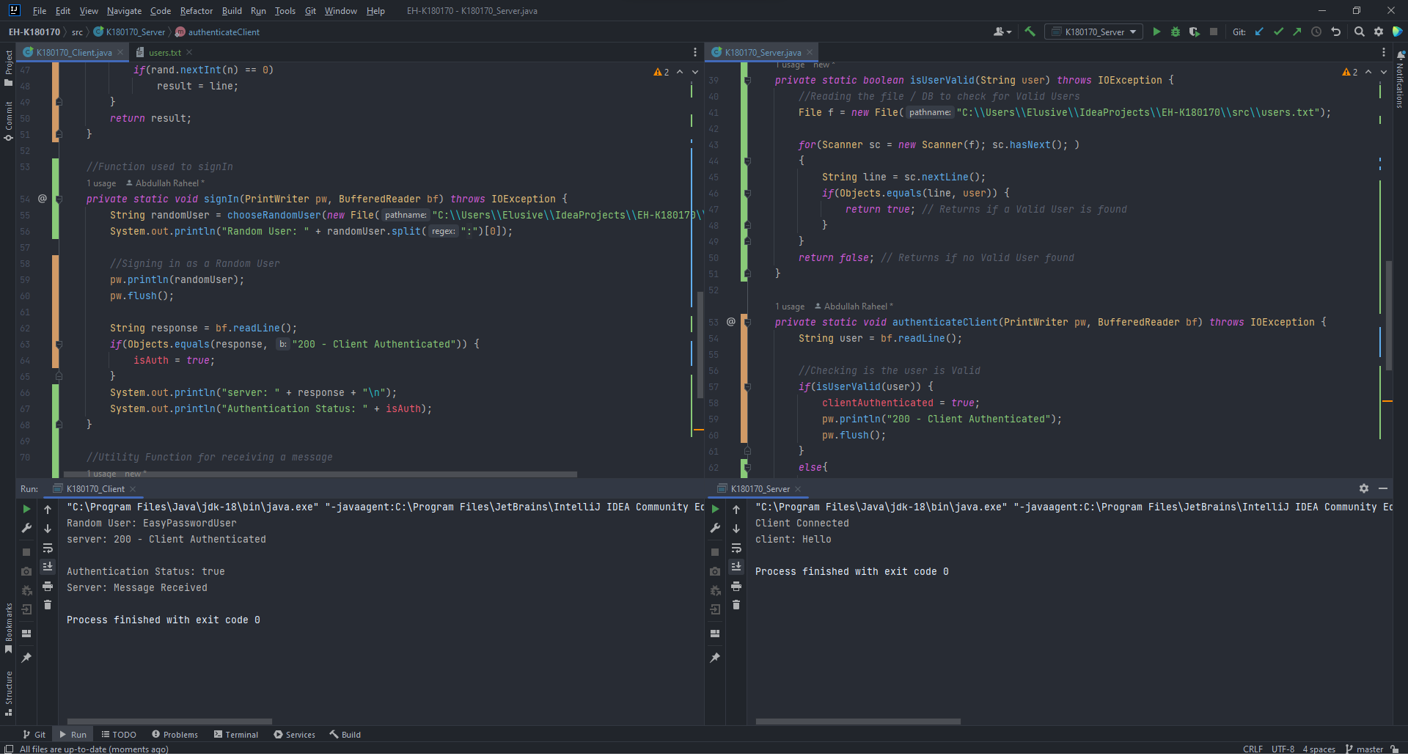

Each time the client File is run a new user at **random** is selected as seen in Fig 7.

Fig 8.

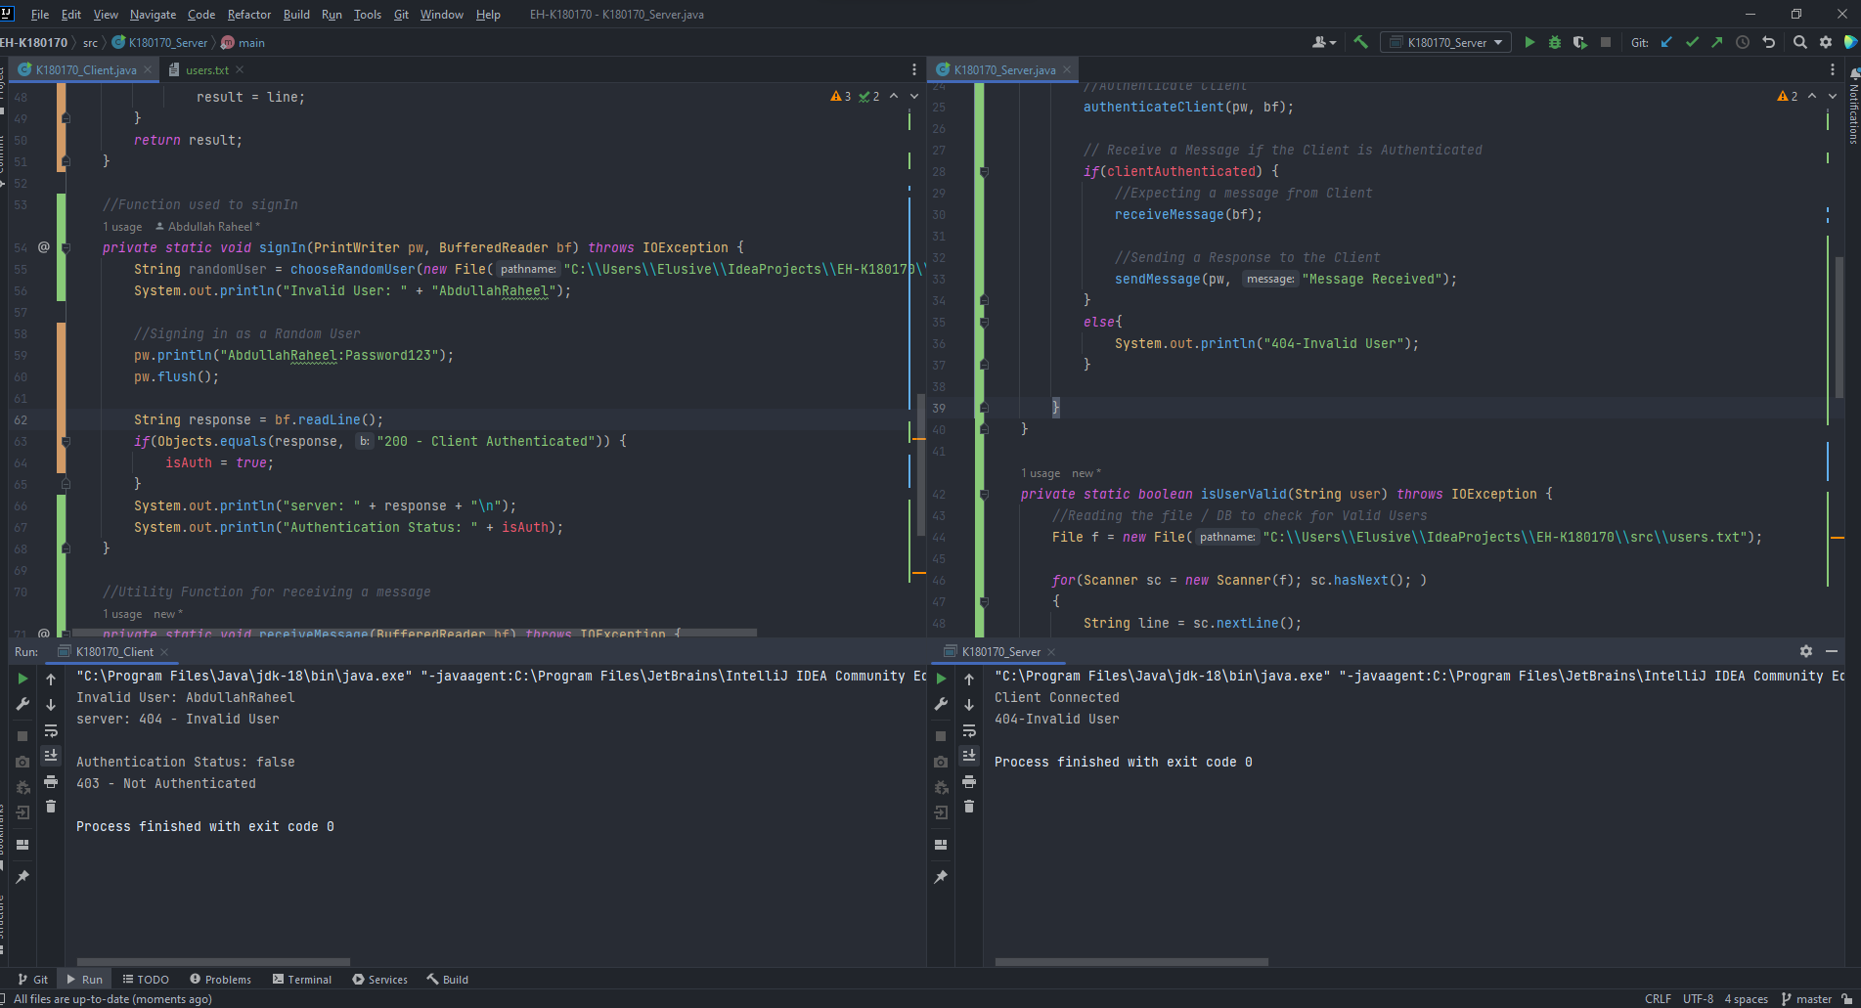

Selecting an invalid user in Fig 8. Server Does not allow the client to send a message since the client is an invalid user and can’t Access the Server. Figure 1 – 8 are steps that I followed. More comments added in the code for further explanation.