**DDOS – Lab**

**Ethical Hacking**

Abdullah Raheel

18K-0170

**My findings:**

**Fig 1:**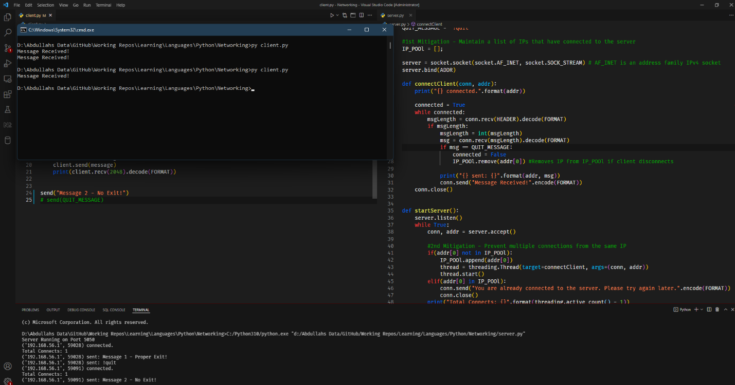

I used threading to flood the server with messages, and the aim of my attack was to consume as many resources of the server as possible so the server can not perform any other task and crashes.

Consider **Fig 1**, In this case client disconnects improperly, i.e without sending a quit message.

**Fig 2:**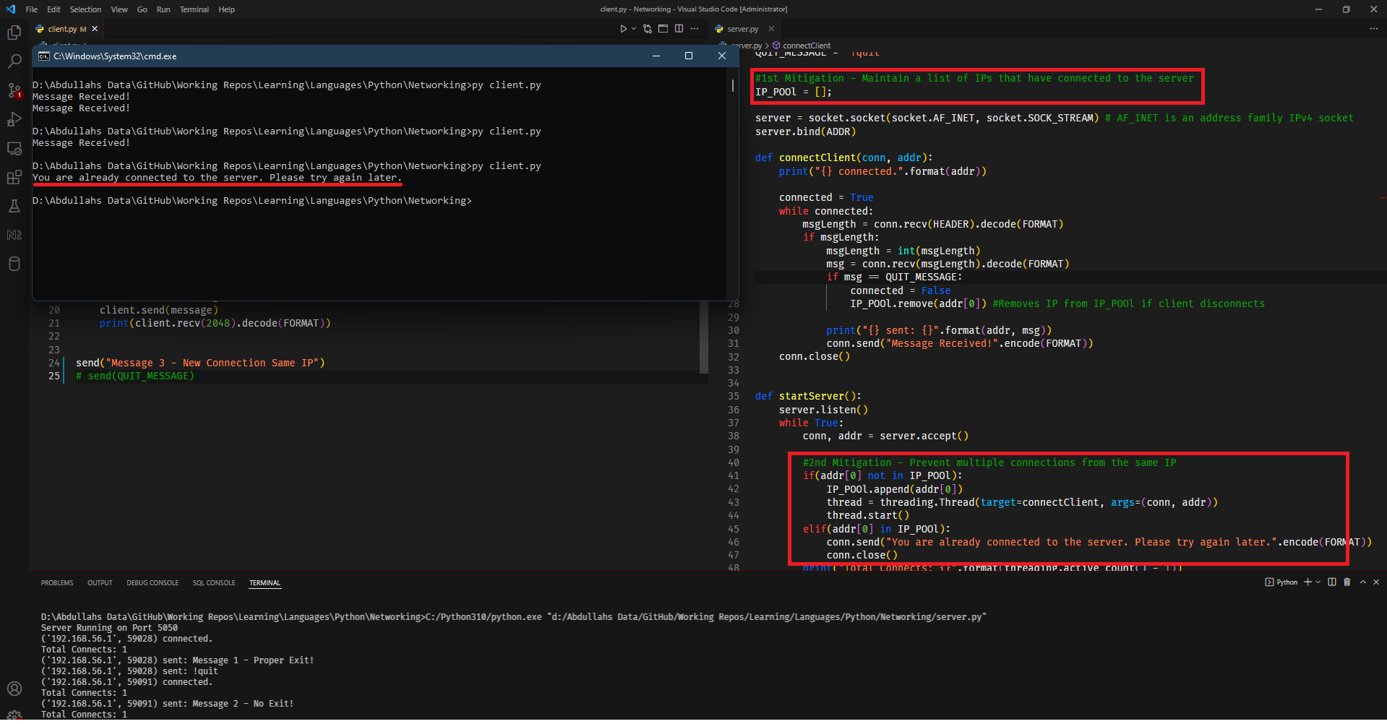

In **Fig 2**¸the client tries to initaite a new connection (without closing the connection as shown in **Fig 1**)

With my DDOS prevention technique in place an IP pool is maintained inside the server and the server checks if that user was previously connected. If so the server refuses the client to make a new connection as shown in **Fig 2**

**Fig 3:**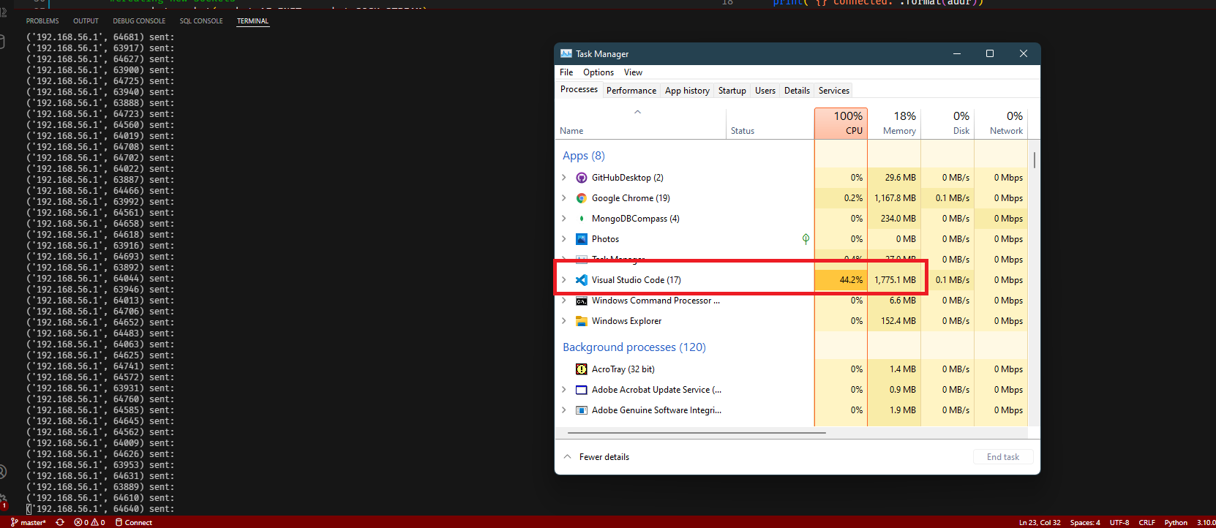

I commented out the prevention technique to see how the server would respond. As it can be seen in **Fig 3**, All of Servers resources are being consumed and the server can not even keep up with the messages it is reciveing therefore it is showing no messages.  
  
  
**Fig 4:**  
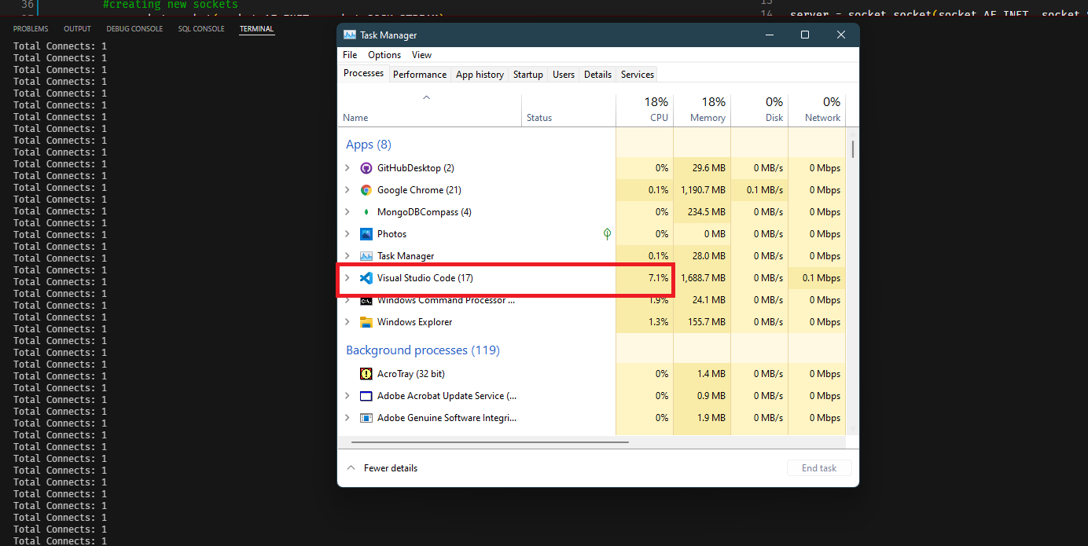

With DDOS prevention in place the server refuses connections to the same client and as we can see in **Fig 4** the total number of connects(connections) is **1**. We can also see in **Fig 4** that the server’s resources are not entierly consumed.