Following the previous task, find the following information:
a. Version: 10.0.26200 Build 26200 (Microsoft Windows 11 Pro)
b. Processor: Intel64 Family 6 Model 151 Stepping 2 GenuineIntel ~1400 MHz
c. System Directory: C:\Windows\System32
d. Motherboard: Manufacturer is Dell Inc and model is OptiPlex 3000
Use the Task Manager and find out what is the real “System Information” utility binary and its path.
C:\Windows\System32\msinfo32.exe
In Task Manager go to the Details tab and determine what is the lowest PID number process.
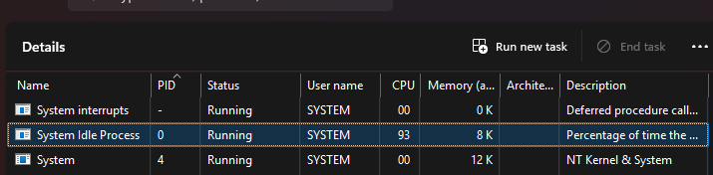

Following the previous task, find out what usernames assigned to the various processes. Usernames list:
- DWM-2 (dwm.exe)
- LOCAL SERVICE
- NETWORK SERVICE
- Student
- SYSTEM
- UMFD-0 (fontdrvhost.exe)
- UMFD-2 (fontdrvhost.exe)
Find the “Registry Editor” utility and run it. Use the Find feature and find the registry key called “.txt” and answer the following questions:
- How many sub-keys it contains?
2
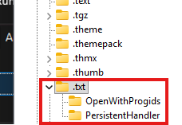
- What binary assigned to run “.txt” files by the registry?
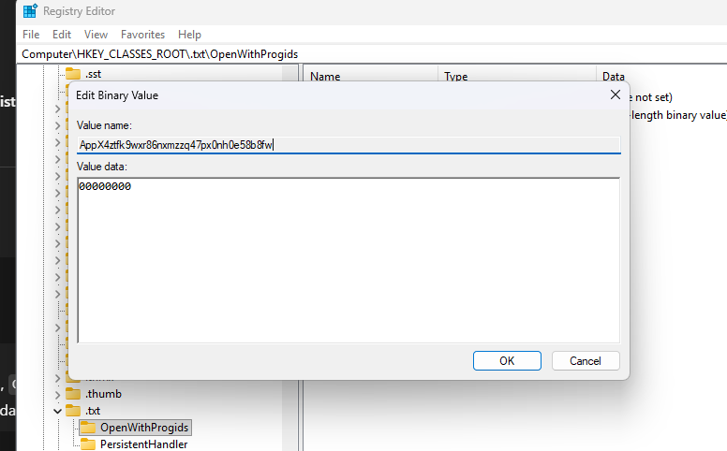
AppX4ztfk9wxr86nxmzzq47px0nh0e58b8fw
Find the “Local Security Policy” utility and run it. Find the following:
- What is the binary name of the utility?
C:\Windows\System32\secpol.msc.
- Inside the utility find the “Password Policy”, what is the Maximum password age?
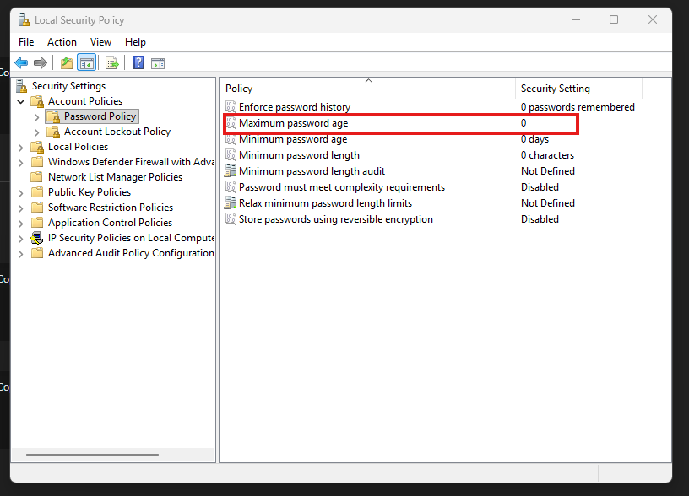
answer: 0

In “Local Security Policy” go to the “Advanced Audit Policy Configuration” → “Detailed Tracking” and configure the “Audit Process Creation” to audit Success and Failure.
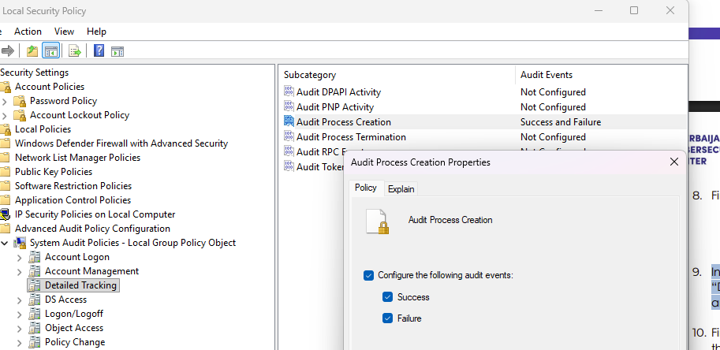
Find the “Event Viewer” utility and run it. Expend the “Windows Logs” and choose the “Security” log. Find the following:
- What is the Process Creation event identifier?
4688
- What is the last process created? Mention its name and creator.
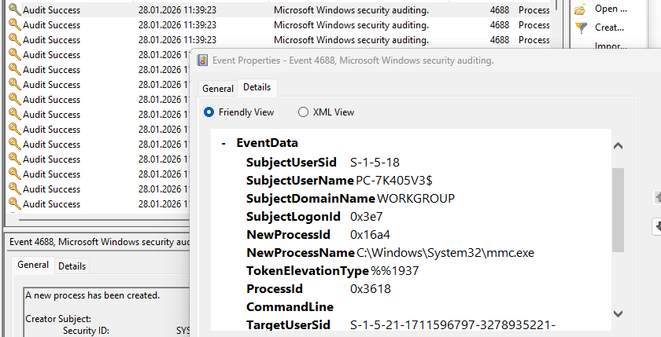
New Process Name: C:\Windows\System32\mmc.exe
Creator Account Name: STUDENT
- What PID assigned to that process? Could you find it in the Task Manager?

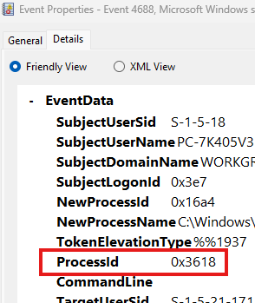
Answer: 0x3618
- Run from the start “Notepad.exe”, what is the PID of the creator? Provide the creator name and if you were able to find it in the Task Manager.
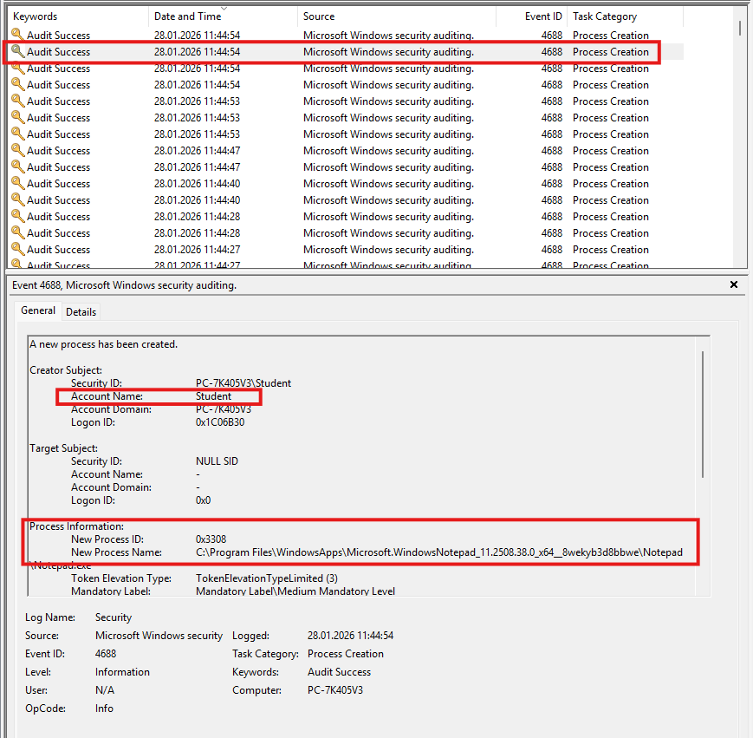
Process name: C:\Program Files\WindowsApps\Microsoft.WindowsNotepad_11.2508.38.0_x64__8wekyb3d8bbwe\Notepad\Notepad.exe
Creator Account Name: Student
