**Installation Guide For Graphical User Interface (GUI) for image analysis of ALI culture filters immunofluorescently stained**

This document provides instructions on installation of GUI for analysis of IF stained ALI culture filters and imaged for Covid positive infections, ‘ALIIFAnalysis’, implemented in Matlab 2022a (Natick, MA). The user will need ideally most recent version Matlab and have Image and Signal Processing toolboxes installed. Older version of Matlab that do not support Maltab App Designer will not be usable as this GUI was designed using App Designer and GUIDE interface in Matlab. Please ensure to download the full package including the gui file ALIIFAnalysis.mlapp, ALIIFAnalysis.prj and supporting scripts, readOMEAlternativeGUI.m, GetOMEData.m, gfp.m and yfp.m, as well as Open Microscopy Environment (OME) package for matlab inside zipped folder ‘bfmatlab’, which can be downloaded on following page:https://www.openmicroscopy.org/bio-formats/downloads/. This package will be used to open your microscopy files such as .czi, .oir, .nd2. Please ensure all of these are in a common folder within the home Matlab directory installed on the computer used for analysis.

*

4

1

3

2

**Figure 1: packaging GUI in Matlab using** **ALIIFAnalysis.prj file.**

Click on ‘Remove main file’ as shown in ‘1’ above and then click on ‘Add main file’ and select ALIIFAnalysis.mlapp file in the folder you have saved on your local Matlab folder. Then click on ‘Add/files/folder’ as shown in ‘2’ above and select the unzipped ‘bfmatlab’ folder on your local folder where you saved all the scripts. Next, ensure all the toolboxes are added as shown in the Figure 1 at ‘3’ and use ‘+’ to add them. Please ensure those toolboxes are added to Matlab during the installation process, as ‘+’ does not install them, only adds them to this GUI. Lastly, click on ‘Package’ as shown in ‘4’ above. The packaging will proceed and when finished it will display at position 4 of Figure 1, ‘Packaging Complete’ (Figure 2a). In the folder where. mlapp and .prj file for this GUI were placed, you will notice a new file ALIIFAnalysis.mlappinstall. Please click on this file and it will open the window as shown in Figure 2b. Click on ‘Install’ and this proceed to add the packaged GUI to the ‘Apps’ tab of Matlab.

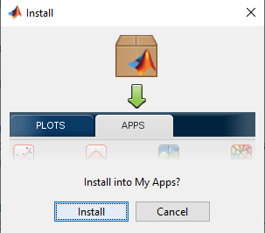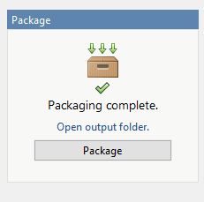

**A**

**B**

**Figure 2: Packaging and Installation of GUI for ALIIFAnalysis.**

Now that GUI is installed, please navigate to Matlab’s ‘Apps’ tab at the top and click on the arrow indicated by ‘1’ below to see all the available Apps, both Matlab built in and custom made ones. In the section ‘My Apps’ you will only have this GUI app installed as shown in ‘2’ in Figure 3 below, but likely not other GUIs in My Apps.

2

1

**Figure 3: Where to find the installed GUI.**

Top open installed GUI, click on the Apps tab as shown in figure 3, and arrow as shown in figure 3 (#1). Locate installed GUI ALIIFAnalysis and click on it to open it. It will open the menu as shown in figure 4 below.

**Figure 4: Overview of ALIIFAnalysis GUI and example of data imported.**

To load Covid positive label image, press the button ‘1’ (Fig. 4). You will be prompted to select an Open Microscopy Environment (OME) file, such as .czi from Zeiss microscopes. The opened image will display in the axes labelled by ‘19’. Next open the image file for the other channel of interest by pressing the button ‘2’. If you have previously saved the analysis parameters using button ‘18’ you can load them by pressing the button ‘3’. This will set the sliders and values to values previously recorded. In order to normalise the background intensity, user is prompted to define some data related parameters. If your image data was captured using tiling mode, please enter size of single tile in x and y dimension (buttons 4 and 5, respectively). Enter number of tiles acquired along x and y dimensions (buttons 6 and 7, respectively). Next, define (8) which corner of the tiled image do you want to use to extract an average background profile. Default is ‘UL’ for upper left corner. Define (edit ‘9’) how many tiles from that corner to use to extract the average profile. Default is 2, meaning 2 by 2 tiles form UL corner will be taken and their average will be calculated and used as normalising average background profile. Pressing button ’10’ initializes the normalisation of each tile by average background profile. The progress bar 20 will indicate the evolution of analysis. Output of correction will displayed as shown in figure 5 a).

**Figure 5: A) Output after background correction. B) Contour selection.**

Next, we proceed with segmentation of cluster. First step is to select a polygon around the part of sample which are deemed usable, and exclude saturated regions of sample, which are result of ALI filter folding and subsequent artefact in imaging. To achieve this, please press button ‘11’ and when the cursor + appears select the polygon around the working sample area. To finish selection double click the right hand button of the mouse to close the polygon and terminate the operation. The resulting polygon will be displayed as shown in figure 5 b). Next, we apply a thresholding slider (12) to binarize the background corrected Covid positive image. Adjust slider 12, until only the true Covid positive regions are selected (Figure 6 a).

Zoom in controls

**Figure 6: a) Binarization of Covid positive image. B) Zoom in to the region in a)**

By hovering over the upper right corner of the image, the zoom in controls appear, allowing to zoom in on part of whole tiled image and see which clusters are being selected via thresholding of slider 12 (Figure 6 b). Clicking on the home icon, brings zoom back to original view. Next step involves cutting small clusters using the slider 13. Usually noise or cluster too small to be actual signal of Covid nano-particles (NP), are removed in this step. Adjust it until getting these small clusters cout out as shown in figure 7.

**Figure 7: a) Overview b) zoom in before and c) after filtering of small clusters.**

Use sliders 14 and 15 to perform same operations on the channel 2 of your data.

Now that images are segmented, user can proceed with exporting (Button ‘16’) the reference binary and normalised images as shown in figure 8:

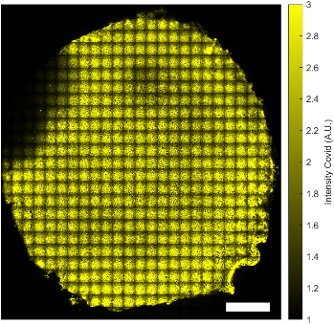

**Figure 8: a) Binary and normalised image for Covid NP data. b) for ch. 2 data**

Finally, using button ‘17’, user can export all the statistics into an excel sheet. Here is the summary (figure 9) of excel sheets contents:



**Figure 9: summary of sheets of the output stats file.**

First sheet gives the percentage of the area coverage of NP Covid particles vs whole area. Second sheet is percentage of channel 2 label positive area vs whole area of sample. Third sheet gives the percentage of overlapping areas between Covid NP and channel 2 label to the total surface area of the sample. Sheets 4 and 5 provides some intensity stats of whole areas for two considered images:

Sheets 6 and 7 give the x and y envelopes of the histograms of the intensities of all pixels belonging to the extracted covid positive and reference channel areas, respectively. Sheet 8 outputs all the covid positive pixels’ intensities. Sheets 9 and 10 output the stats of the clusters from segmentation, post filtering, for either covid positive image or for the reference channel. Here is example of the properties exported:

For each object found (rows) several geometric and intensity properties are exported.