**Installation guide for Graphical User Interface (GUI) for FFCS analysis**

This document provides instructions on installation and usage of GUI for basic simulating and analysing by FFCS approaches, as implemented in Matlab 2022a (Natick, MA). The user will need ideally most recent version Matlab and have Image Processing and Signal Processing toolboxes installed. Older version of Matlab that do not support Maltab App Designer will not be usable as this GUI was designed using App Designer and GUIDE interface in Matlab. Please ensure to download the full package including the gui file FFCSguide_GUI.mlapp, FFCSguide_GUI.prj and supporting scripts included inside ‘for GUI’ folder. Please ensure all of these are in a common folder within the home Matlab directory installed on the computer used for analysis.

First proceed by packaging the GUI by opening the FFCSguide_GUI.prj file in Matlab

session as shown in Figure 1:

3

1

2

4

**Figure 1: packaging GUI in Matlab using FFCSguide_GUI.prj file.**

Click on ‘Remove main file’ as shown in ‘1’ above and then click on ‘Add main file’ and select FFCSguide_GUI.mlapp file in the folder you have saved on your local Matlab folder. Ensure that all the scripts inside the ‘for GUI’ folder are showing inside the column to the left (2). Next, ensure all the toolboxes are added as shown in the Figure 1 at ‘3’ and use ‘+’ to add them. Please ensure those toolboxes are added to Matlab during the installation process, as ‘+’ does not install them, only adds them to this GUI. Lastly, click on ‘Package’ as shown in ‘4’ above. The packaging will proceed and when finished it will display at position 4 of Figure 1, ‘Packaging Complete’ (Figure 2a). In the folder where .mlapp and .prj file for this GUI were placed, you will notice a new file FFCSguide_GUI.mlappinstall. Please click on this file and it will open the window as shown in Figure 2b. Click on ‘Install’ and this proceed to add the packaged GUI to 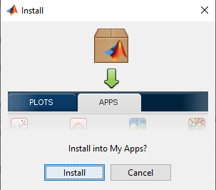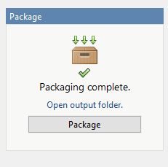the ‘Apps’ tab of Matlab.

**B**

**A**

**Figure 2: Packaging and Installation of GUI for CBF analysis.**

Now that GUI is installed, please navigate to Matlab’s ‘Apps’ tab at the top and click on the arrow indicated by ‘1’ below to see all the available Apps, both Matlab built in and custom made ones. In the section ‘My Apps’ you will only have CBF calculator app installed as shown in ‘2’ in Figure 3 below. 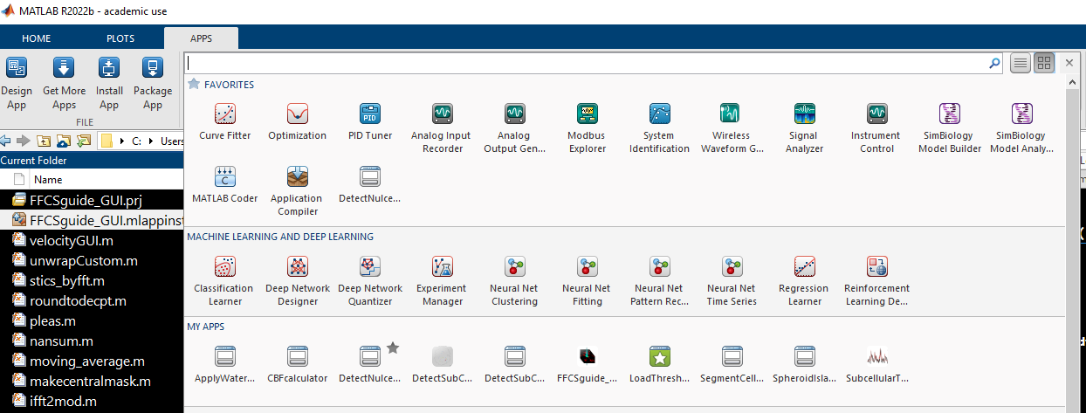

2

1

**Figure 3: Where to find the installed GUI.**

Click on the FFCSguide_GUI to open the GUI as shown in figure 4 below. Click on the button ‘1’ as shown in Figure 4 to initialise simulation parameters and then adjust the other simulation parameters as detailed in exercices of the manuscript. For instance, to simulate FCS data as shown in figure 4, after pressing button Intialise Parameters, set # of images (time points) in series to 10000, PSF Axial radius to 1.2 um, and Do FCS experiment to ‘yes’. Set the Diffusion coefficient to 0.1 um^2/s and press Simulate FCCS data now.

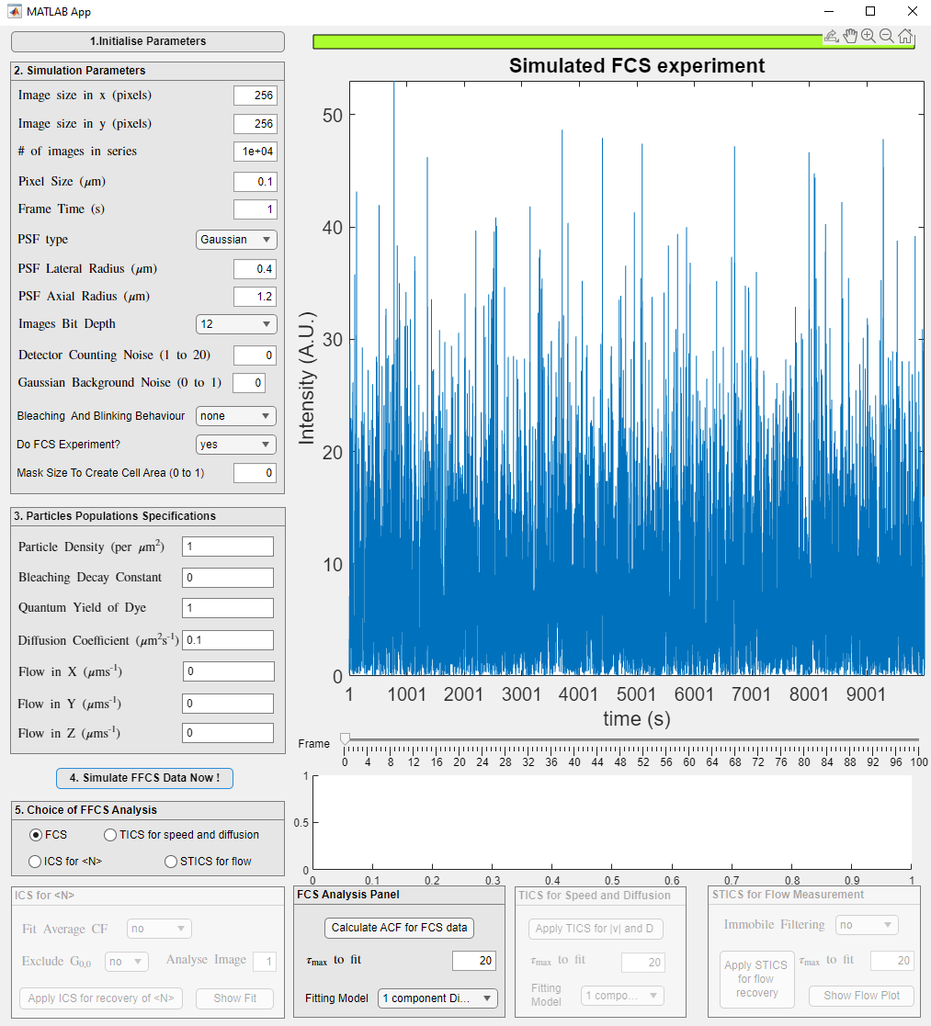

**Figure 4: FCS simulated data (left) and 3D Diffusion model fit (right)**

The Analysis panel (5) has 4 choices. By default it is set at choice FCS which enables the FCS Analysis Panel. First press calculate ACF for FCS data and then adjust max tau fit (as needed) and select the fitting model for Auto-Correlation function (ACF). Depending on the model chosen , you will get fit and outputted parameters as shown in Figure 4 right.

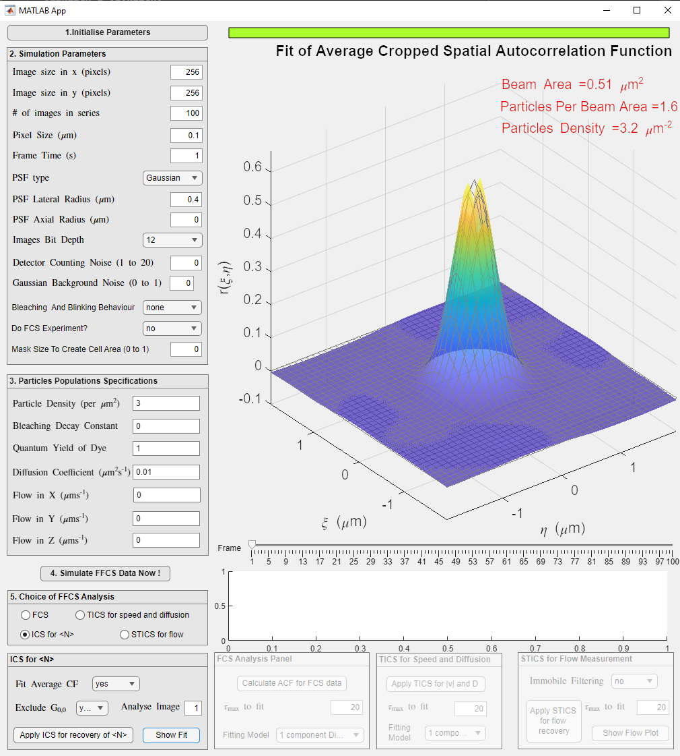

**Figure 5: Simulated time series (left) and ICS fit (right).**

To simulated the time series, set simulator as shown on left in Figure 5. To proceed with ICS analysis, click on ICS for <N> on panel 5, as this will enable ICS for <N> panel. Select whether to fit average ACF or no, if to exclude G(0,0) in the fit, and proceed by applying ICS. Finally click Show fit to show the ICS fit to ACF.

For other exercises, follow instructions as shown in the manuscript. When simulating multiple dynamic populations, ensure that panel 3 of the GUI, has 1 parameter per population. For example, if one is to simulate one diffusing and one flowing population, as shown in figure 6 left, put 1 value for each dynamic population inside the panel 3, and values separated by space.

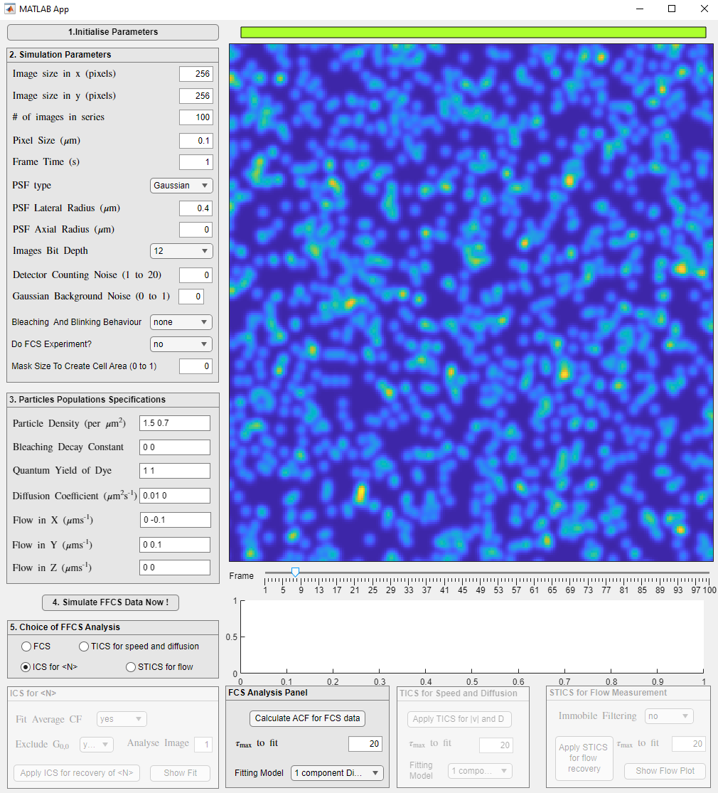 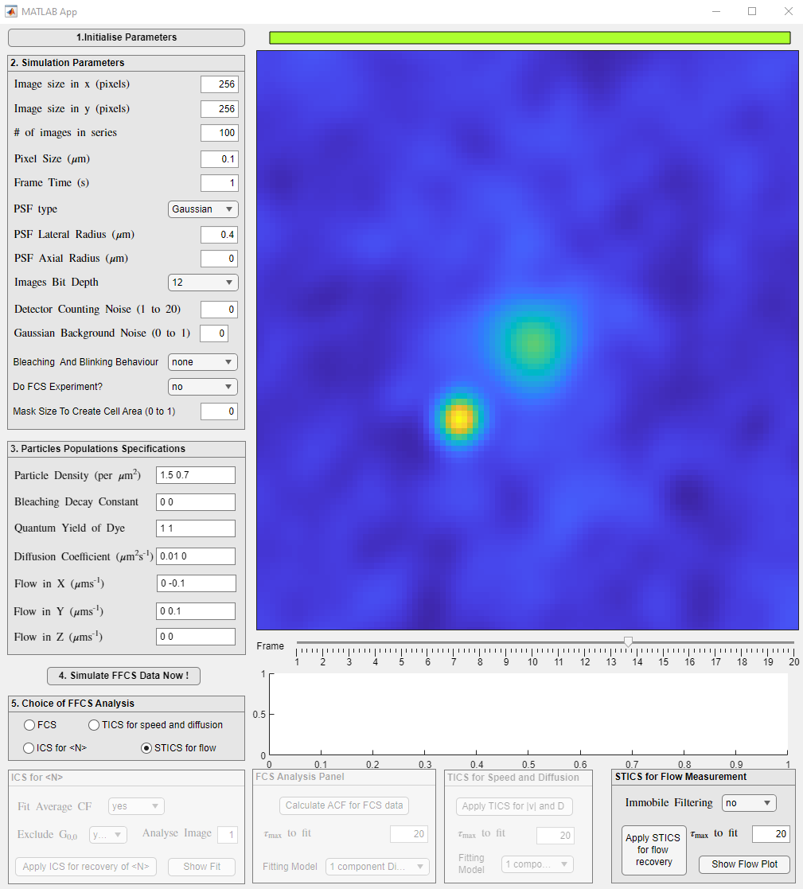

**Figure 6: Simulated time series with 2 dynamic populations (left) and STICS analysis showing one correlation peak flowing and one spreading centrally due to diffusion (right).**

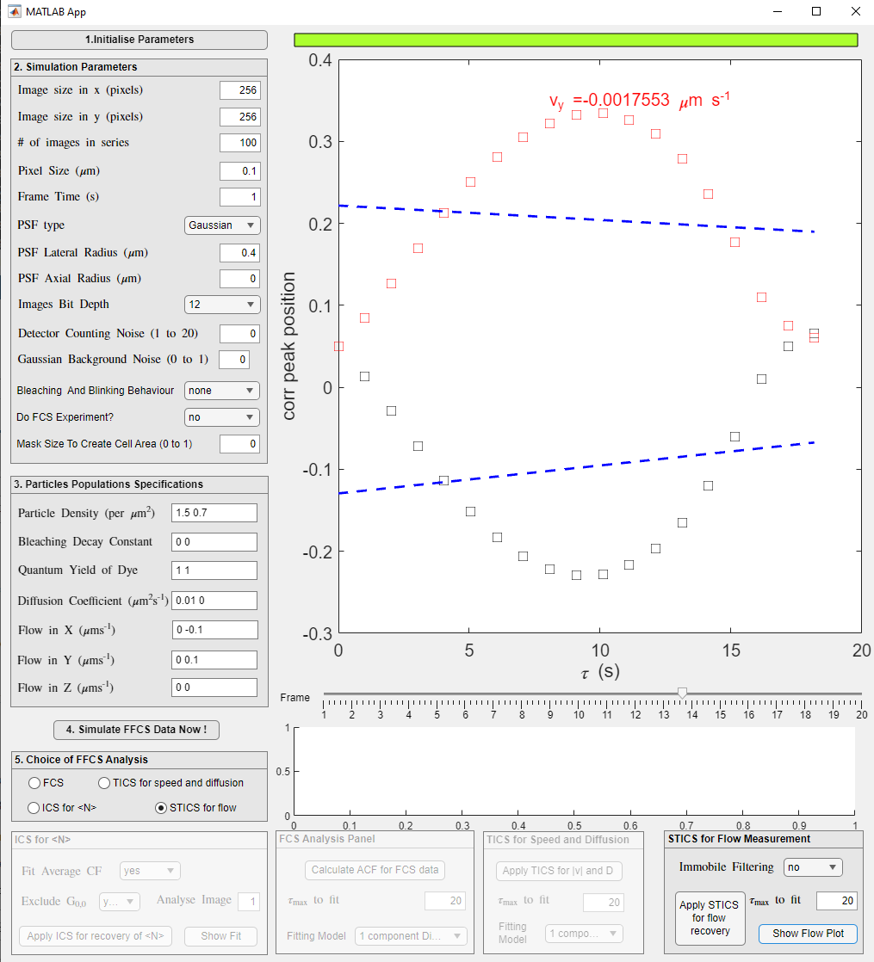

**Figure 7: Flow plot resulting from STICS analysis when no immobile filtering is applied (left) and flow plot after immobile filter was applied (right).**