**Installation Guide For Graphical User Interface (GUI) for Cellular segmentation and calcium signal analysis.**

This document provides instructions on installation of GUI for calcium signal detection within cell analysis ‘SegmentCellsExtractCalciumSignalingStats’, implemented in Matlab 2020b (Natick, MA). The user will need ideally most recent version Matlab and have Image and Signal Processing toolboxes installed. Older version of Matlab that do not support Maltab App Designer will not be usable as this GUI was designed using App Designer and GUIDE interface in Matlab. Please ensure to download the full package including the gui file SegmentCellsExtractCalciumSignalingStatsV3.mlapp, SegmentCellsExtractCalciumSignalingStats.prj and supporting scriptsmoving_average.m, nansum.m, pkfnd.m, readOMEAlternativeGUI.m, smoothSeries.m, GetOMEData.m as well as Open Microscopy Environment (OME) package for matlab inside zipped folder ‘bfmatlab’. Please ensure all of these are in a common folder within the home Matlab directory installed on the computer used for analysis.

First proceed by packaging the GUI by opening the SegmentCellsExtractCalciumSignalingStats.prj file in Matlab session as shown in Figure 1:

1

2

3

4

**Figure 1: packaging GUI in Matlab using CBFcalculator.prj file.**

Click on ‘Remove main file’ as shown in ‘1’ above and then click on ‘Add main file’ and select SegmentCellsExtractCalciumSignalingStatsV3.mlapp file in the folder you have saved on your local Matlab folder. Then click on ‘Add/files/folder’ as shown in ‘2’ above and select the unzipped ‘bfmatlab’ folder on your local folder where you saved all the scripts. Next, ensure all the toolboxes are added as shown in the Figure 1 at ‘3’ and use ‘+’ to add them. Please ensure those toolboxes are added to Matlab during the installation process, as ‘+’ does not install them, only adds them to this GUI. Lastly, click on ‘Package’ as shown in ‘4’ above. The packaging will proceed and when finished it will display at position 4 of Figure 1, ‘Packaging

Complete’ (Figure 2a). In the folder where. mlapp and .prj file for this GUI were placed, you will notice a new file SegmentCellsExtractCalciumSignalingStats.mlappinstall. Please click on this file and it will open the window as shown in Figure 2b. Click on ‘Install’ and this proceed to add the packaged GUI to the ‘Apps’ tab of Matlab.

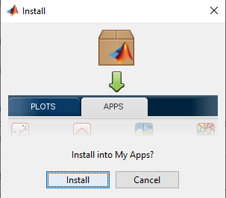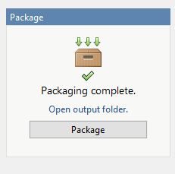

**A**

**B**

**Figure 2: Packaging and Installation of GUI for CBF analysis.**

Now that GUI is installed, please navigate to Matlab’s ‘Apps’ tab at the top and click on the arrow indicated by ‘1’ below to see all the available Apps, both Matlab built in and custom made ones. In the section ‘My Apps’ you will only have this GUI app installed as shown in ‘2’ in Figure 3 below, but likely not other GUIs in My Apps.

2

1

**Figure 3: Where to find the installed GUI.**