FOUNDER APPROVAL MEMORANDUM
Publication of Vulnerability Disclosure Policy (VDP) and security.txt
- What Is Being Approved

Publication of the Tempris Vulnerability Disclosure Policy (VDP) page and the associated security.txt file, to be made publicly available under the tempris.tech domain. This authorisation permits the responsible disclosure programme to go live and to be listed on a public bug bounty / VDP platform for researcher discovery.
- Scope Boundaries Confirmed

The following in-scope and out-of-scope boundaries, as defined in the VDP policy document, are reviewed and confirmed:
- sandbox.tempris.tech — primary testing target (Tier 2, Invited). All features in scope.
- tempris.tech — marketing/public web (Tier 1, Public). Report only, no active testing without invitation.
- api.tempris.tech — REST API (Tier 2, Invited). Authentication, authorisation, injection, business logic.
- Tempris mobile apps (if published) and open-source repositories — Tier 1, Public.
- Out of scope: production client environments, third-party infrastructure, social engineering, physical security testing, DoS/DDoS, and any testing against client or partner systems without their written permission.
3. Safe-Harbor Terms Confirmed

The Safe Harbor commitment, published in alignment with the disclose.io framework (Full Safe Harbor with Coordinated Disclosure, Level 5), is reviewed and confirmed. This includes:
- Authorisation against the Computer Misuse and Cybersecurity Act (CMCA) for good-faith testing within scope.
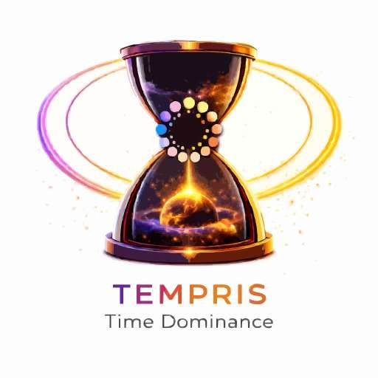
- Exemption from anti-circumvention provisions (Copyright Act 2021) for in-scope, good-faith research.
TEMPRIS TECHNOLOGY PTE. LTD.

UEN 202613990D · tempris.tech

- Exemption from Terms of Service restrictions that would otherwise prohibit security testing.
- Good-faith acknowledgement and fair treatment of all reports submitted under this policy.
This safe harbor applies only to activities within the scope and Rules of Engagement defined in the published policy. Out-of-scope testing remains unauthorised and may constitute a CMCA offence.
4. No-Cash Reward Structure Confirmed — Current Phase

Tempris does not currently offer cash rewards under this programme. The following non-cash recognition model, tiered by severity, is confirmed for this phase:
- Critical — Hall of Fame listing + formal signed Letter of Recommendation on Tempris letterhead.
- High — Hall of Fame listing + Certificate of Responsible Disclosure.
- Medium — Hall of Fame listing + written acknowledgement.
- Low / Informational — Written acknowledgement from the Tempris security team.
This structure will be reviewed and may be revised to include cash rewards once Tempris has paying clients funding the programme.

5. Condition of Approval

This memorandum constitutes approval-in-principle of the structure and terms described above. The final published version of the VDP page and security.txt file must be reviewed and separately confirmed by the undersigned before the programme is published live and listed on any external bug bounty platform.


TEMPRIS TECHNOLOGY PTE. LTD.

UEN 202613990D · tempris.tech

Approved by: | Prepared by:
Sherie — Founder, Tempris Technology Pte. Ltd.  Date: 14th June 2026 | Elvand — Developer, Tempris Technology Pte. Ltd.  Date: 17th June 2026  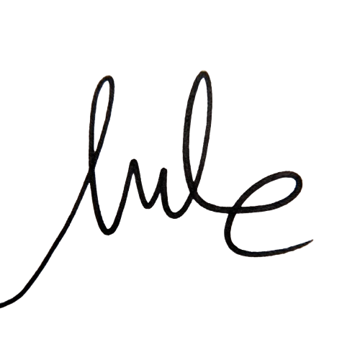
Tempris Technology Pte. Ltd. · UEN 202613990D · Internal record — retain on file

