HTTP

JSON

Client:



Port: 8080

HTTP Methods:

* GET
* POST
* PUT
* DELETE

Payara Server



URI

Mongo Data Base:

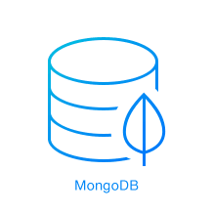

REST API ARCHITECTURE