Game Design Document

Fill up the following document

1. Write the title of your project.

100

1. What is the goal of the game?

To destory the 100 asteroid that is heading for earth

1. Write a brief story of your game.

The fighter plane is saving earth from the asteroids and the player has to protect earth by shooting 100 asteroids by doing this the game will end and earth will live again to see another day.

1. Which are the playing characters of this game?

* Playing characters are the ones who respond to the user based on the input from the user.
* Cars, monkeys, dinos, wizards, etc., are the playing characters in the game.

|  |  |  |
| --- | --- | --- |
| Number | Character Name | What can this character do? |
| 1 | Fighter plane | Move up and down but there is gravity pulling down so you have to prevent it from falling down and can press space to shoot meteors and can get fuel from space debris by flying into it |
| 2 |  |  |
| 3 |  |  |
| 4 |  |  |
| 5 |  |  |
| 6 |  |  |
| 7 |  |  |
| 8 |  |  |

1. Which are the Non-Playing Characters of this game?

* Non-Playing characters are the ones that don't have an action or behavior when the user interacts with the game.
* Hurdles, stones, bananas, coins, etc., are non-playing characters in the game.

|  |  |  |
| --- | --- | --- |
| Number | Character Name | What can this character do? |
| 1 | asteroid | If touching w/ plane it loses lives and will die |
| 2 | fuel | Gives player a boost |
| 3 |  |  |
| 4 |  |  |
| 5 |  |  |
| 6 |  |  |
| 7 |  |  |
| 8 |  |  |

Draw your imagination of this game. What does this game look like?

* Draw the game either on your computer or on paper.
* Add images of the game scenes to show each of the playing and non-playing characters at least once.

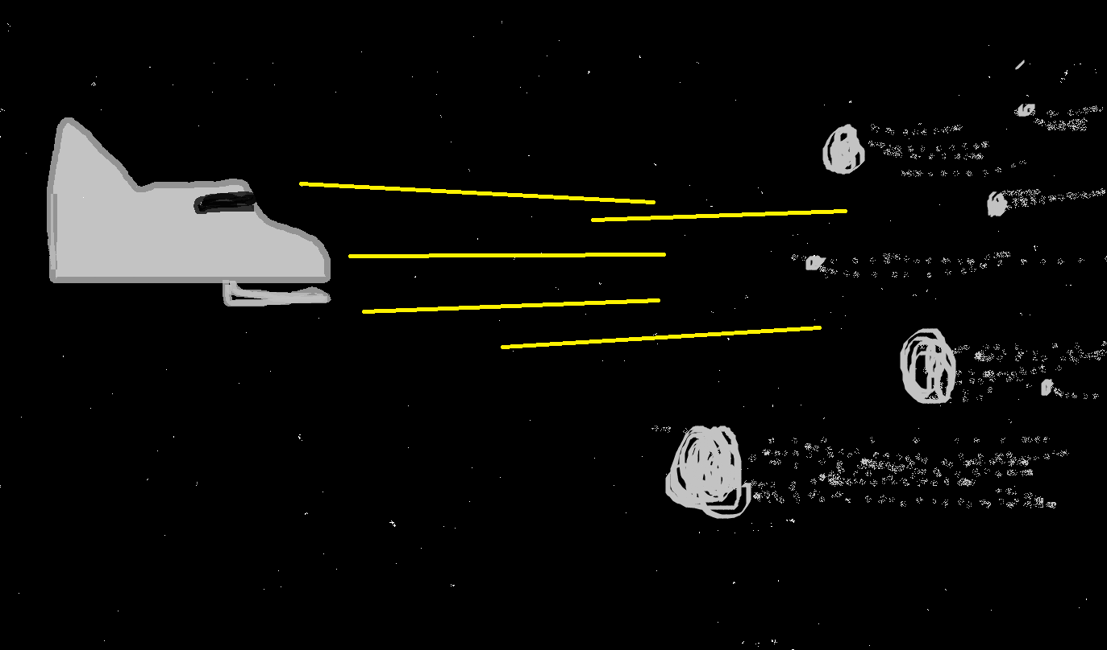

How do you plan to make your game engaging?

The player must try its best to not fall down so it must always move up a bit and the metoers will be coming fast at them so they have to shoot it