Modelling Human Activity States from Smartphone Motion Data
with a From-Scratch Hidden Markov Model
Formative 2 · Hidden Markov Models · Individual submission · 27 October 2026
Author: Elvin Cyubahiro · Code and data: github.com/Elvin100s/hmm-activity-recognition
1. Background and Motivation
This project works towards a waist-worn phone that tells a carer what someone living alone is doing through the day: walking, standing, moving vigorously, or not wearing the device at all. The last case is the costly one to get wrong: a phone left on a table must never be reported as a person lying motionless, which would raise a false alarm and hide that the monitor has gone blind. The activity is never observed directly. The device reports only accelerometer, gyroscope and gravity, and a person standing quietly and a phone resting on a surface both produce an almost flat trace. A hidden Markov model matches this structure: the activity is a discrete state persisting from second to second, the features are noisy emissions of it, and the transition matrix encodes what a body can plausibly do next. The same pipeline transfers to gait monitoring, rehabilitation adherence and smart-home occupancy sensing.
2. Data Collection and Pre-processing
2.1 Recordings
Sixty-five clips were recorded with Sensor Logger 1.68 on one TECNO BG6 handset, exporting accelerometer, gyroscope and gravity as timestamped CSV. The phone was held at the waist for standing, walking and jumping, laid on a surface for still, and every clip is 8–10 s after cleaning. Table 1 summarises the result: 614.3 s in total, each activity above the 1 min 30 s minimum, 526 windows once windowed.
Activity | Clips | Cleaned duration | Windows
Standing | 15 | 144.7 s | 124
Walking | 15 | 145.3 s | 122
Jumping | 15 | 140.6 s | 121
Still | 20 | 183.8 s | 159
Total | 65 | 614.3 s | 526
Table 1 — Dataset after cleaning. The twenty still clips deliberately span five different phone placements (Section 5).
2.2 Sampling rates and harmonisation
The app was set to sampleRateMs = 10, a nominal 100 Hz, but the measured rate is 98.7 Hz on all 65 clips and the three sensors start together but deliver slightly different sample counts, so gyroscope and gravity are interpolated onto the accelerometer clock and every recording is resampled onto a uniform 1/50 s grid (Table 2). Fifty hertz is not arbitrary: human motion lies below 20 Hz, a 25 Hz Nyquist rate retains all of it, and a 2 s window then holds exactly 100 samples. The target rate is one parameter, so a second phone at any higher rate would be decimated onto the same grid.
Device tag | Hardware | App setting | Measured native | Harmonised | Clips
tecnobg6 | TECNO BG6 | sampleRateMs = 10 | 98.7 Hz | 50 Hz | 65
Table 2 — Measured rate (1 / median Δt) and the single target rate all clips are resampled to.
2.3 Cleaning and windowing
Each export is joined across sensors on its timestamp and converted to seconds from the first sample, trimmed by 1 s at both ends — tapping Start and Stop is itself hand motion — and cut to its central 10 s so every training file obeys the brief. Two still clips needed a larger start trim (3 s and 2 s) because the phone was still settling. Timestamps are monotonic with no gaps beyond three sample periods, and no NaNs reach the feature matrix.
Features are computed on 2.0 s windows — 100 samples at 50 Hz — advanced by 1.0 s, so the hop is exactly one HMM time step. The length is set by the resolution it buys: a 100-sample FFT resolves 0.5 Hz, and the per-window dominant frequency of |a| has a median of 1.0 Hz for walking and 4.5 Hz for jumping (a jump rate of about 2.2 Hz, with take-off and landing each giving a peak), several bins apart. A 1 s window would resolve only 1 Hz and hold barely one stride; a 3 s window would span two activities inside an 8–10 s clip. The 50 % overlap gives one decision per second — a sensible alert latency — and turns 65 short clips into 526 windows, 6–9 per clip.
2.4 Video documentation
Four clips accompany this submission; each is 5–10 s, shows the whole body and face in adequate light, and shows the phone recording the activity.
Standing: [ paste standing video link ]
Walking: [ paste walking video link ]
Jumping: [ paste jumping video link ]
Still: [ paste still video link ]
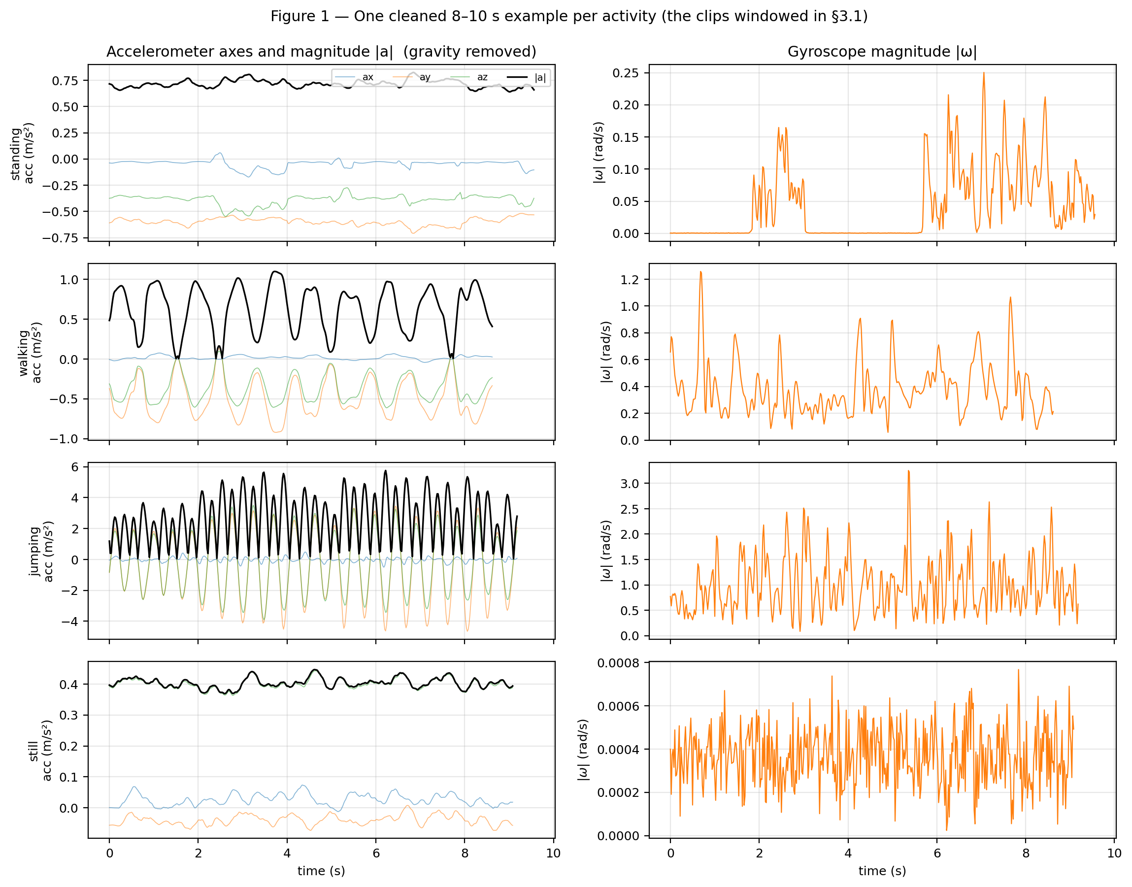
Figure 1 — One cleaned clip per activity: standing and still are flat, walking is a regular ~1.1 Hz oscillation, jumping shows impacts an order of magnitude larger (acceleration in m/s², gravity removed). Figure numbers here match the submitted notebook.
3. HMM Setup and Implementation
Element | Definition for this task
Hidden states Z | 4 activities: standing, walking, jumping, still
Observations X | one 15-dimensional Z-scored feature vector per 2 s window; a recording becomes a sequence of such vectors 1 s apart
Transition matrix A (4×4) | A[i,j] = P(z(t+1) = j | z(t) = i), initialised from labelled windows stitched into plausible routines, then refined by Baum–Welch
Emission model B | b_j(x) = N(x; μ_j, diag σ²_j) — one diagonal Gaussian per state, variance floor 1e-3
Initial probabilities π | P(z(0) = j); uniform before training, then estimated and refined by EM
Table 3 — Model components, implemented from scratch in numpy.
3.1 Features and normalisation
Fifteen features are extracted per window: eight time-domain, two orientation and five frequency-domain. Each exists to separate a specific pair of states (Table 4); all five FFT features come from the spectrum of the mean-removed magnitude signal, which makes cadence independent of how the phone is held.
Feature | Domain | Why it separates the activities
acc_mag_std | time | strongest intensity separator: ≈0.015 m/s² still → ≈1.2 m/s² jumping
acc_mag_peak | time | jump take-off and landing impacts give the largest single samples
acc_mag_sma | time | signal magnitude area: total movement per window
acc_jerk_rms | time | RMS of d|a|/dt — walking is smooth, jumping impulsive
acc_mag_mean | time | mean |a| rises with any activity
gyro_mag_rms | time | trunk rotation present in gait, absent when still
gyro_mag_std | time | episodic versus steady rotation
corr_acc_xy | time | correlated axes mean a repeatable gait; jitter is uncorrelated
grav_tilt_y_deg | orientation | standing ~38° versus still ~82°
grav_tilt_z_deg | orientation | direct flat-versus-upright test: ~53° versus ~9°
acc_dom_freq | FFT | cadence: median 1.0 Hz walking, 4.5 Hz jumping (two impacts per jump)
acc_spec_energy | FFT | log10 total power in 0.3–15 Hz
acc_loco_ratio | FFT | power share in 0.8–3 Hz: walking ~89 %, jumping ~24 %
acc_spec_entropy | FFT | flat spectrum means no cadence, peaked means a clear rhythm
gyro_dom_freq | FFT | rotation rhythm, independent of the linear channel
Table 4 — The observation vector; extraction code is in notebook Section 4.
The two gravity features are unsigned tilt angles, arccos(|g_axis| / |g|), not raw gravity components: a phone laid on a table can be rotated arbitrarily about the vertical, so its x and y components describe which way it points rather than what the body is doing, while the angle form is invariant to that rotation and still separates the stationary pair by roughly 45°. All features are Z-scored with μ and σ fitted on the training windows only and applied unchanged to the test windows, so no test statistic reaches the model. Standardisation is required because the features carry incompatible units (m/s², rad/s, Hz, degrees, log-power, correlation) and a diagonal Gaussian is scale-sensitive; Z-scoring was preferred to min–max, which is decided by a single extreme sample such as one hard jump landing.
3.2 Training and algorithms
Random initialisation of a 4-state, 15-dimensional model on 526 windows is unstable and can settle on a permuted labelling, so the model starts from the labelled windows stitched into 10 plausible routines — an activity followed only by one that can physically follow it — and is then refined by Baum–Welch on those unlabelled sequences, exposed to 29 non-self transitions; a permutation check confirms EM never swapped the states. Baum–Welch stops when the mean per-sequence log-likelihood improves by less than ε = 1e-4, which took 3 iterations: the total log-likelihood rose from 456.89 at the labelled start to 459.19 (mean 45.92 per sequence, notebook Figure 3). EM stops quickly because the labelled start is already near a likelihood maximum. The variance floor of 1e-3 is a numerical guard against a constant feature, fixed a priori and never tuned on test data. Nine unit tests cover correctness: forward and Viterbi agree with exhaustive enumeration of every state path (to 1e-8) on short sequences, Baum–Welch never decreases the likelihood, and a 5 000-window sequence decodes without underflow.
The three algorithms answer three different questions. Forward–backward computes log P(X | λ) and the posteriors, and log P(X) is exactly the quantity whose relative change is the convergence test. Baum–Welch is the only step that improves the means and variances, which is what sensitivity and specificity depend on. Viterbi returns the most probable path, and A suppresses implausible single-window flips — the one capability a per-window Gaussian classifier lacks, and therefore the one that has to be shown by comparison.
4. Results and Interpretation
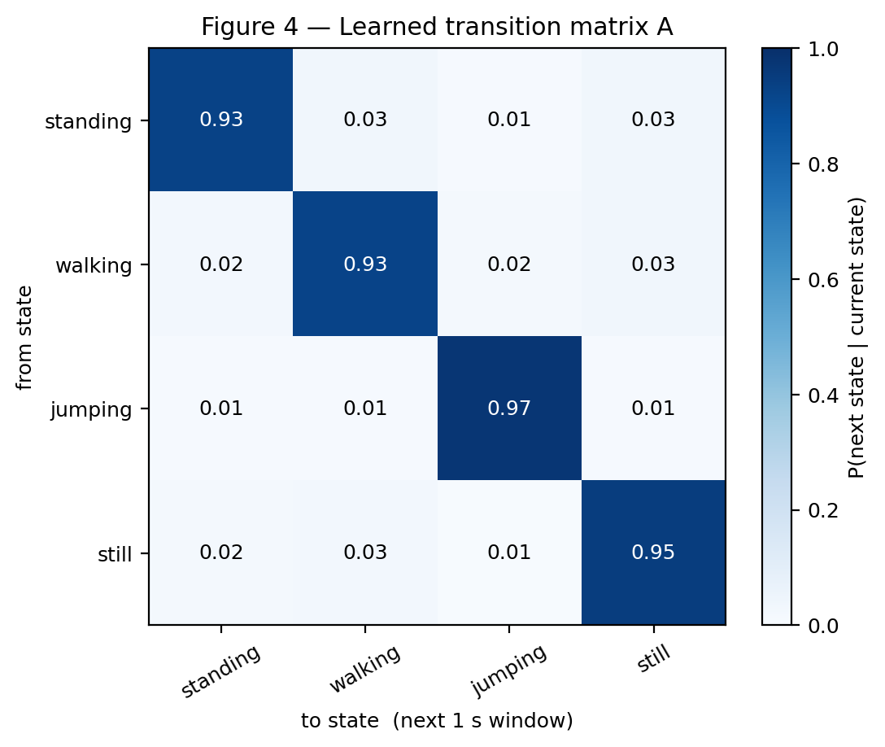
Figure 4 — Learned transition matrix A. The diagonal dominates (0.93–0.97): activities persist from second to second.
The learned A is strongly diagonal — standing 0.93, walking 0.93, jumping 0.97, still 0.95, mean self-transition 0.944 — which is what a 1 s step should look like, since activities last for seconds and do not flicker. The largest off-diagonal masses are the plausible ones: standing → walking and walking → standing (0.03 and 0.02) as someone starts and stops, plus walking → still and standing → still (0.03 each) as they come to rest. Still → jumping is the smallest entry (0.006), consistent with the fact that a jump cannot begin with the phone lying on a surface; that value comes from the stitching prior, which almost never places those clips side by side, rather than from anything the model discovered.
The emissions (Figure 5) are correspondingly separated: jumping occupies its own region of high acceleration and low locomotion ratio, walking is defined by a dominant frequency near 1 Hz with ~89 % of its power in the 0.8–3 Hz band, and the stationary pair differs mainly along the tilt features.
4.1 Evaluation on unseen data
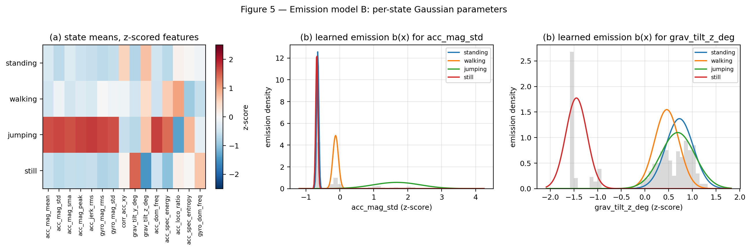
Figure 5 — Emission model B: per-state Gaussian means over the 15 features (z-scored). Jumping is displaced on every intensity feature.
The model was tested on two continuous recordings, neither of which was used to fit the normalisation, π, A or B. test_01 (100 s) was recorded on 24 October as a separate session after every training clip of that evening; test_02 (101 s) was recorded three days later in a different room, with the phone put down at 21° instead of the 8° of the original still clips. Both contain all four activities, annotated by hand. test_02 is not fully blind: its first decoding failed, prompting the tilt features and five extra still clips, two near 20° (Section 5); test_01 played no part in those changes. Windows whose 2 s span crosses an activity boundary are dropped, since no single label is correct for them: 10 in test_01 and 7 in test_02, leaving 89 and 93 scored windows.
State (Activity) | Number of Samples | Sensitivity | Specificity | Overall Accuracy
Standing | 60 | 1.000 | 0.959 | 0.962
Walking | 38 | 0.842 | 1.000 | 0.962
Jumping | 57 | 1.000 | 0.984 | 0.962
Still | 27 | 0.963 | 1.000 | 0.962
Table 5 — Viterbi decoding of both unseen recordings (182 scored windows).
Overall accuracy is 96.2 % against a 25 % chance level, and not uniform: 1.000 on test_01 and 0.925 on test_02, the harder session with the unusual placement. The confusion matrix (Figure 6) locates every remaining error. Standing and jumping are perfect. Still recovers 26 of 27 windows; its one miss, predicted as jumping, is the first window after the phone is put down (88 s in test_02), while it is still settling. Walking is weakest at 0.842: of 38 windows, 5 read as standing and 1 as jumping, all within one 62–69 s stretch of test_02 where the accelerometer spread falls to 0.11–0.17 m/s² against a training median of 0.31 m/s². The walk slowed to short steps there, which places it between the walking and standing distributions.
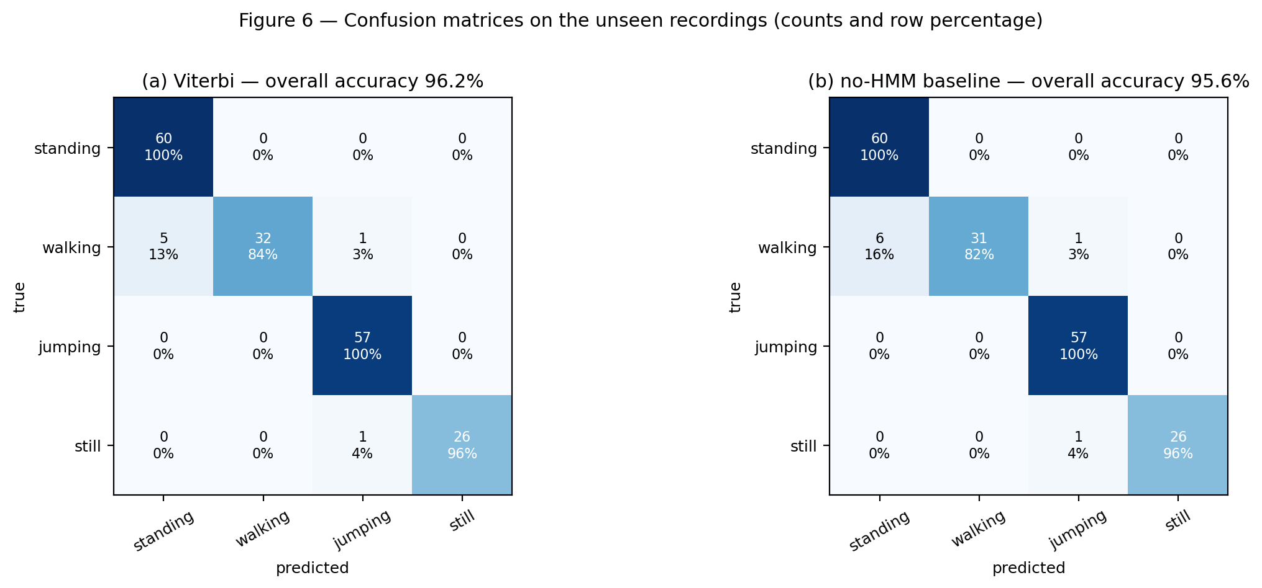
Figure 6 — Confusion matrices on the unseen recordings: (a) Viterbi, 96.2 %; (b) per-window Gaussian baseline, 95.6 %.
A no-HMM baseline that scores each window independently gives 95.6 %, so transitions add 0.5 percentage points: of the six walking windows the baseline read as standing, A pulled one back, and it changed nothing that was already correct. The gain is small because the Gaussian separation is already strong.
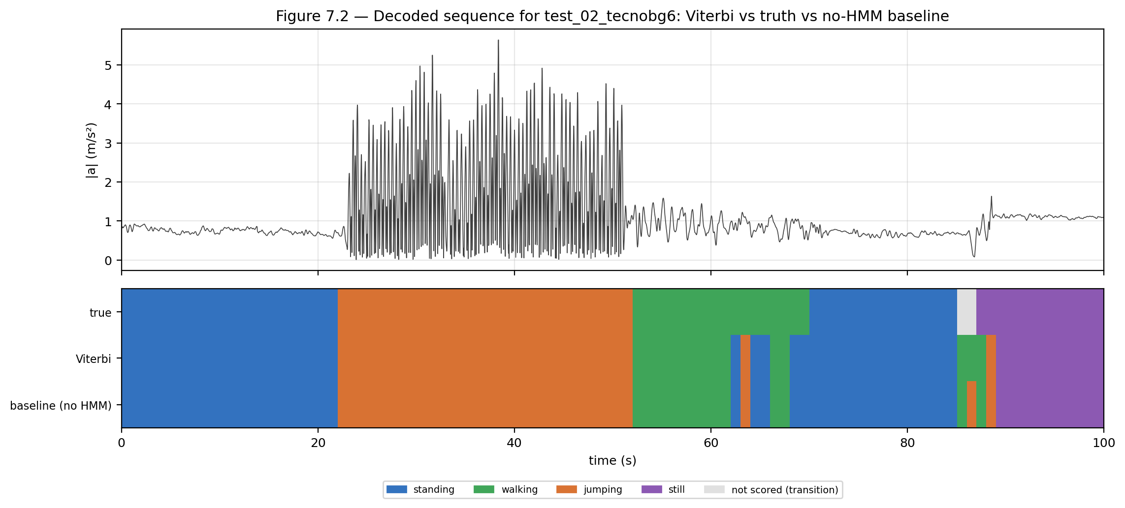
Figure 7 — Decoded sequence for test_02: the Viterbi path over the true labels.
5. Discussion and Conclusion
Jumping was trivially separable: its intensity features sit an order of magnitude above every other state. The hard pair was standing versus still, and the most instructive result. All 15 original still clips shared one placement: their z-axis tilt spread was 0.12° and the within-state spread of grav_x was 0.012 m/s², so the fitted Gaussian behaved as a delta function. When the second session set the phone down at 21° instead of 8°, that state scored a log-likelihood near −44 000 and every still window was decoded as jumping: accuracy 0.901, still sensitivity 0.556. Two changes fixed it, in order of importance — replacing raw gravity components with yaw-invariant tilt angles, and recording five more still clips at deliberately varied placements (propped on books at about 10° and 18°, a soft indoor surface, grass outdoors), which widened the state's tilt coverage from 7.9–8.3° to 7.9–20.5°. Still sensitivity rose to 0.963 and overall accuracy to 0.962 with no hyper-parameter change, and the variance-floor sweep from 1e-3 to 0.1 is flat. Because the fix was prompted by test_02, its still score is partly a re-test on a condition the training set was extended to cover; test_01, untouched by the change, scores 1.000. A class defined by how a sensor is mounted needs that mounting variation in its training set; an over-confident emission model is usually a symptom of missing coverage rather than of bad regularisation.
The transition probabilities reflect realistic behaviour: a self-transition near 0.94 at a 1 s step means an activity persists for about 18 s on average, and the off-diagonals favour orders a body can actually perform.
Sampling and noise shaped the result in two ways. The nominal 100 Hz rate measured 98.7 Hz and the sensors' sample counts differed slightly; resampling to 50 Hz after anti-alias filtering removes both the rate error and the timestamp jitter, and 0.5 Hz resolution is comfortably finer than the gap between the 1.0 Hz walking and 4.5 Hz jumping peaks. The remaining difficulty is behavioural, not electrical: the seconds during which a person changes activity cannot be given one label, which is why those windows are dropped, and hand tremor through the grip is what makes standing and still overlap.
A third test session recorded after all changes would make every reported number fully blind. Walking, now the weak state, needs clips at different paces and on stairs, and a pocket placement and a second handset would test whether the tilt features survive a different grip. Reprojecting acceleration into vertical, forward and lateral axes would remove the remaining dependence on how the phone is held, a Gaussian mixture per state would describe walking better than one diagonal Gaussian, and multi-minute routines would estimate A from real transition timing.
In conclusion, a from-scratch HMM — supervised initialisation, Baum–Welch to a measured convergence criterion, Viterbi decoding — recognises four activities at 96.2 % on two unseen recordings from new sessions (100 % on the strictly blind one), with residual error concentrated in walking where it is physically expected.

