Topic Classification for Kinyarwanda News:
Sparse, Recurrent and Transformer Models on a Deduplicated KINNEWS Benchmark
Elvin Cyubahiro
[[TODO: course name / institution]]
Summative Project: Text Classification for an African Language · October 2026

Project links
Resource | Link
GitHub repository | https://github.com/Elvin100s/kinyarwanda-news-classification
Demo video | [[TODO: demo video URL]]
Live system | https://huggingface.co/spaces/Elvin100S/kinyarwanda-news-classifier

Abstract
Kinyarwanda is spoken by an estimated 30 million people (Niyongabo et al., 2020) but remains poorly served by NLP resources (Joshi et al., 2020). This project builds and deploys a 14-class topic classifier for Kinyarwanda news using the KINNEWS corpus. An audit found that 55.2% of the training file consists of duplicated articles and that the official train and test splits have markedly different class distributions; the training set was therefore deduplicated (17,014 to 7,626 articles) before a stratified validation split was drawn, and the official test set was left untouched. Nine configurations were compared under identical splits: a majority-class floor, TF-IDF word n-grams with logistic regression (the baseline), TF-IDF character n-grams, a BiLSTM with random and with fastText initialisation, fine-tuned XLM-R and AfroXLMR with a class-weighted loss, and two ablations; the neural models were also re-trained with three seeds. With macro-F1 as the primary metric, the character n-gram model had the best validation score and was selected (0.587 test macro-F1, 95% CI 0.571–0.603), beating the word baseline by 7.6 points with half the parameters. fastText initialisation improved the BiLSTM by 8.4 points, and African-centric adaptation improved on XLM-R by 25.4 points; both results held on all three seeds and were significant under McNemar's test. AfroXLMR reached the highest test score (0.614) despite a lower validation score, showing much greater robustness to the train/test shift. The main conclusions are that representing sub-word structure and pre-training exposure to the language matter more than model size, and that a validation set drawn from the training distribution can understate the value of a more robust model.

1. Introduction
Kinyarwanda is an official language of Rwanda and, according to figures cited by Niyongabo et al. (2020), is spoken by approximately 30 million people across Rwanda, Uganda, the Democratic Republic of Congo and Tanzania. Despite this, it sits in the long tail of languages with little labelled data or tooling (Joshi et al., 2020). Rwandan outlets publish news in Kinyarwanda every day, and assigning each article to a topic is a routine task for newsrooms, archives and aggregators. Automating it saves editorial time, makes archives searchable by subject, and lets readers and downstream systems filter content.
The task is also a good test of how NLP methods behave on an African language. Kinyarwanda is a morphologically rich Bantu language (Nzeyimana & Niyongabo Rubungo, 2022) with a system of noun classes marked by prefixes (Kimenyi, 1980): a single stem appears in many written forms depending on its prefixes and affixes (for example umukino, imikino, abakinnyi around the stem for “play/game”). A word-level model sees each form as a separate feature, which spreads the evidence for one concept thinly. This property motivates the research questions below.
Intended users are newsroom and archive staff tagging incoming articles, content aggregators routing news by topic, and researchers or developers who need a documented Kinyarwanda classifier.
Objective. Build, evaluate and deploy a classifier that assigns a Kinyarwanda news article to one of 14 topics, and use controlled experiments to answer four research questions:
RQ | Question
RQ1 | How far can a sparse linear model go, and do character n-grams beat word n-grams?
RQ2 | Do subword (fastText) embeddings trained on in-domain text help a BiLSTM over random initialisation?
RQ3 | Does African-centric pretraining (AfroXLMR) beat general multilingual pretraining (XLM-R)?
RQ4 | What does the best model still get wrong, and why?

2. Related Work

2.1 NLP for low-resource African languages
Joshi et al. (2020) show that NLP resources are distributed extremely unevenly: a small number of languages hold almost all labelled data and benchmarks, while languages such as Kinyarwanda, despite millions of speakers, have very little; Niyongabo et al. (2020) note that this taxonomy places both Kinyarwanda and Kirundi in the “Scraping-By” category. In this setting a corpus of a few thousand labelled articles is a substantial resource, and methods that generalise from few examples matter more than on English benchmarks. Ogueji et al. (2021) challenge the assumption that low-resource languages need very large multilingual models, showing that a model pretrained on a small, focused African-language corpus can compete with much larger general models.

2.2 KINNEWS and prior Kinyarwanda classification
Niyongabo et al. (2020) introduced KINNEWS and KIRNEWS, paired news classification corpora for Kinyarwanda and the closely related Kirundi, with the aim of enabling cross-lingual transfer between two under-resourced Bantu languages. They reported monolingual and cross-lingual baselines: multinomial Naive Bayes, logistic regression and a linear SVM over TF-IDF features, a character-level CNN, and a CNN and a BiGRU over Word2Vec embeddings. This project uses the Kinyarwanda portion. Its results are not directly comparable with the original baselines, because the training set here was deduplicated (Section 3) and the primary metric is macro-F1 rather than accuracy.

2.3 Sparse and recurrent text classification
Logistic regression over TF-IDF features is a fast, interpretable and strong baseline for topic classification (Pedregosa et al., 2011). Character-level modelling has already been applied to Kinyarwanda: Niyongabo et al. (2020) include a character-level CNN among their baselines. Bojanowski et al. (2017) carried the same idea into dense representations: fastText extends Word2Vec (Mikolov et al., 2013) by composing each word vector from its character n-grams, so related forms share structure and unseen words still receive a vector. Recurrent models based on the LSTM (Hochreiter & Schmidhuber, 1997), run in both directions (Schuster & Paliwal, 1997), were the standard neural text classifiers before Transformers. Most directly relevant to this project, Nzeyimana and Niyongabo Rubungo (2022) argue that the unsupervised subword tokenization used by multilingual models, such as byte-pair encoding, is sub-optimal for morphologically rich languages, and propose KinyaBERT, a Kinyarwanda language model that uses a morphological analyser to represent words explicitly as compositions of morphemes.

2.4 Multilingual and African-centric Transformers
The Transformer (Vaswani et al., 2017) and the pretrain-then-fine-tune paradigm (Devlin et al., 2019) now dominate text classification. XLM-R (Conneau et al., 2020) is a multilingual encoder pretrained with masked language modelling on the CC-100 web corpus. Checked directly for this project, Kinyarwanda (“rw”) is absent from CC-100’s 116 language files and from the 94 languages listed on the xlm-roberta-base model card, although related Bantu languages (Swahili, Zulu, Xhosa) are included. Alabi et al. (2022) proposed multilingual adaptive fine-tuning (MAFT): continuing masked-language-model training of an existing model on a set of African languages. The resulting AfroXLMR-base covers 17 African languages, and its model card lists Kinyarwanda. Because AfroXLMR reuses XLM-R’s tokenizer unchanged, comparing the two isolates the effect of adapted weights from the effect of tokenization.

2.5 Gap addressed
This project introduces no new dataset or architecture. Its contribution is a controlled comparison on KINNEWS of sparse word versus sparse character features, a recurrent model with and without subword embeddings, and a general versus an African-adapted Transformer, all on identical deduplicated splits, with confidence intervals, paired significance tests, seed variance, a detailed error analysis and a deployed tool. It also documents two properties of the benchmark (a 55% duplicate rate and a strong train/test class shift) that change how any result on it should be read.

3. Dataset and Data Preparation

3.1 Source and licence
KINNEWS (Niyongabo et al., 2020) contains Kinyarwanda news articles collected from fifteen news websites and five newspapers in Rwanda, released under the MIT licence. Each article has a headline, its content and the source URL. The raw version was used rather than the pre-cleaned one, so that the Transformer models receive natural text and the preprocessing is documented in this project. The Hugging Face version of the dataset ships as a loading script that current versions of the datasets library no longer run, so the corpus is read directly from the authors’ release archive, whose SHA-256 hash is recorded to pin the exact version. All published statistics were confirmed programmatically: 17,014 training and 4,254 test articles, 14 classes, and the six documented fields.
How the categories were defined. According to Niyongabo et al. (2020), the publishers had originally filed the articles under 48 different categories. Because many were closely related, the dataset’s annotators merged them into 14 topics: politics, sport, economy, health, entertainment, history, technology, tourism, culture, fashion, religion, environment, education and relationship. Two annotators, both linguistics graduates and native speakers, then reviewed each article and assigned it one of these topics based on its title and content; articles they were unsure about were given a neutral label and removed. Each topic has a numeric label (1–14), an English label and a Kinyarwanda label. This project uses these labels as published; Section 3.2 shows that the released training file nevertheless contains conflicting labels for identical articles.

3.2 Quality audit
A systematic audit before any modelling found four issues that shaped the rest of the project:
- Heavy duplication. Only 7,629 of 17,014 training rows carry distinct text; 55.2% are copies, and one article appears 80 times. If duplicates are not removed before the validation split is drawn, copies of the same article land in both training and validation, and validation measures memorisation.
- Label noise. 156 groups of identical articles carry more than one label (1,446 training rows). No model can be right about both copies, which places a ceiling on achievable accuracy.
- Train/test distribution shift. The official splits do not share a class distribution. Environment is about 19 times more frequent in the test set than in the raw training set, and fashion about 11 times; economy is about five times less frequent. The total variation distance between the two distributions is 0.383 (0.320 after deduplication). Figure 1 shows the ratios after deduplication.
- Train/test leakage. Three training articles were verbatim copies of test articles and were removed; 61 test articles (1.4%) have a near-duplicate (TF-IDF cosine > 0.9) in training. These were reported, not removed, because the test set is never modified.
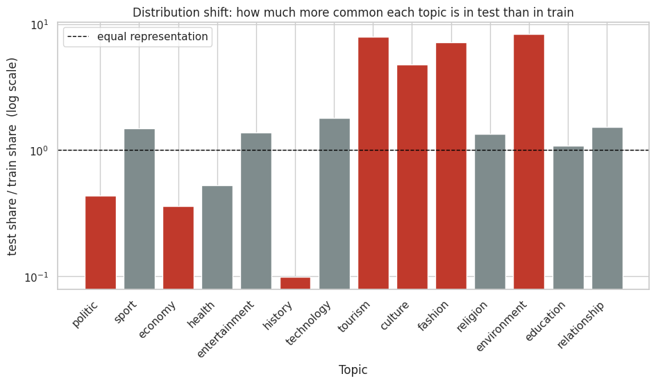
Figure 1. How much more common each topic is in the test set than in the deduplicated training set (log scale). Red bars differ from equal representation by more than a factor of two.

3.3 Characteristics
Articles are long: the median training article has 292 words and 716 XLM-R subword tokens (Figure 2). 94.9% of articles exceed 256 subword tokens and 74.5% exceed 512, so a Transformer with a 512-token limit never sees the end of three-quarters of the corpus. Vocabulary is highly sparse: the corpus contains 231,516 distinct word types in 2.38 million tokens, and 61.6% of word types occur exactly once. The XLM-R and AfroXLMR tokenizers both split Kinyarwanda into 2.47 subword tokens per word on average, and produce identical output.
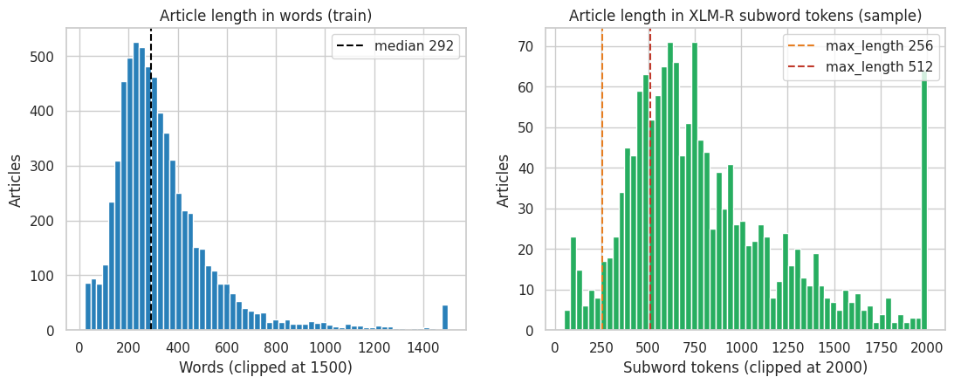
Figure 2. Article length in words (left) and in XLM-R subword tokens (right). Dashed lines mark the 256 and 512 token limits used by the Transformer models.

3.4 Deduplication and splits
Exact duplicates (after Unicode normalisation) were removed from the training file, keeping the first occurrence, which reduced it from 17,014 to 7,626 articles and the class imbalance ratio from 117.5 to 53.2. A stratified 10% validation split was then drawn with a fixed seed (42); the official test split was used as published. Split indices are saved to data/splits.json, and the notebook asserts that no article text is shared across the three splits.
Table 1. Data splits after deduplication.
Split | Articles | Use
Train | 6,863 | Model fitting (deduplicated, stratified 90%)
Validation | 763 | All hyperparameter choices, early stopping, model selection, app threshold
Test | 4,254 | Official split, untouched; evaluated once per final model

The smallest classes are very small after deduplication: tourism has 31 training articles (3 in validation), environment and fashion 34 each, and culture 69, while the test set contains 150–200 articles of each. Class weighting is therefore essential rather than optional.

3.5 Preprocessing
Two preprocessing pipelines were used, matched to what each model family expects:
- Classical and BiLSTM models: Unicode NFC normalisation, lower-casing, replacement of URLs, e-mail addresses and numbers with placeholder tokens, removal of punctuation except apostrophes (which mark elision in Kinyarwanda, as in n’ibindi), and whitespace normalisation.
- Transformers: Unicode NFC normalisation and whitespace normalisation only, so the input stays close to the natural text the models were pretrained on.
In both cases the model input is the title followed by the article body.

4. Methodology
All models were trained on the same deduplicated training split, tuned only on the validation split, and evaluated once on the test split. Class imbalance was handled the same way for every trained model: balanced class weights (n / (K · n_k)) in the loss. The implementation is a single notebook that runs end to end on Kaggle or Google Colab with one GPU.

4.1 Baselines
- B0 – majority class. Always predicts the most frequent training class (politics). It sets the floor and shows why accuracy is misleading on this data.
- B1 – TF-IDF word n-grams + logistic regression (the baseline). Word unigrams and bigrams (minimum document frequency 2, up to 200,000 features, sublinear term frequency) fed to a multinomial logistic regression with balanced class weights. The regularisation strength C was selected from {0.1, 1, 10} on validation (C = 1). This is the standard strong baseline for topic classification.

4.2 Experiments
- E1 – TF-IDF character n-grams + logistic regression (RQ1). Identical to B1 except for the features: character 2–5-grams within word boundaries (char_wb, minimum document frequency 3). Only the feature type changes, so any difference is attributable to it.
- E2a / E2b – BiLSTM (RQ2). A bidirectional LSTM written from scratch in PyTorch: 300-dimensional word embeddings, one layer of 128 hidden units per direction, masked mean pooling over the non-padding positions, dropout 0.3 and a linear layer to 14 classes. Inputs are truncated to 400 words; the vocabulary (72,309 types, minimum frequency 2) is built on the training split only. Training uses Adam (Kingma & Ba, 2015; learning rate 0.001), batch size 64, gradient clipping at 1.0, class-weighted cross-entropy, and early stopping on validation macro-F1 (patience 3, up to 15 epochs). E2a initialises the embeddings randomly. E2b initialises them from fastText skip-gram vectors (300 dimensions, character n-grams of length 3–6, window 5, 10 epochs) trained on the training split only, on a single thread so the vectors are reproducible.
- E3 / E4 – fine-tuned Transformers (RQ3). xlm-roberta-base (E3) and Davlan/afro-xlmr-base (E4), each with the standard sequence-classification head on the first-token representation, fully fine-tuned (278 million parameters) with AdamW (Loshchilov & Hutter, 2019), learning rate 2e-5, linear schedule with 10% warm-up, weight decay 0.01, batch size 16 on one GPU, 3 epochs, mixed precision, and a maximum length of 512 tokens. A custom trainer replaces the default loss with class-weighted cross-entropy using the same weights as the other models. The checkpoint with the best validation macro-F1 is kept. The two runs differ only in the pretrained weights, since the tokenizers are identical.

4.3 Ablations and seed variance
Both ablations modify the stronger Transformer (E4, chosen on validation) so that a single factor changes:
- A1 – title only. Trains and evaluates on the headline alone, measuring how much topic signal the headline carries.
- A2 – maximum length 256. Halves the input length, measuring what the second 256 tokens contribute given the truncation documented in Section 3.3.
Seed variance. E2a, E2b, E3 and E4 were re-trained with seeds 43 and 44 in addition to 42, and their test macro-F1 is reported as mean ± standard deviation. The fastText vectors are trained once and reused, so for E2b the seeds vary only the BiLSTM. The linear models are deterministic given the data and were not re-seeded.

4.4 Evaluation protocol
Macro-F1 is the primary metric: it averages F1 over the 14 classes, so every topic counts equally regardless of size. Accuracy rewards predicting the large classes: B0 reaches 10.4% accuracy on test but only 1.3% macro-F1. Accuracy, weighted F1 and per-class precision, recall and F1 are also reported. Uncertainty on the test score is estimated with a 95% bootstrap confidence interval over 1,000 resamples of the test set (Efron & Tibshirani, 1993). Pairs of models are compared with McNemar’s test on their paired correct/incorrect predictions (McNemar, 1947), using the continuity-corrected chi-squared form (exact binomial when fewer than 25 predictions disagree). The final model was selected on validation macro-F1, never on test.

4.5 Implementation and resources
The project is implemented in Python with scikit-learn (Pedregosa et al., 2011), PyTorch (Paszke et al., 2019), gensim (Řehůřek & Sojka, 2010) and Hugging Face Transformers (Wolf et al., 2020); the app uses Gradio (Abid et al., 2019). Library versions are pinned in requirements.txt. All reported results come from one complete run on a Kaggle notebook with a single NVIDIA T4 GPU (1 hour 42 minutes, including the seed-variance runs). Every experiment writes a JSON result file and a per-article prediction file, and every table and finding in the notebook is generated from those files rather than typed by hand.
Existing resources versus own work. The dataset (KINNEWS), the pretrained checkpoints (xlm-roberta-base, Davlan/afro-xlmr-base) and the libraries above are existing resources. The data audit and deduplication, preprocessing, the BiLSTM architecture and training loop, the fastText training, the class-weighted fine-tuning, the evaluation and significance testing, the seed-variance study, the error analysis and the web application were implemented for this project. [[TODO: state your use of AI assistance here if your course requires it]]

5. Experiments and Results
Table 2 lists every configuration, sorted by validation macro-F1, the criterion used to select the final model.
Table 2. All experiments (seed 42). The selected model (best validation macro-F1) is highlighted. CI: 95% bootstrap confidence interval.
ID | Model | RQ | Val macro-F1 | Test macro-F1 | 95% CI (test) | Test acc. | Params
E1 | TF-IDF char 2–5-grams + LR | RQ1 | 0.699 | 0.587 | 0.571–0.603 | 0.726 | 1.36 M
E2b | BiLSTM + fastText | RQ2 | 0.671 | 0.526 | 0.508–0.543 | 0.691 | 22.1 M
E4 | AfroXLMR-base, fine-tuned | RQ3 | 0.653 | 0.614 | 0.598–0.631 | 0.757 | 278 M
B1 | TF-IDF word 1–2-grams + LR | baseline | 0.639 | 0.512 | 0.494–0.528 | 0.693 | 2.80 M
A2 | E4, max length 256 | ablation | 0.610 | 0.575 | 0.559–0.591 | 0.729 | 278 M
E2a | BiLSTM, random init. | RQ2 | 0.573 | 0.442 | 0.424–0.458 | 0.591 | 22.1 M
A1 | E4, title only | ablation | 0.449 | 0.421 | 0.409–0.433 | 0.644 | 278 M
E3 | XLM-R-base, fine-tuned | RQ3 | 0.367 | 0.360 | 0.350–0.371 | 0.614 | 278 M
B0 | Majority class | floor | 0.027 | 0.013 | 0.012–0.015 | 0.104 | –

5.1 RQ1: character n-grams versus word n-grams
E1 reaches 0.587 test macro-F1 against B1’s 0.512, a gain of 7.6 points with non-overlapping confidence intervals and less than half the parameters (1.36 M versus 2.80 M). McNemar’s test confirms the difference is systematic: E1 is right on 278 articles that B1 gets wrong, and B1 on only 135 that E1 gets wrong (p = 2.8 × 10⁻¹²). The gain is concentrated in the smallest training classes: environment improves by 0.295 F1, tourism by 0.234, fashion by 0.201 and culture by 0.172, while the large classes barely move. Character n-grams let the model pool evidence across the many inflected forms of a stem, which matters most when a class has few examples. The highest-weighted E1 features confirm this: they are stems and affixes such as “kipe” (team), “uzima” (health) and “dukik” (from ibidukikije, environment).

5.2 RQ2: fastText initialisation for the BiLSTM
Initialising the BiLSTM with fastText vectors raised test macro-F1 from 0.442 (E2a) to 0.526 (E2b), +8.4 points with non-overlapping confidence intervals; E2b is right on 639 articles that E2a gets wrong, against 212 the other way (McNemar p = 2.7 × 10⁻⁴⁸). The largest gains were in technology (+0.16 F1), economy (+0.12) and culture (+0.12). The vectors behave as intended: the nearest neighbours of ibidukikije (environment) are its inflected forms (kubidukikije, y’ibidukikije, n’ibidukikije), and an invented out-of-vocabulary form, ibidukikijebyacu, still receives a vector whose neighbours are the same family. The improvement held on all three seeds (Table 3). Even so, the BiLSTM stays well below E1 (0.526 versus 0.587) and overfits quickly: E2b’s validation loss is lowest at epoch 8 and rises afterwards while its training loss falls to 0.02. With 22 million parameters (21.7 million in the embedding layer) and fewer than 7,000 training articles, the recurrent model has far more capacity than the data can support.

5.3 RQ3: African-centric versus general multilingual pretraining
AfroXLMR (E4) outperformed XLM-R (E3) by 25.4 points (0.614 versus 0.360), with non-overlapping confidence intervals; E4 is right on 814 articles that E3 gets wrong, against 206 the other way (McNemar p = 1.5 × 10⁻⁸⁰). Because the two models share an identical tokenizer and identical fine-tuning settings, the difference is attributable to the adapted weights, that is, to AfroXLMR having seen Kinyarwanda during adaptation (Alabi et al., 2022). The gap is starkest on the smallest classes: XLM-R scores an F1 of zero on tourism, fashion, culture and environment, where AfroXLMR reaches 0.66, 0.65, 0.44 and 0.37. XLM-R also proved unstable across seeds (0.298 ± 0.128, with one seed collapsing to 0.150), whereas AfroXLMR was almost identical across seeds (0.616 ± 0.003). A model with no exposure to Kinyarwanda cannot learn a topic from about thirty examples; a model already adapted to the language can.
Class weighting mattered for this result. In a development run without it, AfroXLMR reached only 0.457 test macro-F1; with the same weights as the other models it reached 0.614, and per-class F1 rose most on the rare classes that macro-F1 weights equally.

5.4 Ablations
Title only (A1). Using only the headline reduced E4’s test macro-F1 from 0.614 to 0.421 (−19.3 points). The loss is concentrated in the rare classes: tourism fell from 0.66 to 0.00 and fashion from 0.65 to 0.01. Headlines carry enough signal for the common topics but not for the rare ones, which matters for the app, where users often paste only a headline. Max length 256 (A2). Halving the input length cost 3.9 points (0.614 to 0.575), with non-overlapping confidence intervals; culture and fashion lost the most. The second half of the 512-token window carries useful information, so longer contexts would likely help further.

5.5 Seed variance
Table 3. Test macro-F1 over three training seeds.
Model | Seed 42 | Seed 43 | Seed 44 | Mean ± std
E2a BiLSTM, random | 0.442 | 0.423 | 0.409 | 0.425 ± 0.016
E2b BiLSTM + fastText | 0.526 | 0.500 | 0.493 | 0.506 ± 0.018
E3 XLM-R | 0.360 | 0.382 | 0.150 | 0.298 ± 0.128
E4 AfroXLMR | 0.614 | 0.619 | 0.615 | 0.616 ± 0.003

E2b beat E2a and E4 beat E3 on every seed, so the directions of the RQ2 and RQ3 results are not artefacts of a single initialisation. The single-seed gap between E2a and E2b (8.4 points) is also several times larger than either model’s seed standard deviation.

5.6 Model selection and the validation–test gap
Following the protocol, E1 was selected because it had the highest validation macro-F1 (0.699). On the test set, however, AfroXLMR scored higher (0.614 versus 0.587; the confidence intervals, 0.598–0.631 and 0.571–0.603, overlap only slightly). The two models respond very differently to the distribution shift: from validation to test, E1 loses 11.3 points, B1 12.8 and E2b 14.5, while E4 loses only 3.8. Validation follows the training class distribution, and the models trained from scratch fit that distribution closely; the test set over-represents the rarest training classes, where AfroXLMR’s prior knowledge of the language helps most.
The selection was not changed after seeing the test results, because choosing a model for its test score would make that score an optimistic estimate. The finding is still important: on this benchmark, a validation set drawn from the training distribution understates the value of a model that is more robust to shift. A validation set that mirrors the expected deployment distribution would be the better selection criterion (Section 8).

5.7 Inference cost
Measured with batched inference on the training machine, E1 classifies an article in about 0.03 ms on the CPU, the BiLSTMs in about 0.36 ms and the full Transformers in about 7.5 ms on the GPU. E1 is small (10.8 MB saved) and needs no GPU, so it can be served on a free CPU host; a Transformer would be roughly 1.1 GB and noticeably slower without a GPU.

6. Error Analysis and Discussion
The error analysis focuses on the selected model, E1. Table 4 shows its per-class performance on the test set.
Table 4. E1 per-class test performance, sorted by F1 (macro-F1 0.587, weighted F1 0.730, accuracy 0.726).
Class | Train n | Test n | Precision | Recall | F1
sport | 878 | 812 | 0.955 | 0.925 | 0.940
entertainment | 994 | 848 | 0.828 | 0.824 | 0.826
relationship | 380 | 360 | 0.722 | 0.947 | 0.820
religion | 401 | 335 | 0.835 | 0.740 | 0.785
health | 978 | 320 | 0.619 | 0.741 | 0.674
technology | 136 | 152 | 0.539 | 0.822 | 0.651
tourism | 31 | 152 | 0.827 | 0.533 | 0.648
politics | 1,628 | 442 | 0.699 | 0.584 | 0.636
fashion | 34 | 151 | 0.852 | 0.497 | 0.628
economy | 1,000 | 222 | 0.488 | 0.662 | 0.562
environment | 34 | 175 | 0.927 | 0.291 | 0.443
culture | 69 | 203 | 0.656 | 0.300 | 0.412
education | 104 | 70 | 0.179 | 0.071 | 0.102
history | 196 | 12 | 0.048 | 0.833 | 0.091

6.1 Where the model works
Classes with distinctive vocabulary are handled well even when small. Sport reaches 0.94 F1, driven by unambiguous stems such as ikipe (team), umukino (match) and club names. Relationship, religion and entertainment are above 0.78. Technology (136 training articles) and tourism (31) reach about 0.65, which shows that character n-grams can learn a topic from few examples when its vocabulary is specific (for tourism: pariki, Nyungwe, ingagi “gorillas”, and the tourism board RDB).

6.2 Where the model fails
Figure 3 compares the baseline and final confusion matrices; Table 5 lists the most frequent confusions.
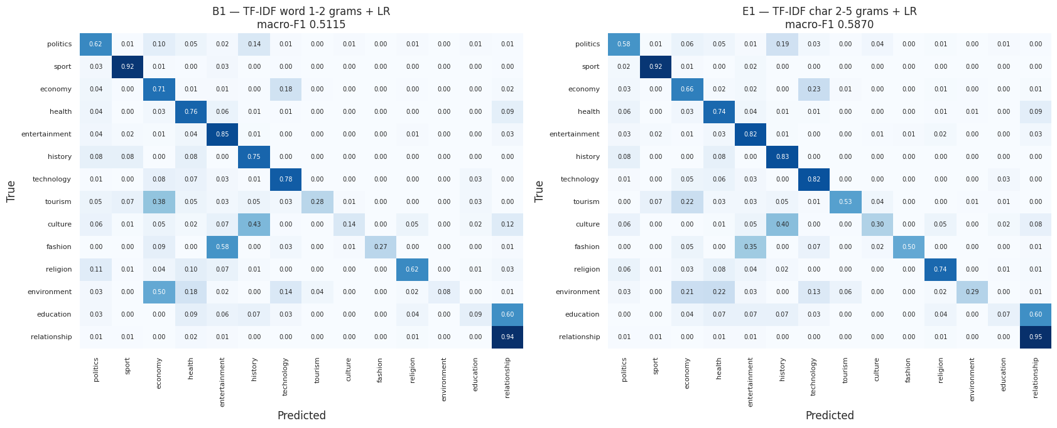
Figure 3. Row-normalised test confusion matrices for the baseline B1 (left) and the selected model E1 (right). The diagonal is per-class recall.
Table 5. The most frequent confusions of E1 on the test set.
True class | Predicted | Articles | Share of true class
politics | history | 85 | 19.2%
culture | history | 82 | 40.4%
fashion | entertainment | 53 | 35.1%
economy | technology | 50 | 22.5%
education | relationship | 42 | 60.0%
environment | health | 39 | 22.3%
environment | economy | 37 | 21.1%
tourism | economy | 33 | 21.7%

- Genuine topic overlap. Many errors are between topics that share vocabulary and subject matter. Politics articles about the 1994 Genocide against the Tutsi, or a biography of the President, are predicted as history; a culture article about Rwanda’s last queen is predicted as history; fashion shows are predicted as entertainment (“Met Gala”, “Victoria’s Secret”). These are arguably ambiguous rather than wrong, and a multi-label scheme would describe them better.
- Over-prediction of history. History has 196 training articles but only 12 test articles. With balanced class weights and a strong overlap with politics and culture, E1 predicts history 208 times, giving high recall (0.83) but precision of 0.05. This is a direct consequence of the train/test shift combined with class weighting.
- Very small classes. Grouping test articles by the training size of their true class, accuracy is 79.1% for classes with 500 or more training articles, 78.5% for 100–499, but only 39.4% for classes with fewer than 100 (tourism, environment, fashion, culture). Environment illustrates the problem: its precision is high (0.93) but it is recalled only 29% of the time, because 34 training articles cannot cover the variety of environmental reporting, which is often framed in terms of health, economy or local government.
- Label noise and annotation choices. The ten most confident mistakes are dominated by articles labelled entertainment that are clearly about football (e.g. a match draw between Rayon Sports and AS Kigali, predicted sport with 0.98 confidence) or about church events (predicted religion). Combined with the 156 duplicate groups carrying conflicting labels, this suggests that a share of the “errors” are labelling inconsistencies in the source data. These cases are collected in a manual review sheet for a Kinyarwanda reader rather than silently corrected.
- Education and scraping artefacts. Education is the weakest class (F1 0.10): 60% of its test articles are predicted as relationship. Its top word features also include “caption”, WordPress image markup left over from scraping, so the model partly learned how articles were scraped rather than what they say. A related artefact appears in culture, whose features include “nâ” and “wâ”: curly apostrophes stored with the wrong character encoding in some source articles.
- Article length. The longest articles are the hardest: above 500 words, macro-F1 is 0.56 and accuracy 61%, against 0.58–0.60 and 74–77% for articles of 100–500 words. Long articles often cover several topics. (The 94 articles under 100 words score 0.66, but on too few examples to read much into.)

6.3 Qualitative examples
Table 6 shows real test headlines with the true label and E1’s prediction. In the first three E1 is right and the word-level baseline B1 is wrong; the rest are E1 errors.
Table 6. Example test headlines and predictions. English glosses are approximate.
Headline (Kinyarwanda) | Approximate English gloss | True | Predicted | Reading
Coronavirus: Ibitaramo bya Madonna na Miley Cyrus byahagaritswe | Coronavirus: Madonna and Miley Cyrus concerts cancelled | entertainment | E1: entertainment (B1: health) | Correct
Ghana: Umuhanzi ukunzwe mu ndirimbo ziririmbirwa Imana araregwa kubeshya ko avura SIDA | Ghana: a popular gospel singer is accused of falsely claiming to cure AIDS | entertainment | E1: entertainment (B1: health) | Correct
Ku rutonde rw’abantu bishimirwa cyane ku isi Bill Gates na Michelle Obama barayoboye… | Bill Gates and Michelle Obama top the list of the world’s most admired people… | entertainment | E1: entertainment (B1: sport) | Correct
Tombora yongeye guhuza Rayon Sports na AS Kigali | The draw has again paired Rayon Sports with AS Kigali | entertainment | sport (0.98) | Likely label noise
Shekinah Worship Team Masoro yamuritse album mu gitaramo cyamaze amasaha 12 | Shekinah Worship Team Masoro launched an album at a 12-hour concert | entertainment | religion (0.93) | Topic overlap
Imyaka 26 irashize umwamikazi wa nyuma w’u Rwanda, Rosalie Gicanda yishwe | 26 years since Rwanda’s last queen, Rosalie Gicanda, was killed | culture | history (0.72) | Topic overlap
Imyambarire idasanzwe yaranze ibirori bya Met Gala (Amafoto) | The unusual outfits of the Met Gala (photos) | fashion | entertainment (0.59) | Topic overlap

The successes share a pattern: the headline contains a word pointing to another topic (“Coronavirus”, SIDA “AIDS”, or a ranking that resembles sport coverage), which misleads the word-level model, while character n-grams from the rest of the text, such as ibitaramo (concerts) and umuhanzi (artist), carry the entertainment signal.

6.4 Out-of-domain behaviour
E1 assigns a topic to any input: English and French news sentences, Kirundi text, social-media Kinyarwanda and random characters all received a label, but with confidence between 0.13 and 0.24, well below typical in-domain confidence. A low-confidence threshold of 0.46 was chosen on the validation set by maximising Youden’s J statistic (Youden, 1950), treating correct and incorrect predictions as the two groups. Predictions above it are 89.5% accurate on validation and those below it 64.8%; all the out-of-domain probes fall below it. The app uses this threshold to warn users.

6.5 Relation to the literature
The results agree with the view that representing subword structure is central for morphologically rich, low-resource languages (Bojanowski et al., 2017; Nzeyimana & Niyongabo Rubungo, 2022): both subword mechanisms tested here, character n-grams and fastText, gave large and significant improvements concentrated on the smallest classes. The RQ3 result strongly supports Alabi et al. (2022): adapting a multilingual model to African languages transformed performance on a language the base model never saw. At the same time, the selected model is a linear classifier with 0.5% of AfroXLMR’s parameters that scores within 2.7 points of it on test and higher on validation, consistent with Ogueji et al. (2021): with limited data, model scale alone does not guarantee better performance.

7. Deployment
The selected model is exposed through a web application built with Gradio (Abid et al., 2019). A user pastes a Kinyarwanda headline or article and the app shows the predicted section in English and in Kinyarwanda (the dataset’s own label names) with a confidence meter, the next two most likely topics, the probabilities of all 14 sections, and an explanation of the prediction. The app loads the notebook’s saved pipeline (TF-IDF vectoriser and logistic regression in one file) together with its preprocessing settings, so inputs are processed exactly as in training. It rejects empty input and inputs shorter than three words, shows a low-confidence warning when the top probability is below 0.46 (Section 6.4), and offers example buttons drawn from real test articles, including a known failure and an English out-of-domain example. An “About the model” tab shows the metrics and the main limitations.
Explaining each prediction. Because E1 is linear, the score of topic k for a text is the sum, over the character n-grams j it contains, of xⱼ·wₖⱼ, where xⱼ is the n-gram’s TF-IDF weight and wₖⱼ its logistic-regression coefficient, plus an intercept. The softmax is unchanged when the same amount is added to every topic, so each coefficient is centred on its mean over the 14 topics; a contribution then measures how much an n-gram separates topic k from the others. Each n-gram’s contribution is shared equally among its occurrences and summed per word. The app highlights the words that push towards the predicted topic, underlines those that push against it, and lists the strongest n-grams. The word scores add up exactly to the model’s score margin for that topic; this was checked to within 10⁻¹⁴ on 300 full test articles. The explanation makes the errors in Section 6 visible: on the headline Tombora yongeye guhuza Rayon Sports na AS Kigali (Table 6), only Rayon and Sports are highlighted, showing that the club name alone drives the sport prediction. For an English sentence, the app reports that the words carry almost no evidence and the prediction rests on the model’s topic priors.
The app is hosted on Hugging Face Spaces (Figure 4). Because E1 is 10.8 MB and classifies an article in well under a millisecond, it needs no GPU; a full article, including its explanation, is processed in about 30 ms. The free CPU tier was not available to this account, so the Space runs on the free ZeroGPU tier; the app declares the one GPU function that tier requires, but never calls it, and every prediction is computed on the CPU. Re-scoring the full official test set through the app’s own preprocessing and model reproduces E1’s macro-F1 (0.587) and accuracy (0.726) exactly, and the deployed Space returns the same predictions as the local copy for every example and edge case.
Live app: https://huggingface.co/spaces/Elvin100S/kinyarwanda-news-classifier
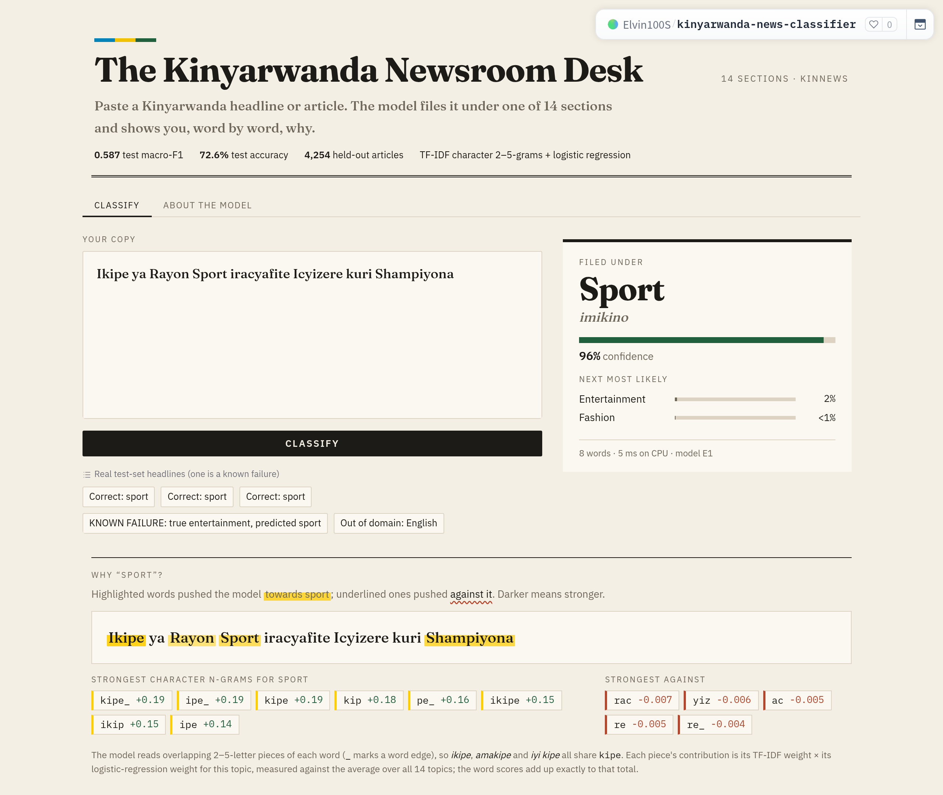
Figure 4. The deployed app after classifying a test-set headline: the predicted section with its Kinyarwanda name and confidence, the next most likely topics, and the explanation. Highlighted words pushed the prediction towards sport; the strongest character n-grams (pieces of ikipe, “team”) are listed with their contributions.

8. Limitations and Future Work

8.1 Limitations
- Dataset shift and model selection. The test set’s class distribution differs sharply from training. Test scores therefore describe a reweighted sample, and a validation set drawn from training under-rewarded the most shift-robust model (Section 5.6).
- Label noise. Conflicting labels on identical articles and apparently inconsistent annotation (Section 6.2) place a ceiling on achievable accuracy and make some measured errors unreliable.
- Limited seeds and tuning. Neural models were run with three seeds and the linear models with one (they are deterministic given the data). The Transformers used a single learning rate and three epochs; XLM-R’s instability across seeds suggests these settings were not well suited to it.
- Truncation. 74.5% of articles exceed the Transformers’ 512-token limit, and A2 shows that context length matters.
- Scraping artefacts and encoding errors (Section 6.2) leak into the features.
- No out-of-domain detection. The model always outputs a topic; the confidence warning mitigates but does not solve this.
- One corpus and period. Performance on newer articles or other sources has not been tested.

8.2 Future work
- Select models on a validation set that mirrors the expected deployment distribution, or report results under several reweightings, so that robustness to shift is rewarded.
- Tune the Transformers (learning rate, epochs) and run more seeds, to stabilise XLM-R and test whether AfroXLMR can also lead on validation.
- Handle long documents with sliding windows or hierarchical encoding, so the Transformers see whole articles.
- Evaluate a morphology-aware Kinyarwanda model such as KinyaBERT (Nzeyimana & Niyongabo Rubungo, 2022), which addresses the tokenizer limitation directly.
- Clean the scraping artefacts and encoding errors, and audit the confident mistakes with Kinyarwanda speakers; consider multi-label annotation for overlapping topics.
- Add explicit language identification and calibrated probabilities to the app.
- Exploit KIRNEWS for cross-lingual transfer to Kirundi, the purpose for which the paired corpora were built (Niyongabo et al., 2020).

9. Conclusion
This project built, evaluated and deployed a 14-class topic classifier for Kinyarwanda news. Auditing the data first changed the project: more than half of the training file was duplicated, and the official test set follows a different class distribution, so the training data was deduplicated before splitting and macro-F1 was chosen as the primary metric.
Character n-grams beat word n-grams by 7.6 points with half the parameters (RQ1); fastText initialisation improved a BiLSTM by 8.4 points (RQ2); and African-centric adaptation improved a Transformer by 25.4 points (RQ3). The RQ2 and RQ3 results held on every seed, and all three improvements were largest on the rarest classes. The selected model, TF-IDF character n-grams with logistic regression, reached 0.587 test macro-F1 and 72.6% accuracy and is the cheapest to run, while AfroXLMR reached the highest test score (0.614) and proved far more robust to the train/test shift. The remaining errors (RQ4) come mainly from overlapping topics, classes with only a few dozen training examples, and inconsistencies in the source labels.
The main lessons are that, on a small corpus in a morphologically rich language, how words are represented and whether a model has seen the language matter more than model size, and that the way a validation set is drawn can decide which of two strong models is chosen.

References
Abid, A., Abdalla, A., Abid, A., Khan, D., Alfozan, A., & Zou, J. (2019). Gradio: Hassle-free sharing and testing of ML models in the wild. arXiv preprint arXiv:1906.02569 (ICML 2019 Workshop on Human in the Loop Learning).
Alabi, J. O., Adelani, D. I., Mosbach, M., & Klakow, D. (2022). Adapting pre-trained language models to African languages via multilingual adaptive fine-tuning. In Proceedings of the 29th International Conference on Computational Linguistics (pp. 4336–4349). https://aclanthology.org/2022.coling-1.382/
Bojanowski, P., Grave, E., Joulin, A., & Mikolov, T. (2017). Enriching word vectors with subword information. Transactions of the Association for Computational Linguistics, 5, 135–146. https://doi.org/10.1162/tacl_a_00051
CC-100: Monolingual datasets from web crawl data. (n.d.). Retrieved from https://data.statmt.org/cc-100/
Conneau, A., Khandelwal, K., Goyal, N., Chaudhary, V., Wenzek, G., Guzmán, F., Grave, E., Ott, M., Zettlemoyer, L., & Stoyanov, V. (2020). Unsupervised cross-lingual representation learning at scale. In Proceedings of the 58th Annual Meeting of the Association for Computational Linguistics (pp. 8440–8451). https://aclanthology.org/2020.acl-main.747/
Davlan. (n.d.). afro-xlmr-base [Model card]. Hugging Face. https://huggingface.co/Davlan/afro-xlmr-base
Devlin, J., Chang, M.-W., Lee, K., & Toutanova, K. (2019). BERT: Pre-training of deep bidirectional Transformers for language understanding. In Proceedings of NAACL-HLT 2019 (pp. 4171–4186). https://aclanthology.org/N19-1423/
Efron, B., & Tibshirani, R. J. (1993). An introduction to the bootstrap. Chapman & Hall.
Facebook AI. (n.d.). xlm-roberta-base [Model card]. Hugging Face. https://huggingface.co/xlm-roberta-base
Hochreiter, S., & Schmidhuber, J. (1997). Long short-term memory. Neural Computation, 9(8), 1735–1780. https://doi.org/10.1162/neco.1997.9.8.1735
Joshi, P., Santy, S., Budhiraja, A., Bali, K., & Choudhury, M. (2020). The state and fate of linguistic diversity and inclusion in the NLP world. In Proceedings of the 58th Annual Meeting of the Association for Computational Linguistics (pp. 6282–6293).
Kimenyi, A. (1980). A relational grammar of Kinyarwanda (University of California Publications in Linguistics, Vol. 91). University of California Press.
Kingma, D. P., & Ba, J. (2015). Adam: A method for stochastic optimization. In Proceedings of the 3rd International Conference on Learning Representations (ICLR). https://arxiv.org/abs/1412.6980
Loshchilov, I., & Hutter, F. (2019). Decoupled weight decay regularization. In Proceedings of the 7th International Conference on Learning Representations (ICLR). https://arxiv.org/abs/1711.05101
McNemar, Q. (1947). Note on the sampling error of the difference between correlated proportions or percentages. Psychometrika, 12(2), 153–157.
Mikolov, T., Chen, K., Corrado, G., & Dean, J. (2013). Efficient estimation of word representations in vector space. arXiv preprint arXiv:1301.3781.
Niyongabo, R. A., Hong, Q., Kreutzer, J., & Huang, L. (2020). KINNEWS and KIRNEWS: Benchmarking cross-lingual text classification for Kinyarwanda and Kirundi. In Proceedings of the 28th International Conference on Computational Linguistics (pp. 5507–5521).
Niyongabo, R. A., et al. (2020). KINNEWS and KIRNEWS [Dataset card, MIT licence]. Hugging Face. https://huggingface.co/datasets/andreniyongabo/kinnews_kirnews
Nzeyimana, A., & Niyongabo Rubungo, A. (2022). KinyaBERT: A morphology-aware Kinyarwanda language model. In Proceedings of the 60th Annual Meeting of the Association for Computational Linguistics (Volume 1: Long Papers) (pp. 5347–5363). https://aclanthology.org/2022.acl-long.367/
Ogueji, K., Zhu, Y., & Lin, J. (2021). Small data? No problem! Exploring the viability of pretrained multilingual language models for low-resourced languages. In Proceedings of the 1st Workshop on Multilingual Representation Learning (pp. 116–126). https://aclanthology.org/2021.mrl-1.11/
Paszke, A., Gross, S., Massa, F., Lerer, A., Bradbury, J., et al. (2019). PyTorch: An imperative style, high-performance deep learning library. In Advances in Neural Information Processing Systems 32 (NeurIPS 2019).
Pedregosa, F., et al. (2011). Scikit-learn: Machine learning in Python. Journal of Machine Learning Research, 12, 2825–2830.
Řehůřek, R., & Sojka, P. (2010). Software framework for topic modelling with large corpora. In Proceedings of the LREC 2010 Workshop on New Challenges for NLP Frameworks (pp. 45–50). ELRA.
Schuster, M., & Paliwal, K. K. (1997). Bidirectional recurrent neural networks. IEEE Transactions on Signal Processing, 45(11), 2673–2681. https://doi.org/10.1109/78.650093
Vaswani, A., Shazeer, N., Parmar, N., Uszkoreit, J., Jones, L., Gomez, A. N., Kaiser, Ł., & Polosukhin, I. (2017). Attention is all you need. In Advances in Neural Information Processing Systems 30 (pp. 5998–6008).
Wolf, T., et al. (2020). Transformers: State-of-the-art natural language processing. In Proceedings of EMNLP 2020: System Demonstrations (pp. 38–45).
Youden, W. J. (1950). Index for rating diagnostic tests. Cancer, 3(1), 32–35. https://doi.org/10.1002/1097-0142(1950)3:1<32::AID-CNCR2820030106>3.0.CO;2-3
Software used without a dedicated citation above: pandas, NumPy and Matplotlib (versions pinned in the repository’s requirements.txt).

