Table of DELETE and TRUNCATE comparison:

|  | Duration of operation | Space consumption for TABLE |
| --- | --- | --- |
| CREATE | 16s | 575MB |
| DELETE | 11s | 575MB |
| VACUUM FULL | 6.555s | 383MB |
| TRUNCATE | 1.091s | 0 |
| DROP | 0.007s |  |

Conclusion:

After a DELETE operation space consumption did not decrease automatically, as rows are marked for deletion but not physically removed. In order to reduce space consumption we need to use VACUUM ALL.

TRUNCATE is much faster than DELETE because it doesn't scan individual rows, it is almost instant. The duration of a DELETE operation depends on the number of rows being deleted..

Detailed information on process compering:

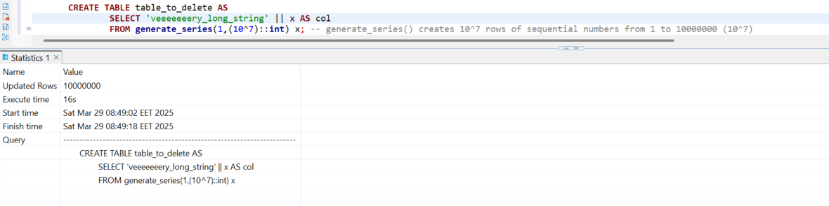

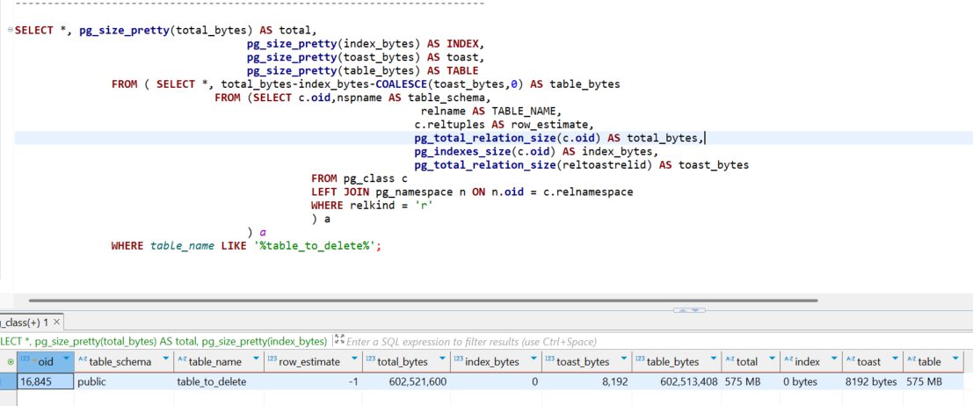

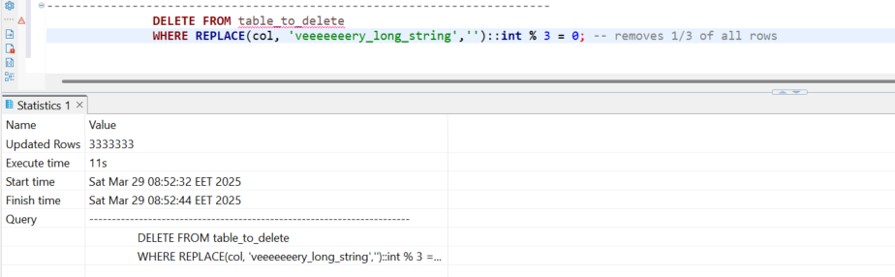

Space after deletion:



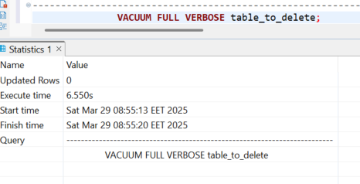

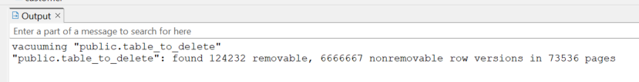

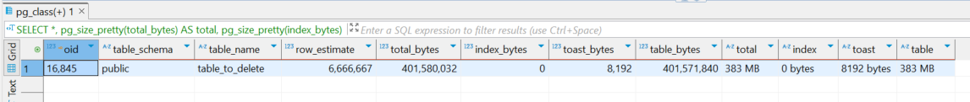

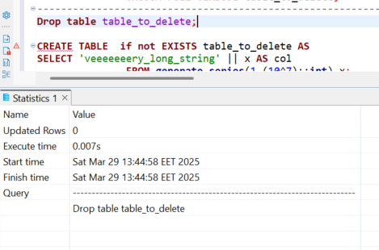

TRUNCATE table_to_delete:

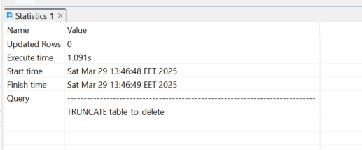

Comepring to DELETE: DELETE took 11s, TRUNCATE took 1.091s

Space consumption:

