CRIME ANALYSIS REPORT
DISTRICT OF COLUMBIA
Problem Statement:
Urban authorities and public safety agencies need to understand when, where, and how crimes are occurring in order to allocate police resources efficiently, reduce crime rates, and improve public safety.
However, crime incidents are:
- Unevenly distributed across locations
- Highly time-dependent
- Influenced by offense type, method, and neighborhood characteristics
Using 2025 crime incident data of Columbia from an official US source (data.gov), the goal is to identify spatial and temporal crime patterns, uncover high-risk areas, understand offense behaviors, and generate insights that can support data-driven policing, prevention strategies, and urban planning decisions.

Objectives:
1: Identify Crime Hotspots
Determine which geographic areas consistently experience higher crime intensity and which types of crimes dominate those locations.
2: Analyze Temporal Crime Patterns
Understand how crime varies by time of day, date, and duration to identify high-risk periods.
3: Understand Crime Types and Methods
Analyze offense categories and methods used to identify dominant crime behaviors and trends.
4: Compare Administrative Regions
Evaluate crime distribution across wards, districts, PSAs and neighborhood clusters to assess inequality and enforcement gaps.
5: Support Strategic Decision-Making
Provide actionable insights for law enforcement and policymakers regarding patrol planning, preventive interventions, and resource allocation.

Data Members:
- CCN : Crime Control Number. Unique identifier for each incident.
- START_DATE : When the crime likely began.
- END_DATE : When the crime ended or was discovered.
- CRIME_MONTH : Month in which the crime happened.
- CRIME_DAY : Day of the crime incident.
- CRIME_HOUR : Hour at which the crime took place.
- DURATION : Duration of the incident.
- SHIFT : Time-of-day category (day, evening, midnight).
- OFFENSE : Type of crime (e.g., assault, theft, burglary).
- METHOD : How the crime was committed (e.g., gun, knife).
- WARD : City ward.
- DISTRICT : Police district.
- PSA : Police Service Area.
- NEIGHBORHOOD_CLUSTER : Grouped neighborhoods for broader spatial analysis.
Objective 1 - Identify Crime Hotspots:
Under this objective we have analyzed the top geographic areas of the District of Columbia under the threat of the criminal activities and the most frequent occurring crimes in those areas.

We have majorly focused on the neighborhood clusters, as analyzing the comparatively smaller areas rather than PSAs and Wards, will help in better allocation of the forces and drawing tactics for the prevention of the crime incidents.

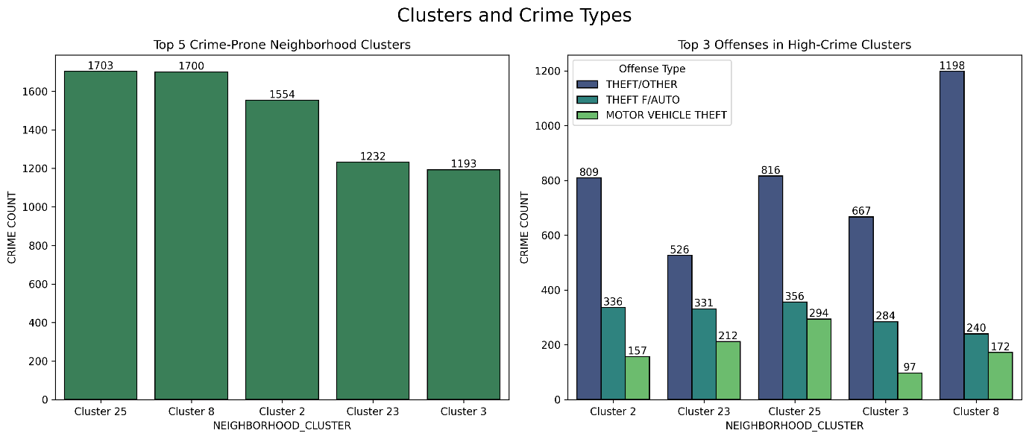
Fig.1.
Key Insights:
- Crime is concentrated in a few neighborhood clusters, with Clusters 25, 8, and 2 emerging as major hotspots.
- Across all high-crime clusters, THEFT/OTHER is the dominant offense, followed by THEFT F/AUTO.
- Crime composition is consistent across hotspots, indicating similar crime behavior patterns rather than isolated anomalies.

Conclusion:
Analysis reveals clear spatial hotspots, with a small number of neighborhood clusters accounting for a disproportionately high number of incidents, dominated primarily by theft-related offenses.

Objective 2 – Analyze Temporal Crime Patterns:
This objective focuses on finding the high risk periods of the occurrence of the crime incidents. Temporal variables such as hour, day, month and duration were extracted and analyzed using aggregations and visualization techniques.

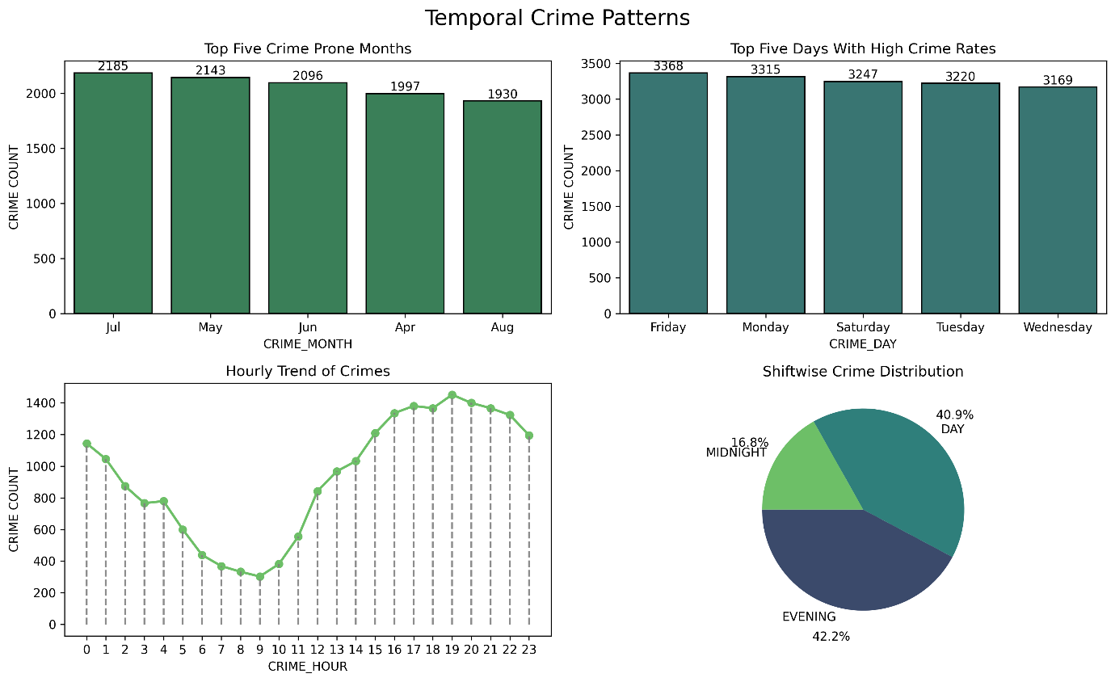
Fig.2.

Key Insights:
- Crime peaks during summer months (May–July), indicating seasonal escalation.
- Weekdays, especially Friday and Monday, show higher crime volumes than weekends.
- Evening hours (17:00–21:00) are the most crime-prone, with a clear spike around 7 PM.
- Evening and Day shifts together account for over 80% of total crimes, highlighting critical patrol windows.

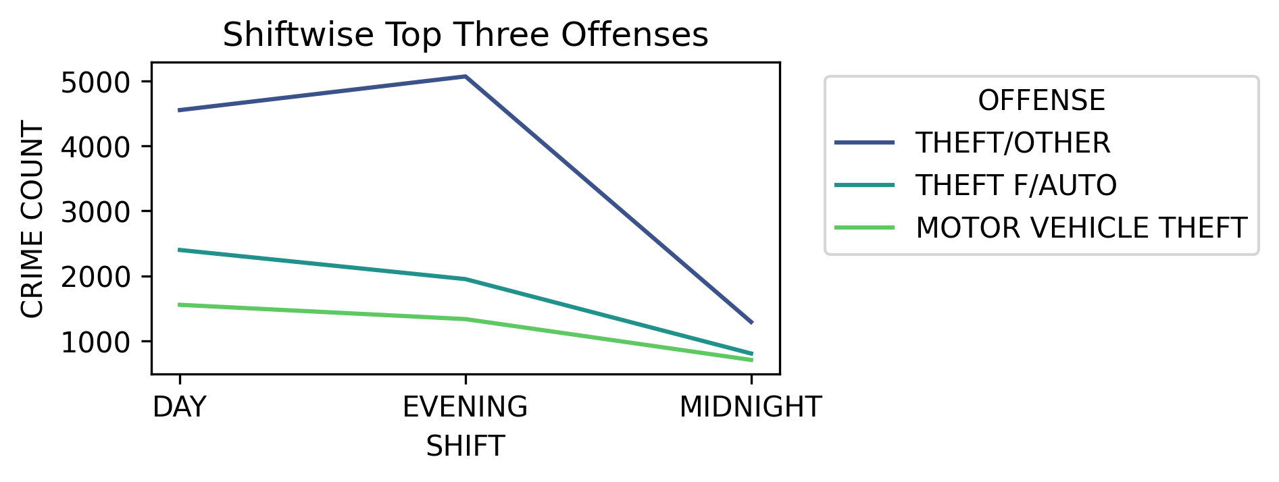
Fig.3.

Key Insights:
- Evening shift has the highest crime volume overall, making it the most critical time window.
- Day shift also reports high theft activity, particularly Theft from Auto, likely linked to parking and commercial activity.
- Midnight shift shows comparatively lower counts, but theft remains the dominant offense even at night.
- Across all shifts, Theft/Other consistently leads.
- Crime intensity peaks after working hours, not late night. Evening is the real pressure point.

Hypothesis Testing: Is there any association between crime shift and the offense type?
A Chi-square test of independence was conducted to examine any relationship between the crime shift and the offense type of the crime.

Null Hypothesis (H₀): Crime shift and offense type are independent.
Alternative Hypothesis (H₁): Crime shift and offense type are associated.
Significance Level: α = 0.05.

After conducting the test, we get the p-value (0.00) < α. So we reject the null hypothesis, therefore, at the 5% significance level, we conclude that there is a statistically significant association between the crime shift and the offense type.

Conclusion:
Crime patterns show strong temporal variation, with significantly higher activity during evening hours and a clear association between time shifts and offense types.

Objective 3 – Understand Crime Types and Methods:
Under this objective we will analyze the distribution of the offenses and their methods of conduction. This helps us to identify the dominant criminal behaviors and operational patterns, which plays an essential role in the targeted prevention of criminal activities and drawing effective investigation strategies. The analysis here is mainly focused on the top 10 offenses and their methods to avoid the dilution caused by the rare occurring crime types. A combined frequency table showing both the variables was aggregated.

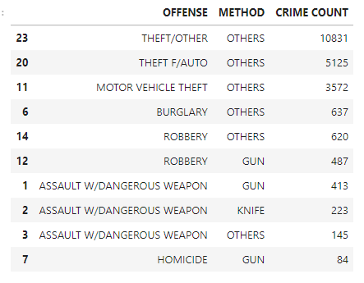
Table.1.
Key Insights:
- Theft-related crimes dominate, especially Theft/Other and Theft F/Auto, mostly involving non-specific methods (“Others”).
- Motor Vehicle Theft remains a major contributor, again largely without weapon involvement.
- Robbery and Assault cases show clear weapon usage, with guns being the most common.
- Assault with Dangerous Weapon frequently involves firearms, followed by knives.
- Homicide incidents are fewer in count but predominantly gun-related, indicating high severity despite low frequency.

Conclusion:
The analysis reveals that theft-related offenses are the most prevalent crime types, with limited variation in recorded crime methods, indicating concentrated crime behavior patterns.
Objective 4 – Compare Administrative Regions:
Now this objective focuses on the administrative level distribution of the crimes, in other words we can say, this objective answers the question related to the distribution of crimes across Districts, PSAs, Wards and Neighborhood Clusters.

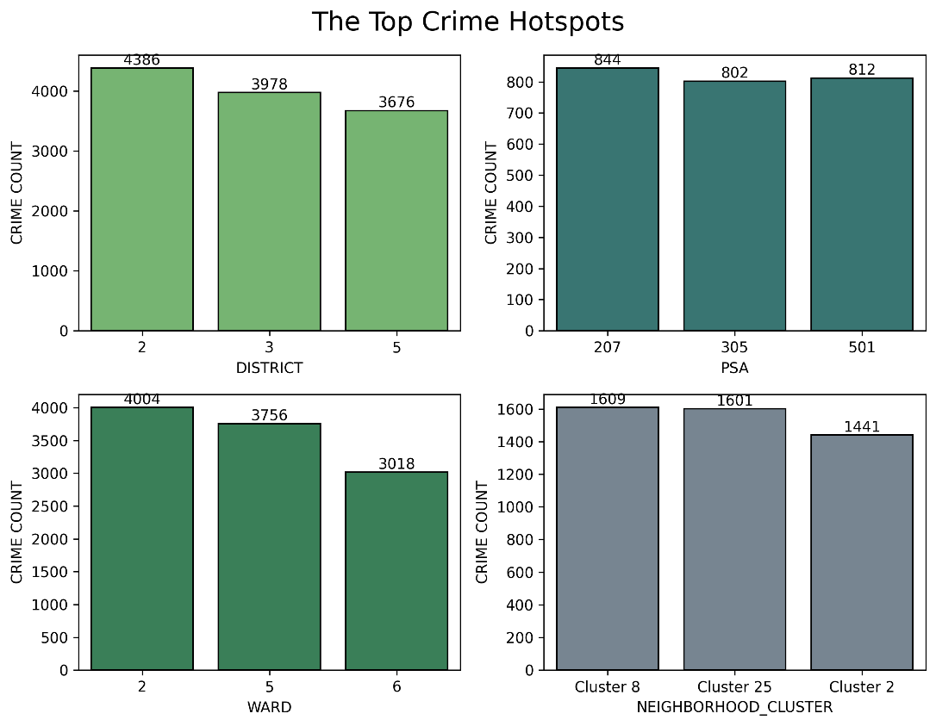

Key Insights:
- District 2 records the highest crime count, followed by Districts 3 and 5, indicating concentrated crime activity in specific districts.
- At the PSA level, PSA 207, 305, and 501 emerge as key hotspots with consistently high crime volumes.
- Ward 2 and Ward 5 show significantly higher crime counts compared to other wards, suggesting localized risk zones.
- Among neighborhood clusters, Cluster 8 and Cluster 25 report the highest crime concentration, pointing to persistent hotspot regions.

Conclusion:
Crime distribution is highly uneven across wards, districts, PSAs, and neighborhood clusters, indicating concentrated hotspots and potential enforcement gaps.

Objective 5 – Support Strategic Decision-Making:
- Increase evening patrol strength
Crime peaks in the evening. This is where extra manpower actually matters.
- Prioritize theft-focused deployment
Theft and vehicle-related crimes dominate. Stop pretending everything is equally urgent.
- Target high-crime wards and PSAs
Uneven distribution means blanket policing is lazy and inefficient.
- Use preventive visibility, not reactive policing
Patrol presence works better than chasing cases after they happen.
- Do NOT over-allocate resources to midnight shifts
Lower crime volume. Keep coverage, but stop wasting peak resources here.

THANKYOU!!
ELVIS GEORGE

