REPORT

InstaCart Customer Behavior Analysis

Elvis George

Analyst

PROBLEM STATEMENT:

E-commerce platforms like Instacart generate large volumes of transactional data, capturing detailed information about customer orders, product purchases, and shopping behavior.
Understanding customer purchasing patterns, product loyalty, and engagement behavior is essential for improving retention, optimizing inventory, and driving business growth.

However, customer behavior in online grocery platforms is:
- Highly dynamic and time-dependent
- Influenced by product categories and usage patterns
- Unevenly distributed across customers and products
Using a sampled dataset of Instacart orders, the goal is to analyze customer behavior, identify repeat purchase patterns, understand product-level loyalty, and generate insights that can support data-driven decision-making in marketing, inventory management, and customer retention strategies.

OBJECTIVES:

1: Sales Performance Overview
Analyze overall order distribution, total orders, and average basket size to understand general purchasing behavior.

2: Customer Segmentation & Value Analysis
Identify high-value customers, evaluate reorder behavior, and segment users based on engagement levels.

3: Product Reorder & Loyalty Analysis
Determine product-level reorder probability and identify products that drive repeat purchases.

4: Category & Department Performance
Analyze department-wise and aisle-wise performance to understand category-level contribution to repeat purchases.

DATA MEMBERS:

order_id : Unique identifier for each order
user_id : Unique identifier for each customer
product_id : Unique identifier for each product

product : Product name
order_dow : Day of week when the order was placed
order_hour_of_day : Hour of day when the order was placed
days_since_prior_order : Gap between consecutive orders
reordered : Indicates whether the product was reordered
department_id : Product department identifier

department : Name of department
aisle_id : Product aisle identifier

aisle : Name of aisle

ENTITY RELATIONSHIP DIAGRAM (ERD):

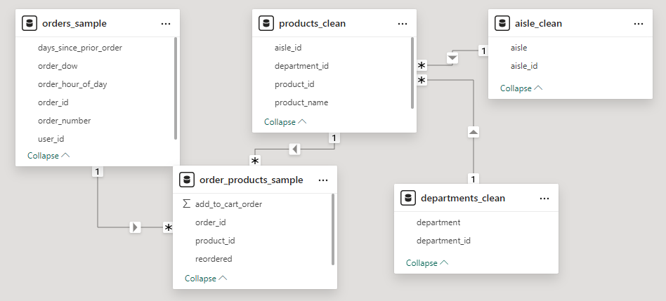

OBJECTIVE 1 – SALES PERFORMANCE OVERVIEW:

Under this objective, overall order distribution across days and hours was analyzed to understand when customers are most active and how purchasing behavior varies over time.
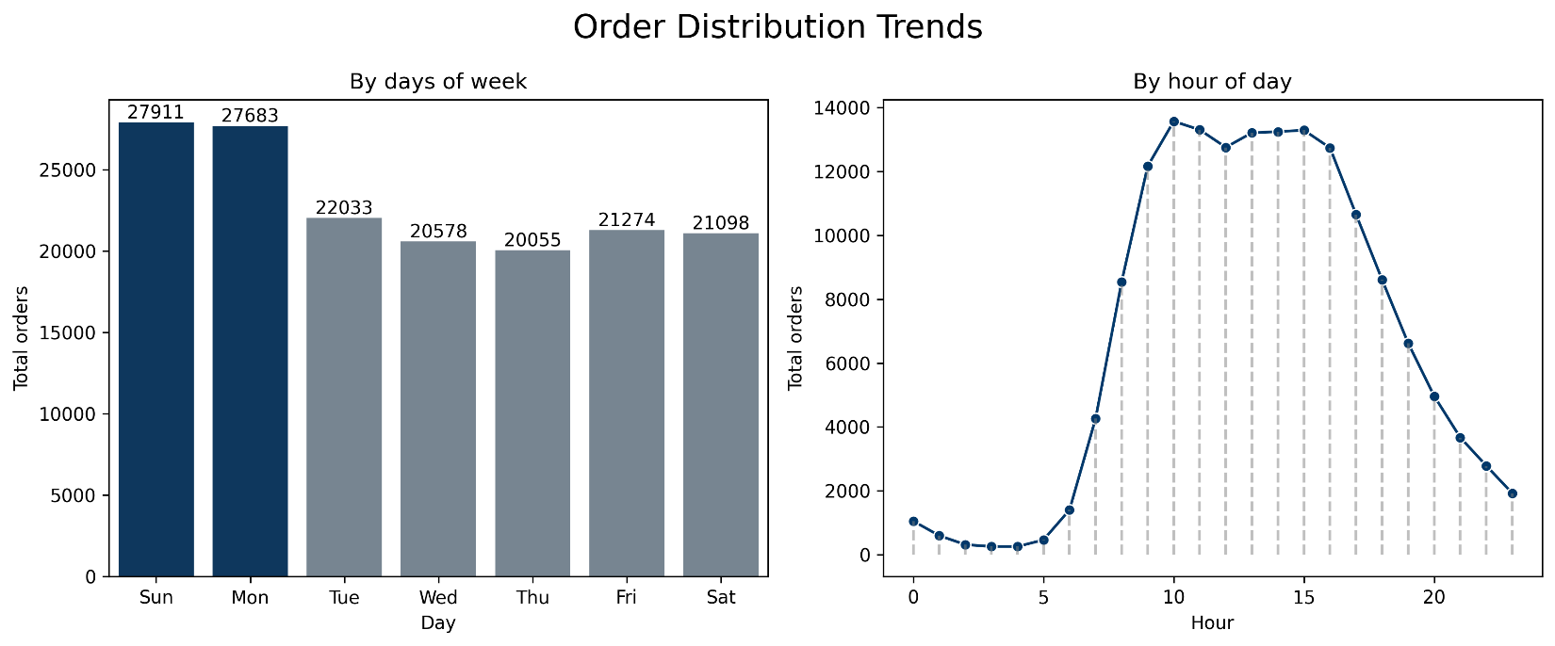
Fig.1.
Key Insights:
- Orders are highest on Sunday (~27.9k) and Monday (~27.6k), indicating stronger customer activity during weekends and early week periods.
- Mid-week days (Tuesday to Thursday) show relatively lower and stable order volumes (~20k–22k), reflecting reduced engagement during working days.
- Order volume peaks between 10 AM and 3 PM (~13k–14k), marking this as the primary shopping window.
- Early morning hours (midnight to 6 AM) show minimal activity, while evening orders gradually decline after peak hours.
Conclusion:
Customer ordering behavior is strongly influenced by both day and time, with peak activity concentrated during weekends and mid-day hours.

OBJECTIVE 2 – CUSTOMER SEGMENTATION & VALUE

ANALYSIS:

This objective focuses on identifying high-value customers and analyzing their reorder behavior, engagement levels, and purchase frequency. Customers were segmented into high, medium, and low engagement groups based on their ordering patterns.
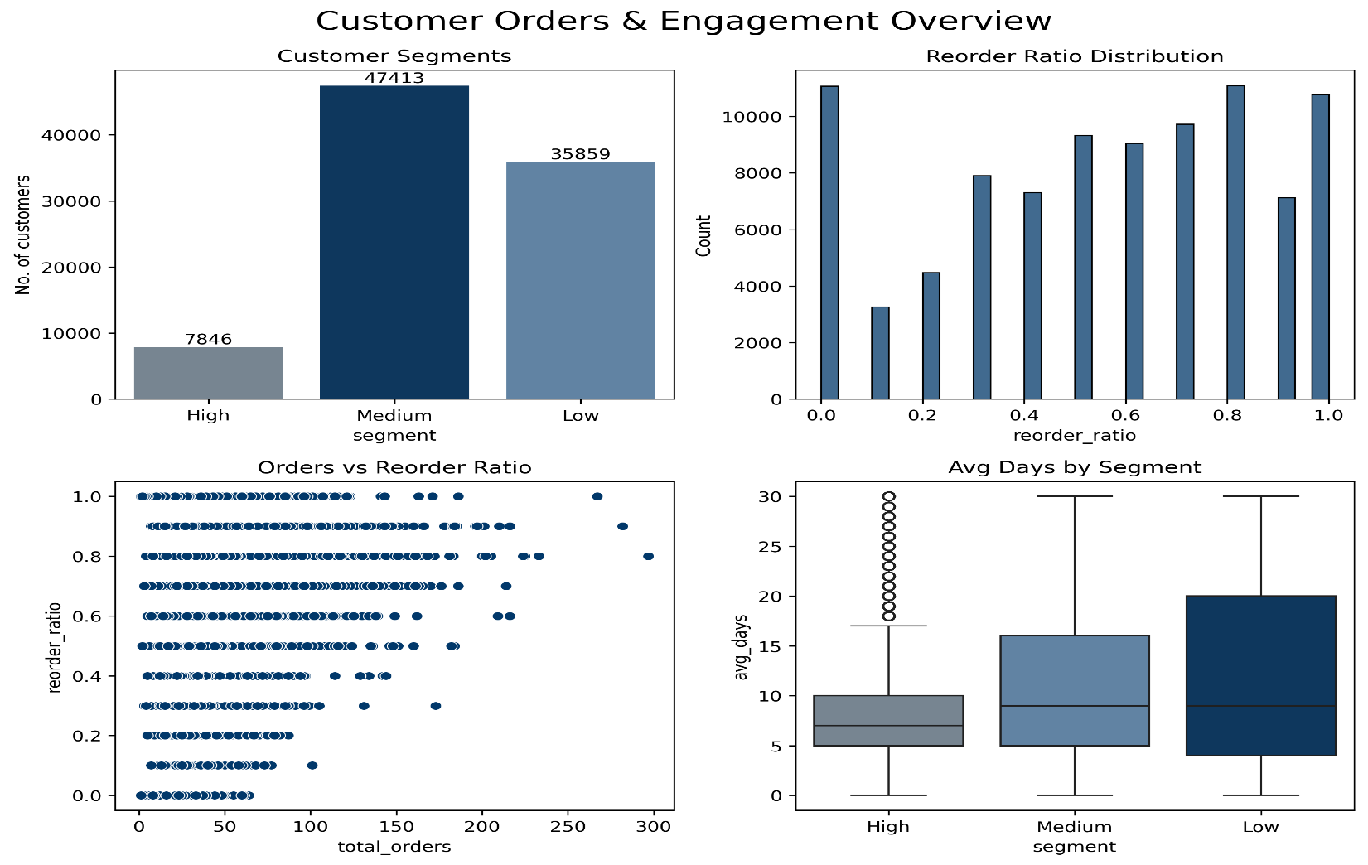
Fig.2.
Key Insights:
- Most customers fall into the medium segment, followed by low, while high-value customers form a significantly smaller group.
- Reorder ratios are generally higher across customers, indicating moderate to strong loyalty behavior.
- Customers with higher total orders tend to show higher reorder ratios, though the relationship is not strictly linear.
- High-value customers have lower average days between orders, indicating more frequent and consistent purchasing behavior.
- Low-value customers show higher and more inconsistent gaps between orders, reflecting weaker engagement.
Conclusion:
A small group of high-value customers drives consistent activity, while medium customers form the primary user base and represent strong growth potential.

OBJECTIVE 3 – PRODUCT REORDER & LOYALTY ANALYSIS:

This objective analyzes product-level reorder behavior to identify which products contribute to repeat purchases and customer retention.
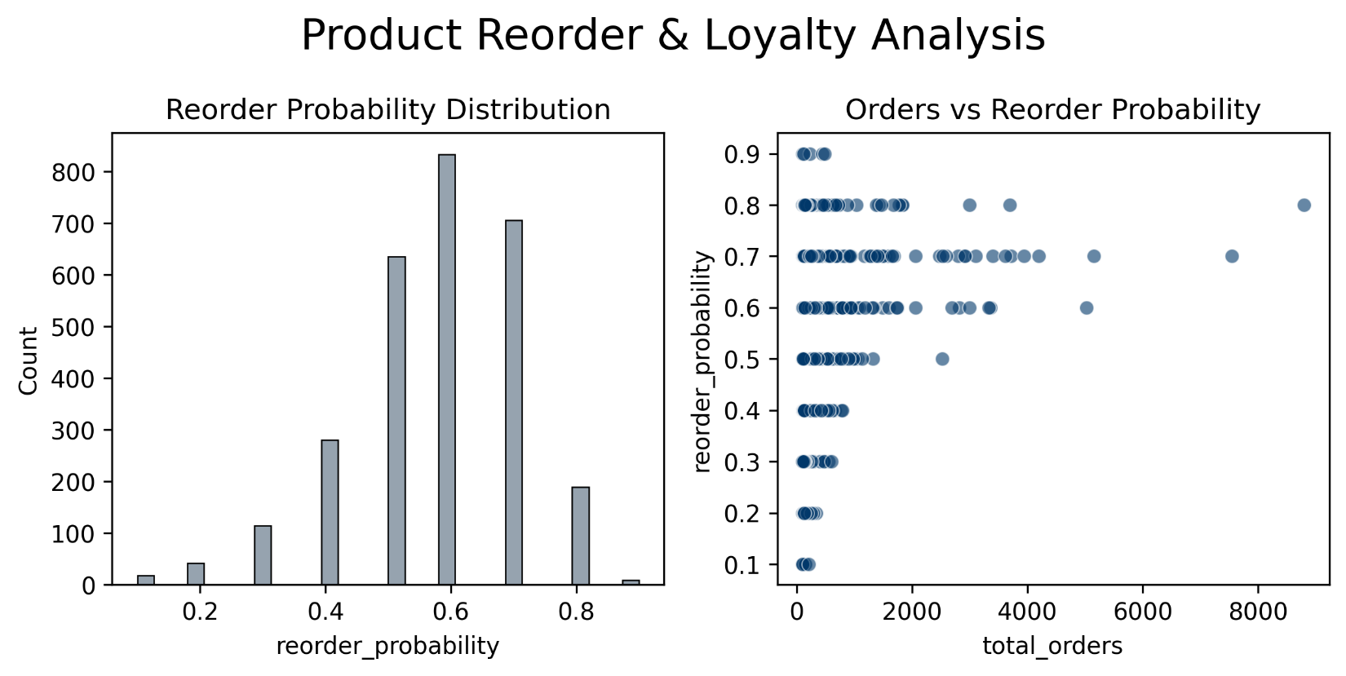
Fig.3.
Key Insights:
- Most products have reorder probabilities concentrated between 0.5 and 0.7, indicating moderate repeat behavior across the catalog.
- Very few products lie at extreme values, showing that highly loyal or purely one-time products are limited.
- Products with low total orders show unstable reorder patterns, indicating less reliable behavior.
- Higher order products tend to stabilize at moderate to high reorder probabilities, showing consistent purchasing behavior.
- There is no strong relationship between product popularity and reorder probability, meaning frequently purchased products are not always the most loyal.

Conclusion:
Product loyalty is moderate overall, with only a limited set of products driving strong repeat purchases.

OBJECTIVE 4 – CATEGORY & DEPARTMENT PERFORMANCE:

This objective focuses on analyzing how different product categories (departments and aisles) contribute to repeat purchasing behavior and customer engagement.
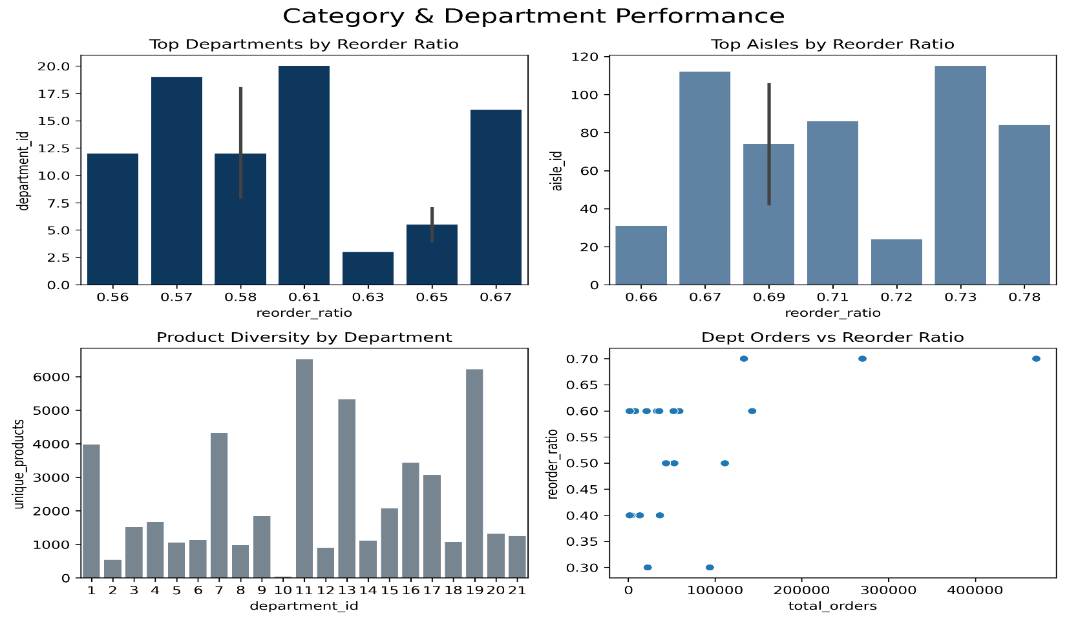
Fig.4.
Key Insights:
- A few departments show higher reorder ratios, indicating that these categories contain frequently repurchased, essential products.
- Only certain aisles contribute significantly to repeat purchases, showing that loyalty is concentrated in specific product categories.
- Some departments with high order volumes do not show equally high reorder ratios, indicating that popularity does not always translate into loyalty.
- Product diversity varies widely across departments, but higher variety does not necessarily lead to higher repeat purchases.
Conclusion:
Repeat purchasing behavior is driven by a limited number of categories, highlighting key areas for business focus and customer retention strategies.

FINAL CONCLUSION:

Customer purchasing behavior is influenced by a combination of order timing, purchase frequency, and product category.
A small group of highly engaged customers and a limited set of products contribute significantly to repeat purchases. While most customers and products show moderate engagement, there is a clear opportunity to improve retention by focusing on high-frequency users, high-reorder categories, and peak demand periods.

RECOMMENDATIONS:

- Focus on retaining high-value customers through personalized offers and loyalty programs.
- Ensure availability and visibility of high-reorder products, as they drive repeat purchases.
- Target medium-segment customers with incentives to convert them into high-value users.
- Optimize marketing and operations around peak days (Sunday, Monday) and peak hours (10 AM – 3 PM).
- Improve positioning and promotion strategies for low-reorder products to enhance engagement.

THANKYOU!!

-ELVIS GEORGE

ANALYST

