TheLook E-Commerce
Cart Abandonment & Checkout Funnel Analysis

Prepared by: Elvis George [Analyst]
Dataset: Google BigQuery Public Dataset — TheLook E-Commerce
Report Type: Exploratory Data Analysis & Hypothesis Testing
Date: May 2026

Executive Summary

This report presents a comprehensive analysis of cart abandonment and checkout funnel drop-off behavior on TheLook, a fictitious e-commerce clothing retail platform developed by the Google Looker team. The dataset spans multiple years of transactional and behavioral data across 7 interconnected tables covering customers, products, orders, web events, and logistics.

The central business problem addressed in this analysis is the systematic identification of where customers drop off in the checkout funnel, which customer segments abandon most, and what the estimated revenue impact of abandonment looks like on a weekly and monthly basis. Fourteen analytical questions were explored covering funnel behavior, customer segmentation, traffic channel attribution, product and pricing analysis, revenue quantification, hypothesis testing, and behavioral pattern analysis.

Key Findings at a Glance
- Overall cart-to-purchase conversion rate stands at just 32.08%, with a 67.92% drop-off at the final checkout stage.
- First-time visitors abandon at 97.20% versus 87.69% for returning customers — a 10-point gap driven by trust and familiarity.
- Total estimated revenue lost due to cart abandonment: $756,855 — with monthly losses accelerating from $220 in Jan 2019 to $57,861 in Jan 2024.
- No traffic source, age group, gender, price range, or product category shows a statistically meaningful advantage — abandonment is platform-wide.
- China dominates abandoned sessions geographically with 12,112 sessions, suggesting localization gaps in the Asian market.
- Users who later cancelled or returned orders showed 21% higher browsing activity than those who completed purchases successfully.

About the Dataset

TheLook is a fictitious e-commerce clothing retail platform developed by the Google Looker team and hosted on Google BigQuery as a public dataset. Despite being synthetic, the data is modeled to reflect real-world e-commerce operations with the same complexity, relationships, and messiness found inside an actual retail organization. The dataset spans multiple years of transactional and behavioral data and is continuously updated by Google.

Table | Description | Rows (Post-Cleaning)
orders | Order-level status, timestamps, item count | 125,226
order_items | Line-item detail — product, price, status | 181,759
users | Customer demographics, traffic source | 99,042
products | Product catalog — category, brand, pricing | 29,120
events | Web session behavior — clicks, cart, purchase | 300,000 (sampled)
inventory_items | Inventory cost and stock records | 100,000 (sampled)
distribution_centers | Warehouse locations | 10

Business Problem Statement

TheLook's e-commerce platform generates consistent web traffic across multiple channels — organic search, paid advertising, email, and social media. Users land on product pages, browse categories, and add items to their carts. However, a significant portion of these users never complete their purchase.

The business has been measuring success primarily through total revenue and order volume, but lacks a systematic view of where exactly in the checkout funnel customers are dropping off, which customer segments abandon most, and what the estimated revenue loss from abandonment looks like on a weekly and monthly basis.

The core leadership question driving this analysis:

Key Finding: Are we losing customers because of a product problem, a pricing problem, a channel problem, or a checkout experience problem?

Section 1 — Funnel & Conversion Analysis

Q1. Overall Funnel Conversion Rate & Biggest Drop-off Step
The funnel was defined using three event types from the events table: product view, cart add, and purchase. The home and department stages were excluded because product view sessions exceeded home page visits, confirming that users enter directly via search or paid ads rather than through the home page.

Funnel Stage | Unique Sessions | Conversion Rate | Drop-off Rate
Product View | 100,344 | — | —
Cart Add | 69,846 | 69.61% | 30.39%
Purchase | 22,407 | 32.08% | 67.92% ← HIGHEST

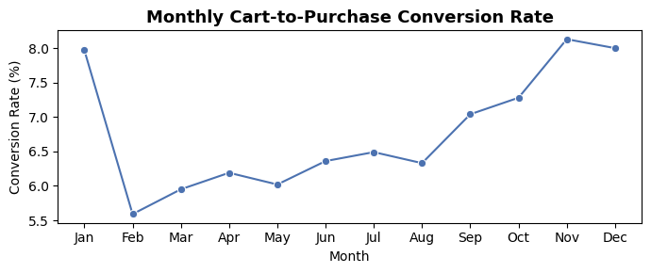

Key Finding: The biggest drop-off occurs at the Cart → Purchase stage with a 67.92% drop-off rate, meaning nearly 7 out of 10 users who add items to cart never complete the purchase. This is the primary area of concern and the core of the cart abandonment problem.

Q2. Monthly Cart-to-Purchase Conversion Rate Trend
Monthly cart and purchase sessions were extracted and conversion rate was computed per month to assess whether abandonment is worsening over time.

Month | Cart Sessions | Purchase Sessions | Conversion Rate
January | 7,784 | 620 | 7.97%
February | 4,326 | 242 | 5.59%
March | 4,905 | 292 | 5.95%
April | 4,927 | 305 | 6.19%
May | 5,332 | 321 | 6.02%
June | 5,127 | 326 | 6.36%
July | 5,689 | 369 | 6.49%
August | 5,765 | 365 | 6.33%
September | 5,897 | 415 | 7.04%
October | 6,363 | 463 | 7.28%
November | 6,508 | 529 | 8.13%
December | 7,224 | 578 | 8.00%

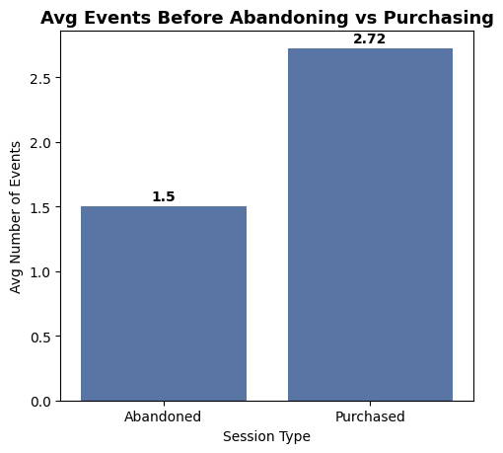

Key Finding: Conversion rate fluctuates between 5.59% (February) and 8.13% (November) but shows no consistent worsening trend. Abandonment is a persistent, year-round problem. The year-end uptick (Sep–Nov) likely reflects seasonal shopping intent.

Q3. Average Events Before Abandoning vs. Purchasing
Session-level event counts were computed for sessions that ended in purchase versus those that ended in abandonment (cart with no purchase), to understand engagement depth differences.

Session Type | Average Events Completed
Abandoned | 1.50
Purchased | 2.72

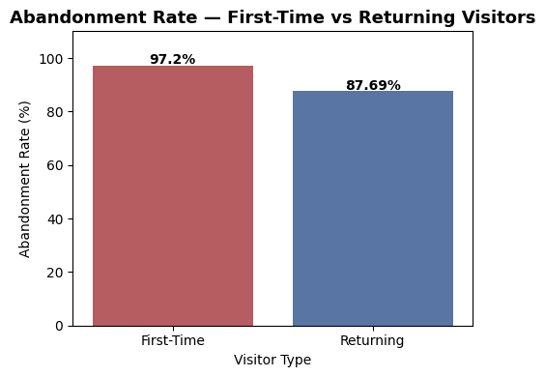

Key Finding: Purchasing users engage with nearly 2x more events (2.72 vs 1.50) than abandoning users. Abandoned sessions end very early — after just 1–2 interactions — suggesting users lose interest or encounter friction before developing any serious purchase intent.

Section 2 — Customer Segment Analysis

Q4. First-Time vs. Returning Visitor Abandonment Rate
Users with only one unique session were classified as first-time visitors; users with two or more sessions as returning. Anonymous sessions (null user_id) were also treated as first-time.

Visitor Type | Cart Sessions | Abandoned | Abandonment Rate
First-Time | 39,672 | 38,561 | 97.20%
Returning | 30,174 | 26,460 | 87.69%

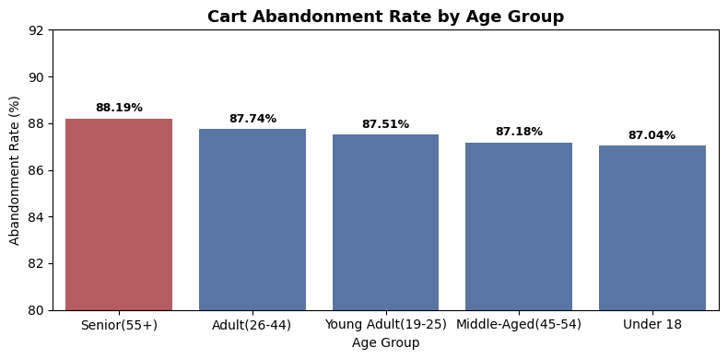

Key Finding: First-time visitors abandon at 97.20% versus 87.69% for returning customers — a nearly 10-percentage-point gap. Trust and platform familiarity are critical conversion drivers. First-time visitor retention and trust-building must be prioritized in the abandonment recovery strategy.

Q5. Cart Abandonment Rate by Age Group
Users were segmented into five age groups. Abandonment rate was computed per group using session-level cart and purchase flags joined to user demographics.

Age Group | Cart Sessions | Abandoned | Abandonment Rate
Senior (55+) | 10,721 | 9,455 | 88.19% ← Highest
Adult (26–44) | 12,537 | 11,000 | 87.74%
Young Adult (19–25) | 4,562 | 3,992 | 87.51%
Middle-Aged (45–54) | 6,668 | 5,813 | 87.18%
Under 18 | 4,608 | 4,011 | 87.04%

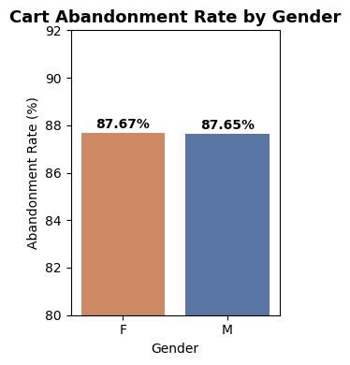

Key Finding: Abandonment rates are consistently high across all age groups (87–88%), with Seniors (55+) abandoning the most at 88.19%. The ~1% spread across groups confirms that age is not a meaningful differentiator — cart abandonment is a platform-wide problem affecting every demographic equally.

Q6. Gender-wise Abandonment Rate (Chi-Square Hypothesis Test)
A Chi-square test of independence was conducted to determine whether abandonment rates differ significantly between male and female customers.

H₀: Abandonment rate is the same for both male and female customers.
H₁: Abandonment rate is significantly different between genders. | Significance level: α = 0.05

Gender | Cart Sessions | Purchased | Abandonment Rate
Female (F) | 19,520 | 11,217 | 87.67%
Male (M) | 19,576 | 11,190 | 87.65%

Chi-Square Statistic | P-Value | Degrees of Freedom | Result
0.3529 | 0.5525 | 1 | Fail to Reject H₀ — No Significant Difference

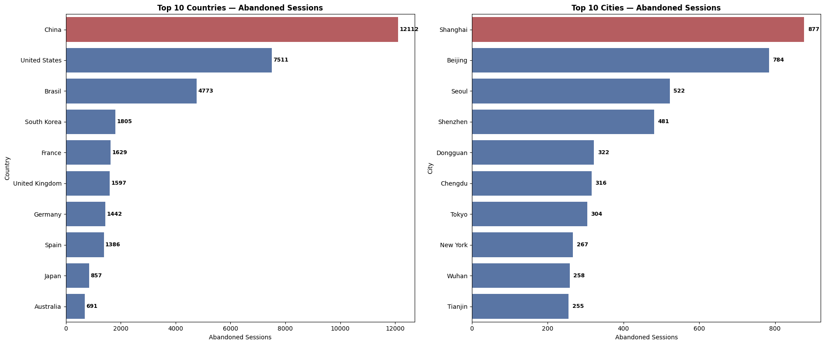

Key Finding: With only a 0.02% difference in abandonment rates and a p-value of 0.5525, gender has no statistically meaningful impact on cart abandonment behavior. Gender-specific marketing strategies for abandonment recovery would not yield differential results.

Q7. Geographic Concentration of Abandoned Sessions
Abandoned sessions (cart with no purchase) were aggregated by country and city using the users table joined to event-level session flags.

Rank | Country | Abandoned Sessions
1 | China | 12,112
2 | United States | 7,511
3 | Brasil | 4,773
4 | South Korea | 1,805
5 | France | 1,629
6 | United Kingdom | 1,597
7 | Germany | 1,442
8 | Spain | 1,386
9 | Japan | 857
10 | Australia | 691

Rank | City | Abandoned Sessions
1 | Shanghai | 877
2 | Beijing | 784
3 | Seoul | 522
4 | Shenzhen | 481
5 | Dongguan | 322
6 | Chengdu | 316
7 | Tokyo | 304
8 | New York | 267
9 | Wuhan | 258
10 | Tianjin | 255

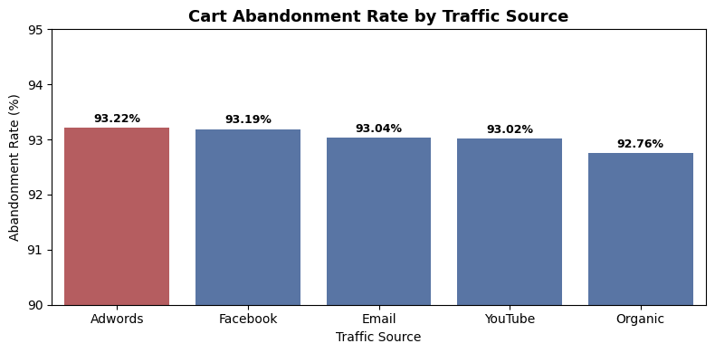

Key Finding: China dominates with 12,112 abandoned sessions — 1.6x more than the United States. Eight of the top 10 cities are Asian cities, with Shanghai and Beijing alone accounting for the majority of Chinese abandonment. This suggests critical gaps in localization, payment method availability, or checkout UX for Asian markets.

Section 3 — Traffic Source & Channel Analysis

Q8. Abandonment Rate by Traffic Source
Cart sessions were grouped by traffic_source directly from the events table. Abandonment rate was computed per channel.

Traffic Source | Cart Sessions | Abandoned | Abandonment Rate
Adwords | 20,924 | 19,505 | 93.22% ← Highest
Facebook | 7,112 | 6,628 | 93.19%
Email | 31,225 | 29,051 | 93.04%
YouTube | 7,036 | 6,545 | 93.02%
Organic | 3,549 | 3,292 | 92.76% ← Lowest

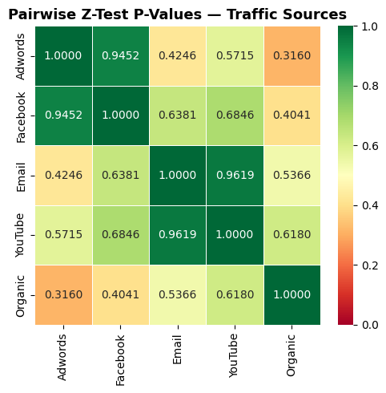

Key Finding: Adwords drives the highest abandonment (93.22%) while Organic performs best (92.76%). However the spread is only ~0.5% across all channels. Email drives the highest cart volume (31,225) but fails to convert — suggesting email campaign targeting needs refinement. Organic users convert best, confirming that intent-driven traffic outperforms paid.

Q9. Statistical Significance of Abandonment Rate Differences Between Traffic Sources (Proportion Z-Test)

H₀: Abandonment rate differences between traffic sources are statistically insignificant.
H₁: Abandonment rate differences between traffic sources are statistically significant. | α = 0.05

Comparison Pair | Z-Statistic | P-Value | Result
Adwords vs Facebook | 0.0687 | 0.9452 | Not Significant
Adwords vs Email | 0.7985 | 0.4246 | Not Significant
Adwords vs YouTube | 0.5658 | 0.5715 | Not Significant
Adwords vs Organic | 1.0028 | 0.3160 | Not Significant
Facebook vs Email | 0.4703 | 0.6381 | Not Significant
Facebook vs YouTube | 0.4062 | 0.6846 | Not Significant
Facebook vs Organic | 0.8343 | 0.4041 | Not Significant
Email vs YouTube | 0.0477 | 0.9619 | Not Significant
Email vs Organic | 0.6179 | 0.5366 | Not Significant
YouTube vs Organic | 0.4986 | 0.6180 | Not Significant

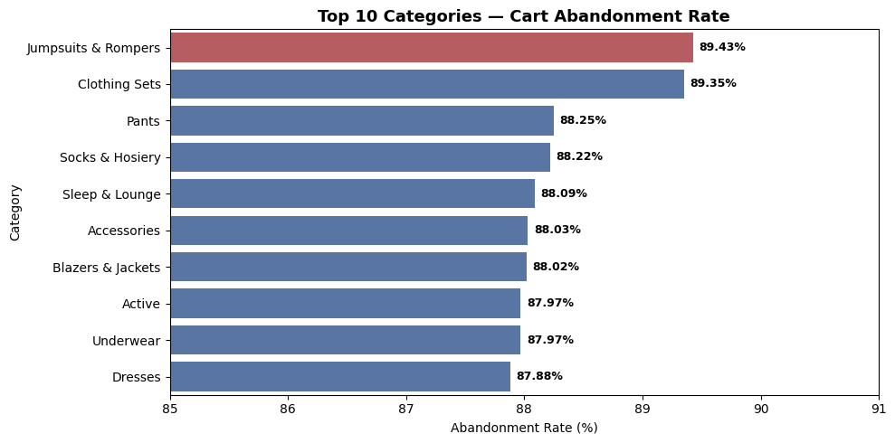

Key Finding: All 10 pairwise z-tests yield p-values well above 0.05. The abandonment problem is entirely channel-agnostic — no traffic source performs meaningfully better or worse. The root cause lies in the checkout experience itself, not traffic quality or acquisition channel.

Section 4 — Product & Category Analysis

Q10. Product Categories with Highest Cart Abandonment Rate

Category | Cart Sessions | Abandoned | Abandonment Rate
Jumpsuits & Rompers | 776 | 694 | 89.43% ← Highest
Clothing Sets | 169 | 151 | 89.35%
Pants | 6,061 | 5,349 | 88.25%
Socks & Hosiery | 3,191 | 2,815 | 88.22%
Sleep & Lounge | 9,117 | 8,031 | 88.09%
Accessories | 8,286 | 7,294 | 88.03%
Blazers & Jackets | 2,712 | 2,387 | 88.02%
Active | 7,658 | 6,737 | 87.97%
Underwear | 6,369 | 5,603 | 87.97%
Suits (Lowest) | 840 | 723 | 86.07%

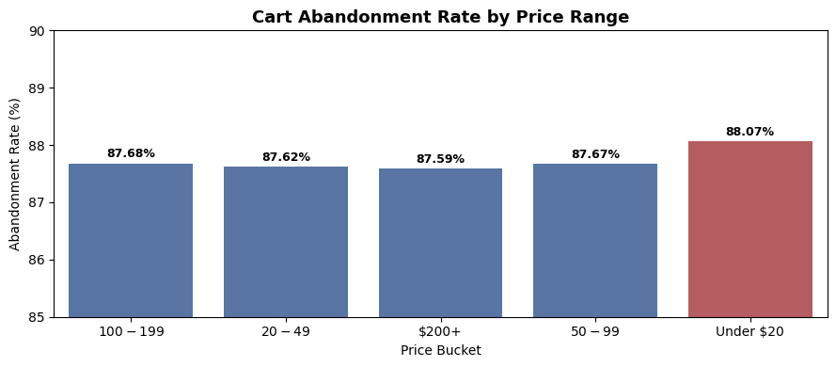

Key Finding: Jumpsuits & Rompers (89.43%) and Clothing Sets (89.35%) lead in abandonment rate, but the spread across all 26 categories is only 3.4%. High-volume categories — Intimates (11,185 sessions), Jeans (10,772), and Tops & Tees (9,990) — represent the largest absolute recovery opportunity.

Q11. Price Range vs. Cart Abandonment Rate
Products were bucketed into five price ranges. Abandonment rate was computed per bucket to identify if a price threshold triggers abandonment spikes.

Price Range | Cart Sessions | Abandoned | Abandonment Rate
Under $20 | 30,163 | 26,566 | 88.07% ← Highest
$20–$49 | 59,470 | 52,109 | 87.62%
$50–$99 | 36,722 | 32,195 | 87.67%
$100–$199 | 16,514 | 14,479 | 87.68%
$200+ | 9,684 | 8,482 | 87.59%

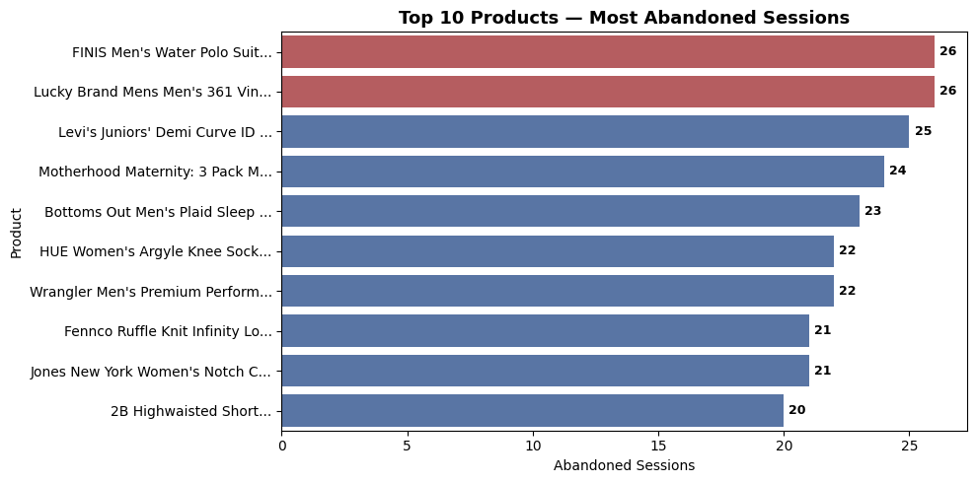

Key Finding: Contrary to expectation, high-price products are NOT abandoned more frequently. Under $20 products actually show the highest abandonment (88.07%). There is no discernible price threshold where abandonment spikes — price is not the primary driver of cart abandonment on this platform.

Q12. Products Appearing Most Frequently in Abandoned Sessions

Product Name | Category | Retail Price | Abandoned Sessions
FINIS Men's Water Polo Suit | Swim | $27.99 | 26
Lucky Brand Mens 361 Vintage Straight... | Jeans | $99.00 | 26
Levi's Juniors' Demi Curve ID Skinny Jean | Jeans | $39.99 | 25
Motherhood Maternity: 3 Pack Bikini... | Maternity | $14.98 | 24
Bottoms Out Men's Plaid Sleep Jam | Sleep & Lounge | $25.00 | 23
HUE Women's Argyle Knee Sock | Plus | $7.00 | 22
Wrangler Men's Premium Cowboy Cut... | Jeans | $49.99 | 22
Fennco Ruffle Knit Infinity Loop Scarf | Accessories | $21.99 | 21
Jones New York Women's Notch Collar Jacket | Blazers & Jackets | $114.50 | 21
2B Highwaisted Short | Shorts | $29.95 | 20

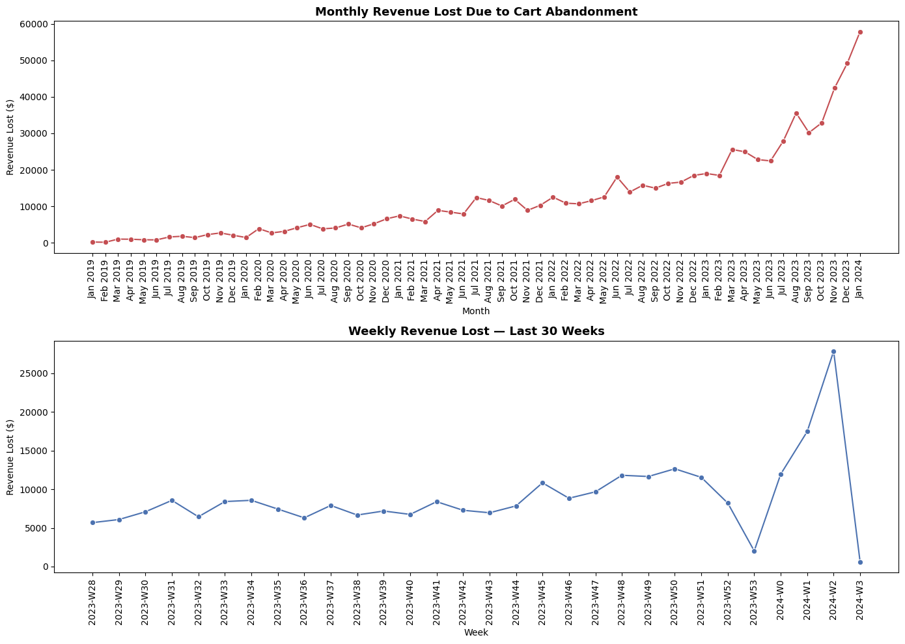

Key Finding: Jeans appear 3 times in the top 10 most abandoned products. Abandoned counts per product are low (20–26), indicating abandonment is spread broadly across the catalog rather than concentrated on specific items. This points to a platform-level checkout experience problem rather than product-specific friction.

Section 5 — Revenue Impact Analysis

Q13. Estimated Weekly & Monthly Revenue Lost to Cart Abandonment
Revenue lost was estimated by identifying cancelled order amounts for users who had abandoned cart sessions. Weekly and monthly aggregations were computed across the full dataset period.

Metric | Value
Average Weekly Revenue Lost | $2,922.22
Average Monthly Revenue Lost | $12,407.46
Total Revenue Lost (All Time) | $756,855.34
Lowest Monthly Loss | $160.00 (Feb 2019)
Highest Monthly Loss | $57,861.72 (Jan 2024)
Peak Weekly Loss | $27,850.13 (Week 2, 2024)

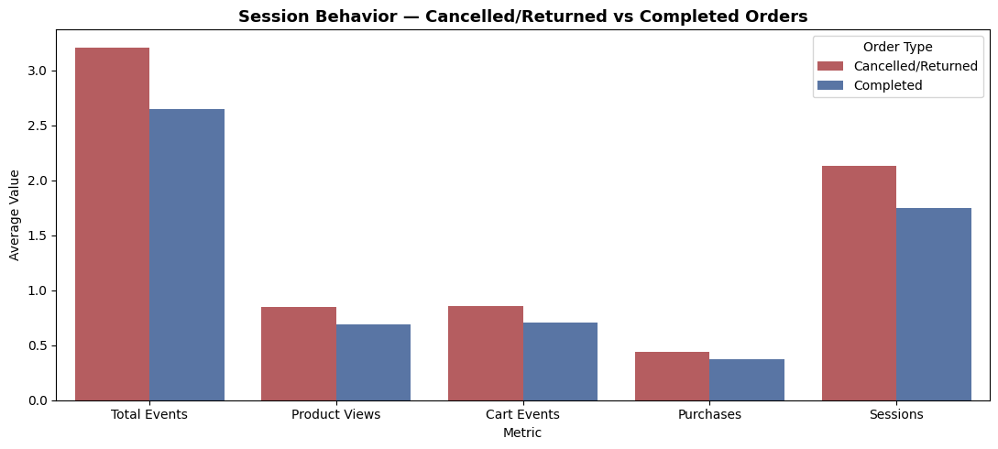

Key Finding: Cart abandonment has caused $756,855 in total revenue loss. Monthly losses have grown 262x from Jan 2019 to Jan 2024, accelerating sharply as platform traffic increased. This is a compounding problem — as traffic grows without improving conversion, revenue loss scales proportionally. Even a 5% improvement in cart-to-purchase conversion would recover over $37,000 annually at current loss rates.

Section 6 — Behavioral Pattern Analysis

Q14. Session Behavior Patterns of Cancelled/Returned vs. Completed Orders
Users were classified by whether they ever had a cancelled or returned order. Session-level behavioral metrics were then compared across groups.

Metric | Cancelled / Returned | Completed | Difference
Avg Total Events | 3.21 | 2.65 | +21.1%
Avg Product Views | 0.85 | 0.69 | +23.2%
Avg Cart Events | 0.86 | 0.71 | +21.1%
Avg Purchases | 0.44 | 0.37 | +18.9%
Avg Sessions | 2.13 | 1.75 | +21.7%



Key Finding: Users who later cancelled or returned orders were consistently more active browsers across every behavioral metric — 21% more events, 23% more product views, 22% more sessions. High browsing activity without clear purchase intent is a leading behavioral signal for future cancellations. Pre-purchase nudges — size guides, reviews, clear return policies — are critical interventions for this segment.

Conclusions & Strategic Recommendations

1. Fix the Checkout Experience — Not the Traffic
Every analytical dimension — traffic source, age group, gender, price range, product category — shows statistically identical abandonment rates. The abandonment problem is not a channel problem, not a demographic problem, and not a product problem. It is a checkout experience problem. The 67.92% cart-to-purchase drop-off demands immediate UX, trust signal, and checkout flow improvements.

2. Prioritize First-Time Visitor Conversion
The 97.20% abandonment rate among first-time visitors versus 87.69% for returning customers reveals a 10-point trust gap. Onboarding incentives, guest checkout options, social proof, and first-purchase discounts could meaningfully move this needle.

3. Address the Asian Market Gap
China alone accounts for 12,112 abandoned sessions — more than any other country. A localized checkout experience including local payment methods (Alipay, WeChat Pay), local language support, and region-specific trust signals is strongly recommended.

4. Refocus Email Campaigns on Conversion
Email drives the highest cart volume (31,225 sessions) but converts at the same low rate as every other channel. Email abandonment recovery sequences — personalized cart reminder emails, limited-time offers — represent the highest-volume recovery opportunity available.

5. Quantify Recovery Value
With monthly revenue losses growing from $220 (Jan 2019) to $57,861 (Jan 2024) and a total loss of $756,855, even a 5% improvement in cart-to-purchase conversion would generate meaningful incremental revenue. Leadership should establish cart conversion as a primary KPI alongside total revenue.

6. Monitor Behavioral Early-Warning Signals
Users who later cancel or return show 21% more browsing activity before purchasing. Behavioral scoring models — flagging high-browse, low-intent sessions — can enable targeted pre-purchase interventions such as live chat prompts, size recommendations, or purchase confidence messaging.

— End of Report —

