Tuberculosis Analysis
Global TB Burden and Treatment Effectiveness Analysis (2013–2024)
Elvis George | Analyst

Problem Statement
Tuberculosis remains a major global health burden, with substantial variation in case notifications and treatment outcomes across countries and regions. However, aggregated reporting and missing outcome data may obscure true demographic and regional disparities. This study investigates the relationship between TB incidence and treatment effectiveness, focusing on regional trends, cohort outcomes, and the extent to which high-burden settings achieve comparable treatment success using WHO global data (2013–2024) taken from the official website of WHO.

Objectives
1) Analyze global and regional distribution in TB incidence from 2013–2024.
2) Evaluate treatment success, failure, death, and loss-to-follow-up rates across countries and WHO regions.
3) Examine the association between TB burden (incidence) and treatment success rates.
4) Assess demographic variation in treatment outcomes by age group and sex, acknowledging aggregated reporting (“a” category).
5) Test whether treatment success rates differ significantly across regions using statistical hypothesis testing.

Data Members
- country : Country name
- iso3 : Three letters country code
- g_whoregion : WHO specified regions
- year : Year
- c_newinc : New incident cases in respective year
- new_ep : New cases having extrapulmonary TB
- newrel_coh : Cohort of new or relapse TB patients
- newrel_succ : Number of patients succesfully treated
- newrel_fail : Number of patients whose treatment failed
- newrel_died : Number of patients who died during treatment
- newrel_lost : Number of lost to follow up patients
- tsr : Treatment success rate
- tfr : Treatment failure rate
- tdr : Treatment death rate
- tlr : Treatment lost rate

Data Members
- age_group : Age Group
- sex : Sex of patient
- coh : Cohort Size(demographic)
- succ : Number of successfull treatments
- fail : Number of failed treatments
- died : Number of deaths
- lost : Number of lost to follow up cases
- category : Category of patient (child/male/female)

Objective: 1
Analyze global and regional distribution in TB incidence

The analysis of global TB incidence from 2013 to 2024 reveals a clear overall increasing trend, indicating a persistent and gradually growing global disease burden. Despite year-to-year fluctuations, the long-term trajectory shows that TB continues to remain a major public health concern worldwide.
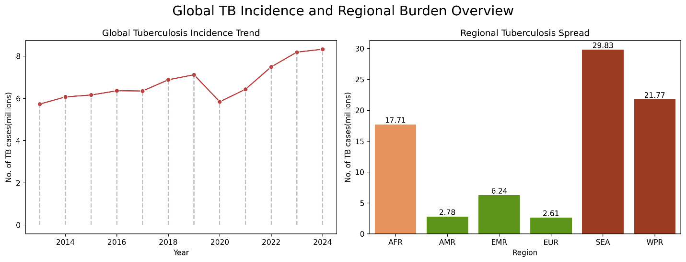
Fig.1.
A noticeable dip in reported incidence is observed around 2020, followed by a sharp rebound in the subsequent years. This temporary decline is unlikely to reflect an actual reduction in TB transmission. Instead, it more plausibly indicates under-reporting and disruptions in surveillance, diagnosis, and case notification systems during the COVID-19 pandemic, which affected healthcare services globally.
Regional analysis highlights significant disparities in the distribution of TB burden. The South-East Asia (SEA) region consistently contributes the highest share of global TB cases, identifying it as the primary high-burden region requiring focused intervention. The Western Pacific (WPR) and African (AFR) regions also exhibit substantial case loads, though comparatively lower than SEA.
In contrast, regions such as Europe (EUR) and the Americas (AMR) report relatively lower TB incidence levels, suggesting better disease control measures, stronger healthcare infrastructure, or lower baseline prevalence in these regions.
Overall, the findings demonstrate that the global TB burden is highly uneven and concentrated in specific geographic regions rather than being uniformly distributed across the world.

Objective: 2
Evaluate treatment outcome rates across regions
and countries

The analysis of treatment outcome indicators across the top 10 high-burden countries reveals that most countries, including Bangladesh, China, Pakistan, and Nigeria, maintain Treatment Success Rates (TSR) of 85% or higher. This indicates relatively strong treatment effectiveness and reflects the presence of structured TB control programs and treatment adherence mechanisms in these settings.
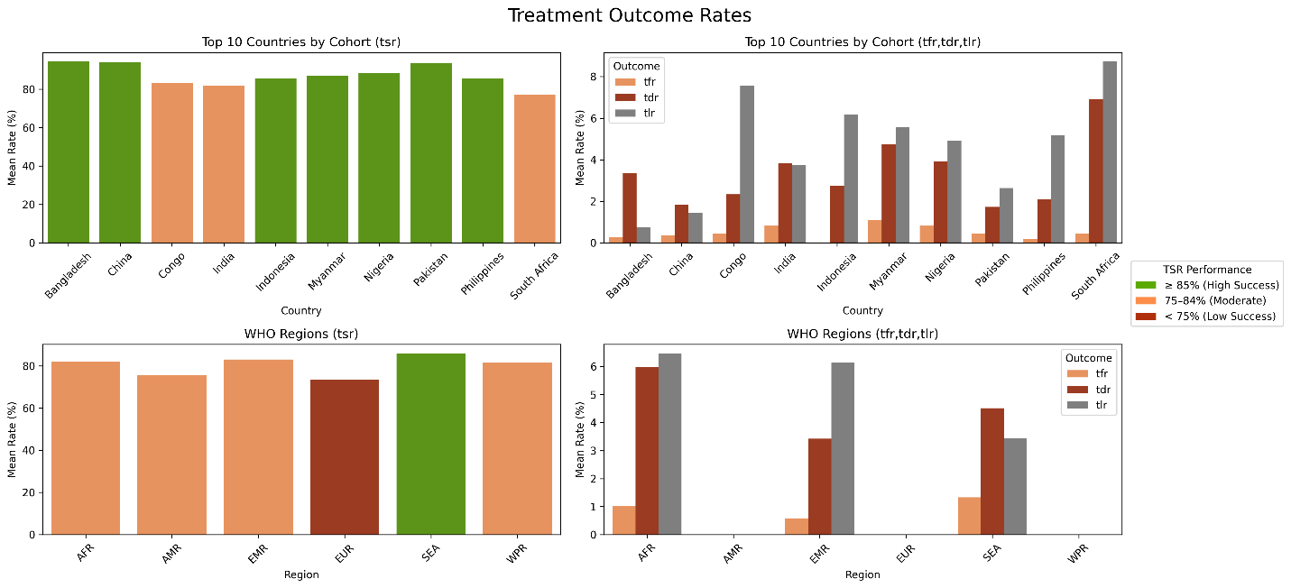
Fig.2.
Countries such as India and Congo fall within the 75–84% TSR range, suggesting moderate performance and highlighting potential gaps in treatment adherence, healthcare accessibility, and follow-up systems. These countries may benefit from strengthened patient monitoring and improved continuity of care to enhance treatment outcomes.
At the regional level, the South-East Asia (SEA) region demonstrates the highest overall TSR, whereas the European (EUR) region records comparatively lower success rates. This contrast underscores notable disparities in TB management efficiency and healthcare system responsiveness across regions.
Across both country-level and regional analyses, Treatment Failure Rate (TFR) and Death Rate (TDR) remain substantially lower than TSR, indicating that standard treatment regimens are largely effective in curing patients when treatment is completed successfully.
However, certain countries such as South Africa and Congo exhibit relatively higher Treatment Loss to Follow-up Rates (TLR), suggesting persistent challenges in patient retention, treatment completion, and long-term engagement with healthcare services.
The African (AFR) region shows comparatively higher TDR than other regions, which may reflect delays in diagnosis, limited treatment access, and the impact of comorbid conditions such as HIV-TB co-infection.
Overall, most WHO regions maintain TSR values above 75%, suggesting that global TB treatment programs are broadly effective, although clear regional inequalities in healthcare infrastructure and service delivery remain evident.
Finally, the presence of null or missing outcome values in some WHO regions indicates incomplete reporting or data gaps. These limitations may introduce minor bias in regional comparisons and therefore the results should be interpreted with appropriate caution.

Objective: 3
Association between TB incidence and TSR
The correlation analysis between TB incidence and Treatment Success Rate (TSR) reveals a very weak positive association (r = 0.1). This value is close to zero, indicating that TB incidence and treatment success are almost unrelated in a linear sense. As incidence increases, TSR does not consistently rise or fall, suggesting the absence of a meaningful linear relationship between disease burden and treatment effectiveness.
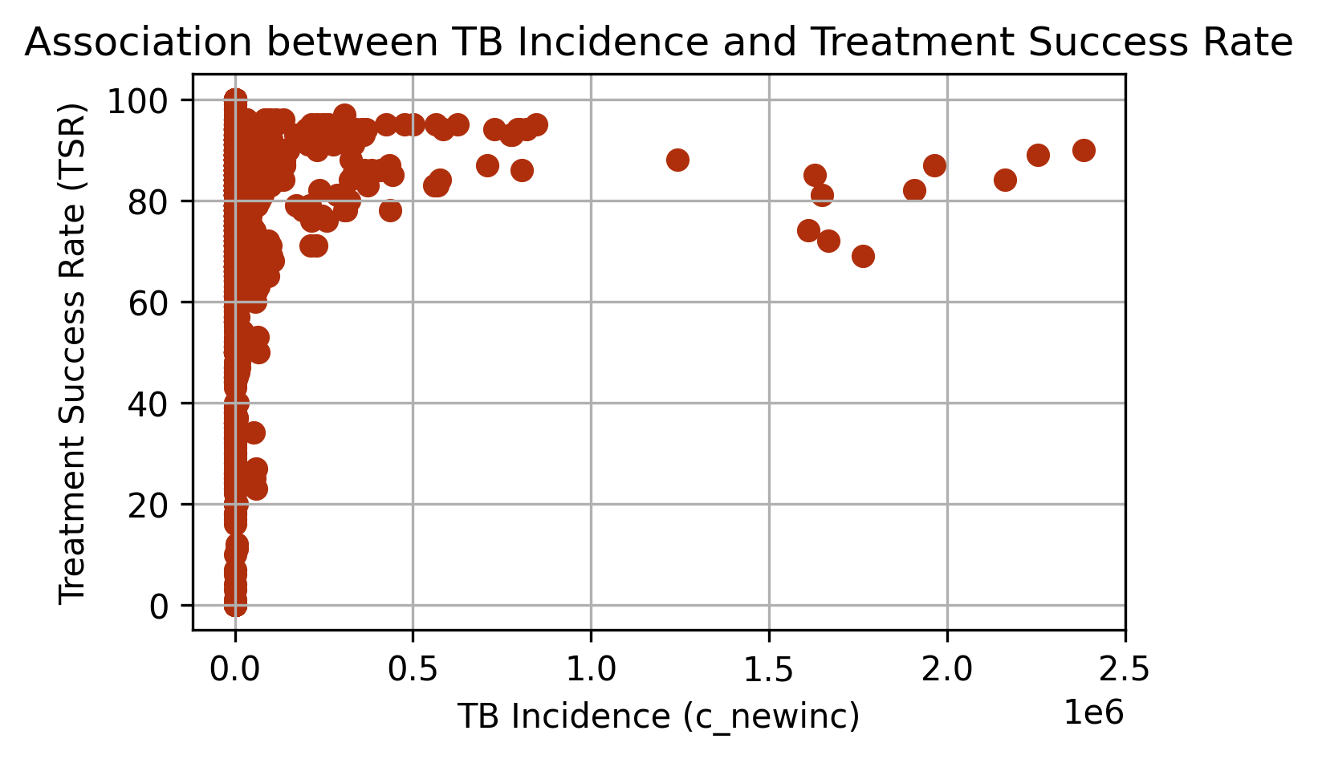
Fig.3.
A large proportion of countries fall within the low-incidence range; however, their TSR values vary significantly from very low to very high levels. This wide variation indicates that having a lower TB burden does not automatically translate into better treatment outcomes. Factors such as healthcare quality, treatment adherence systems, and program implementation appear to play a more decisive role than incidence levels alone.
Interestingly, a few countries with very high TB incidence still maintain TSR levels in the range of 80–90%. This demonstrates that strong and well-structured treatment programs can achieve high success rates even under substantial disease burden. In other words, high incidence does not inherently prevent effective TB control at the treatment level.
Overall, the findings suggest that reducing TB incidence alone will not automatically improve treatment success rates. Targeted interventions are essential, including strengthening diagnostic capacity, improving adherence monitoring, ensuring stable drug supply chains, and enhancing overall healthcare infrastructure. These systemic improvements are necessary to achieve sustained progress in TB treatment outcomes irrespective of baseline incidence levels.

Objective: 4
Assess demographic variation in treatment outcomes
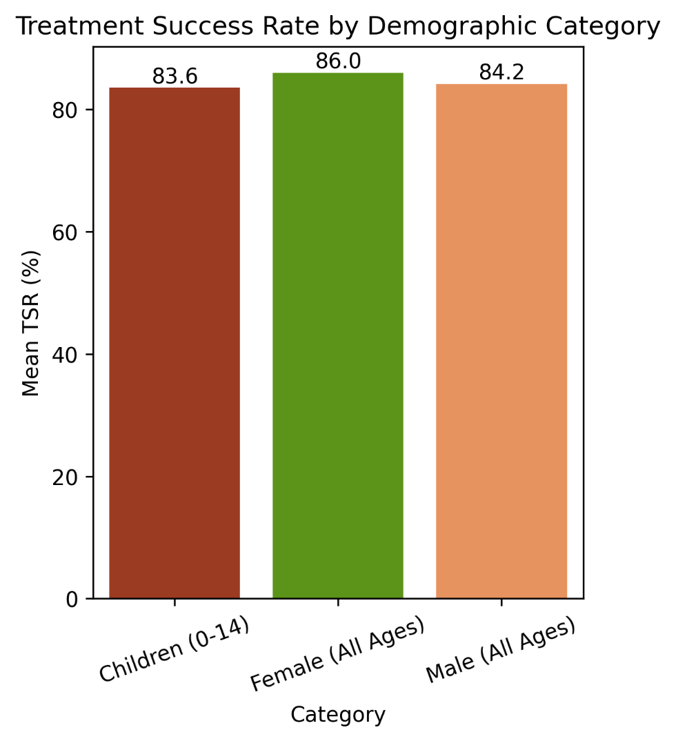
Fig.4.
The demographic analysis of Treatment Success Rate (TSR) across age and sex categories indicates consistently high treatment effectiveness, with TSR values remaining above 80% across all groups. This suggests that TB treatment programs are broadly effective irrespective of demographic classification.
Among the groups analyzed, females (all ages) demonstrate the highest mean TSR, approximately 86%. This may reflect slightly better treatment adherence, stronger healthcare engagement, or more consistent follow-up behavior compared to other demographic categories.
Children aged 0–14 years show a slightly lower TSR (approximately 83.6%) compared to adults. This marginal decline may be associated with challenges specific to pediatric TB, including diagnostic complexity, delayed detection, difficulties in treatment monitoring, and differences in disease manifestation.
Male patients (all ages) exhibit a TSR of approximately 84.2%, which is marginally lower than that observed among females. This difference may suggest gender-related variations in health-seeking behavior, adherence to long-term treatment, or continuity of care.
However, the gap between male and female TSR remains relatively small, indicating that while sex-based disparities in treatment outcomes exist, they are not substantial. The overall variation across demographic groups is modest, reinforcing the conclusion that TB treatment programs are generally effective across population segments.
Nevertheless, targeted improvements in pediatric care and male patient adherence strategies could further enhance treatment outcomes and reduce minor demographic disparities.

Objective: 5
Test whether treatment success rates differ significantly across regions.
- Null hypothesis: Mean treatment success rates are equal across all WHO regions.
- Alternative hypothesis: At least one WHO region has a different mean treatment success rate.

- Statistical test: One-Way Anova.
- Confidence level (α) : 0.05

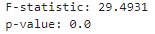
Fig. 5.
The one-way ANOVA results indicate that treatment success rates (TSR) vary significantly across WHO regions. This is supported by a high F-statistic and an extremely low p-value (p < 0.001), demonstrating strong statistical evidence against the assumption of equal mean TSR across regions.
Based on these findings, the null hypothesis that all WHO regions have equal mean treatment success rates is rejected. The alternative hypothesis is therefore supported, confirming the presence of statistically significant regional differences in treatment outcomes.
These regional disparities likely reflect variations in healthcare infrastructure, accessibility of diagnostic and treatment services, program implementation efficiency, patient follow-up systems, and the overall strength of public health frameworks. Differences in comorbidities, socioeconomic conditions, and resource allocation may also contribute to the observed variation.
Overall, the statistical evidence confirms that treatment success is not uniformly distributed across WHO regions, emphasizing the need for region-specific policy interventions and targeted strengthening of TB control programs.

THANKYOU

