**Elvis Chukwuani N.**

**CSC6260 Term Project Part 1**

**Group 4**

**Instructor: Dr. Lee**

**11th November 2023.**

**PART I**

* Team member name(s).
  + **Elvis Chukwuani**
  + Kiana Kiashemshaki
  + Uchechi Nwala

**PART II**

**Detailed explanation of the visualization design.**

For this project, we are going to be implementing the four-level nested visualization design model. This model follows a hierarchical nested structure containing the following levels: domain characterization, data/task abstraction, encoding/interaction design, and algorithm design.

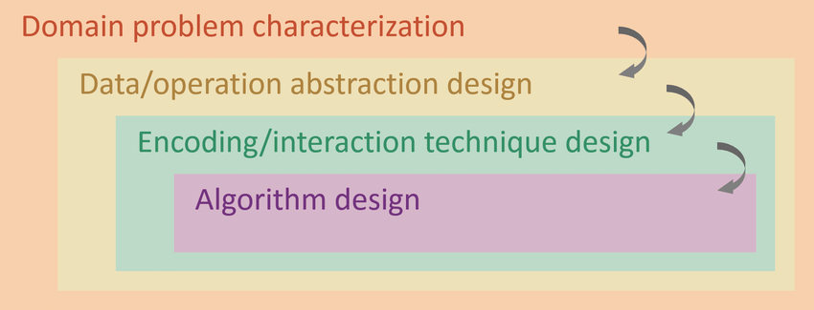

1. **Domain Problem Characterization.**

**Audience Characteristics**

Our visualization tool is going to be used by a top researcher in the geological feed. He is of expert level in his field, and very familiar with research about soil and water analysis. Through interviews, we sought to gain profound insights into their scientific inquiries, preferences, and the intricacies of the data at hand. In addition, we were able to gauge his ability to comprehend complex information.

**Goals and Objectives**

Our visualization tool aims to illustrate the evolving dynamics of compounds present in water and soil across various samples, guiding the researcher through a visual journey of transformation. The focus lies in pinpointing trends within this dataset, unraveling the chronicles of chemical changes over time, and juxtaposing site locations to unveil disparities. It's about deciphering fluctuations in concentrations and quantities, painting a vivid narrative of how these analytes morph across different points, and capturing the essence of temporal evolution within the data.

**Context of use**

The visualization tool will be used on a laptop screen most of the time and will often be displayed on a larger screen for presentation to an audience. This tool will be mostly used in classroom conditions so we will make sure it meets the environmental standards of a school environment.

**Constraints/Limitations**

Small dataset we might not get elaborate information.

Many irregularities in the dataset, like missing values and blank spaces. We will have to come up with processes to handle that.

**Accessibilities**

We will ensure our tool adheres to the WCAG 2.0 AA standard enacted on December 11, 2018. To ensure that the tool is accessible to individuals using screen readers and other assistive technology.

1. **Data/Task Abstraction.**

**Data Abstraction**

Following the interview, we had with the researcher we got to know how their experiment was carried out and how their data was collected. The data given to us was an Excel sheet with two tabs one for soil and the other for water. This data had about three hundred rows and fifteen columns, the data was quantitative, spatial, and temporal. In terms of granularity, each record represents a single sample.

**Task Abstraction**

The researcher is going to be **comparing** changes in wetland values over time.

He will also be **analyzing** their impact on the transfer of phosphorus and nitrogen within the ecosystem.

To streamline the process, **filtering** access to relevant information and sorting data systematically are crucial steps.

The researcher aims to uncover **patterns** and **correlations**, providing insights into the ecological quality of the wetlands.

**Mapping Data to Tasks**

At this stage, we are going to be designing the way we want to structure our data so it can meet our needs. The original format of the data is an Excel file we are going to be converting this to both CSV and JSON formats which is a much easier structure to use in the D3 library.

**Data Preparation**

Here we are going to ignore the blank values and apply statistical approaches to find outliers.

1. **Encoding/Interaction Technique Design.**

**Visual Encoding**

* We chose to use a map to show the 43 wetland pools and their mean attributes.

* Implement static and dynamic line graphs.

* Also include bar charts, pie charts, and contour maps.

**Interaction Encoding**

* Zoom in/out.
* Checkbox.
* Slider.
* Buttons.
* Tooltip.

**Performance and Scalability**

Our tool is going to efficiently handle vast amounts of data without performance delays. Also going to have a responsive design to adjust different screen sizes and devices.

**Annotation and Contextualization**

Our tool is going to contain an overview pane on the home page, this pane will have a text guide and direction for the researcher to understand how our tool works.

**Aesthetic Consideration**

Our tool will contain appealing colour schemes.

1. **Algorithm Design.**

At this level, we designed the process that drove our visualization tool. For this project, we made use of the D3 JavaScript library to develop our tool. The algorithm was about developing functions and assigning function calls. We have functions to implement graph algorithms and determine and visualize relationships between events. Also, there are interactivity functions to allow zooming, panning, displaying event information when icons are clicked, matching user-input keywords with data, and dynamically filtering relevant content. In addition, there will be loading functions to set up a data storage system, which may involve databases or data structures, to efficiently store and retrieve historical data.

**PART III**

* How each team member, including yourself, contributed to the teamwork.

1. **Communication:**

We communicated using Teams chat and had two Teams call. We also had a couple of in-person meetings.

1. **Team Member Contribution:**

* **Elvis Chukwuani:** I worked on the Domain Characterization and Data/Task Abstraction level.
* Kiana Kiashemshaki: She worked on the Encoding/Interaction level.
* Uchechi Nwala: She worked Algorithm level.