Transpiration response to vapor pressure deficit associated with genotypic plasticity in soybean water use efficiency

Introduction

Material and Methods

Results
- Of the 6 genotypes exhibiting a breaking point in transpiration response, 4 were previously classified with an expected plasticity in water use efficiency (Chamarthi et al.)

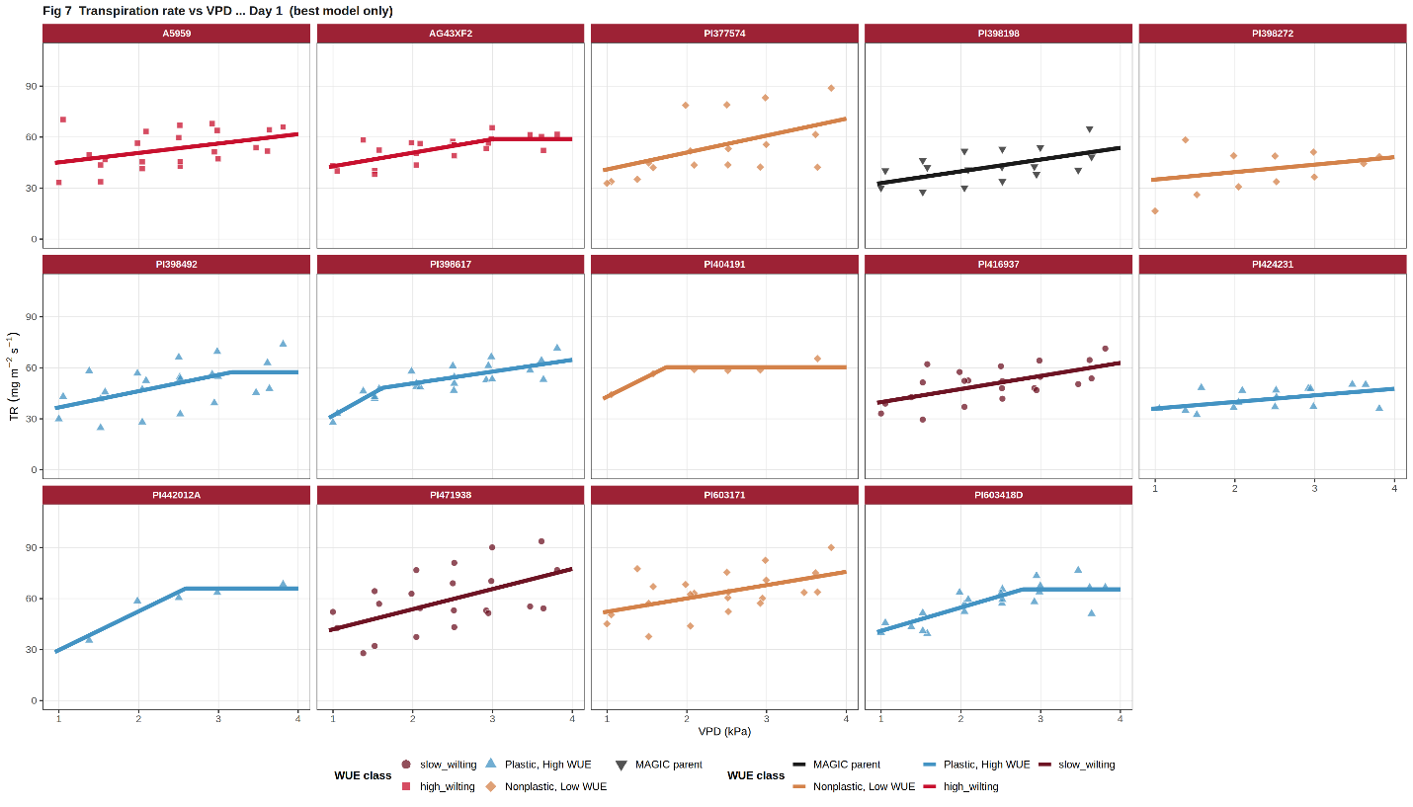
Figure 1. Transpiration response to vapor pressure deficit of multiple soybean genotypes with expected differences in water use efficiency plasticity.
• 8 genotypes were best described by a linear model, 5 by a linear-plateau model, and 1 by a bilinear model, indicating diverse VPD response strategies across the 14 accessions.
• Initial slopes ranged from 3.9 to 26.2 mg/m2/s per kPa and intercepts from 5.7 to 44.5 mg/m2/s, reflecting large genotypic variation in both baseline transpiration rate and VPD sensitivity.
• Plastic, High WUE genotypes did not uniformly show lower transpiration: PI398617 combined the highest slope (26.2 mg/m2/s per kPa) with the lowest intercept (5.7 mg/m2/s) among all genotypes, a pattern of near-zero baseline transpiration with high VPD sensitivity.

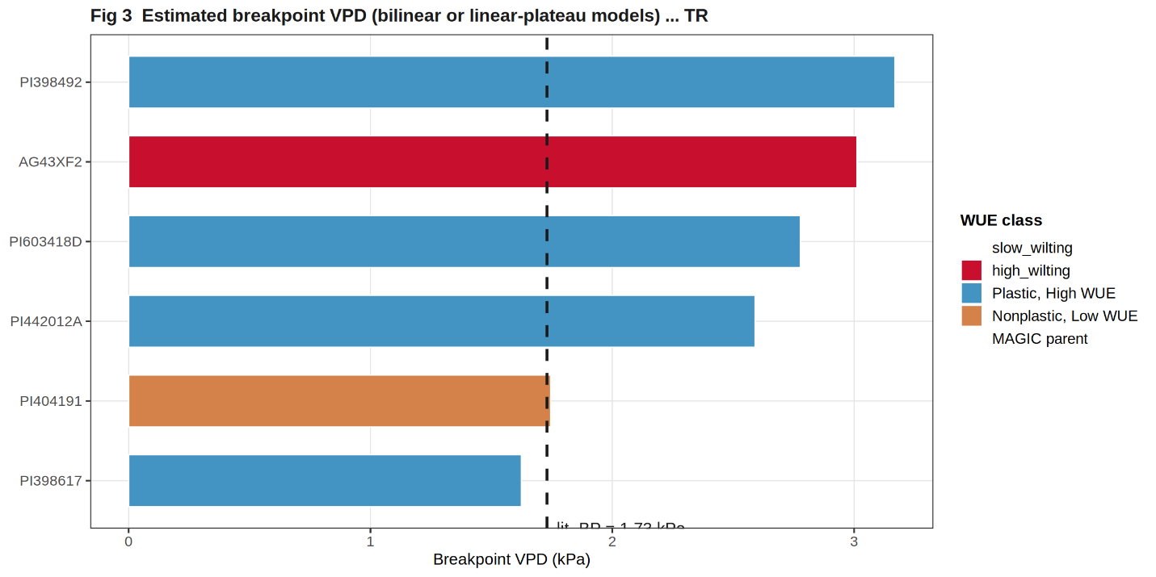
Figure 3. Genotypic variability in the breaking points from the transpiration response to vapour pressure deficit.
• 6 of 14 genotypes (43%) showed a non-linear transpiration response, with VPD breakpoints ranging from 1.62 to 3.17 kPa (mean 2.49 kPa).
• 4 of the 6 genotypes with a breakpoint were previously classified as Plastic, High WUE (Chamarthi et al. 2022), consistent with the expected limited-transpiration phenotype.
• The two earliest breakpoints (1.62 and 1.75 kPa in PI398617 and PI404191) indicate that stomatal restriction can occur before VPD reaches typical midday field values (~2.0-2.5 kPa), potentially conserving water during morning hours.

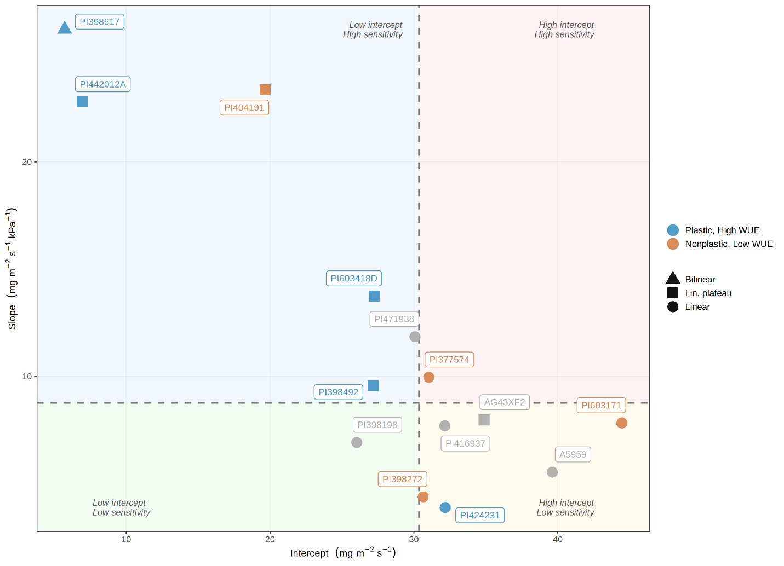
Figure 3. Genotype classification based on the slope (transpiration sensitivity to VPD ) and intercept (transpiration rate at low VPD) obtained from the fitted models (Figure 1).
• 4 of 5 Plastic, High WUE genotypes clustered in the Low intercept - High sensitivity quadrant, consistent with lower baseline transpiration and stronger stomatal responsiveness at elevated VPD.
• Nonplastic, Low WUE genotypes were distributed across 3 quadrants, indicating within-class heterogeneity not captured by the Chamarthi et al. plasticity classification alone.
• PI398617 and PI442012A (both Plastic, High WUE) occupied the most extreme position with intercepts below 7 mg/m2/s and initial slopes above 22 mg/m2/s/kPa, making them the strongest candidates for limited-transpiration trait characterization.

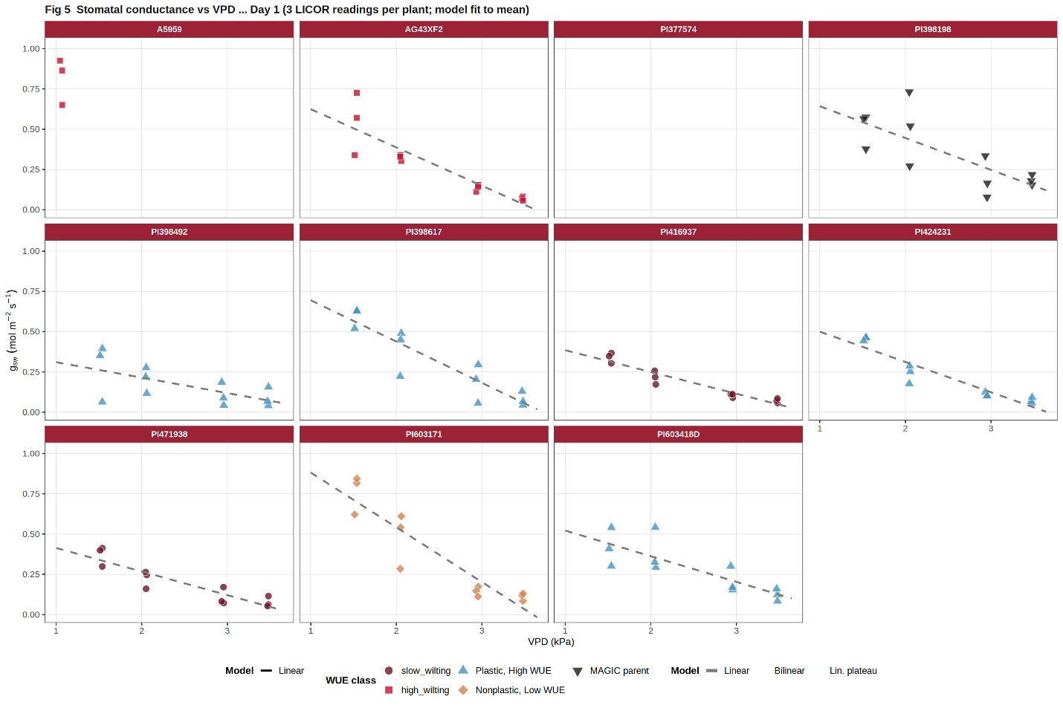
Figure 4. Stomatal conductance response to vapor pressure deficit in a subset of soybean genotypes with expected differences in water-use efficiency plasticity.
• All 9 measured genotypes showed negative stomatal conductance slopes (range: -0.34 to -0.10 mol/m2/s/kPa), confirming universal stomatal closure in response to increasing vapor pressure demand.
• Slow wilting genotypes (PI416937 and PI471938) had intermediate slopes (-0.135 and -0.146 mol/m2/s/kPa) and lower intercepts, consistent with the expected limited-transpiration response.
• PI603171 (Nonplastic, Low WUE) had the steepest negative slope (-0.34 mol/m2/s/kPa) and highest intercept (1.22 mol/m2/s), indicating paradoxically high baseline conductance relative to its non-plastic classification.

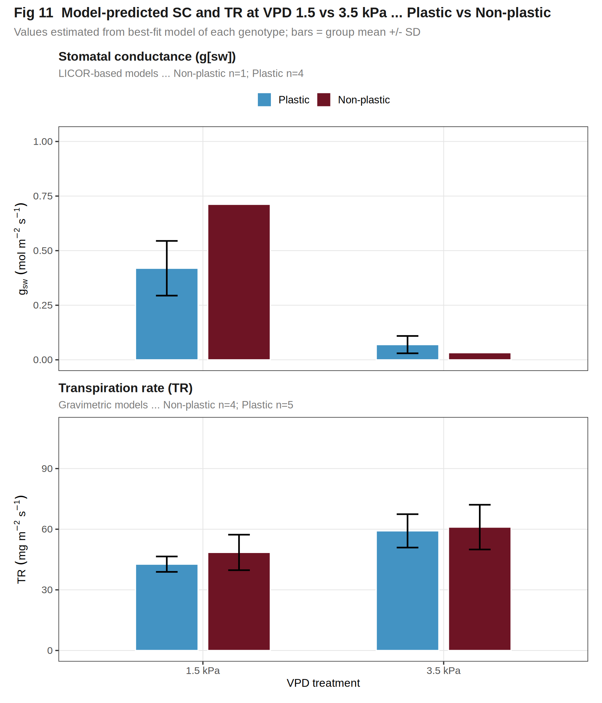
Figure 5. Predicted stomatal conductance and transpiration rate at VPD 1.5 kPa and VPD 3.5 kPa for a Plastic (blue) and Non-plastic (dark red) genotype. Values are extracted from each genotype’s best-fit model at the two VPD targets.
• 6 genotypes with plateau or bilinear models showed attenuated or no increase in transpiration above their breakpoint VPD, while the 8 linear-model genotypes continued to increase through 3.5 kPa, demonstrating the functional consequence of the VPD threshold response.
• Stomatal conductance declined consistently from VPD 1.5 to 3.5 kPa across all 9 measured genotypes (range: -95 to -72%), with the magnitude of decline reflecting differences in stomatal sensitivity rather than a uniform, species-level response.
• The divergence between TR and gsw patterns at 3.5 kPa - rising TR despite declining gsw in several genotypes - suggests that transpiration under high atmospheric demand is increasingly driven by boundary layer conductance and vapor pressure gradient rather than stomatal aperture alone.

Discussion

