Research Incentive Grant (RIG) – 2024-2025 Interim Report
Date of Report: March 1st, 2025

Title: Investigating transpiration responses of soybean genotypes to vapour pressure deficit for enhanced water use efficiency and drought tolerance
Lead Investigator: Elvis Elli
Co-Investigators: Samuel Fernandes, Caio Canella Vieira
Status: Year 1 of 2
Objective: Quantify the transpiration response of diverse soybean accessions in terms of water use efficiency plasticity to increased vapor pressure deficit levels.

Progress/Accomplishments: March 1st, 2025
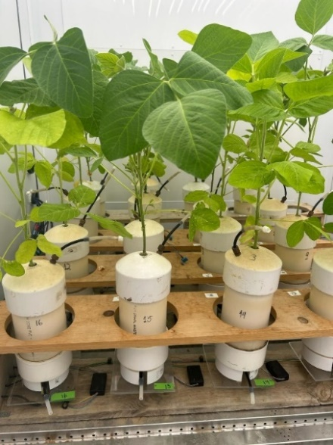
In 2024, we collected transpiration data in response to VPD levels from 4 maturity group IV soybean accessions with associated differences in the environmental plasticity of carbon 13 ratio, a surrogate measure for water use efficiency (WUE, Chamarthi et al., 2023). We grew six genotypes in pots sealed at the top with end caps, in a controlled-environment chamber. At stage R1, six different levels of VPD (~1, 1.5, 1.9, 2.4, 2.8 and 3.3 kPa) were applied. Each pot was placed above an individual scale that measured and recorded transpiration rates every 2 minutes (Figure 1). After transpiration measurements, the plant leaf area was determined destructively by passing the leaves through a Licor LI-3000C leaf area meter. Transpiration rates for each genotype were regressed against VPD levels, and best-fit models were selected based on the highest R² (Figure 2). Preliminary findings from this project were included in a USDA NIFA proposal titled Designing agronomic and genetic strategies to maximize soybean systems’ performance under climate change, which is currently under review.
Figure 1. Soybean plants grown on portable balances to monitor real-time transpiration rates.
Key preliminary findings included the following:
- Some genotypes demonstrated the characteristic of stabilizing the transpiration rates as VPD levels increased, while other genotypes kept their transpiration rates increasing as VPD increased (Figure 2).
- Of the 6 genotypes, 4 showed a linear response in transpiration to VPD, 1 showed a Bi-Linear response with a breaking point of 1.69 kPa, and 1 showed a Linear-Plateau response with a breaking point of 2.57 kPa (Table 1).
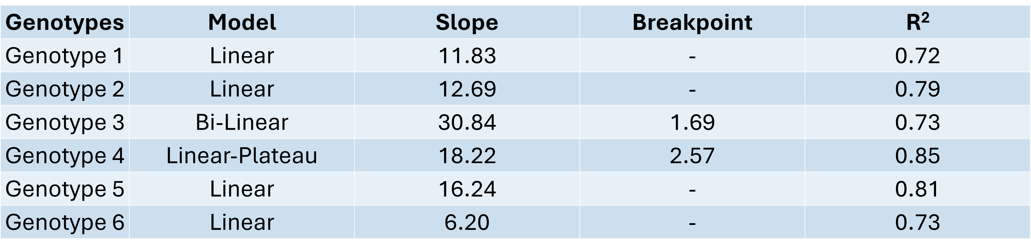
Table 1. Model, slope, breakpoint, and R² were obtained for each genotype in response to different levels of VPD.
The observed variability in transpiration response to VPD provides promising opportunities for identifying accessions with enhanced water use efficiency. Interestingly, the limited transpiration trait was not identified for all genotypes with expected WUE plasticity, suggesting that other mechanisms control WUE for certain genotypes. Expanding the number of soybean accessions will be key to confirming our initial findings. Moreover, we learned that an additional “high” VPD treatment (>3.4 Kpa) is needed as some genotypes started to alter their transpiration patterns at very high VPD levels (data not shown).
Figure 2. Transpiration responses of two contrasting soybean accessions (PI507408 and PI603457A) to vapor pressure deficit (VPD).

Upcoming Actions/Activities:
- Expanding the number of soybean accessions to confirm our initial findings.
- Identify the association between the results obtained in controlled-environment chambers and field results like seed yields and in-season variation of leaf stomatal conductance.
- Combine our findings with process-based modeling to identify geographical areas in the US Mid-South in which soybean production could benefit from expressing the limited-transpiration trait.

