Supplementary Material

EARLIER PLANTING AND LATE MATURING SOYBEANS OFFSET HIGH TEMPERATURE STRESS
Elvis F. Elli^{1*}, Caio dos Santos², Samuel B. Fernandes¹, Montserrat Salmeron³, Rafael Battisti⁴, Rogério de S. Nóia-Júnior⁵
¹ Department of Crop, Soil, and Environmental Sciences, University of Arkansas, Fayetteville, Arkansas, USA
² Department of Agronomy, Iowa State University, Ames, Iowa, USA
³ Department of Plant and Soil Sciences, University of Kentucky, Lexington, Kentucky, USA
⁴ Escola de Agronomia, Universidade Federal de Goiás, Goiânia, Brazil
⁵ LEPSE, Univ Montpellier, INRAE, Institut Agro Montpellier, Montpellier, France

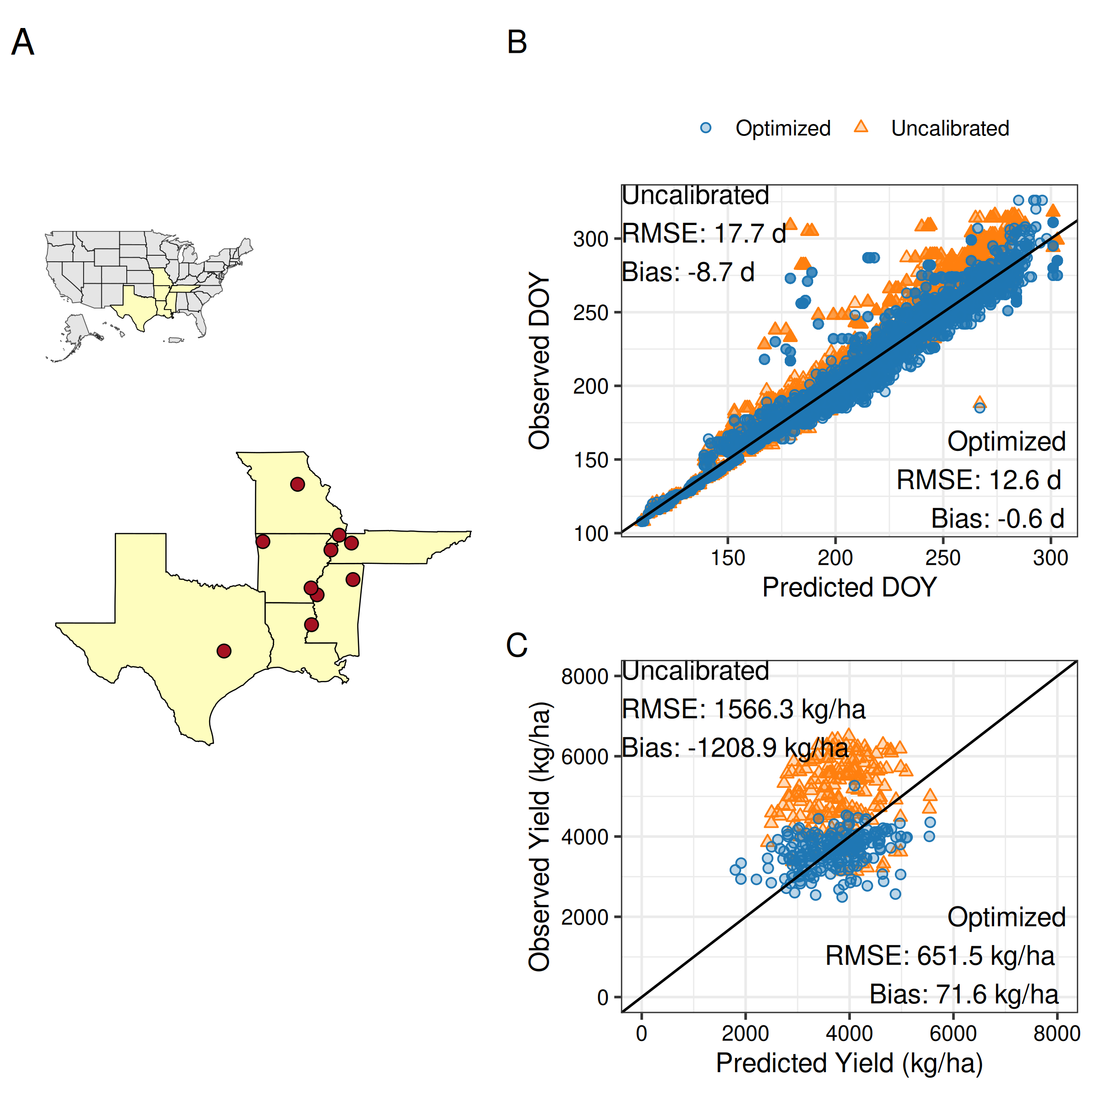
Figure S1. Locations of multi-environment trials used to collect phenology and yield data for soybean maturity groups 4 to 5 (A). Relationship between APSIM-simulated and observed day of year (DOY) for key phenological stages: emergence, beginning of flowering, beginning of pod development, beginning of seed filling, and physiological maturity (B). Relationship between APSIM-simulated and observed soybean yield at 13% grain moisture (C).

Model calibration
The occurrence of phenological stages, converted to days of the year (DOY), was used to derive the cultivar-specific model parameters (Table S1) using an iterative optimization procedure based on the Nelder–Mead algorithm (Nelder and Mead, 1965). This algorithm explores the parameter space iteratively using a geometric figure called simplex. The optimization procedure aims to minimize the residual sums of squares (Wallach et al., 2001) between the estimated and actual timing to reach the studied phenology stages for each maturity group (early 4, late 4, early 5, late 5). We ran the algorithm using R software (R Development Core Team, 2021) and the APSIMX package (Miguez, 2020). Our focus was on optimizing phenology parameters, while keeping cardinal temperature-related parameters constant, giving little evidence of changes across genotypes (Archontoulis et al., 2014). Two growth parameters were selected: area of the largest leaf and radiation use efficiency. The optimization workflow followed an approach similar to that outlined in Wallach et al. (2019), in which all parameters were optimized simultaneously to potentially capture parameter interactions.

Table S1. Maturity group (MG) – specific default and optimized APSIM parameter values targeted in the optimization of early and late maturity groups 4 and 5 cultivars.
APSIM Parameter | Units | Early MG 4 | Early MG 5
Vegetative Target | °C-day | 484 | 634
Early Flowering Target | °C-day | 185 | 189
Early Grain Filling Target | Fraction (0-1) | 0.338 | 0.042
Late Grain Filling Target | °C-day | 384 | 418
Area of Largest Leaf | m² | 0.004 | 0.004
Radiation Use Efficiency | g MJ⁻¹ | 1.48 | 1.05

Figure S2. APSIM-simulated (lines) and measured (points) leaf biomass (green colour), seed biomass (black colour), and total biomass (yellow colour) in Fayetteville, Northwest Arkansas, for 2 different maturity groups (early 4 and early 5). Measured data were obtained from an experiment conducted in 2008 under irrigated conditions in a randomized complete block design with 4 replications. Further information on field data collection can be found in (Mastrodomenico and Purcell, 2012). Vertical lines represent the standard deviations. RMSEs for seed yield, leaf biomass, and total biomass were 659 kg/ha, 572 kg/ha, and 1335 kg/ha, respectively.

Study location and weather
The studied region is predominantly irrigated, with accumulated rainfall of 590 mm, unevenly distributed over the growing season (May to October). The average growing season temperature is 24°C, with values ranging from 20.9 to 27.1°C across all site-years (Figure S1). The studied area exhibits significant variability in soil conditions, ranging from shallow (less than 50 cm in depth) sandy soils with low soil water-holding capacity (0.4 mm cm⁻¹) to deeper soils with an effective root depth greater than 100 cm and high soil water-holding capacity (2 mm cm⁻¹). The soil organic carbon (0-30 cm) typically ranges from 0.5 to 3%.

Figure S3. Environmental characterization of baseline conditions across all studied site-years (A) and number of calendar days to flower under baseline and the 2°C temperature increase scenario (B). Panel A contains the APSIM phenology response curve (0-1), where 1 represents maximum development rate. The solid vertical and horizontal lines indicate the median growing-season average temperature and total growing-season precipitation, respectively.

Figure S4. Density distribution in simulated soybean yields under baseline, climate change with and without CO₂ fertilization (A), and geographical distribution in soybean yields over the simulated study area under baseline, climate change (CC) with and without CO₂ fertilization (B).

Figure S5. Geographical distribution of the relative effects of rising temperatures on soybean seed yield and adaptive agronomic management strategies. Values per pixel in panel B are averages across 40 weather years. LM & ES represent the combined effect of a late-maturing variety and early sowing.

References
Archontoulis, S. V., Miguez, F.E., Moore, K.J., 2014. A methodology and an optimization tool to calibrate phenology of short-day species included in the APSIM PLANT model: Application to soybean. Environmental Modelling & Software 62, 465–477. https://doi.org/10.1016/J.ENVSOFT.2014.04.009
Mastrodomenico, A.T., Purcell, L.C., 2012. Soybean Nitrogen Fixation and Nitrogen Remobilization during Reproductive Development. Crop Sci. 52, 1281–1289. https://doi.org/10.2135/CROPSCI2011.08.0414
Miguez, F., 2020. apsimx: Inspect, read, edit and run ‘“APSIM”’ ‘next generation’ and ‘“APSIM”’ classic. 2020, http://dx.doi.org/10.32614/cran.package.apsimx, CRAN: Contributed Packages, The R Foundation.
NASS, 2023. Surveys. National Agricultural Statistics Service, USDA. URL: https://www.nass.usda.gov/Surveys. Accessed November 2, 2023.
Nelder, J.A., Mead, R., 1965. A Simplex Method for Function Minimization. Comput. J. 8, 308–313. https://doi.org/10.1093/comjnl/8.1.27
R Development Core Team, 2021. R: a language and environment for statistical computing. R Foundation for Statistical Computing, Vienna, Austria. URL: http://www.R-project.org.
Salmerón, M., Gbur, E.E., Bourland, F.M., Buehring, N.W., Earnest, L., Fritschi, F.B., Golden, B.R., Hathcoat, D., Lofton, J., McClure, A.T., Miller, T.D., Neely, C., Shannon, G., Udeigwe, T.K., Verbree, D.A., Vories, E.D., Wiebold, W.J., Purcell, L.C., 2016. Yield Response to Planting Date Among Soybean Maturity Groups for Irrigated Production in the US Midsouth. Crop Sci. 56, 747–759. https://doi.org/10.2135/CROPSCI2015.07.0466
Wallach, D., Goffinet, B., Bergez, J.E., Debaeke, P., Leenhardt, D., Aubertot, J.N., 2001. Parameter estimation for crop models: A new approach and application to a corn model. Agron. J. 93, 757–766. https://doi.org/10.2134/agronj2001.934757x
Wallach, D., Makowski, D., Jones, J.W., Brun, F., 2019. Working with Dynamic Crop Models: Methods, Tools and Examples for Agriculture and Environment Third Edition, 3rd edition. ed. Elsevier Academic Press. https://doi.org/10.1016/B978-0-12-811756-9.09996-2

