Supplementary Material

Synergistic maturity group and planting date ADAPTATION sustains soybean yields under warming
Elvis F. Elli^{1*}, Caio dos Santos², Samuel B. Fernandes¹, Montserrat Salmeron³, Rafael Battisti⁴, Rogério de S. Nóia-Júnior⁵
¹ Department of Crop, Soil, and Environmental Sciences, University of Arkansas Division of Agriculture, Fayetteville, Arkansas, USA
² Department of Agronomy, Iowa State University, Ames, Iowa, USA
³ Department of Plant and Soil Sciences, University of Kentucky, Lexington, Kentucky, USA
⁴ Escola de Agronomia, Universidade Federal de Goiás, Goiânia, Brazil
⁵ LEPSE, Univ Montpellier, INRAE, Institut Agro Montpellier, Montpellier, France

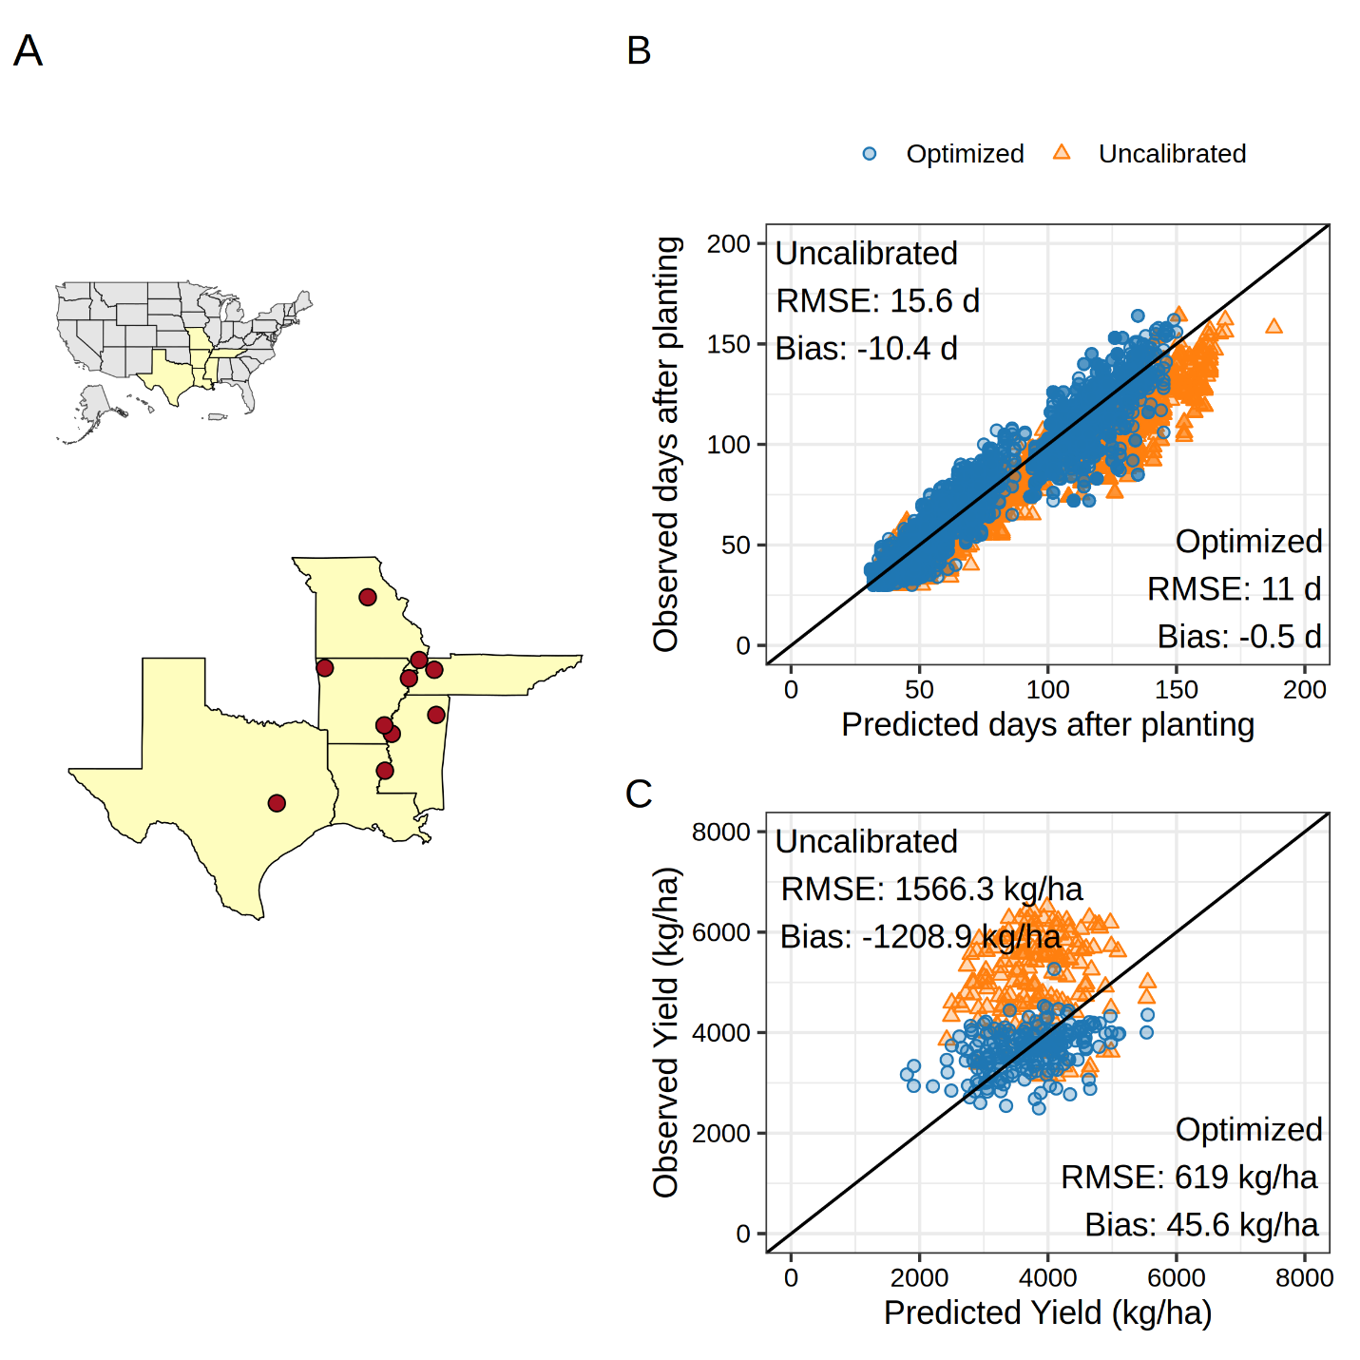
Figure S1. Locations of multi-environment trials used to collect phenology and yield data for soybean maturity groups 4 to 5 (A). Relationship between APSIM-simulated and observed days after sowing for key phenological stages: emergence, beginning of flowering, beginning of pod development, beginning of seed filling, and physiological maturity (B). Relationship between APSIM-simulated and observed soybean yield at 13% grain moisture (C).

Model calibration
The occurrence of phenological stages, converted to days after sowing, was used to derive the cultivar-specific model parameters (Table S1) using an iterative optimization procedure based on the Nelder–Mead algorithm (Nelder and Mead, 1965). This algorithm explores the parameter space iteratively using a geometric figure called simplex. The optimization procedure aims to minimize the residual sums of squares (Wallach et al., 2001) between the estimated and actual timing to reach the studied phenology stages for each maturity group (early 4 and early 5). We ran the algorithm using R software (R Development Core Team, 2021) and the APSIMX package (Miguez, 2020). Our focus was on optimizing phenology parameters while keeping cardinal temperature-related parameters constant, giving little evidence of changes across genotypes (Archontoulis et al., 2014). Two growth parameters were selected: area of the largest leaf and radiation use efficiency. The optimization workflow followed an approach similar to that outlined in Wallach et al. (2019), in which all parameters were optimized simultaneously to potentially capture parameter interactions.

Table S1. Maturity group (MG) – specific default and optimized APSIM parameter values targeted in the optimization of early and late maturity groups 4 and 5 cultivars.
APSIM Parameter | Units | Early MG 4 | Early MG 5
Vegetative Target | °C-day | 484 | 634
Early Flowering Target | °C-day | 185 | 189
Early Grain Filling Target | Fraction (0-1) | 0.338 | 0.042
Late Grain Filling Target | °C-day | 384 | 418
Reproductive Photoperiod Modifier | Fraction (0-1) | 11.48, 17.24 | 12.70, 14.31
Area of Largest Leaf | m² | 0.004 | 0.004
Radiation Use Efficiency | g MJ⁻¹ | 1.48 | 1.05

Figure S2. APSIM-simulated (lines) and measured (points) leaf biomass (green colour), seed biomass (black colour), and total biomass (yellow colour) in Fayetteville, Northwest Arkansas, for 2 different maturity groups (early 4 and early 5). Measured data were obtained from an experiment conducted in 2008 under irrigated conditions in a randomized complete block design with 4 replications. Further information on field data collection can be found in (Mastrodomenico and Purcell, 2012). Vertical lines represent the standard deviations. RMSEs for seed yield, leaf biomass, and total biomass were 659 kg/ha, 572 kg/ha, and 1335 kg/ha, respectively.

Study location and weather
The studied region is predominantly irrigated, with accumulated rainfall of 590 mm, unevenly distributed over the growing season (May to October). The average growing season temperature is 24°C, with values ranging from 20.9 to 27.1°C across all site-years (Figure S1). The studied area exhibits significant variability in soil conditions, ranging from shallow (less than 50 cm in depth) sandy soils with low soil water-holding capacity (0.4 mm cm⁻¹) to deeper soils with an effective root depth greater than 100 cm and high soil water-holding capacity (2 mm cm⁻¹). The soil organic carbon (0-30 cm) typically ranges from 0.5 to 3%.

Figure S3. Environmental characterization of baseline conditions across all studied site-years. The APSIM phenology response curve (0-1) is presented, where 1 represents maximum development rate. The solid vertical and horizontal lines indicate the median growing-season average temperature and total growing-season precipitation, respectively.

Figure S4. USDA-NASS soybean sowing progress in Arkansas progress from 1990 to 2025. Grey lines represent the historical years, while the green, thicker line indicates the average sowing progress. 50% and 10% average sowing progress are indicated in the figure.

Figure S5. Density distribution of simulated soybean yields without adaptation under the baseline and +2°C scenarios with and without elevated [CO2] (A), and its geographical distribution (B).

References
Archontoulis, S. V., Miguez, F.E., Moore, K.J., 2014. A methodology and an optimization tool to calibrate phenology of short-day species included in the APSIM PLANT model: Application to soybean. Environmental Modelling & Software 62, 465–477. https://doi.org/10.1016/J.ENVSOFT.2014.04.009
Mastrodomenico, A.T., Purcell, L.C., 2012. Soybean Nitrogen Fixation and Nitrogen Remobilization during Reproductive Development. Crop Sci. 52, 1281–1289. https://doi.org/10.2135/CROPSCI2011.08.0414
Miguez, F., 2020. apsimx: Inspect, read, edit and run ‘“APSIM”’ ‘next generation’ and ‘“APSIM”’ classic. 2020, http://dx.doi.org/10.32614/cran.package.apsimx, CRAN: Contributed Packages, The R Foundation.
Nelder, J.A., Mead, R., 1965. A Simplex Method for Function Minimization. Comput. J. 8, 308–313. https://doi.org/10.1093/comjnl/8.1.27
R Development Core Team, 2021. R: a language and environment for statistical computing. R Foundation for Statistical Computing, Vienna, Austria. URL: http://www.R-project.org.
Wallach, D., Goffinet, B., Bergez, J.E., Debaeke, P., Leenhardt, D., Aubertot, J.N., 2001. Parameter estimation for crop models: A new approach and application to a corn model. Agron. J. 93, 757–766. https://doi.org/10.2134/agronj2001.934757x
Wallach, D., Makowski, D., Jones, J.W., Brun, F., 2019. Working with Dynamic Crop Models: Methods, Tools and Examples for Agriculture and Environment Third Edition, 3rd edition. ed. Elsevier Academic Press. https://doi.org/10.1016/B978-0-12-811756-9.09996-2

