Response to the reviewer and editor comments

We want to thank the reviewers and editor for all the suggestions. All the comments have been carefully analyzed and answered one by one below (our responses are in blue).

Associate Editor's Comments to Author:
One of the reviewers noted that "This revised version is considerably better than the previous one" while another reviewer noted that "the paper is short with minimal content... perhaps work to expand the message to increase the novelty of the paper". It seems the authors have considerably improved the manuscript but the short word limit of this journal may prevent expansion. The reviewers did provide a few comments that could further improve the manuscript. As a last note, both reviewers provided a comment such as "the authors did not provide a point-by-point response to the reviewers' comments, which should have been included" (either in comments to author or comments to editor). While a response to reviewers was provided, it may have been difficult to find given both reviewers mentioned this. Overall, I recommend revisions considering the reviewer comments.
Response: We appreciate the Editor’s feedback. We have addressed all the reviewer comments one by one (please see below).

Reviewer 1:

Comment #1
This appears to be a resubmission after the manuscript was originally rejected earlier this year. Overall, my opinion has not changed substantially from my previous reading. The authors have conducted a simulation study to evaluate impacts of earlier planting and variety selection for soybean in the Mid-South to offset heat and drought stress. The paper is short with minimal content. Similar results and conclusions have been found in other literature, so the novelty and impact of the paper is minimal. Authors could perhaps work to expand the message to increase the novelty of the paper. There is plenty of room for expansion to a fuller, more comprehensive research paper.
Response: Thank you for the feedback. While a response to the reviewers was provided addressing this comment in the previous review, it seems the reviewers were unable to find the review letter. Apologies for the inconvenience. As stated in the previous review letter, we believe our contribution is original for the following reasons:

- To our knowledge, this is the first study to quantify the synergistic impact of maturity group and sowing date under possible warming scenarios.

- Our study is unique in terms of resolution of simulations, quantifying impacts across over 4,000 fields and 40 weather years per field.

- We advanced previous simulation studies by exploring stacked management options under warming.

- We have tested and applied the newest APSIM framework (APSIM Next Generation), which advances previous APSIM classic work.

All these points have been clarified and incorporated into the previous review. Lastly, while the reviewer states that there is room for expansion, we have focused on the most important study messages within the recommended word limit (2,500 words) as per the journal guidelines.

Comment #2
L34 – limit
Response: Addressed.
Comment #3
L37 – Subscript the ‘2’
Response: Addressed.

Comment #4
L47 - Minimize use of first person pronouns here and throughout.
Response: Addressed. The use of first-person pronouns was considerably reduced throughout the whole manuscript.

Comment #5
L62 – model was previously successful
Response: Addressed.

Comment #6
L81 – Define [CO2] on first use.
Response: Addressed.
Comment #7
L95 – Does this mean 2°C was added to max and min T weather station data on a daily basis?
Response: Addressed. The new sentence reads:

“For the high-temperature scenario, 2°C was added to the daily maximum and minimum temperatures from the historical weather station data.”

Comment #8
L98 – What is the meaning of “simple”? Simple as compared to what?
Response: Simpler compared to using global circulation climate models for the temperature increase projections, which is also a common approach found in the literature. We have clarified the sentence. It reads:

“The +2°C scenario is a simpler approach compared to using direct outputs of global circulation climate models, but it has produced results with similar direction and magnitude while substantially reducing computational requirements (Elli et al., 2022).”

Comment #9
L100 – How does this reduce computational requirements? The model still needs to run for either case, which likely consumes most of the computational requirement.
Response: Thank you for the question. When global circulation models (GCMs) are used, multiple GCMs and representative concentration pathway scenarios are run, which substantially increases computational requirements compared to the approach adopted in the present study. For example, if at least 15 climate models are run, we would need to run 15 times the 4,651 fields across the 40 weather years considered in the present study, while still providing similar results in direction and magnitude. This was the rationale for using the simpler +2°C scenario.

Comment #10
L109 – What is a site? Is it a pixel that intersects soybean fields in CDL?
Response: Thank you for the suggestion, and we have clarified it. The “site” is interchangeable with “field”. In the Materials and Methods section, the following sentence clarifies the definition of a field. It reads:

“The soybean cropland data layer (NASS, 2025) was used to identify soybean-cropped pixels and define the spatial extent of the simulation fields, which were resampled to a 2.5 km grid (~0.025°). Each grid cell classified as soybean cropland was treated as one simulation field.”

To avoid confusion, we have replaced “site” with field here and elsewhere.

Comment #11
L115 – were – Use past tense throughout.
Response: Addressed and thank you.

Comment #12
L174-175 – Use past tense.
Response: Addressed and thank you.

Comment #13
L199 – evidence from irrigated soybean in the US Mid-South…
Response: Addressed and thank you.

Reviewer 2:

Comment #14
This revised version is considerably better than the previous one. However, the authors did not provide a point-by-point response to the reviewers' comments, which should have been included. This would have facilitated the review process, particularly since the manuscript was previously submitted to and rejected by this journal.
Response: Thank you for the feedback. We apologize for the inconvenience of not finding a point-by-point response to the previous reviewer’s comments. We did submit a review letter addressing all the previous comments, one by one. Apparently, this may have been difficult for the reviewers to find in the journal system.

Comment #15
The main comments raised by this reviewer have been addressed. Although the study has limited novelty and does not provide a mechanistic analysis of the physiological processes underlying the simulated yield responses, it highlights the importance of the interaction between planting date and maturity group and reinforces the need to improve the prediction of these responses under future climate conditions.
Response: Thank you for the positive feedback.

Comment #16
Because the study is limited to an irrigated production system in the Arkansas Delta region, this should be stated more clearly in the title, Introduction, and Discussion. The conclusions may not be directly applicable to rainfed soybean production, which is also common in other parts of the region.
Response: Thank you for the thoughtful suggestion. We have clarified in the title, introduction and discussion that results generated here may not be applied to rainfed systems, and that our focus was irrigated production systems in the Arkansas Delta region. The new text reads:

Title

“Synergistic maturity group and planting date adaptation sustains irrigated soybean yields under warming”

Introduction

“A comprehensive simulation study across 4,651 fields and 40 weather-years was conducted using a well-tested version of the APSIM (Agricultural Production Systems Simulator) framework. Irrigated soybean production systems in the Arkansas Delta region were considered a case study, an environment particularly vulnerable to warming (Sharma et al., 2023), with hot summers and frequent late-season drought events, which accounts for over 1.5 million hectares of soybean-planted area (NASS, 2025). The study’s hypothesis was that under high temperatures, using late-maturing soybean genotypes combined with early planting will offset the negative impacts of warming on irrigated soybean yield.”

Discussion

“Because this study focuses on irrigated soybean production systems in the Arkansas Delta region, the results generated may not be directly applicable to rainfed systems.”

Comment #17
Along the same lines, the evaluated adaptation strategies assume an adequate irrigation water supply. However, the long-term availability of irrigation water may become a limitation in the Arkansas Delta due to increasing pressure on groundwater resources. The authors should briefly discuss this limitation or acknowledge that future work should evaluate adaptation strategies under limited irrigation or water-constrained scenarios.
Response: Thank you for the great suggestion. We have added a sentence to the discussion acknowledging this limitation and suggesting work to address this. The new text reads:

“Lastly, our simulations assume an adequate supply of irrigation water. Increasing pressure on groundwater resources raises concerns about the long-term availability of irrigation water in the study region. Future studies could focus on adaptive strategies under deficit-irrigation scenarios and on maximizing systems' water use efficiency.”

Comment #18
The authors state that "extending the seed filling period was a promising strategy to maximize soybean seed yield" (lines 183–184). However, it is not clear how the seed-filling period was determined from APSIM. Please describe this in the Materials and Methods, including which phenological stages were used to calculate this duration.
Response: Thank you for the suggestion. We have clarified in the material and methods how seed-filling is determined in APSIM and added information on which stages were used to calculate seed-filling. The new sentences read:

In section “2.1. APSIM-Soybean model testing”

“The APSIM-Soybean model uses a multiplicative function to describe the daily relative development rate as a function of temperature and photoperiod (Archontoulis et al., 2014). The timing of key development phases is determined by integrating the daily development over time.”

In section “2.2. Regional simulations and scenario analysis”

“In addition to seed yield (0% moisture), changes in the total crop cycle and seed-filling period were quantified. The seed filling period was the number of days from the beginning of seed (R5) to physiological maturity (R7), while the total crop cycle was the number of days from emergence (VE) to R7.”

Comment #19
Were other developmental phases also affected by the adaptation strategies? Presenting the duration of the vegetative and reproductive phases (or their relative changes) would provide a clearer mechanistic explanation of the observed yield responses. As currently presented, it is not evident why extending the seed-filling period was the primary driver of increased yield.
Response: Thank you for the comment. In the discussion section, we stated that “extending the seed filling period was a promising strategy to maximize soybean seed yield ”. We agree that the present analysis does not imply that the seed-filling period was the “primary” driver of the increase in yield. All the text was revised to ensure that no misleading conclusions were made. To address your suggestion, we have created a new supplementary figure showing changes in duration of different phases, which complements Figure 2 of the manuscript. The new supplementary figure is shown below:
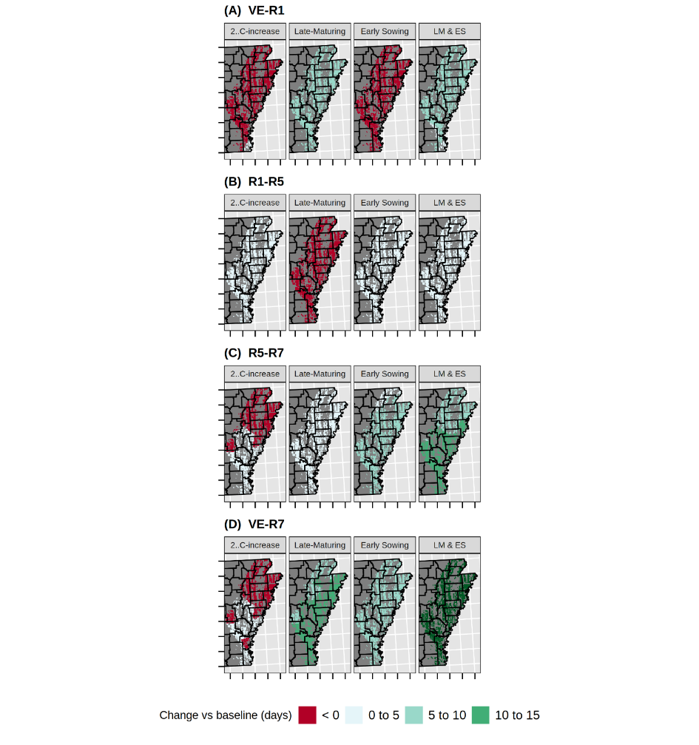
Figure S6. Geographical distribution of the relative effects of rising temperatures and adaptive genotypic and agronomic management strategies on changes in different soybean phenological phases in relation to the baseline: (A) emergence to first flower (VE-R1), (B) first flower to beginning seed (R1-R5), (C) beginning seed to physiological maturity (R5-R7), and (D) emergence to physiological maturity (VE-R7) across 4,651 soybean fields in the US Mid-South. Values per pixel are averages across 40 weather years. LM & ES represent the combined effect of a late-maturing variety and early sowing. All adaptive scenarios were simulated under +2°C.

Comparing phenological changes in the new figure with yield changes (Figure 1 in the manuscript) across scenarios, the additional analysis reinforces the message that the seed-filling period was associated with increased yields. However, further research is needed to determine whether the seed filling period is the primary driver of increased yield, a question beyond the scope of the present study.

Comment #20
In addition, please verify the figure citation in lines 183–184. It appears that Figure 2, rather than Figure 1, should be referenced.
Response: Thank you for catching this. Addressed.

