BioLand-US — main figures and tables (review draft)
Generated by scripts/13_build_review_document.py from the pipeline outputs; all numbers are current.
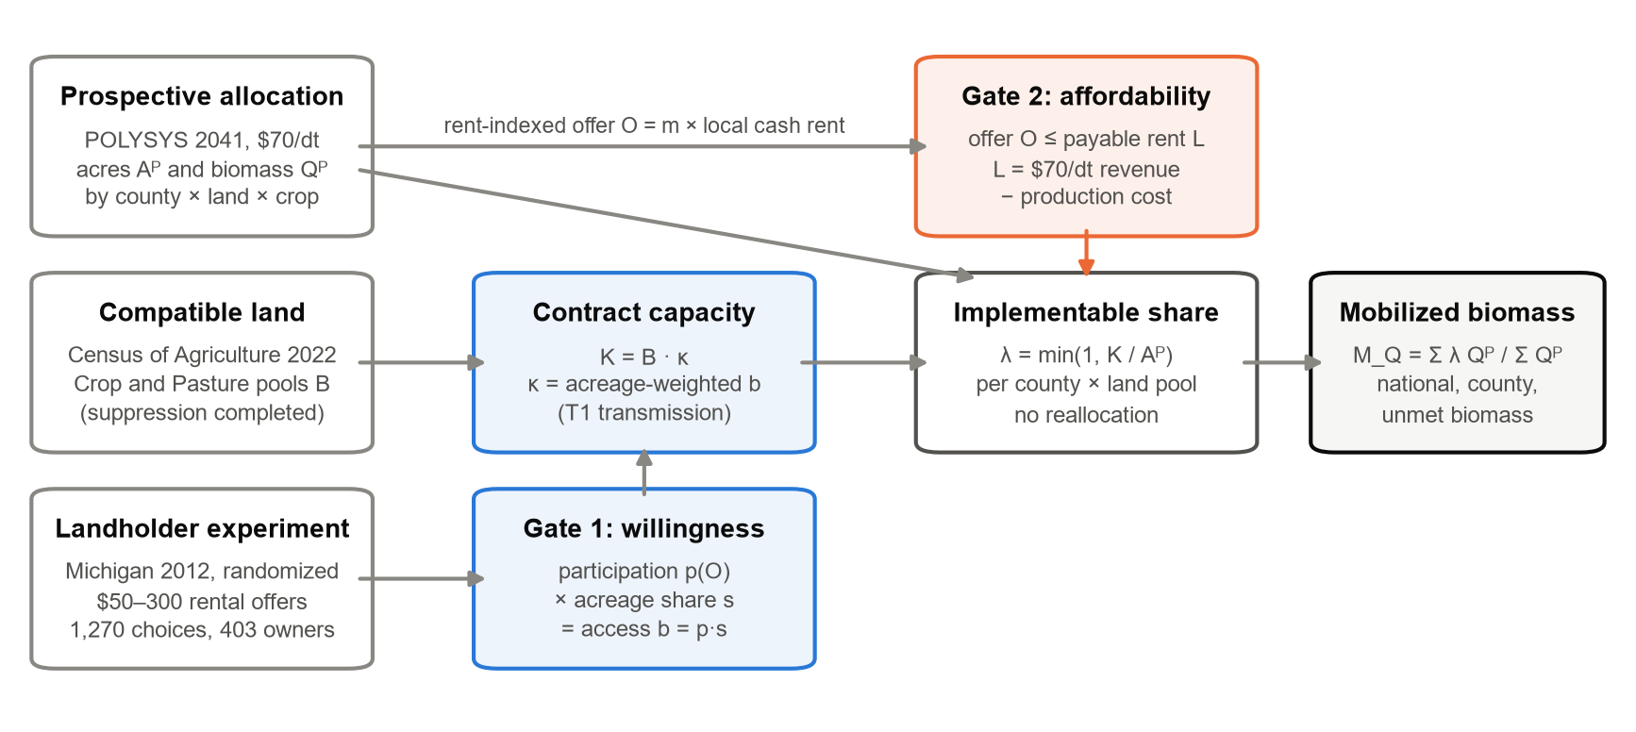
Fig. 1. BioLand-US framework. Three evidence streams (prospective POLYSYS allocation, compatible Census land and a randomized landholder experiment) pass two contractual gates: willingness, which sets contract capacity K = Bκ, and affordability, which asks whether the offer can be paid from biomass revenue. Capacity is matched to the fixed allocation within each county and land pool without reallocation.
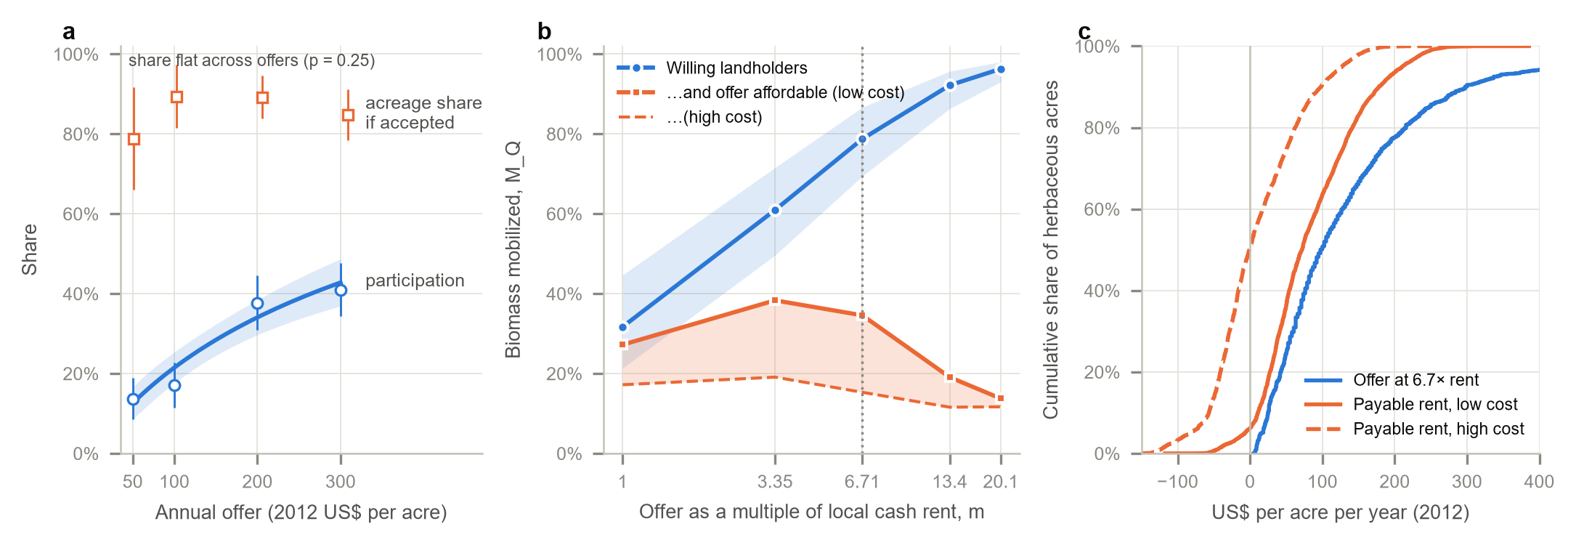
Fig. 2. The two gates. (a) Participation rises with the randomized annual offer, from 13.7% at US$50 to 41.0% at US$300 (circles: categorical margins with 95% CIs; line and band: smooth model), while the acreage share committed after acceptance stays flat (squares; joint offer test p = 0.25). (b) National biomass mobilization under rent-indexed offers: willing landholders alone support 78.8% at m = 6.71 (band: 95% paired respondent bootstrap); requiring the offer to be payable from the US$70/dt price lowers this to 15.3%–34.6% (high- to low-cost budget), and higher multipliers make it worse. (c) Across herbaceous POLYSYS acres, the reference offer exceeds the land payment the biomass price can fund. Values in 2012 US dollars; five-year contracts.
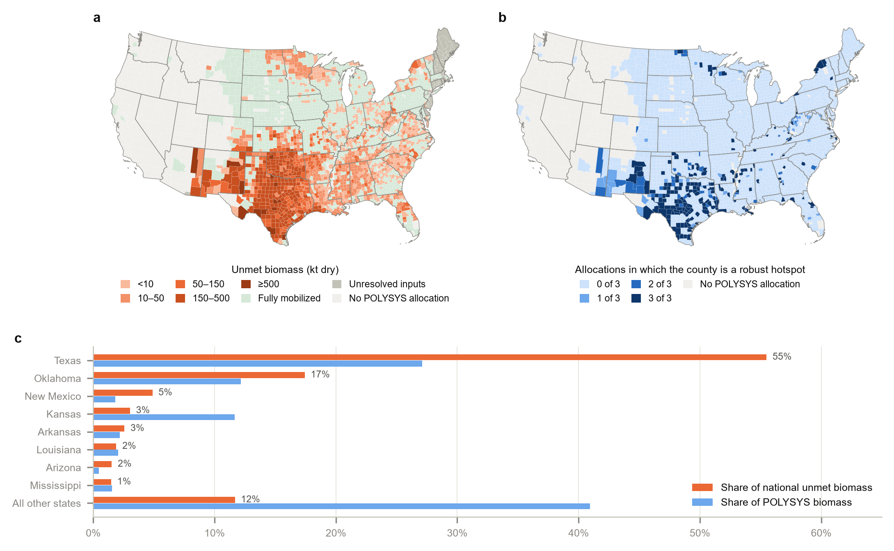
Fig. 3. Geography of the shortfall at the reference offer (m = 6.71, five-year). (a) Unmet biomass, county mean across the three POLYSYS allocation families; grey counties lack rent data. (b) Number of allocation families in which a county is a robust top-decile pressure hotspot. (c) Shares of national unmet and allocated biomass by state: Texas, Oklahoma and New Mexico hold 77.8% of unmet biomass; without them 91.7% of the remaining allocation is supported. The top 10% of counties hold 56.6% of the shortfall.
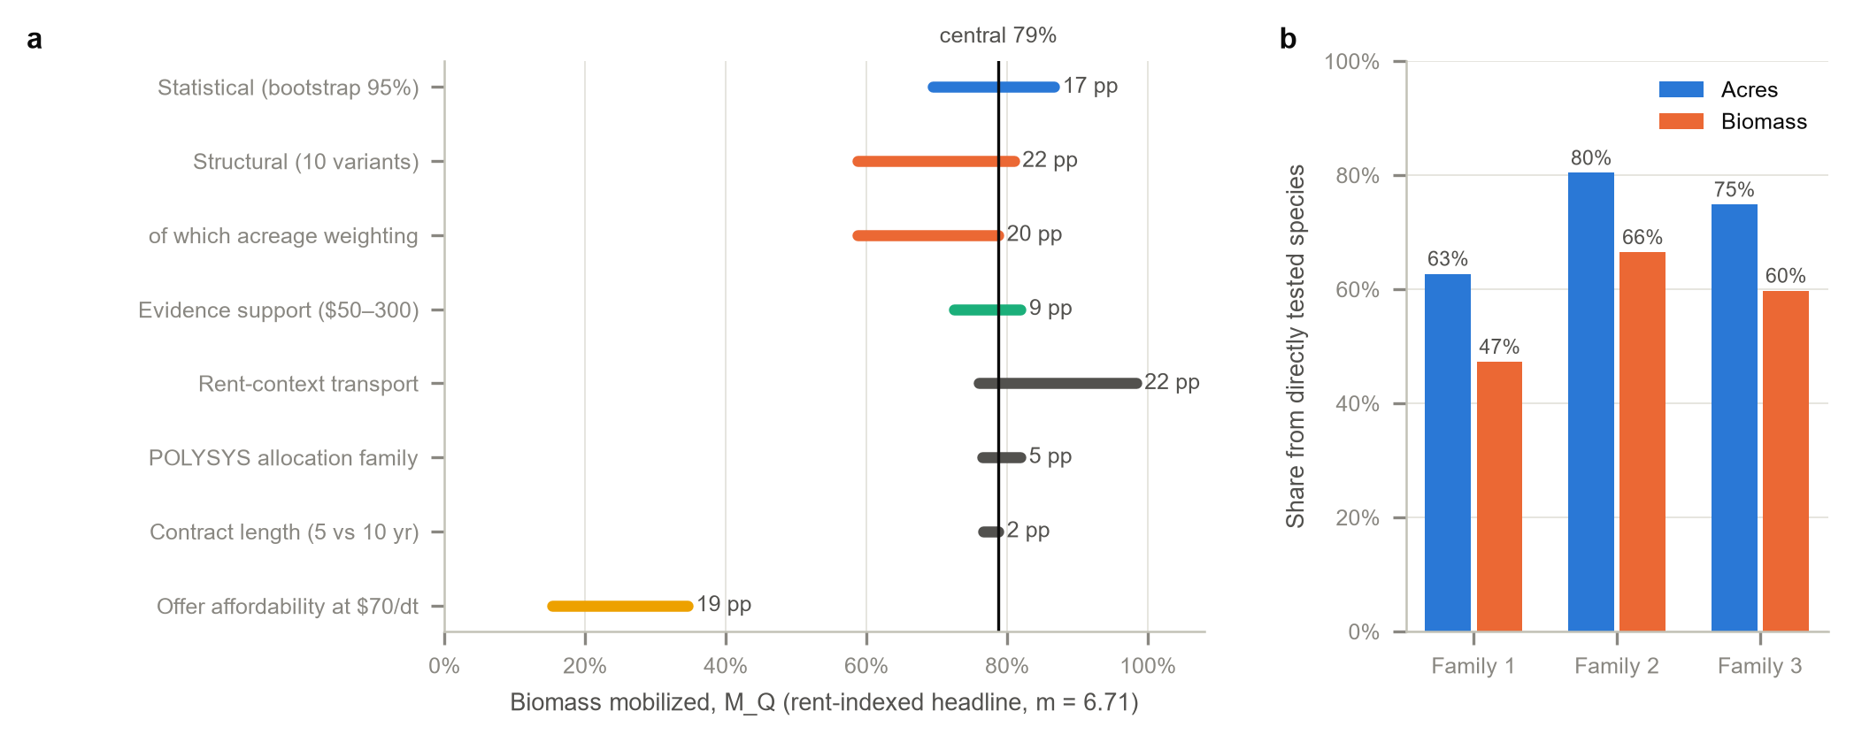
Fig. 4. Sources of variation around the reference result (78.8%). Bars show the range each check produces; they are reported separately and not combined. (b) Share of POLYSYS acres and biomass from the two species tested in the experiment.

Table 1. BioLand-US components and evidential basis.
Component | Symbol | Evidence | Status | Policy lever
Prospective allocation | Aᴾ, Qᴾ | POLYSYS, 2023 Billion-Ton, 2041, US$70/dt | Modelled; held fixed | Biomass price; siting
Compatible land | B | Census of Agriculture 2022; suppressed cells completed | Observed; completed | Eligibility rules
Participation | p(O) | Randomized rental-offer experiment | Experimentally identified | Payment level
Conditional acreage | s | Accepted contracts | Experimentally informed | Contract terms
Behavioural access | b = p(O)s | Experimental estimates | Derived | —
Institutional transmission | κ | Model specification (T1) | Assumed | Tenure; aggregation; extension
Contractual capacity | K = Bκ | Capacity–requirement matching | Derived | —
Payable land rent | L | POLYSYS price and yield; published production budget | External check; upper bound | Price; cost-share
Mobilized biomass | M_Q | λ = min(1, K/Aᴾ) | Derived | —

Table 2. Prospective biomass mobilization under alternative annual rental offers.
Annual offer | M_Q (%) | 95% bootstrap (%) | Unmet (%) | Family range (pp) | Within tested range (%) | Affordable M_Q (%)
US$50 | 57.6 | 41.6–71.2 | 42.4 | 5.8 | 100 | 25–43
US$100 | 81.3 | 69.1–89.8 | 18.7 | 3.8 | 100 | 19–46
US$200 | 96.1 | 90.9–98.4 | 3.9 | 0.8 | 100 | 10–18
US$300 | 98.7 | 96.4–99.5 | 1.3 | 0.4 | 100 | 11–11
m = 1 (rent parity) | 31.7 | 21.4–44.7 | 68.3 | 9.2 | 11 | 17–27
m = 3.35 | 61.0 | 49.6–71.6 | 39.0 | 8.3 | 57 | 19–38
m = 6.71 (reference) | 78.8 | 69.4–86.7 | 21.2 | 5.5 | 73 | 15–35
m = 13.42 | 92.2 | 86.3–95.7 | 7.8 | 2.2 | 55 | 12–19
m = 20.13 | 96.3 | 93.1–98.1 | 3.7 | 1.0 | 38 | 12–14
Five-year contracts; family-balanced deterministic central values; intervals are behavioural sampling only (1,000 paired respondent draws). Rows 1–4: uniform national offers; rows 5–9: offers m × local cash rent. Within tested range: share of biomass offered US$50–300. Affordable M_Q: offers above the payable land rent refused, high- to low-cost production budget, US$70/dt in 2022 dollars. 2012 US dollars.

Table 3. Robustness of the reference result (M_Q = 78.8%, m = 6.71, five-year).
Check | What varies | M_Q range (%) | Largest shift (pp) | Where reported | Verdict
Behavioural sampling | Paired respondent bootstrap, 1,000 draws | 69.4–86.7 | 9.3 | Table 2 | Moderate (5–15 pp)
Leave one survey county out | 12 participation models | 75.2–81.0 | 3.6 | Fig. S1c | Robust (≤5 pp)
Conditional acreage representation | Lower, IPW, central, upper | 66.7–81.0 | 12.0 | Table S2 | Moderate (5–15 pp)
Census suppression completion | Farmland-weighted vs equal shares | 78.7–78.8 | 0.1 | Note S1 | Robust (≤5 pp)
Person-to-acreage weighting | Acreage-weighted participation and share | 58.7–78.8 | 20.0 | Table S1 | Large (>15 pp)
Out-of-range offers | Monotone evidence bounds outside $50–300 | 72.5–81.9 | 6.2 | Fig. S2b | Moderate (5–15 pp)
Rent in participation | Offer + rent model | 76.0–78.8 | 2.8 | Table S3 | Robust (≤5 pp)
Offer-to-rent ratio (stress test) | Ratio model; restriction rejected, p = 0.0002 | 78.8–98.3 | 19.6 | Table S3 | Stress test only (model rejected)
Missing rent | USDA-region fallback for 73 cells | 78.8–78.9 | 0.1 | Note S2 | Robust (≤5 pp)
POLYSYS allocation family | Three independent allocations | 76.4–81.9 | 3.1 | Table 2 | Robust (≤5 pp)
Contract length | 10-year instead of 5-year | 76.6–78.8 | 2.1 | Table 2 | Robust (≤5 pp)
Offer affordability at $70/dt | Low / high cost budget; 2016–2022 price dollars | 15.3–49.9 | 63.4 | Table S4 | Large (>15 pp)
Each row changes one element and is reported separately; ranges are not combined. Verdict: robust ≤ 5 pp, moderate 5–15 pp, large > 15 pp shift from the reference.

