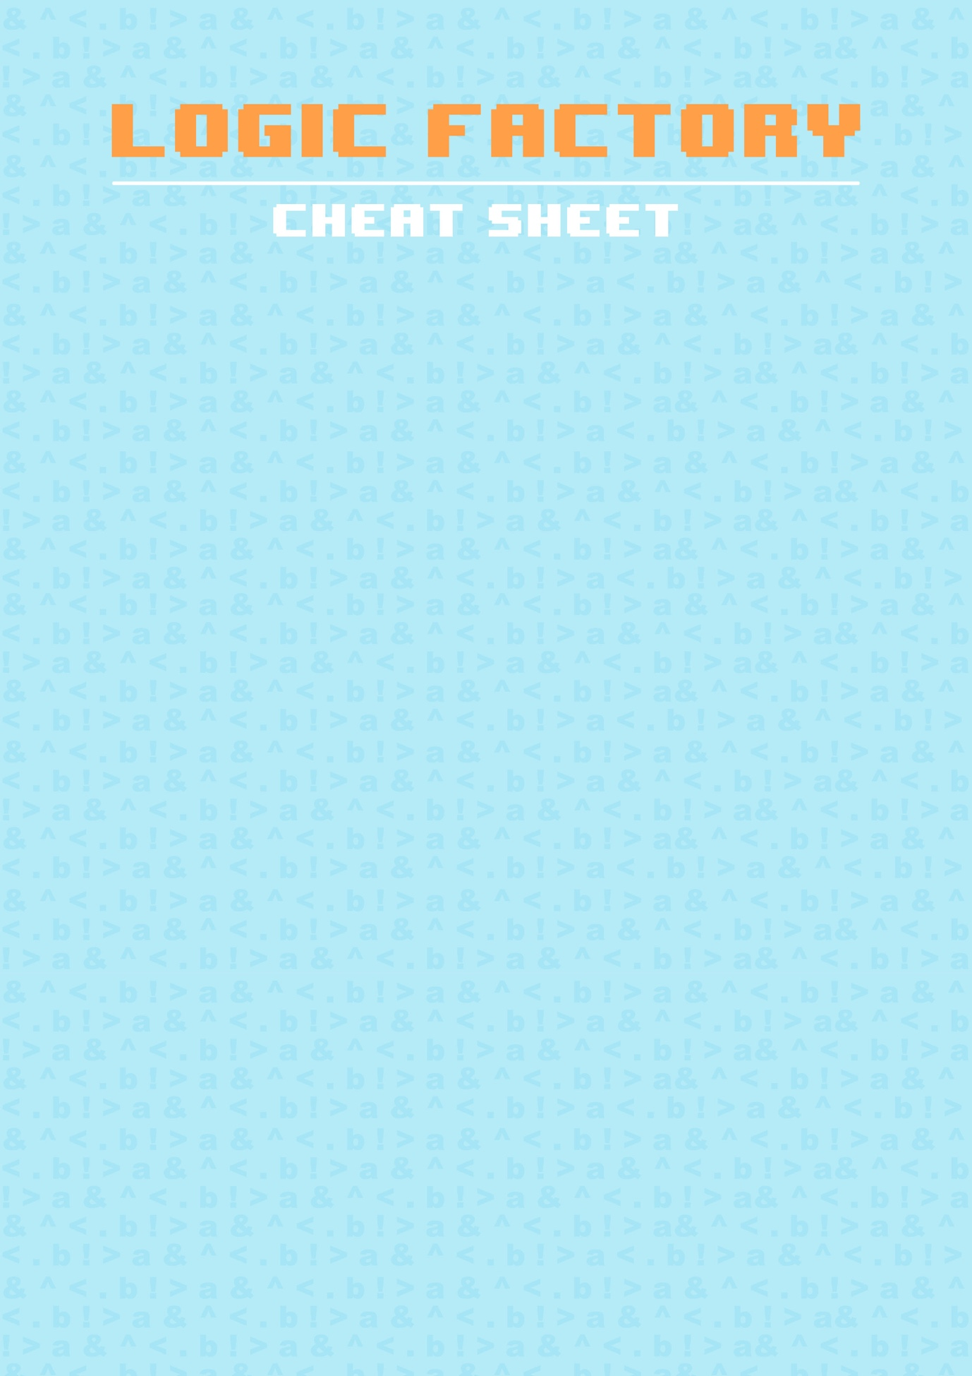

**EXAMPLE**

∃ x,y • x.size > y.size ∧ x.type != y.type

“There exists object x and y such that x’s size is greater than y’s size and x’s type does not equal y’s type”

**MANIPULATING OBJECTS**

Manipulate objects by using the following buttons: ‘Bigger’, ‘Smaller’, ‘Copy’ and ‘Remove’. You can dynamically change the Name variable of an object using the NAME textbox. All theses manipulations can be used as fields in expressions.

**EVALUATING**

To evaluate an expression to true or false, click Go!

**ADDING**

To add an expression to the expression list, click ‘Add Expression’. To delete, click ‘Clear Expression’.

**FIELDS**

The fields that objects have include:

type, width & height or radius, size, x, y, colour and name. The colours are:

red, green, blue, orange, yellow, purple, brown, black and white.

**WRITING**

Use the logic buttons to write your expressions, hover over the buttons to see tooltips & shortcuts. Write expressions about objects you’ve added to the world

Expressions

**LIBRARIES**

A library can be selected in the top-right corner, which defines the set of objects that can exist in the world at one time. You can select an object from the TYPE dropdown box and a set the colour for a Geometry object from the COLOUR dropdown box, then click ‘Add Object’ to add it to the world.

**SAVING**

To save a file, select the Save File button in the right-hand corner, which will prompt you for a filename, then downloads as a JSON file.

Objects in world

**LOADING**

To load a file, select the Load File button in the right-hand corner, which will prompt you to select a JSON file from your system.

File Handling