Paravel Systems
APPLICATION NOTE 013
Installing and Configuring the LiveWire Audio-IP Driver on EL7

SCOPE
This application note details the procedures for installing and configuring the LiveWire Audio-IP driver on RedHet Enterprise Linux [EL7] derived distributions running on Intel 64 bit [x86_64] architectures.

PREREQUISITES
A system running one of the following Linux distributions:

CentOS 7

RedHat Enterprise Linux 7

Scientific Linux 7

An installation serial number from Paravel Systems for either the single channel or multichannel driver

Internet access

PROCEDURE
Configure the Software Repository
Download http://download.paravelsystems.com/CentOS/7com/RPM-GPG-KEY-Paravel-Broadcast to the '/etc/pki/rpm-gpg/' directory.

Download http://download.paravelsystems.com/CentOS/7com/Paravel-Commercial.repo to the '/etc/yum.repos.d/' directory.

Install the driver packages
In the Applications->System menu, click Xfce Terminal to open a command prompt.

Enter su - , then press Enter. You will be prompted for a password. Enter the 'root' password, then press Enter. (You will not see the characters for the password appear on the screen).

Enter the following: yum -y install axia-alsa-gui. The system will install packages.

Close the terminal window.

In the Applications→System menu, click Axia LiveWire Audio-IP Driver to launch the driver configuration applet.

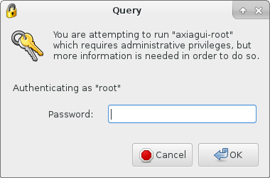

Enter the root (administrator) password when prompted,

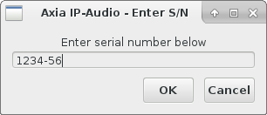

Enter the product serial number and then press the OK button. To obtain a serial number, contact Paravel Systems at 'sales@paravelsystems.com', following which the configuration screen will appear. (Depending upon the specific product purchased, the appearance of the configuration dialog may vary from what is pictured here).

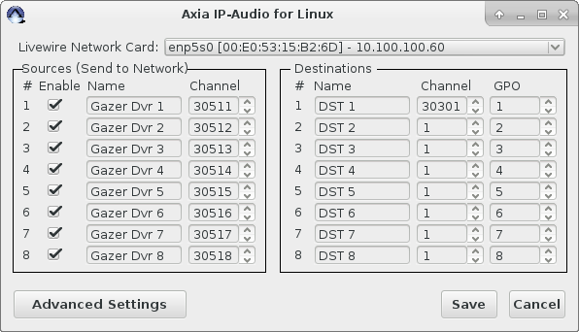

Select the network interface that is connected to the Livewire network from the Livewire Network Card dropdown list.

Configure the Livewire sources and destinations as desired. A full description of these concepts is beyond the scope of this document, but can be found in the Introduction to Livewire Systems Primer, available at http://axiaaudio.com/manuals.

Click the Save button to save the configuration and close the dialog. Depending upon the options selected, the system may require a reboot at this point.

The driver is now ready for service. To access the driver configuration again, select the Applications menu, then click System Tools and then Axia Audio-IP Driver.

REVISION HISTORY
Wed 19 Jun 2013 – Fred Gleason <fredg@paravelsystems.com>
Initial document creation.
Fri 25 Aug 2017 – Fred Gleason <fredg@paravelsystems.com>
Updated RHEL7 procedures.

