Paravel Systems
APPLICATION NOTE 010
Installing The Traffic Light-X from Hardy Data Systems on RHEL 6

SCOPE
This application note details the procedures for installing and configuring The Traffic Light-X from Hardy Data Systems on RedHat Enterprise Linux [EL6] derived distributions running on Intel 32 bit [i386] and 64 bit [x86_64] architectures.

PREREQUISITES
- A system running one of the following Linux distributions:
  - CentOS 6
  - Paravel Systems Broadcast Appliance 2
  - RedHat Enterprise Linux 6
  - Scientific Linux 6
- Internet access

PROCEDURE
- Configure the Software Repository [users of Broadcast Appliance 2 can skip to step 2), as these files are already included.]
  - Download http://download.paravelsystems.com/CentOS/6com/RPM-GPG-KEY-Paravel-Broadcast to the '/etc/pki/rpm-gpg/' directory.
  - Download http://download.paravelsystems.com/CentOS/6com/Paravel-Commercial.repo
to the '/etc/yum.repos.d/' directory.
- In the System menu, click Administration, then Add/Remove Software.
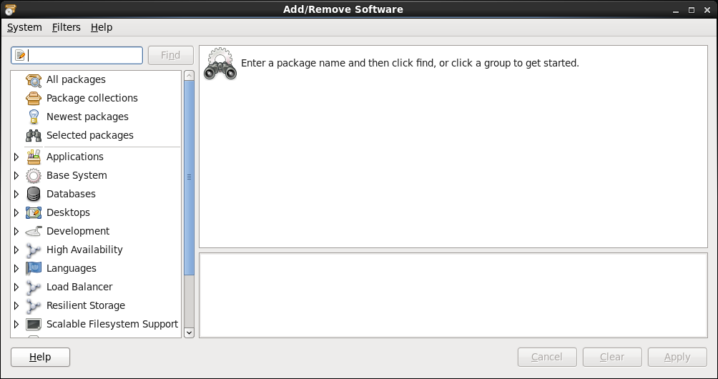
- In the search control at the upper left-hand corner, enter 'tfcx' and then click the Find button.

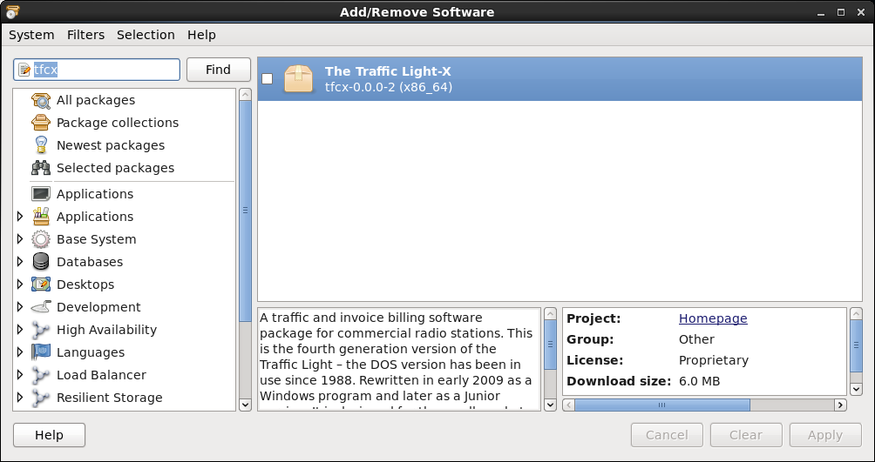
- Check the item that appears for the search results and then click the Apply button.
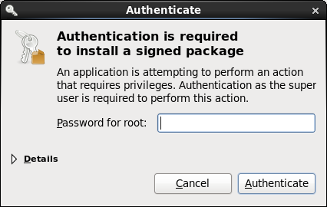

- Enter the root (administrator) password when prompted, following which the system will download and install the software (this may take several minutes).
- Close the Add/Remove Software window.
- To start the program, pull down the Applications menu and select Office, then The Traffic Light-X. Initially, the program will start in Demo Mode. To purchase a key to unlock the full features of the program, contact Hardy Data Systems at:

Hardy Data Systems
PO Box 7304
Tifton, GA 31793

(229) 387-7373 / jim@hds.net

REVISION HISTORY
Sat 1` Jul 2015 – Fred Gleason <fredg@paravelsystems.com>
- Added contact information for Hardy Data Systems.
Fri 10 Jul 2015 – Fred Gleason <fredg@paravelsystems.com>
- Initial document creation.

