Paravel Systems
APPLICATION NOTE 007
Installing and Configuring the LiveWire Audio-IP Driver on EL6

SCOPE
This application note details the procedures for installing and configuring the LiveWire Audio-IP driver on RedHet Enterprise Linux [EL6] derived distributions running on Intel 32 bit [i386] and 64 bit [x86_64] architectures.

PREREQUISITES
- A system running one of the following Linux distributions:
  - CentOS 6
  - Paravel Systems Broadcast Appliance 2
  - RedHat Enterprise Linux 6
  - Scientific Linux 6
- An installation serial number from Paravel Systems for either the single channel or multichannel driver
- Internet access

PROCEDURE
- Configure the Software Repository [users of Broadcast Appliance 2 can skip to step 2), as these files are already included.]
  - Download http://download.paravelsystems.com/CentOS/6com/RPM-GPG-KEY-Paravel-Broadcast to the '/etc/pki/rpm-gpg/' directory.
  - Download http://download.paravelsystems.com/CentOS/6com/Paravel-Commercial.repo
to the '/etc/yum.repos.d/' directory.
- In the System menu, click Administration, then Add/Remove Software.

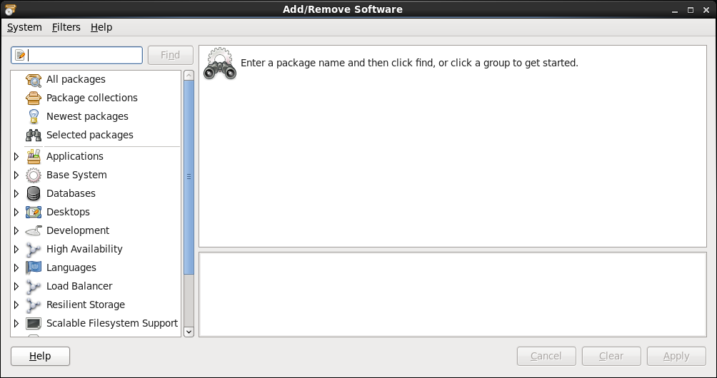

- In the search control at the upper left-hand corner, enter 'axia' and then click the Find button.

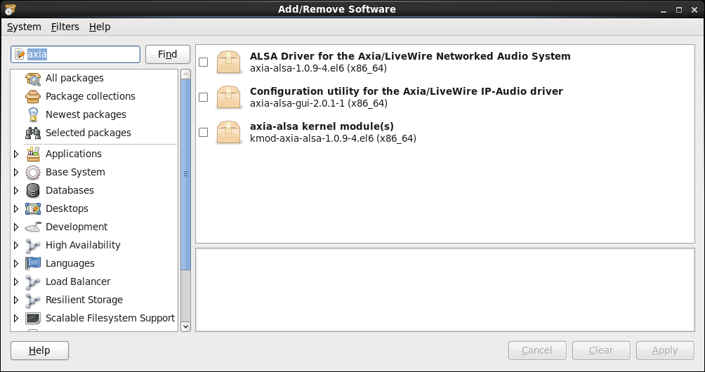
- Check the three items that appear for the search results and then click the Apply button.
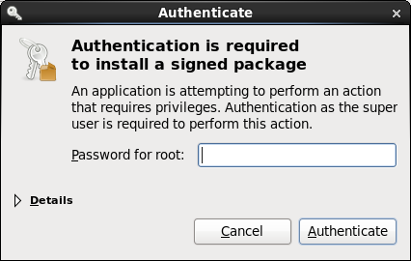

- Enter the root (administrator) password when prompted, following which the system will download and install the software (this may take several minutes).
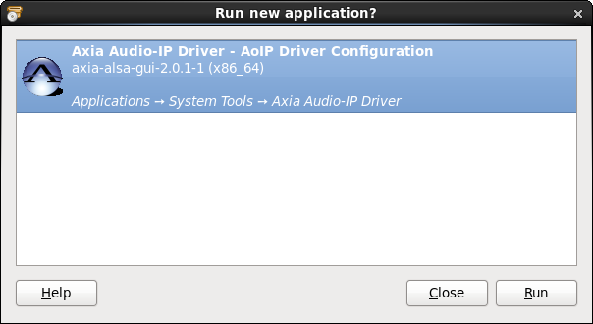
- When the 'Run new application?' window appears, click the Run button. Enter the root password when prompted.

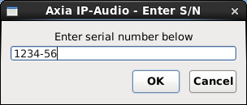
- Enter the product serial number and then press the OK button. To obtain a serial number, contact Paravel Systems at 'sales@paravelsystems.com'. (Depending upon the specific product purchased, the appearance of the configuration dialog may vary from what is pictured here).

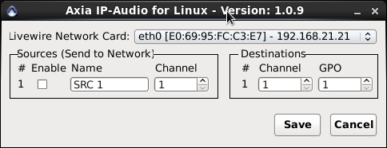
- Select the network interface that is connected to the Livewire network from the Livewire Network Card dropdown list.
- Configure the Livewire sources and destinations as desired. A full description of these concepts is beyond the scope of this document, but can be found in the Introduction to Livewire Systems Primer, available at http://axiaaudio.com/manuals.
- Click the Save button to save the configuration and close the dialog. Depending upon the options selected, the system may require a reboot at this point.
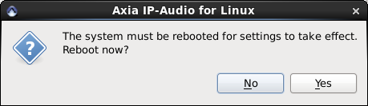
- The driver is now ready for service. To access the driver configuration again, select the Applications menu, then click System Tools and then Axia Audio-IP Driver.

REVISION HISTORY
Wed 19 Jun 2013 – Fred Gleason <fredg@paravelsystems.com>
- Initial document creation.

