Paravel Systems
APPLICATION NOTE 008
Configuring Remote Starts on Axia LiveWire Consoles

SCOPE
This application note details the procedures for configuring remote starts and stops on Axia audio consoles.

PREREQUISITES
- An Axia console.
  - Element (both PowerStation and StudioEngine based)
  - Radius
  - Others should work, but have not been tested as of this writing.
- Rivendell v2.5.0 or later.

OVERVIEW
GPIO lines in LiveWire are organized into bundles of five lines, with each bundle being associated with a particular LiveWire source number. The specific function of each line within a bundle varies depending upon the type of device being controlled. A set of tables breaking down the line functions can be found in the manual for each LiveWire-compliant console.

PROCEDURE
- On the Axia Console (screenshots shown are for an Element console, screens on other Axia consoles are similar but not identical).
  - Configure the Source Profile(s). For each source to be controlled, ensure that:
    - The Source Type is set to Computer Player.
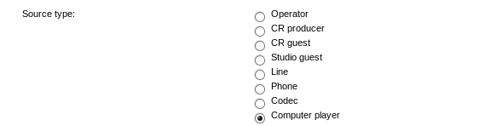
    - GPIO Ready enable/disable is set to Disabled
- If you are using the Axia IP-Audio for Linux software driver, verify that the driver's integrated GPIO is disabled as follows:
  - Open the Axia IP-Audio Driver configurtion applet.
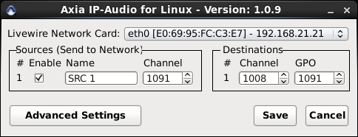
  - Touch the Advanced Settings button.
  - Uncheck the Control GPIO Subsystem via LWRP and then touch the OK button.
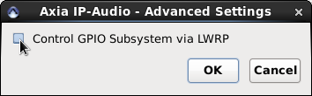
- Add a LiveWire Virtual GPIO Driver to Rivendell as follows:
  - In RDAdmin, touch the Manage Hosts button, select the desired host to configure, then touch the Edit button, then the Switchers/GPIO button.
  - Touch the Add button, select Livewire Virtual GPIO from the Switcher Type dropdown list, then touch the OK button.
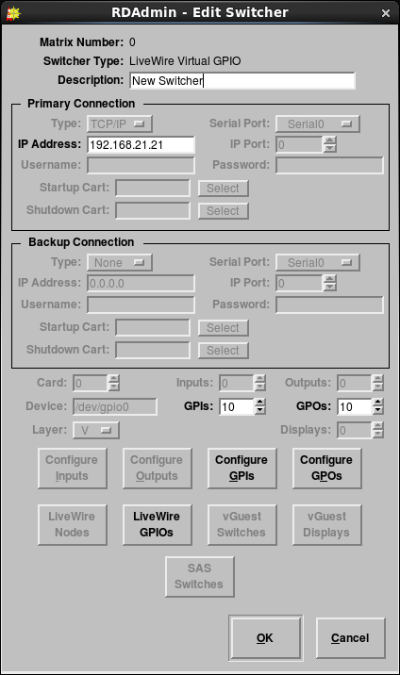
  - In the IP Address field, enter the IP address of the network card on the workstation that is connected to the LiveWire network.
  - Set the GPIs control to the number of LiveWire channels to be controlled, multiplied by five. For example, if you are configuring four LiveWire streams, you would set the control to 20.
  - Touch the LiveWire GPIOs button to open the Livewire GPIO Source Assignments dialog.
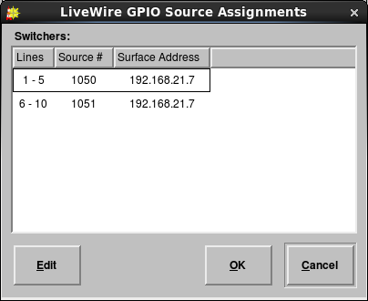
  - For each set of lines, highlight the entry and touch the Edit button, then fill out the Livewire Source and Surface Address fields for that LiveWire stream. (For split Element/StudioEngine setups, use the IP address of the Element power supply, not that of the StudioEngine).
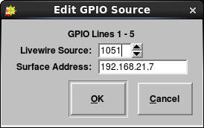
  - Touch OK twice to return to the Edit Switcher dialog.
- Create a 'remapper' cart for each source to be controlled as follows;
  - Open RDLibrary
  - Touch Add, then select Macro from the New Cart Type dropdown list. Enter the desired Group, New Cart Number and New Cart Title. Touch the OK button to open the Edit Macro Cart dialog.
  - Touch the Add button to open the Edit Macro dialog.
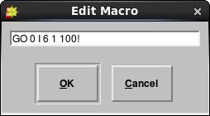
  - Enter RML code in the format GO <matrix> I <line> 1 100!, where <matrix> is the matrix number of the LiveWire Virtual GPIO Driver and <line> is the number of the first GPIO line in the target source. Touch OK to close the Edit Macro dialog.
  - Back in RDAdmin, touch the Configure GPIs button to open the List GPIs dialog.
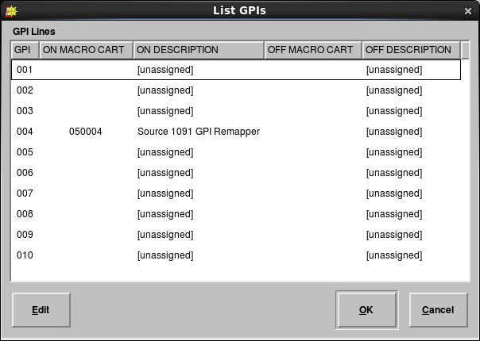
  - Select the fourth line in each bundle of five and touch the Edit button to open the Edit GPI <n> dialog.
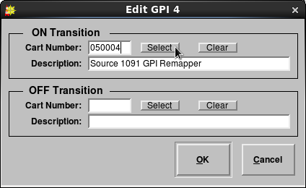

  - In the ON Transition section, touch the Select button to open the Select Cart dialog. Pick the 'remapper' cart that you created for this source (see above) and touch OK.
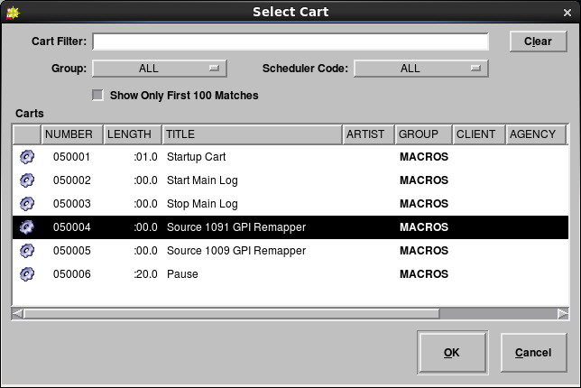
  - Touch OK to close the List GPIs dialog when done assigning macro carts, then touch OK to close the Edit Switcher dialog and Close to close the Rivendell Switcher List dialog.
  - Touch the RDAirPlay button in the Host dialog to open the RDAirPlay Configuration dialog.
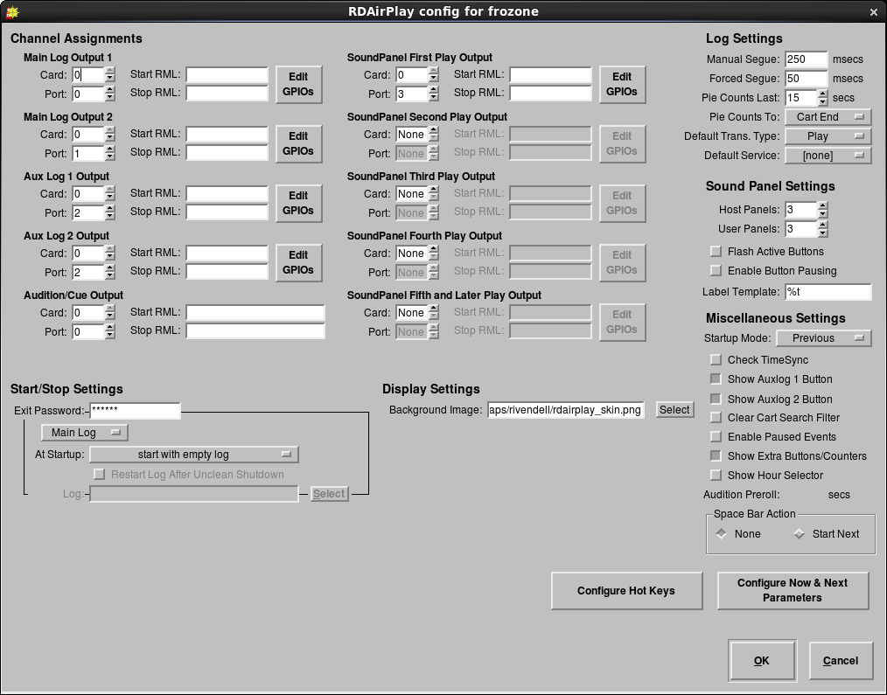

  - Touch the Edit GPIOs button for the output to be configured to open the Edit Channel GPIOs dialog.
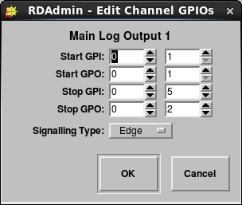
  - In the left-hand column of fields, enter the matrix number of the Virtual GPIO driver you created. In the right-hand column, enter the numbers for the corresponding GPIO line as follows:
    - Start GPI: 1
    - Start GPO: 1
    - Stop GPI: 5
    - Stop GPO: 2
    - Signalling Type: Edge
  - Touch OK to close the dialogs.

REVISION HISTORY
Wed 14 Nov 2013 – Fred Gleason <fredg@paravelsystems.com>
- Initial document creation.

