Paravel Systems
APPLICATION NOTE 009
Installing and Configuring the LiveWire Audio-IP Driver on Ubuntu

SCOPE
This application note details the procedures for installing and configuring the LiveWire Audio-IP driver on Ubuntu distributions running on Intel 32 bit [i386] and 64 bit [x86_64] architectures.

PREREQUISITES
- A system running one of the following Linux distributions:
  - Ubuntu 12.04LTS (Precise Pangolin)
- An installation serial number from Paravel Systems for either the single channel or multichannel driver.
- Internet access.

PROCEDURE
- Download the installer script from http://downloads.paravelsystems.com/ubuntu/dists/precise/axia-alsa-installer
- Open 'Terminal' and run the following commands:
  - cd <directory-where-download-was-saved>
  - chmod 755 axia-alsa-installer
  - sudo ./axia-alsa-installer
- The system will prompt “This will install the Axia LiveWire driver on this system.
Is this what you want (Y/n)?” Enter a 'y' and press ENTER.
- The script will automatically add a new software repository source for the driver. When finished, it will prompt “The following NEW packages will be installed: axia-alsa axia-alsa-gui 0 upgraded, 2 newly installed, 0 to remove and 188 not upgraded. Need to get 0 B/190 kB of archives. After this operation, 525 kB of additional disk space will be used. Do you want to continue [Y/n]?” Enter a 'y' and press ENTER.
- The system will now open a dialog box asking for the installation serial number. Enter a valid serial number and click 'OK'.

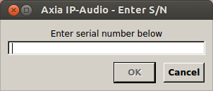
- The system may need to build a custom kernel module. If so, it will display a dialog. Click 'Yes'.

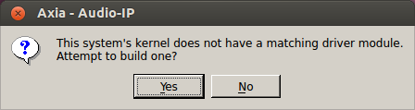
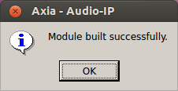
exit

- The main LiveWire configuration screen should now appear. Select the network interface that is connected to the LiveWire network in the 'Livewire Network Card' dropdown list (a reboot may be necessary if this value is changed). Set the desired LiveWire Source, Destination and Channel numbers, and click 'Save'. The driver should now be ready for service.
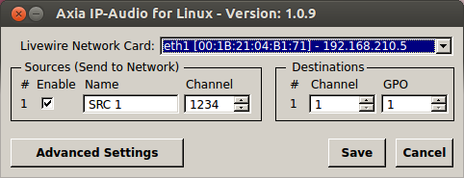

REVISION HISTORY
Fri 24 Jan 2014 – Fred Gleason <fredg@paravelsystems.com>
- Updated for Ubuntu 12.04.

Wed 19 Jun 2013 – Fred Gleason <fredg@paravelsystems.com>
- Initial document creation.

