Minimum System Requirements
Caution!
The Rivendell Broadcast Appliance DVD installs a pre-configured Linux Operating System and the complete Rivendell Radio Automation System software package on your computer. It will completely replace any operating systems and other data previously installed on the target system. It is vital that any existing data that needs to be retained be backed up to external media before beginning the installation! Paravel Systems L.L.C. is not responsible for any loss of data.
- Dedicated Computer Hardware with an AMD or Intel multi-threaded processor with 64-bit support
- 1 GB RAM
- 320 GB Hard drive
- DVD-ROM drive
- PS/2 or USB mouse and keyboard
- 1152x960 video, 256 color
- One or more of the following audio devices:
- An ASI6000 series audio adapter from AudioScience is required to fully support all Rivendell features and is highly recommended for critical applications. The complete line of Rivendell compatible AudioScience adapters is available from Paravel Systems at http://www.paravelsystems.com or (877) 44-PARAVEL / (877) 447-2728.
- ALSA compatible sound card. A list of supported cards can be found at
http://www.alsa-project.org/main/index.php/Matrix:Main.

Instructions
- Ensure that all important data on the target system is backed up to external media (see the Caution! section above).
- Insert the Rivendell Broadcast Appliance installation DVD into the DVD-ROM drive and power-cycle the system.
- When the Welcome to CentOS 6.4 boot screen appears, select one of the list of installation types and then press the ENTER key. Some of the available types are:
  - Install a Rivendell workstation (stand-alone)
    - This installs a complete Rivendell setup with all necessary components (MySQL, audio store) on the primary hard drive. It is intended for situations where a single, self-contained Rivendell system using commodity hardware is desired. (If you are trying out Rivendell for the first time, this is the setup to use!)
  - Install a Rivendell workstation (network client)
    - This installs a Rivendell setup on the primary hard drive, minus MySQL and the dedicated partition for the audio store. It is intended for situations where the system will be used in conjunction with an external Rivendell server.
  - Install a Rivendell server (RAID1, 2 drives, 0 spares)
    - This installs a complete Rivendell setup with all necessary components (MySQL, audio store) on multiple hard drives using RAID1 and LVM. Two hard drives of at least 320 GB capacity each are required.
  - Install a Rivendell server (RAID1, 3 drives, 0 spares)
    - This installs a complete Rivendell setup with all necessary components (MySQL, audio store) on multiple hard drives using RAID1 and LVM, with all three drives simultaneously active in the mirror. Three hard drives of at least 320 capacity each are required.
  - Install a Rivendell server (RAID1, 3 drives, 1 spare)
    - This installs a complete Rivendell setup with all necessary components (MySQL, audio store) on multiple hard drives using RAID1 and LVM, with the third drive configured as a hot spare. Three hard drives of at least 320 GB capacity each are required.
- After a minute or so, the system will display the main CentOS start installation screen. Click the Next button to begin the installation.

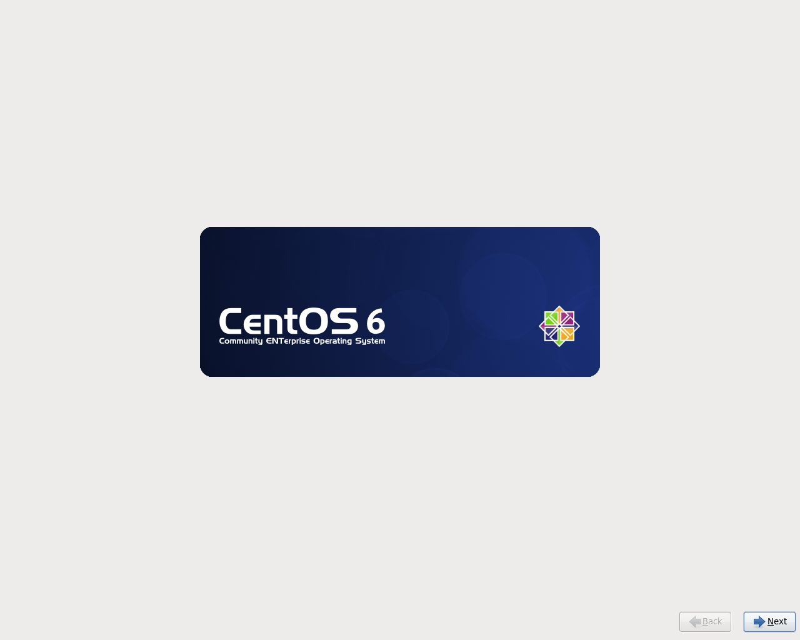
- The system will now ask you to select the language to use for the installation. Choose one and click Next.

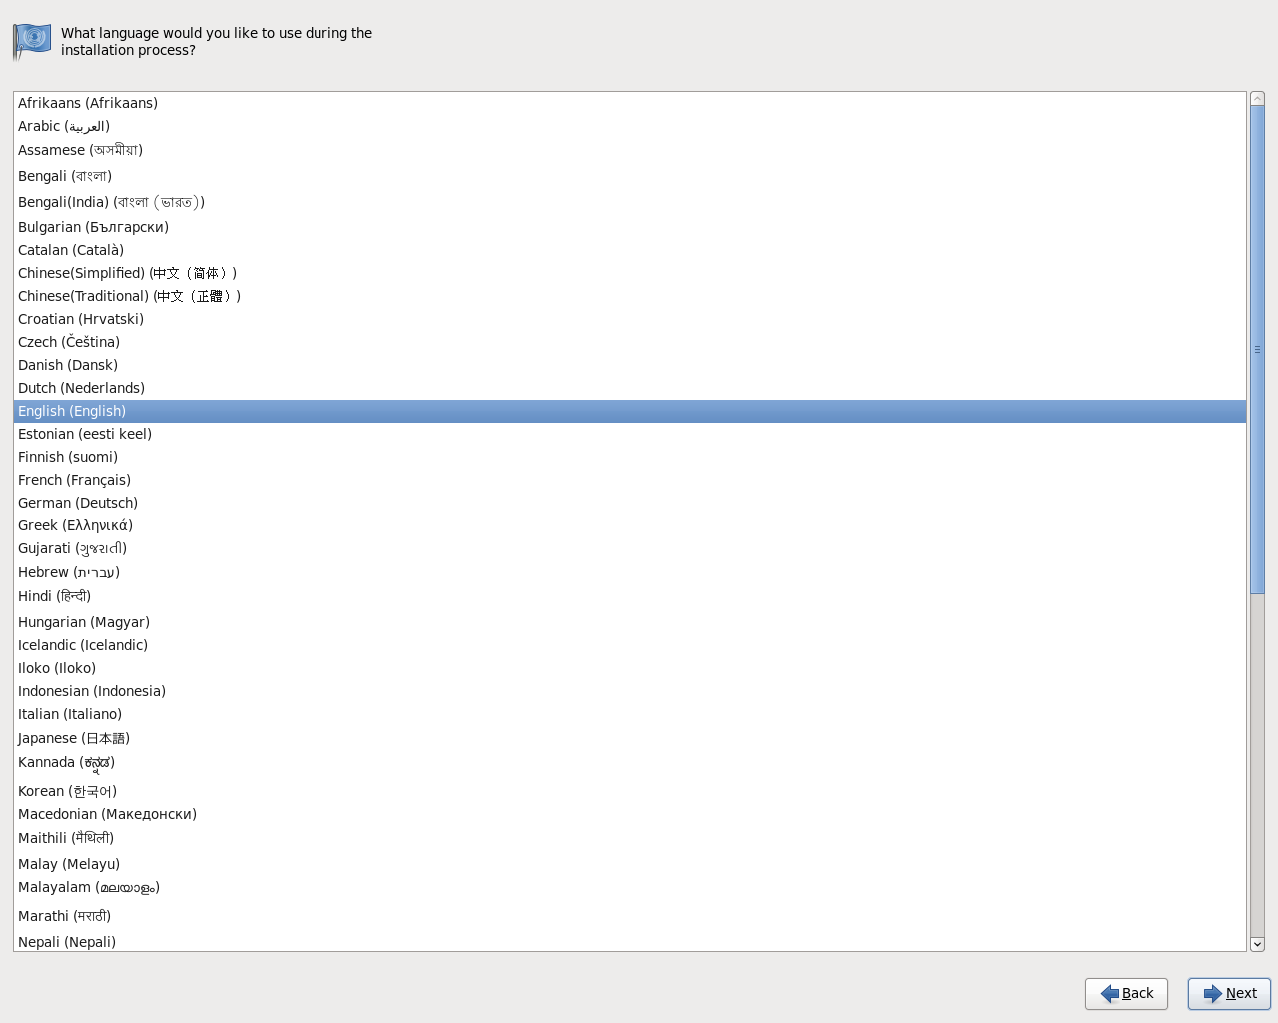
- The system will now ask you to select the style of keyboard to use.. Choose one and click Next.

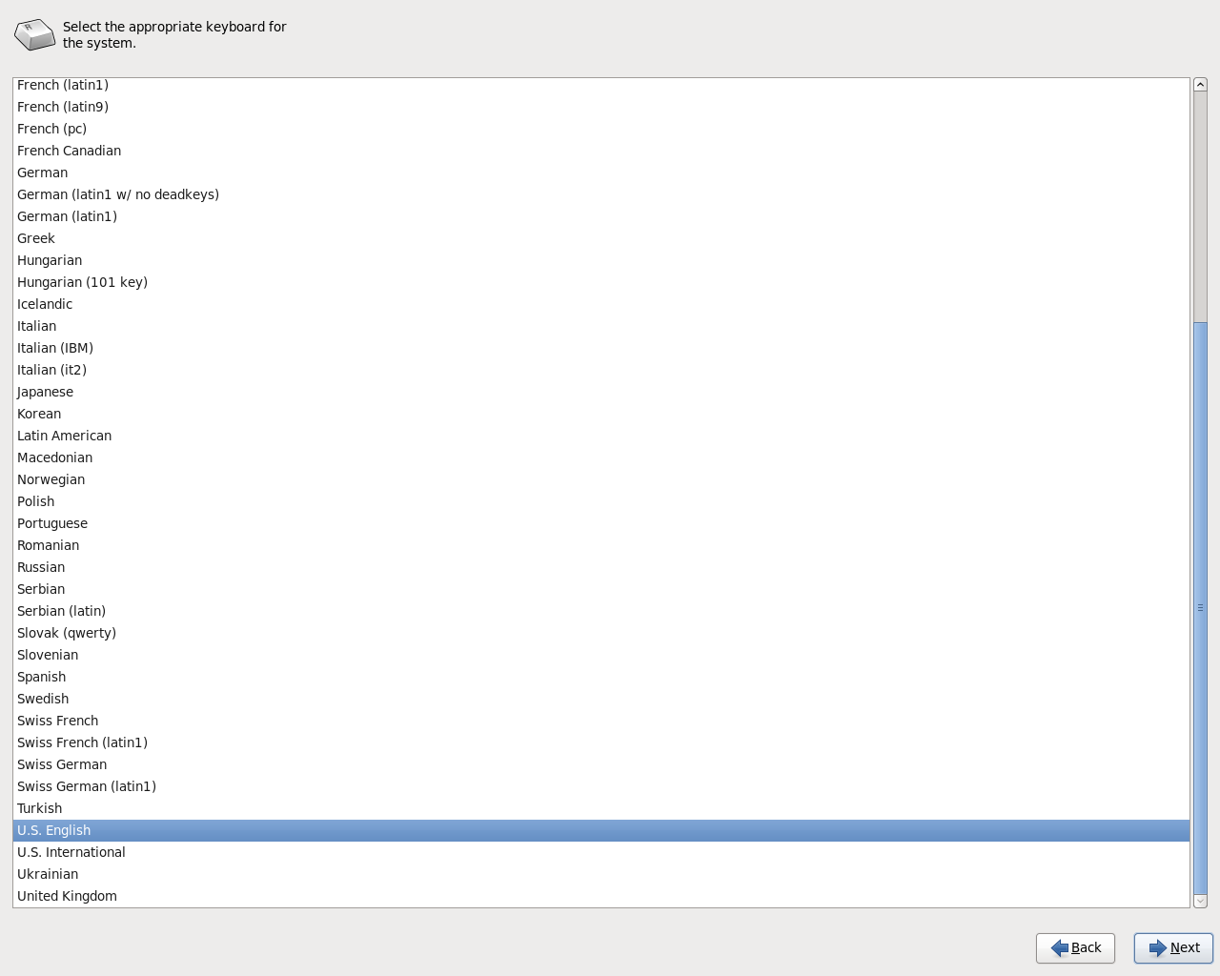
- The system will now ask you about the type of storage devices to use. Most users will want to select Basic Storage Devices, then click Next.

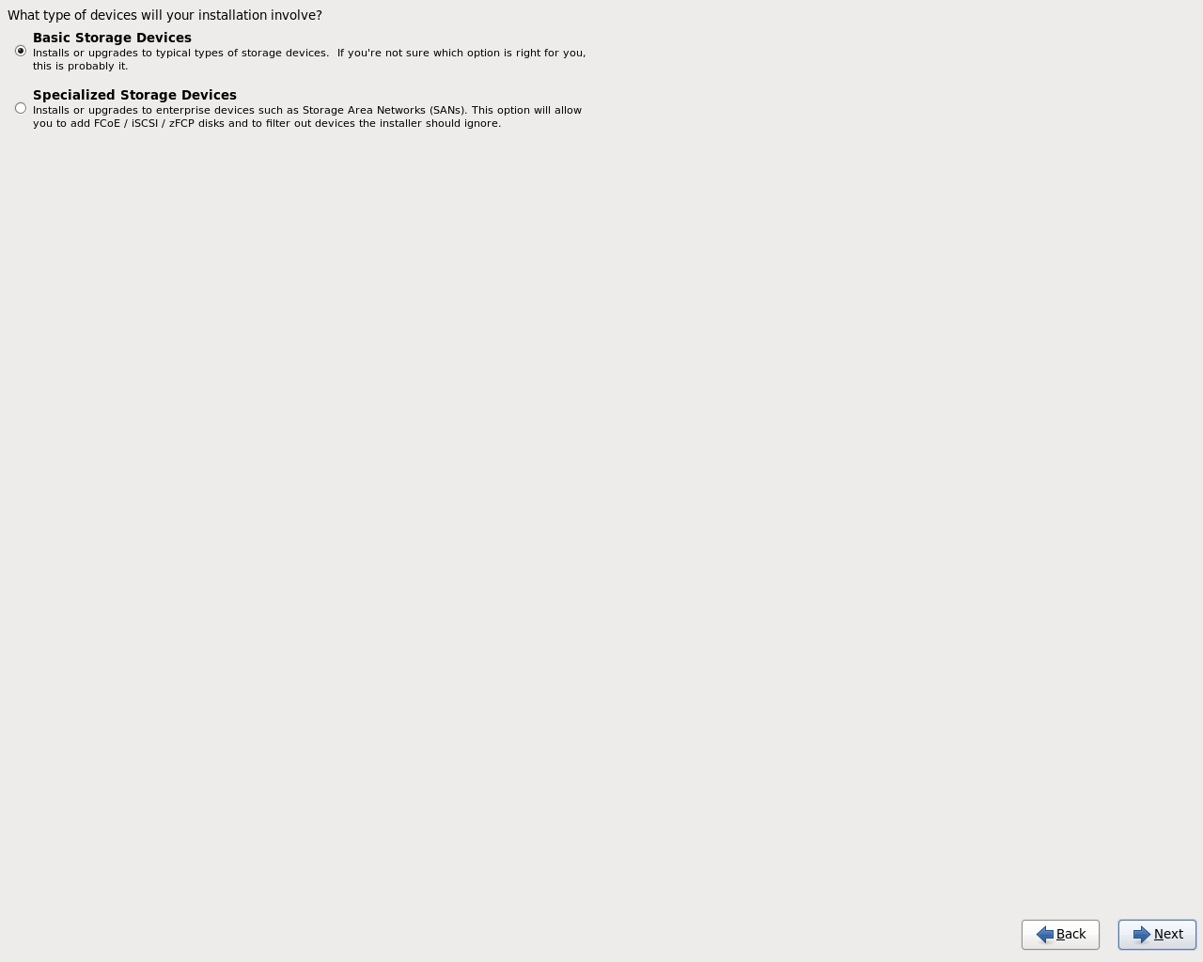

- The system will now ask you to select your time zone. Select the appropriate one and click Next.

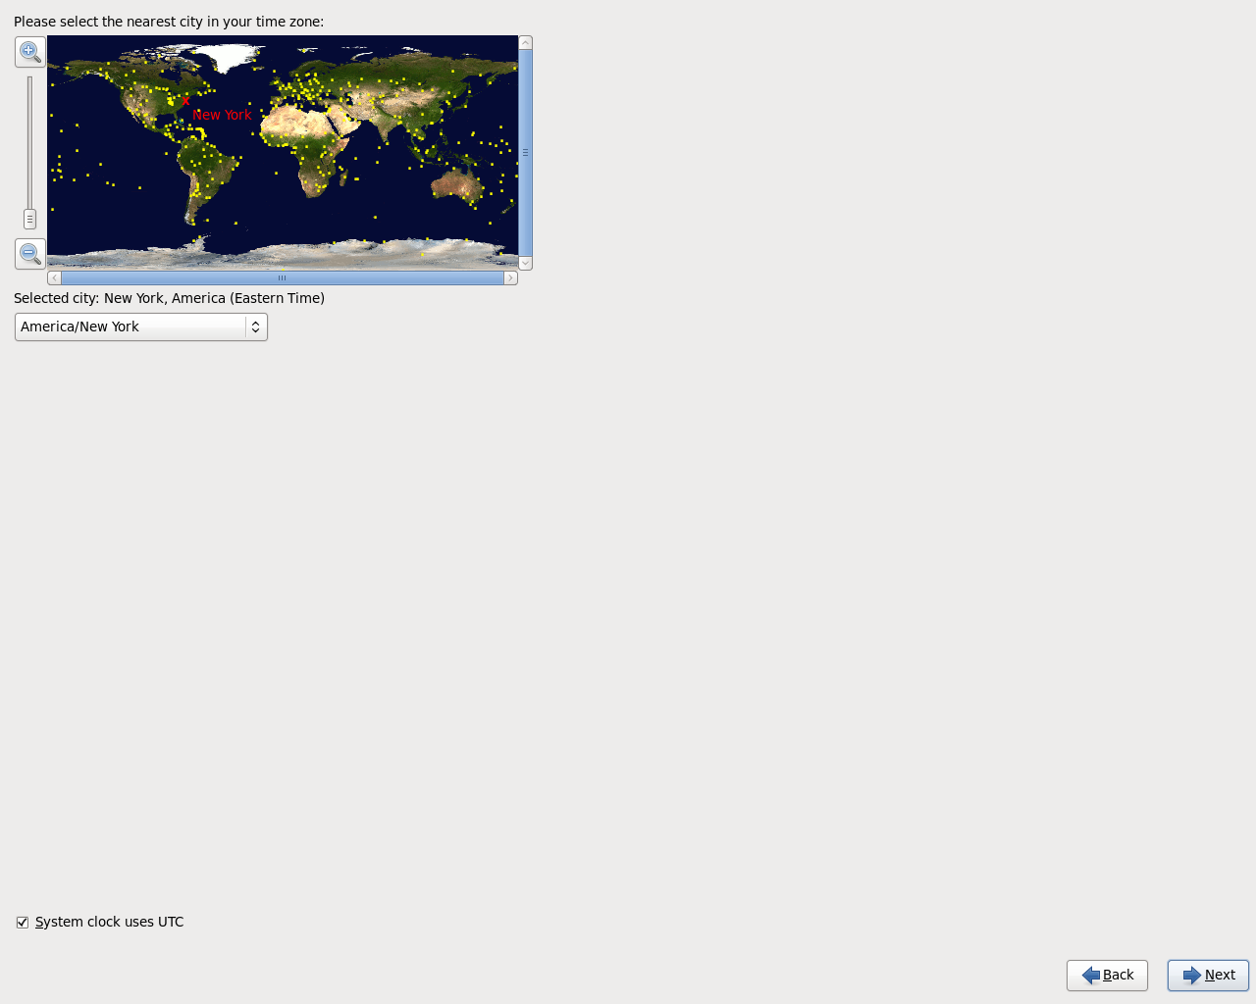

- The system will now ask you to set a root password for administering the system. You will need this password to finish configuring and administering your system, so do not forget what you enter here! When done, click Next.

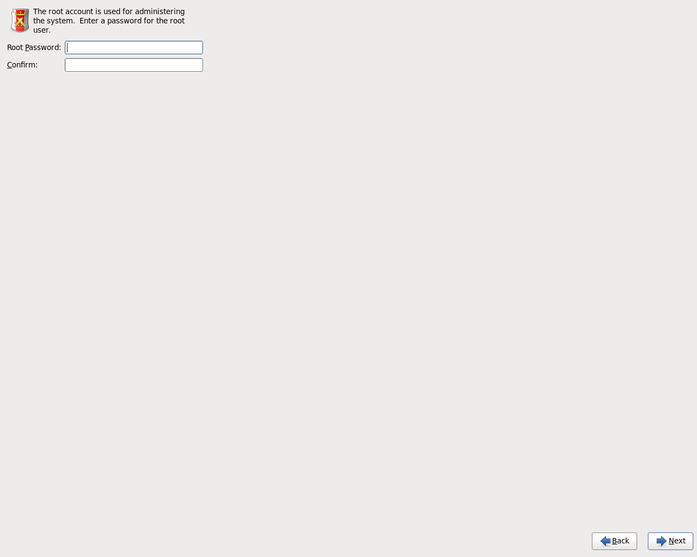

- The system will now ask you about the type of disc partitioning to use. Most users will want Replace Existing Linux Systems(s). (WARNING: this setting will delete all existing data from the hard drive!). To have an opportunity to review and modify the partition layout before making any changes, check the “Review and modify partitioning layout” box first. After making your choices, click Next.

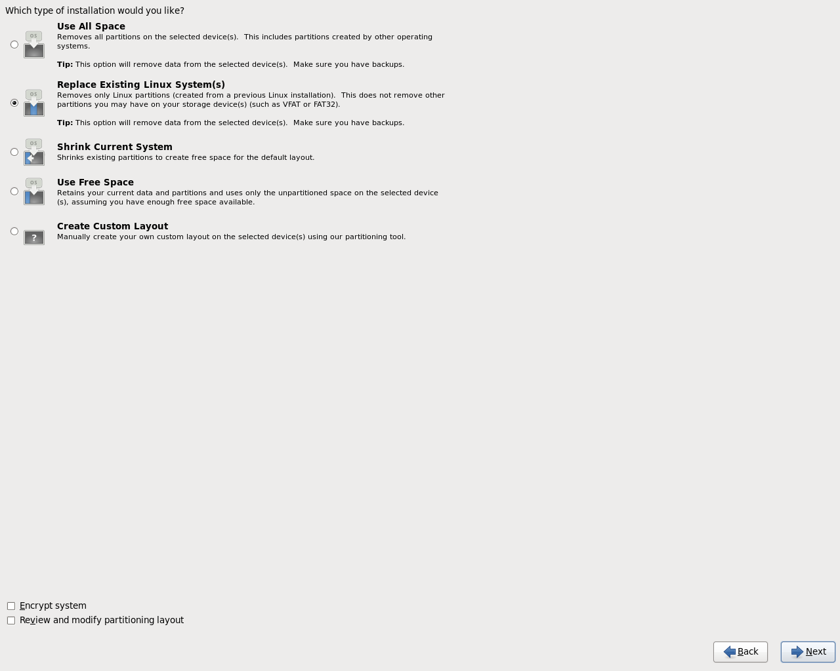
- The system will now ask you about the type of installation to use. Select Desktop and then click Next.

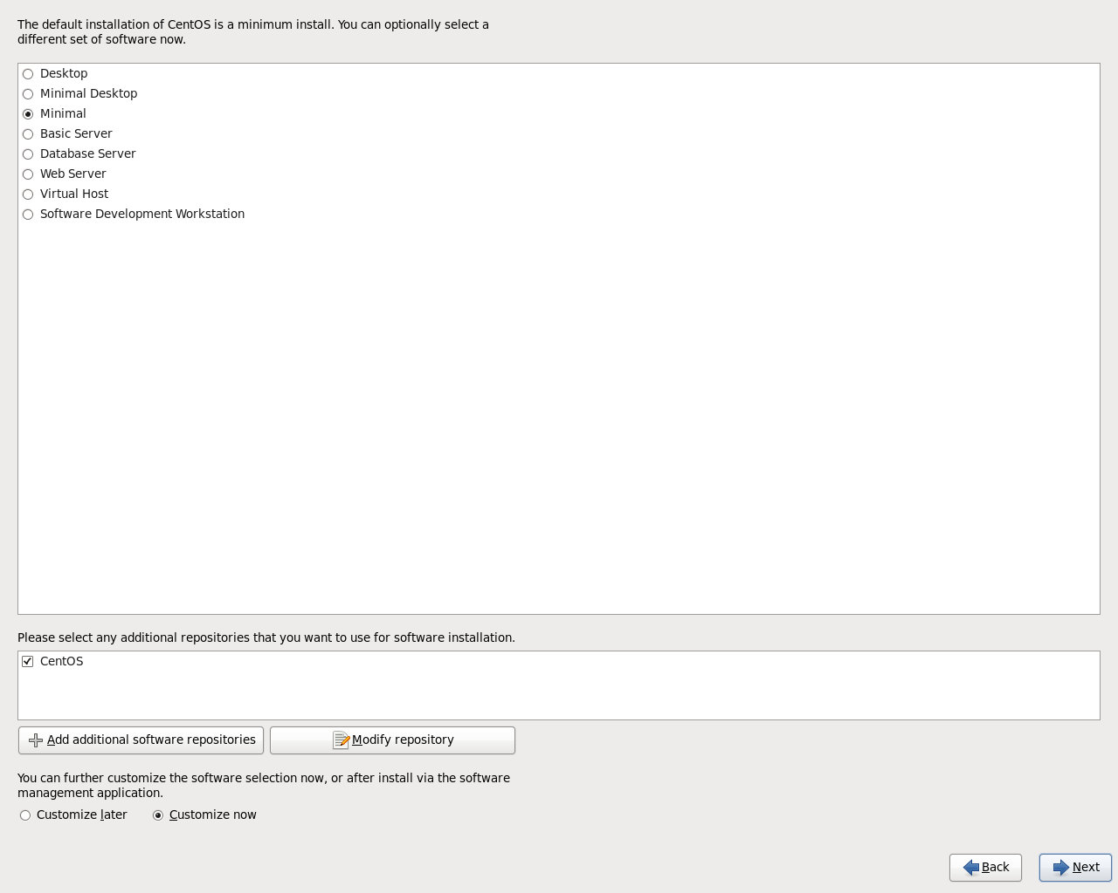

- The system will now allow you to choose Application Groups to install. If you change nothing on this screen, a basic Rivendell workstation will be installed. Click Next after making your choices.

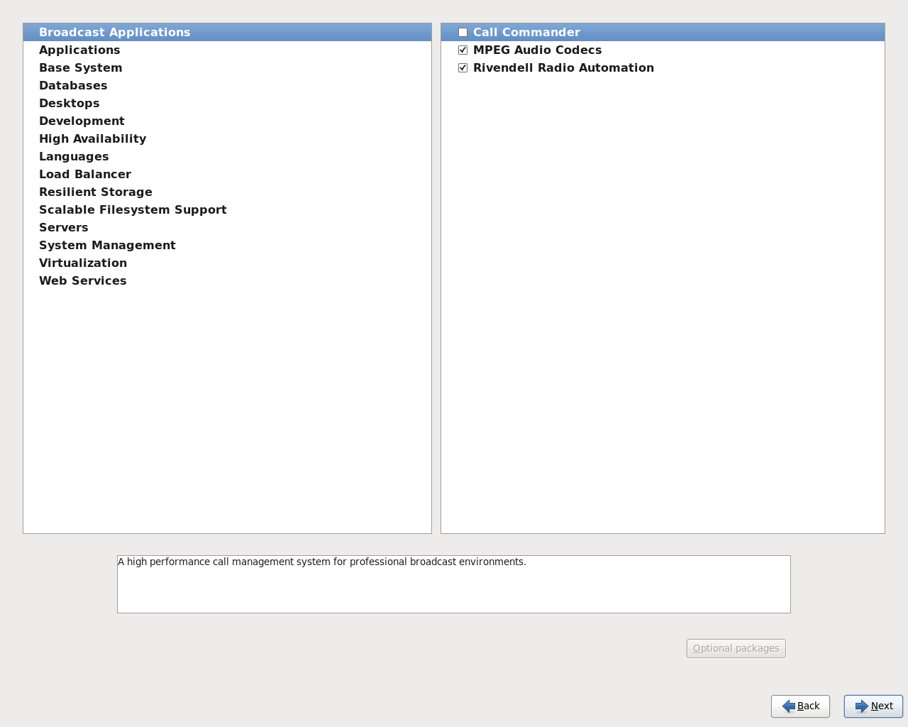
- The system will begin installing packages. This will likely take several minutes. The system will tell you when installation is complete. Remove the DVD from the drive and click Reboot.

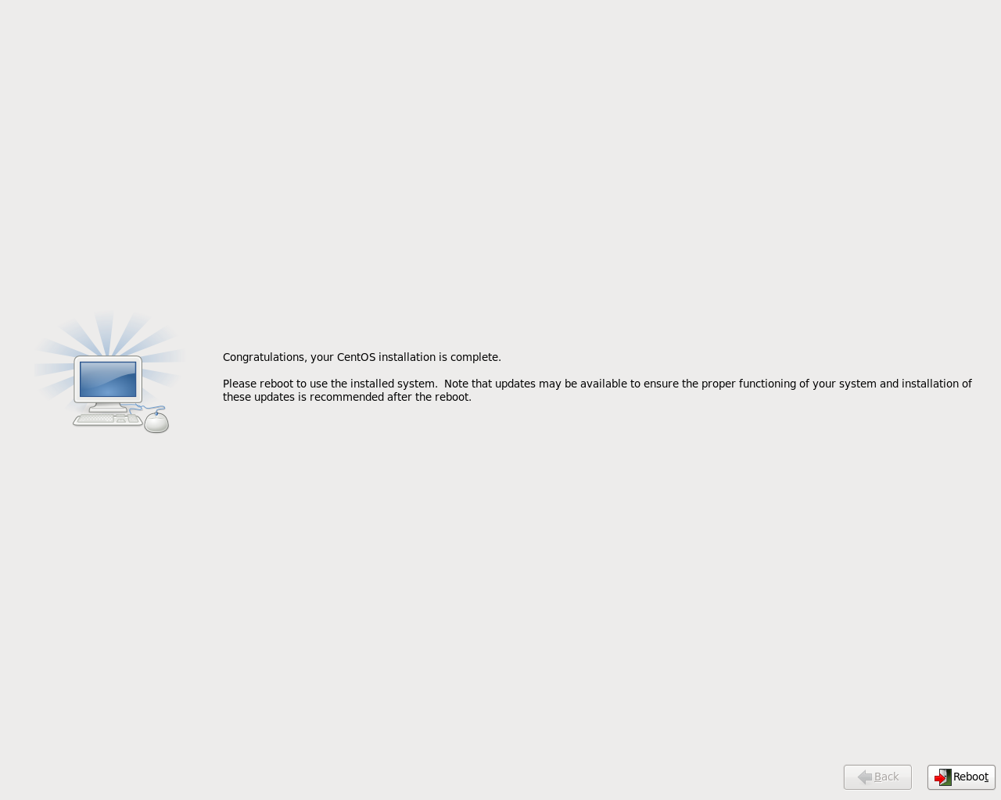
- After rebooting, double-click the First Steps icon on the desktop for pointers to information about configuring and using your new Rivendell system.

