Getting Started
Welcome to Paravel System's Rivendell Broadcast Appliance. Rivendell is a full-featured radio automation system that is targeted for use in professional broadcast environments. It has all of the features you'd expect from a modern broadcast automation system, including automatic or live assist content playout, voice tracking and automatic content acquisition from both satellite and Internet sources. It can work with a vast array of third party hardware and software solutions from manufacturers such as AudioScience, Axia, Broadcast Tools, Logitek, Marketron, RCS, Sierra Automated Systems and many others.

All Rivendell modules can be accessed by means of the Rivendell menu, accessible by clicking Rivendell's Radio Tower/Star icon on the taskbar.

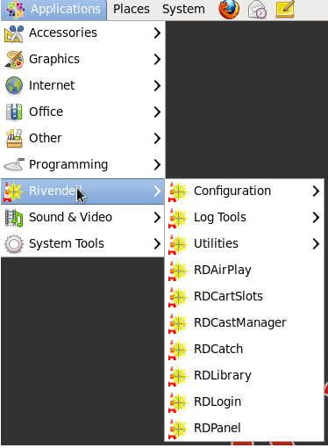
All system configuration is done by means of the RDAdmin module (default login 'admin' with no password).

Documentation and Support
There is a lot of documentation available, beginning with the Rivendell Operations Guide, a comprehensive overview of Rivendell and its modules. To access the Guide, simply double click the Rivendell Ops Guide icon on the desktop.

Paravel Systems offers a full array of Rivendell installation, training and support services, including 24/7 emergency support plans. For information visit Paravel Systems web site at http://www.paravelsystems.com or call (877) 44-PARAVEL / (877) 447-2728.

Professional Audio
Unleash the full power of your Rivendell workstations with professional audio adapters from AudioScience. Some Rivendell features like timescaling (audio stretch and shrink without pitch change) require an AudioScience ASI6000 series audio adapter. An AudioScience adapter also assures that your Rivendell system will provide the best possible audio quality.
Paravel Systems offers the full line of Rivendell compatible AudioScience audio adapters. For information visit Paravel Systems web site at http://www.paravelsystems.com or call (877) 44-PARAVEL / (877) 447-2728.

