Rivendell Operations Guide

Version 0.9

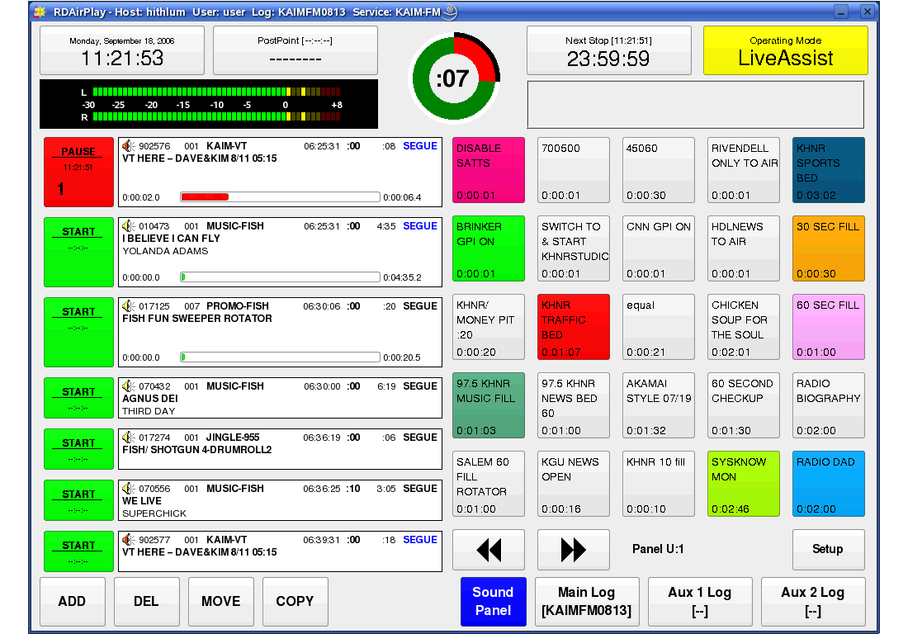

by Fred Gleason

