Rivendell Operations Guide

Version 1.3.3

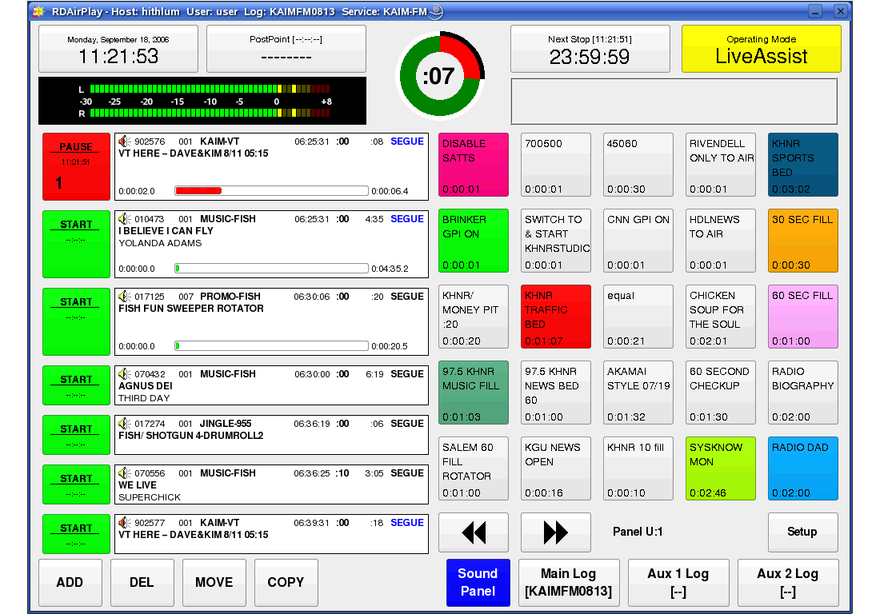

by Fred Gleason

Rivendell Automation System

System Operations Guide

by Frederick F. Gleason, Jr.



Table of Contents

Chapter 1 -- System Overview
Section 1.0 – Introducing Rivendell

Section 1.1 – The Rivendell Security System
1.1.0 Hosts
1.1.1 Users
1.1.2 Groups
1.1.3 Services

Section 1.2 – The Rivendell Hardware Paradigm
1.2.0 Audio Adapters
1.2.1 Serial Ports
1.2.2 GPIO/Switcher Devices

Chapter 2 – Setting the Current User with RDLogin
Section 2.0 - RDLogin

Chapter 3 – Content Management with RDLibrary
Section 3.0 – The Rivendell Library Structure and RDLibrary
3.0.0 Carts
3.0.1 Cuts
3.0.1.0 Multiple Cuts in a Cart
3.0.1.1 Cut Dayparting
3.0.1.2 Cart and Cut Color Coding
3.0.1.3 Recording and Auditioning a Cut in the Record
Dialog

Section 3.1 – Alternative Methods of Audio Ingestion
3.1.0 Importing Audio from a File
3.1.1 Ripping Audio from a CD Track
3.1.2 Ripping Multiple CD Tracks at a Time

Section 3.2 – Macro Carts

Section 3.3 – Navigating the Audio Library
3.3.0 Changing the Cart Sort Order
3.3.1 Selecting Carts by the Filter Field
3.3.2 Selecting Carts by Group
3.3.3 Selecting Carts by Type
3.3.4 Selecting and Opening Carts

Section 3.4 – Library Maintenance
3.4.0 Editing Markers
3.4.1 Copying and Pasting Audio from Cut to Cut

Section 3.5 – Generating Library Reports
3.5.0 The Cart Report
3.5.1 The Cut Report
3.5.2 The Cart Data Dump

Chapter 4 – Automating Tasks with RDCatch
Section 4.0 – Choosing the Correct Automation Tool

Section 4.1 – The RDCatch Main Window
4.1.0 The Record/Play Out Deck Area
4.1.1 The Filter Area
4.1.2 The Event List
4.1.3 The Button Area

Section 4.2 – Adding New Events

Section 4.3 – Automating Recordings
4.3.1 The 'Start Parameters' Section
4.3.2 The 'End Parameters' Section
4.3.3 Programming Multiple Recordings in a Single Event
4.3.4 Selecting a Record Source
4.3.5 Selecting a Record Destination
4.3.6 Setting the Active Days for a Recording
4.3.7 Record List Management with Event Active and Make OneShot

Section 4.4 – Automating Play Outs

Section 4.5 – Automating Uploads/Downloads

Section 4.6 – Automating Macro Execution

Section 4.7 – Automating Switcher Operations

Chapter 5 – Creating and Maintaining Logs with RDLogEdit
Section 5.0 – Logs and Log Events
5.0.1 Audio Carts
5.0.2 Macro Carts
5.0.3 Note Markers
5.0.4 Track Markers
5.0.5 Chain Events
5.0.6 Import Links

Section 5.1 – Event Transitions
5.1.1 The PLAY Transition
5.1.2 The SEGUE Transition
5.1.3 The STOP Transition

Section 5.2 – Time and Time Types
5.2.1 The Relative Time Type
5.2.2 The Hard Time Type
5.2.2.1 Start Immediately
5.2.2.2 Cut to the Event (“Make Next”)
5.2.2.3 Wait N Seconds

Section 5.3 – Editing Log Event Parameters
5.3.1 Specifying a Cart
5.3.2 Specifying Meta Event Parameters
5.3.3 Rearranging Log Events
5.3.4 Saving or Abandoning Changes to a Log
    - Missing/Invalid Cart Events

Section 5.4 – Generating Log Reports
5.4.1 Log Listing
5.4.2 Log Exception Report

Section 5.5 – Auditioning Audio

Chapter 6 – Running Logs with RDAirPlay
Section 6.0 -- Overview
Section 6.1 – Log Machines
Section 6.2 -- Layout
6.2.0 The Wall Clock
6.2.1 The Post Point Counter
6.2.2 The Audio Meter
6.2.3 The Pie Wedge Widget
6.2.4 The Next Stop Counter
6.2.5 The Mode Indicator
6.2.6 The Label Area
6.2.7 The Right-Hand Side
6.2.8 The Full Log Widget
6.2.9 The Button Log Widget

Section 6.3 – Editing a Log
6.3.0 Adding an Event
6.3.1 Moving an Event
6.3.2 Deleting an Event
6.3.3 Copying an Event
Section 6.4 – The SoundPanel
6.4.0 Panel Types
    - Programming a SoundPanel Button

Chapter 7 – Generating Logs with RDLogManager
Section 7.0 -- Overview
Section 7.1 -- Grids
Section 7.2 -- Clocks
Section 7.3 -- Events
Section 7.4 – Generating Logs
Section 7.5 – Generating Reports
7.5.0 Purging Old Report Data

Chapter 8 – Voice Tracker
Section 8.0 – Voicetracking in Rivendell
8.0.1 Prerequisites
8.0.2 Voice Track Markers
Section 8.1 – Using the Voicetrack Interface
8.1.0 The Voicetracker Dialog
8.1.1 Editing Transitions
8.1.2 Inserting and Deleting Track Markers
8.1.3 Moving Between Track Markers
8.1.4 Recording a Voicetrack
8.1.5 Adjusting Transition Levels
8.1.6 Importing Voicetracks
8.1.7 Hitting the Post

Chapter 9 – Rivendell Macro Language (RML)
Section 9.0 – Overview
Section 9.1 – Command Structure
Section 9.2 – Specifying Color
Section 9.3 – Available Commands
Section 9.4 – RML Command Index

Chapter 10 – Interfacing with the Linux Ecosystem: RMLSend and RDImport
Section 10.0 – RMLSend
Section 10.1 – RDImport

Appendix A – The GNU General Public License, Version Two

Appendix B – The Creative Commons Non-Commercial ShareAlike License 2.5

Change History

Chapter One
System Overview

Section 1.0 Introducing Rivendell
Rivendell is a digital audio content management and delivery system that is targeted for use in professional radio broadcast environments. It includes robust tools for the acquisition, organization, management and play out of audio material from and to a diverse array of sources and destinations. Support for a wide variety of external third party hardware devices and software packages commonly used in the radio industry is featured, including interfaces for:

- Audio Routing Switchers
- Satellite Down Link Receivers
- Audio Mixing Consoles
- Commercial Traffic and Music Scheduling Systems

Rivendell is made available under the terms of the GNU General Public License version 2 (GPLv2), a copy of which can be found in Appendix A. As such, it comes with absolutely no warranty, not even the implied warranties of merchantability or fitness for a particular purpose. See the full text of the GPLv2 for details.

Rivendell has been designed and developed from the ground up to run on the popular and highly stable GNU/Linux operating system. Selected tools (mostly having to do with log generation) have also been ported to run in the Microsoft Windows environment as well. Full source code as well as binary installation packages for Windows and select Linux distributions are available on line. Consult the Rivendell Technical and Administration Guide for details.

Rivendell has been designed to be able to operate in a wide variety of roles, ranging from single, self-contained workstations to large, multi-station clusters consisting of multiple workstations and centralized servers. Also included are redundancy and hot-standby capabilities to allow for reliable operation even in the presence of hardware faults. Details can be found in the Rivendell Technical and Administration Guide.

Rivendell is implemented as a set of interactive tools or 'modules' that collectively provide the complete functionality of the system. Briefly, these modules and their functions are:
RDAdmin – System wide configuration
RDLibrary – Library content management
RDCatch – Automatic event scheduler
RDAirPlay – On-air play out application
RDLogEdit – Simple log editing tool
RDLogManager – Automated log generation and interface utility
RDLogin – Set the current user on a Rivendell host
The operation of each of these modules is explained in detail in the chapters that follow. However, we first need to cover some basic concepts common to all Rivendell modules.

Section 1.1 The Rivendell Security Paradigm
All Rivendell modules make use of the following four classes of system resources:

- Hosts
- Users
- Groups
- Services

We'll cover each of these concepts in turn.

1.1.0 Hosts
Every physical computer within a given network that is running Rivendell software is referred to as a host. Any host in a Rivendell network can be individually configured and controlled from any other host (provided the system administrator has enabled this capability). Hosts can be used for a wide variety of applications, including content ingestion and management, automatic recording (sometimes referred to as netcatching), on-air play out or log (sometimes also referred to as playlist) generation. It is also possible for a single host to perform all of these functions.

1.1.1 Users
Every host on a Rivendell network has one or more users available to it. In this context, a 'user' is merely a set of access policies established by the system administrator that defines what tasks a given host is or is not allowed to perform. Every host has at least one user, called the default user. As the name suggests, this is the set of user policies that are loaded by default when the system starts up. It is also possible to change the user currently in use on a given host by running the RDLogin module.

1.1.2 Groups
A Rivendell group is a system of categories that is used by the audio library to classify and organize the audio within the library. Groups are a very powerful capability, and many operations within Rivendell can be specified on the basis of group membership. The actual classification scheme, including the number of available groups and their names, is completely arbitrary so as to allow each facility to tailor a schema that best fits its own operational requirements. Designing and implementing the group schema is one of the most important tasks facing the Rivendell system administrator, as a well-designed schema can make long-term maintenance and management of the system substantially easier vis-a-vis a poorly thought out one. We will cover groups in detail in the chapters devoted to the RDLibrary and RDAdmin modules.
1.1.3 Services
Every facility at which Rivendell is deployed is presumed to have one or more ultimate destinations for which audio is intended. These could be radio stations (e.g. WAVA), satellite uplink channels, live Internet audio streams, or any mix of the above. Each of these sorts of destinations is referred to in Rivendell as a service, and certain parameters, particularly as regards audio play out and log (playlist) creation, can be configured on the basis of what particular service is being referenced.

Section 1.2 The Rivendell Hardware Paradigm
In addition to the core computer hardware (CPU, motherboard, etc), each Rivendell host typically interacts with specialized hardware required to accomplish the task at hand. Three main categories of such 'special' hardware are of interest to us here, the three being audio adapters, serial ports and GPIO/switcher devices. We'll cover each below.

1.2.0 Audio Adapters
An audio adapter in Rivendell is simply a device or facility for getting audio into and/or out of a host on a realtime basis. Most commonly this will be a sound card, although other, more exotic possibilities (using TCP/IP networking or direct routing to other audio applications) also exist. The three main classes of audio adapters supported by Rivendell are:

Advanced Linux Sound Architecture (ALSA) – The standard Linux sound card driver starting with the 2.6.x kernel series, ALSA supports a huge array of commercially available sound cards, ranging from entry level 'game' cards to high-end cards aimed at professional audio uses. More information, including a current list of supported cards, is available at the ALSA web site, http://www.alsa-project.org/.

HPI Adapters – These are high-performance sound cards manufactured by AudioScience Corporation. Designed and built specifically for broadcast automation applications, many feature advanced capabilities (such as on-board MPEG codecs and AES3 i/o) specially aimed for use in that setting. They are so-called because Rivendell uses AudioScience's special 'HPI' driver to access and control them. More information is available at AudioScience's web site, http://www.audioscience.com/.

JACK Audio Interconnect Kit – JACK is not a particular set of hardware devices, but rather an audio 'framework' that allows compliant applications to share audio resources and route audio in realtime amongst themselves. JACK is different from similar efforts within the Linux realm in that it was designed from the ground up for professional audio work, with particular focus upon low-latency operation and synchronous execution of all clients. More information can be found at the JACK web site, http://jackit.sourceforge.net/.

1.2.1 Serial Ports
Commonly known in the DOS/Windows world as 'COM ports', serial ports are often used to communicate with outboard gear, such as satellite receivers and audio switchers. Up to eight serial ports can be accessed simultaneously by each Rivendell host.

1.2.2 GPIO/Switcher Devices
Because these capabilities are often (although not always) bundled together in the same device, Rivendell lumps GPIO and switcher devices together within the same class. 'GPIO' stands for 'General Purpose Input Output'. As the name implies, these devices can be used to interface to a huge variety of outboard equipment by means of control lines. GPI (General Purpose Input) lines can be used to sense changes in an outboard system's state (and Rivendell programmed to take various actions on the basis of that), while GPO (General Purpose Output) lines can be used to send commands to an outboard system. The actual physical interfacing of GPIO devices is complex and generally beyond the scope of this document. Readers are encouraged to consult a good handbook on radio engineering for more information. A current list of GPIO/Switcher devices supported by Rivendell can be found in 'docs/GPIO.txt' file in the Rivendell sources.

Chapter Two
Managing the Current User with RDLogin

Section 2.0 RDLogin
Rivendell uses a sophisticated system of user privileges to keep track of which users have permission to perform what operations. These privileges are tracked by the system on the basis of user accounts. Creating user accounts and administering their permissions are done in the RDAdmin module and are covered in the Rivendell Technical and Administration Guide.

It's important to note that these user accounts are not the same thing as the “Login Name” that is used to log into the computer system itself. Rather, they exist and have meaning only within the Rivendell system. For the rest of this discussion, when we talk about “users”, it is these “Rivendell users” that we are referring to.

Each Rivendell host has a default user. As the name implies, this is the user that is automatically logged in after the system is booted. By default, the name of this user is “user”, but the system administrator may have changed this to some other name.

For many sites, a single default user is all that is ever required. For some sites however, particularly larger ones, it is desirable to have multiple user accounts, each tailored to a particular person or “role”, with privileges assigned appropriately. Such sites require a means to log different users in and out of the system, without interfering with any playout operations that may be ongoing at the time. RDLogin is the module for doing this.

RDLogin will display a small window after being started, showing the currently logged-in user (see Illustration 1). To change to a different user, select the desired user name from the Username: control, enter the correct password, and then touch the Set User button. To “log out” of the system (in reality, just return to the default user), simply touch the Default User button (no password is required to set the default user). To exit RDLogin and do nothing, simply touch the Cancel button.

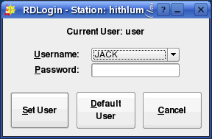Illustration 1: The RDLogin Window

Chapter Three
Content Management with RDLibrary

Section 3.0 The Rivendell Library Structure and RDLibrary
3.0.0 Carts
The Rivendell Library consists of a set of objects called carts. A cart is a data container that holds either one or more pieces of audio (called an audio cart), or macro commands to the system (called a macro cart). The cart is the fundamental schedule building block in Rivendell, in that it is the smallest object or 'atom' that the outside world (like a traffic or music scheduler) can see.

RDLibrary, upon startup, will show the current list of all carts on the system, as in Illustration 2 below:

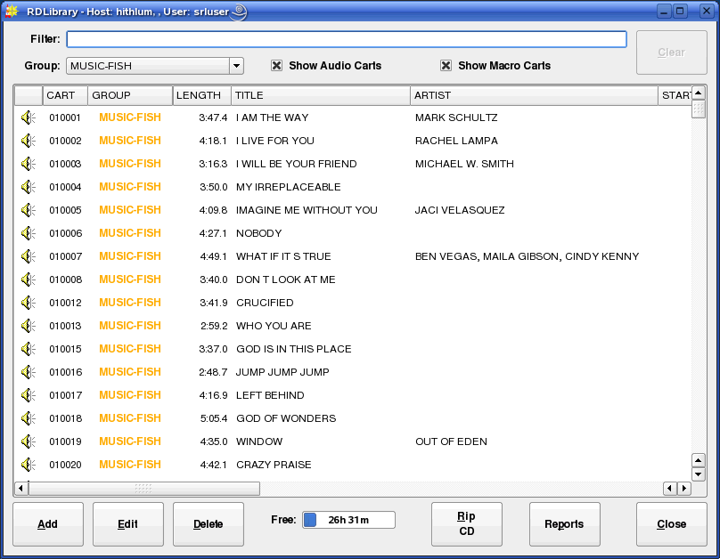Illustration 2: The RDLibrary Cart List

A number of important attributes of carts can be seen from this illustration. First is the cart's number. Each cart in the Library gets assigned a unique number when it is created. This number can range between 000001 and 999999, and is the primary 'handle' by which both Rivendell and external systems (like traffic or music schedulers) refer to the cart. Very often, sites have specific rules concerning which types of audio (commercials, promos, music, etc) and macros get assigned which numbers. We'll cover this area in some detail when we discuss groups.
Immediately to the left of the cart number is an icon indicating the type of cart.
Just to the right of the cart number is the average length of the cart. Except in the case of where timescaling is in use (in which case it will be indicated in blue numerals), this value is calculated automatically by the system.

Next comes various columns showing information from the cart label – Title, Artist, Client and Agency data, etc. This information can be edited by opening RDLibrary's Edit Cart dialog (Illustration 3), either by double-clicking on the desired cart entry in the list, or by touching the desired cart entry and then touching the Edit button. In either case, you should get a dialog similar to that shown in Illustration 3.
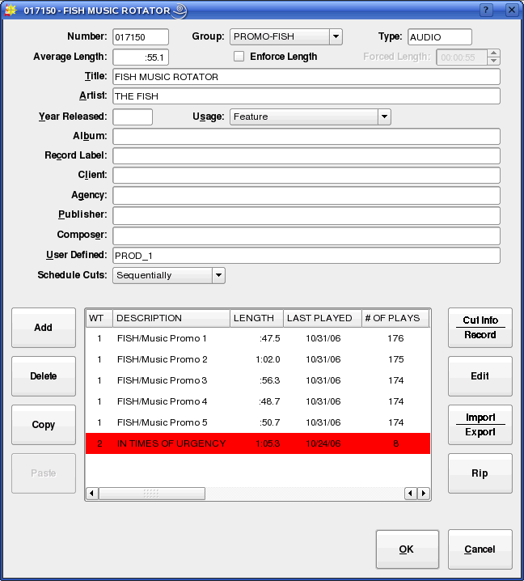Illustration 3: The Edit Cart Dialog
This is how an audio cart looks when loaded into the Edit Cart dialog. The upper half of the dialog is the cart label data. The meaning of most of these fields should be fairly self-evident, but a few call for special comment:

Enforce Length – When checked, this indicates that timescaling should be applied to this cart when it is played in RDAirPlay, meaning that the cart will air at the length indicated by the Forced Length field, rather than the native length of the audio. Care is needed when implementing timescaling within a facility, as there are limits to how much the length can be altered, while only certain types of audio adapters support it at all. See the Rivendell Technical Guide for more information.

Group – This is a pull down menu by which the group ownership for the cart can be set. The system administrator configures the list of available groups for each user in RDAdmin.

User Defined – As the name implies, this field has no dedicated meaning to Rivendell itself, but is provided for each site to use as is seen fit.

The example in Illustration 3 shows an audio cart. As such, the bottom half of the dialog displays the lists of cuts contained within the cart.

3.0.1 Cuts
Each audio cart can contain one or more cuts. A Rivendell cut is an actual piece of audio, somewhat analogous to a 'track' on a CD. Up to 999 such cuts can exist within a single cart. Each line in the cut list contains information about the cut, including:

Description – An arbitrary name, assignable by the user as an aid in keeping track of the content, it is roughly analogous to the 'Title' field in the cart label.

Length – The actual, measured play out length of the cut audio. This field is set automatically by the system.

Last Played – The last date and time that the cut was aired by the RDAirPlay module. Useful for keeping track of stale inventory.

# Of Plays – The total number of times the cut has been aired by the RDAirPlay module.

Origin – The name of the host upon which the audio in the cut was last recorded, along with the date and time.

Outcue – A user settable field. This line shows up in the RDAirPlay log when the cut is played.

3.0.1.0 Multiple Cuts in a Cart
What happens when more than one cut is placed into a cart? The answer, in a word, is rotation. Rotation is the ability to schedule a single cart in a log, but to have that cart play out different material at different times. This capability has a myriad of uses. One of the simplest, common in commercial radio facilities, is to allow multiple versions of a spot to be placed into the system, while still allowing the traffic department to have to track and schedule only one cart number. A more sophisticated use involves use of the cut's dayparting settings, forcing different cuts to play based upon certain date/time criteria, such as day of the week or time of day. Cut dayparting is a very powerful feature in Rivendell, and is something we will discuss shortly.

To edit the properties of a cut, either double-click its entry in the cut list, or touch it once to highlight and then touch the Cut Info/Record button. The Record Dialog (Illustration 4) will now open up.

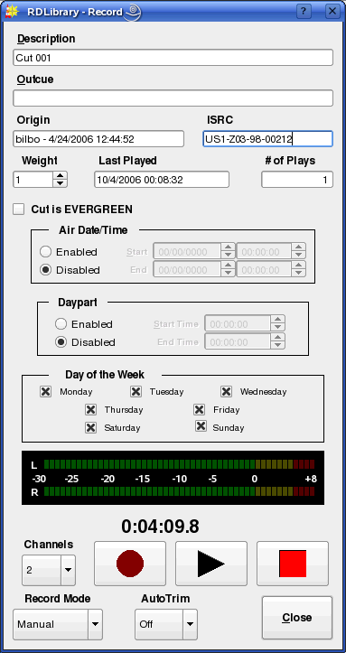Illustration 4: The Record Dialog

Roughly the upper third of the dialog is for editing the various cut parameters, the middle section is for configuring the cut's daypart settings, and the bottom third is a record machine that can be used both to record new audio into the system and to audition any recording already made.

3.0.1.1 Cut Dayparting
Each cut in Rivendell can be dayparted on the basis of three parameters:

- Absolute Start and End Date-Time
- Relative Start and End Time
- Day of the Week

By default, each newly created cut starts out with dayparting disabled, meaning that it will be 'eligible to play' at all times. By clicking the Enabled button in the Air Date/Time box, an absolute start and end date for the cut can be entered, meaning that the cut will be prevented from airing in the RDAirPlay module at any time outside the range of those date-times. Likewise, by selecting the Enabled button in the Daypart box, start and end times (relative to the day the cut is to air) can be entered. Cuts designated in this way will be allowed to air only within the specified range of times. Finally, by selecting or clearing the appropriate boxes in the Day of the Week box, a cut can be designed to air only on certain days of the week.

All of the dayparting parameters can be used either singly or in combination with each other. When combined, the resulting 'eligibility' is calculated as the logical AND of the applied dayparting limits. For example, a cut with the 'Monday' box cleared will refuse to air on Mondays, regardless of whether any of the other daypart rules match.

It's important to remember that dayparting rules affect audio play out only within the RDAirPlay module. You will still be able to audition and play the audio without limitation in the other Rivendell modules.

3.0.1.2 Cart and Cut Color Coding
Each cart or cut in RDLibrary is assigned a color to indicate it's 'playability' for air, as follows:

- NO COLOR – Event will play normally
- RED – Event will not play (due to dayparting or lack of audio)
- GREEN – Event will play an Evergreen

It's important to remember that the color displayed for each event indicates playability at the instant that the event is being viewed.

3.0.1.3 Recording and Auditioning a Cut in the Record Dialog
The lower third of the Record Dialog is used both to audition and record audio. To audition the cut, simply press the play button (the one with the triangular symbol). The button should illuminate, audio should show on the bar meter and start playing immediately. The audio will play to completion, unless either the stop button (square symbol) is pressed, or the Record Dialog is closed.

To record new material into a cut, first ensure that the Channels drop-down menu is set to record the appropriate number of channels, then touch the record button (round symbol). If the cut contains audio that was recorded previously, a warning box will pop up at this point to inform you of this and to give you a chance to abort the recording without erasing what was previously recorded. If Yes is selected here, the previous recording will be overwritten and no longer accessible. The record button should now be illuminated steadily, while the play button will be flashing, indicating that the record machine is in 'ready' mode. The bar meter will also be active to indicate input levels, and this is the point where you want to verify that your levels are correct, with peaks just into the yellow area being optimal. Nothing is actually being recorded just yet.

We have two options for actually starting the record machine. We can start it manually by pressing the play button, at which point the machine will immediately begin recording, or we can set the Record Mode drop-down menu to the VOX (short for voice activated) setting. When in VOX mode, the record machine will start automatically as soon as it senses the presence of audio at the input.

Once started, recording will continue until either the stop button is pushed, or the maximum allowed length for a manual recording (set by the system administrator) has been reached. Once stopped, if the AutoTrim drop-down menu has been set to On, the Start and End markers will be automatically set to the beginning and end of detected audio within the cut. (We will discuss Markers in detail when we get to the section on the Edit Markers dialog).

Section 3.1 Alternative Methods of Audio Ingestion
In addition to manually recording material in realtime, RDLibrary supports two alternative methods for audio ingestion:

- Importing from a File
- Ripping from a CD

3.1.0 Importing Audio from a File
To import audio from a file directly into a cut, we start by opening the cut's parent cart in the Edit Cart Dialog. Next, touch the cut's entry in the cut list and then touch the Import/Export button to open the Import/Export Audio Dialog (Illustration 5).

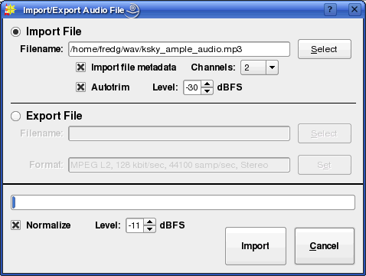Illustration 5: The Import/Export Audio Dialog

Select the file you wish to import, either by entering the path and filename to it in the Filename field or by clicking the Select button to open a file browsing dialog. Rivendell is capable of importing the following types of audio files:

- Microsoft WAV (*.wav) – Both PCM16 and MPEG supported
- MPEG (*.mp1, *.mp2, *.mp3)
- OggVorbis (*.ogg)
- Free Lossless Audio Codec [FLAC] (*.flac)

Next, set the Channels drop-down menu to the appropriate number of channels. You may also wish to adjust the Normalize or Autotrim controls, although these will normally be set to reasonable default values by the system administrator and should seldom have to be altered. If Normalize is selected, then the imported audio will be peak normalized to the level indicated. The Autotrim does the same thing as in the Record Dialog (see section 2.0.1.2, 'Recording and Auditioning a Cut in the Record Dialog' above for details).

Finally, touch the Import button. A progress bar will indicate percentage completion of the import, followed by a popup box to announce completion. The Import Audio Dialog will automatically close after acknowledging completion. The audio is now imported, and can now be auditioned and otherwise processed in the usual way.

3.1.1 Ripping Audio from a CD Track
To rip audio directly off of a CD into a cut, we again start by opening the cut's parent cart in the Edit Cart Dialog. Next, select the cut's by touching the cut's entry in the cut list, and then touch the Rip button to open the Rip CD Dialog (Illustration 6).

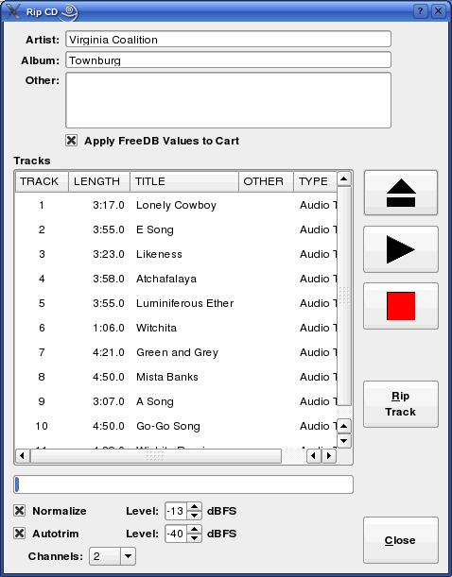Illustration 6: The Rip CD Dialog

Load a CD into the CD drive. After a few seconds, list of tracks should appear in the Tracks area. If the system administrator has enabled the FreeDB CD Lookup Service, the names of the various tracks may appear as well.

Set the Channels, Normalize and Autotrim controls appropriately (see section 2.1.0 for more details on using the Normalize and Autotrim controls). Next, touch the track you wish to rip and then press the Rip Track button. The track will now be ripped into the cut, with a progress bar keeping you informed of progress. When the rip is complete, a message box will pop up to inform you of this.

If FreeDB data was found for the CD, you can have the FreeDB track, artist and album names be automatically placed on the cart label for the cart by checking Apply FreeDB Values to Cart before closing the Dialog.

3.1.2 Ripping Multiple CD Tracks at a Time
Sometimes, when transferring multiple audio tracks from CD, it's more convenient to be able to set up the entire transfer at once and then let the rip run in a 'batch' mode. RDLibrary is capable of ripping audio in this manner as well. To do this, click the Rip CD button near the bottom of the main RDLibrary screen, bringing up the Rip Disk Dialog (Illustration 7).

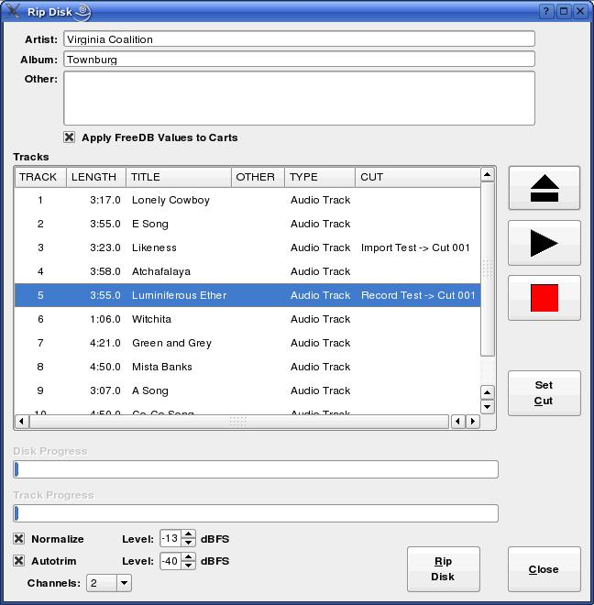Illustration 7: The Rip Disk Dialog

This dialog is similar in many ways to the Rip CD Dialog described above, except that each track can be assigned to transfer to a different cut by double clicking on its listing, or by touching the listing and then the Set Cut button, bringing up the Select Cut Dialog (see Illustration 8).

The destination cut is selected by first choosing the cart from the left-hand pane, followed by the desired cut within that cart on the right-hand pane. The complete set of library filtering tools are available to you here – see section 2.2, 'Navigating the Audio Library' for details on their function, just as in the main RDLibrary screen.

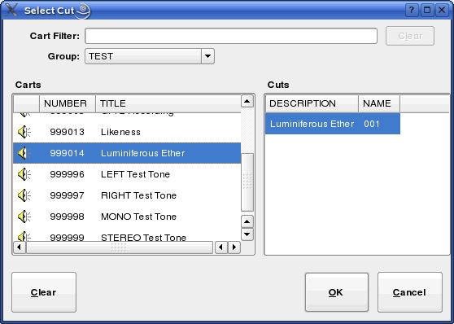Illustration 8: The Select Cut Dialog

Once all of the desired tracks have been assigned to cuts, be sure that the Normalize, Autotrim, Channels and Apply FreeDB Values to Carts controls have been set as desired, then click the Rip Disk button. A set of progress bars will keep you informed of the progress of each track, as well as overall progress. When, the rip is finished, a message box will let you know.

Section 3.2 Macro Carts
A macro cart is a cart that contains one or more commands written in Rivendell Macro Language (or 'RML' for short). The Edit Cart dialog for a macro cart is similar in many ways to that for an audio cart with the exception of the lower half, which contains a list of RML commands to be executed rather than a list of cuts (see Illustration 9). (NOTE: for a complete description of Rivendell Macro Language, including a breakdown of available commands, see Chapter Nine).

To add a new line of RML, select the desired location in the list and touch the Add button. Similarly, a line can be deleted by selecting it and then touching the Delete button, or modified by touching the Edit button. The RML can be tested, eight line-by-line or as a whole by touching the Run Line or Run Cart button respectively. It is also possible to Copy and Paste individual lines both within a given cart or between carts.

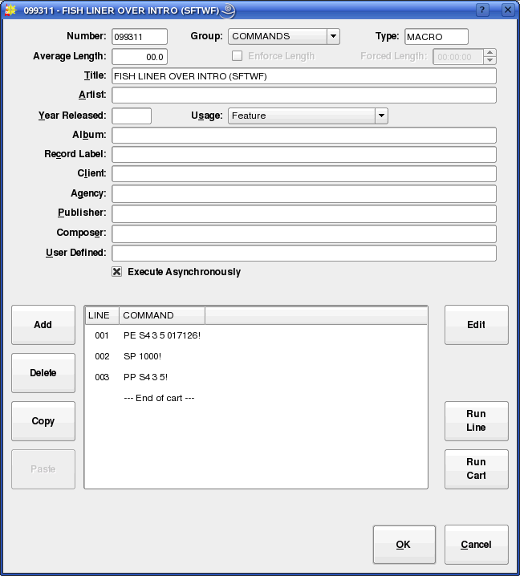Illustration 9: The Edit Cart Dialog for Macro Carts

Section 3.3 Navigating the Audio Library
The uppermost section of RDLibrary's main window contains tools designed to allow for fast searching of the entire audio library, making locating a particular piece of audio easy even in a library containing thousands of carts. It's possible to control what carts are listed, as well as how they are sorted.

3.3.0 Changing the Cart Sort Order
The order in which carts are displayed in the cart list can be changed by simply clicking on the header of the column by which you want them sorted by. By default, the carts are sorted by Cart Number. To instead sort them alphabetically by Title, simply click the TITLE header once. To sort them by Title in reverse –i.e. from 'Z' to 'A' – click the TITLE header once again. Clicking the TITLE header a third time restores the sort to normal 'A' to 'Z' again. And so on for all of the columns in the cart list – it's possible to sort the Library by Artist, Length, or any other parameter shown in the cart list.

3.3.1 Selecting Carts by the Filter Field
Very often, one will want to find a cart or set of carts whose label(s) contains a particular word or phrase. It's possible to narrow the list of displayed carts to this set by simply entering the desired word or phrase into the Filter field at the top of the main RDLibrary screen. The full list can be restored by clearing the Filter field or by clicking the Clear button.

3.3.2 Selecting Carts by Group
It's possible to limit the list of carts to only those in a particular group by setting the Group drop-down menu to the desired group name.

3.3.3 Selecting Carts by Type
You can tell RDLibrary what type of carts to list by checking the Show Audio Carts and Show Macro Carts boxes. Clearing both boxes obviously results in no carts at all being displayed.

It's also possible to combine all four of the above search and sorting methods.

3.3.4 Selecting and Opening Carts
Once the desired cart has been located on the cart list, load it into the Edit Cart Dialog (Illustration 3) by either double clicking its list entry, or by touching its list entry and then touching the Edit button.

Section 3.4 Library Maintenance
3.4.0 Editing Markers
Rivendell uses a system of cue points within audio cuts, referred to as markers. Markers can be used to specify a number of parameters for a piece of audio. Table One shows what markers are available, their purpose and their corresponding color.

Markers are set in the Edit Markers Dialog (see Illustration 10). To access the Dialog, open an audio cart, select the cut to open on the cut list and then touch the Edit button.

The Dialog is divided into three areas: the waveform area in the upper half, consisting of the waveform display and Amplitude and Time buttons; the transport controls area in the center, consisting of Start, Pause, Stop and Loop buttons along with an audio meter; and the marker button area in the lower third of the window, consisting of controls for selecting and positioning markers.
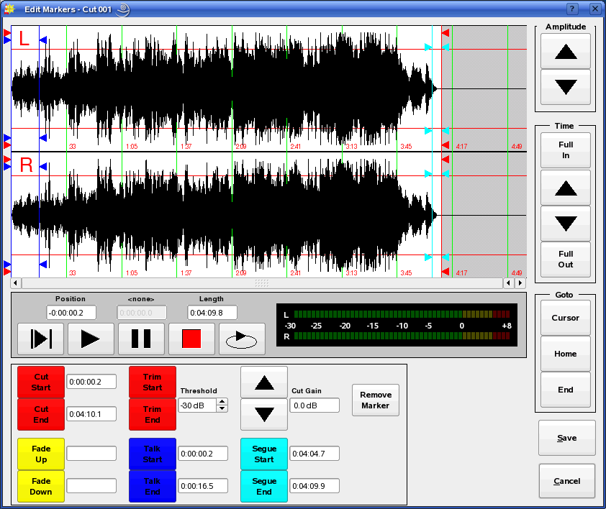Illustration 10: The Edit Markers Dialog

It's possible to 'zoom-in' on the waveform in various ways by clicking the Amplitude and Time buttons. By default, the waveform is displayed fully 'zoomed-

out', thus showing the entire length of the audio cut. The GoTo buttons can be used to jump directly to the current play out cursor position, start or end of the waveform.

Audio can be played one of two ways: either by clicking on the waveform to indicate where play out should start and then clicking the left-hand Play button,
causing play out to start from the selected position, or by clicking the right-hand Play button, which will cause play out to start from the Start Marker (just as it would in RDAirPlay). Clicking the Pause button while playing will cause audio to stop and the play out cursor (a thin vertical black line in the waveform area) to freeze at its current position, while pressing the Stop button will stop the audio while resetting the play out cursor to the position it was in when Play was started. Clicking the Loop button will cause the audio to play out continuously, looping from end back to start, until either the Stop, Pause, Save or Cancel buttons are clicked.

To set a marker, click on the corresponding marker button and then left-click on the waveform area to indicate where on the audio the marker should be placed. (NOTE: With the exception of the FadeUp and FadeDown markers, all markers in

Marker Type | Function | Color
Start / Stop | Indicates start and end points of audio. | RED
TalkStart / TalkStop | Indicates point to start and stop the Talk Counter in RDAirPlay. | BLUE
SegueStart / SegueEnd | Indicates the start and end of the audio overlap during Segue transitions in RDAirPlay. | CYAN
HookStart / HookEnd | Not used at present. | VIOLET
FadeUp | Indicates the point at which audio should be faded up to full level after starting in RDAirPlay. | YELLOW
FadeDown | Indicates the point at which audio should start fading down to off before ending in RDAirPlay. | YELLOW
Table 1: Rivendell Marker Types
Rivendell are assigned in pairs. For example, placing a TalkStart marker will also cause a TalkEnd marker to be placed.) Markers that have already been placed can be moved by selecting the appropriate marker button and then dragging the marker to the desired location. It's also possible to specify the position of a marker in the form of hh:mm:ss.s (relative to time after the Start marker) by entering the desired value next to a selected marker button. It is also possible to remove a set of markers that have already been placed, either by accessing the marker menu by doing a right-click on the waveform display, or by touching the Remove Marker button and then touch the marker button corresponding to the marker to be removed. (NOTE: the exceptions to this are the Start / End markers, which are always present and hence cannot be removed.)

As an aid for accurately setting the Start and End markers, it's possible to use the Trim Start and Trim End buttons to automatically set the markers to the first and last instances of the level specified by the Threshold field, respectively.

3.4.1 Copying and Pasting Audio from Cut to Cut
It's possible to make copies of existing an audio cut on the system by opening up the cut's parent cart in the Edit Cart Dialog, selecting it on the cut list and clicking the Copy button. To paste the copied audio, simply select the desired destination cut (within the same cart or a different one) and press Paste.

Section 3.5 – Generating Library Reports
Various Library reports can be generated by touching the Reports button on the main RDLibrary screen and then selecting the desired report and touching the Generate button. The following reports are available:

3.5.0 The Cart Report
The cart report consists of a list of all selected carts on the system, with their attributes.

3.5.1 The Cut Report
The cut report consists of a list of all cuts contained by the selected carts on the system, with their attributes.

3.5.2 The Cart Data Dump
The cart data dump is a special type of report that consists of column-aligned data elements, one line per cut for the selected carts on the system. It is intended for use where a 'dump' of available carts in the system is desired for import into an external system (such as a music scheduling system).

Chapter Four
Automating Tasks with RDCatch

Section 4.0 Choosing the Correct Automation Tool
Rivendell includes two modules specially optimized for performing automatic operations: The RDCatch and RDAirPlay modules. The two modules take radically different approaches in how they go about organizing and controlling operations, so a few words regarding each may be in order here.

RDCatch is aimed at executing actions on the basis of a strict time-based schedule, referred to as an event list. Each action (which can be a recording, a play out, an up- or download, a macro execution or an operation on an audio switcher device) executes on the basis of its scheduled time in the event list, independently of all other actions. As such, RDCatch is often best suited for use in settings such as network head end operations or 'auxiliary' roles at broadcast stations, where the transitions between events are generally not an important part of the presentation.

RDAirPlay takes a very different approach, in that most events are organized into one or more playlists or logs. A Rivendell log is a list of one or more carts, organized in chronological order. As the name implies, RDAirPlay is optimized for use in situations where the transitions between the various program elements are a key part of the delivery and presentation of the content, such as in live air play environments.

Of course, it's entirely possible to use both modules, even together on the same machine at the same time – the Linux OS makes for a very robust and capable multitasking system.

Section 4.1 The RDCatch Main Window
After starting up RDCatch, you should see the main RDCatch window, looking something like Illustration 11. The window consists of four areas: the record / play out decks at the top, the filter areas just below the decks, the events list and the audition buttons and other buttons at the bottom. We'll cover each of these in turn.

4.1.0 The Record / Play Out Deck Area
If the system administrator has configured one or more RDCatch record or play out decks, they will be visible at the top of the RDCatch main window. A record deck is a virtual 'recorder' that can be used to make automated recordings, while a play out deck can be used to automatically play out audio. It does not matter on which particular host a particular deck 'resides' – all Rivendell decks throughout the system are visible in RDCatch, regardless of which host it is run upon.

Starting at the left-hand edge of each deck, there is the deck's name, consisting of the name of the deck's host machine followed by a number and a letter, an 'R' to indicate a record deck and a 'P' to indicate a play out deck. Next, for record decks, there is a MON button, used to monitor the audio present at the deck input, followed by an ABORT button, used to manually stop an event running in the deck. A description of the currently running event next appears (this area will be blank if no event is currently active), followed by the deck's status, which could be any of the values shown in Table 2.

STATUS | MEANING
IDLE | The deck is available for events
READY | The deck has started monitoring audio but the transport is not yet rolling (record decks only).
WAITING | The deck is waiting for a GPI event (record decks only)
RECORDING | The deck is recording (record decks only).
PLAYING | The deck is playing out (play out decks only).
OFFLINE | The deck is configured but not available.
Table 2: RDCatch Deck Statuses

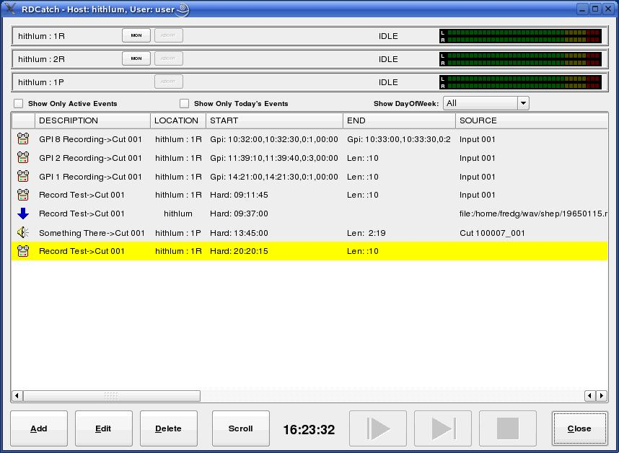Illustration 11: The RDCatch Main Window

Finally, each deck has an audio meter on its right-hand end, used to verify audio levels in realtime.

4.1.1 The Filter Area
Immediately below the decks is the filter area, consisting of the Show Only Active Events, Show Only Today's Events and Show DayOfWeek controls. These controls are used to select which events will be visible in the events list area immediately below.

4.1.2 The Event List
The event list is a system wide list of all events to be executed by RDCatch on all of the various hosts on the Rivendell network, with each event occupying a single line. The status of each event is indicated by its background color, as shown in Table 3.

COLOR | MEANING
YELLOW | The event is next to be executed.
GREEN | The event is active.
CYAN | The event is in the READY state.
VIOLET | The event is in the WAITING state.
RED | The event is reporting an error.
Table 3: RDCatch Event List Colors

Each entry in the event list starts with an icon that indicates the type of the event, as shown in Table 4.

Record Event
Play Out Event
Switch Event
Macro Event
Upload Event
Download Event
Table 4: RDCatch Event Icons

Next on each line comes the description (settable by the user) and location for the event, the location being the name of the host/deck where the event will run. Then, comes the start and end parameters. These time-based parameters come in one of three different forms: a hard time, which is simply an absolute time (in twenty-four hour 'military' format), a length (in HH:MM format, relative to an earlier start time), or a GPI start. The GPI parameters can be somewhat involved. They are specified in the following format:

Gpi: <start-time>,<end-time>,<gpi-num>,<wait-time>

Where:
<start-time> The time, in HH:MM:SS format, when RDCatch will start looking for a GPI
event (also sometimes referred to as the window start time).

<end-time> The time, in HH:MM:SS format, when RDCatch will stop looking for a GPI
event (also sometime referred to as the window end time).

<gpi-num> The number of the GPI event to wait for, in the format MATRIX:LINE. We will
deal with GPI matrix and line numbers in detail when we cover RDAdmin.

<wait-time> The amount of time to wait, in MM:SS format, between the reception of the GPI
event and the actual start of the event (used only for Start parameters).

For example, the start parameter 'Gpi: 14:00:00,14:05:59,0:1,01:00' has a window start time of 14:00:00 [2:00:00 PM], a window end time of 14:05:59, looks for a GPI event on line 0:1 and will wait one minute [01:00] after receiving the GPI before starting the event.

Next come the source and destination fields. The uses of these will vary depending upon what type of event is being listed, but should normally be fairly self-evident. For example, for a record event, the source field indicates the audio source from which the recording is to be made, while the destination indicates the cat/cut combo to which the recording should be made. Some events may leave one or the other of these fields blank.

Now come the day of the week fields. These indicate on which days of the week the listed event should be executed, followed by the origin field, which is simply a readout of the Origin data of the events underlying cut. There are a number of other fields which follow, but these are less important for understanding the operation of RDCatch.

4.1.3 The Button Area
At the bottom of the main window are various buttons. On the left-hand side, the Add, Edit and Delete buttons are used to manage events in the event list. Clicking the Scroll button toggles RDCatch into and out of 'scroll mode'. In this mode, the event list display will be advanced automatically so as to keep the first actively running event centered within the event list area.

On the right hand side, in addition to Close, are three audition buttons. These buttons can be used to audition the head and tail of each cut referenced by an event, thus making it possible to quickly verify that a set of automatic recordings were properly executed.

Section 4.2 – Adding New Events
A new event can be added to the event list by simply clicking the Add button to bring up the Add Event Dialog (see Illustration 12). Simply clicking the button that correspond to the desired type of event will create it.

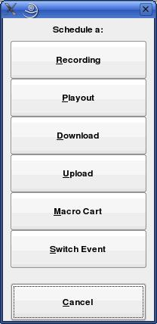Illustration 12: The Add Event Dialog

Section 4.3 – Automating Recordings
Automated recordings are configured by means of the Edit Recording dialog (see Illustration 13), which can be accessed either by clicking the Recording button in the Add Event dialog to create a new record event or by touching the Edit button to modify an existing event.

4.3.1 The 'Start Parameters' Section
The start parameters of each recording are configured in the 'Start Parameters' section. A recording can be programmed to start on the basis of the wall clock time, referred to the hard start time, or upon reception of a general-purpose input, or GPI event originated by a satellite receiver, tone decoder or other external device. Programming a hard start time is merely a matter of entering the desired start time, in 24 hour 'military' format. Programming a GPI start involves, in addition to entry of the GPI parameters themselves (matrix and GPI line numbers) that Window Start and Windows End times be entered, that define the 'window' during which reception of the appropriate GPI event will be 'recognized' by RDCatch. It is also optionally possible to specify a Start Delay between reception of the GPI event and the actual start of the recording.

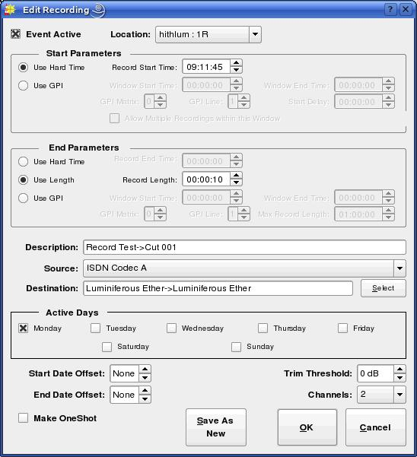Illustration 13: The Edit Recording Dialog

4.3.2 The 'End Parameters' Section
The end parameters of each recording are configured in the 'End Parameters' section. A recording can be programmed to end on the basis of a hard time, its absolute length or in response to a GPI event. Programming of the Hard Time and Length parameters should be fairly self-explanatory, while the parameters needed to program a GPI event are similar to those used for the start parameters, with the exception of the 'Max Record Length' setting, which limits the maximum length of the recording in the event that the expected GPI event is never received.

4.3.3 Programming Multiple Recordings in a Single Event
If a record event is configured to use GPI for its start and Length or GPI for its end parameter, then it is possible to configure the event to make repeated, multiple recordings within a single event by checking the 'Allow Multiple Recordings Within This Window' box in the 'Start Parameters' section. This can significantly reduce the amount of required record events when capturing material with high on-air turnover, such as newscasts or traffic reports.

4.3.4 Selecting a Record Source
If the selected record deck (chosen in the Location drop-down menu at the top of the dialog) as been configured to operate with an audio switcher device, the appropriate audio input can be chosen from the Source drop-down menu.

4.3.5 Selecting a Record Destination
Each programmed recording must have a 'destination', a designated Cart/Cut which will hold the audio. The currently programmed destination is shown in the Destination field, and can be changed by clicking the Select button.

4.3.6 Setting the Active Days for a Recording
A check should be placed next to each day of the week for which a recording should be made in the Active Days box. If no days are checked, then no recordings at all will be made.

4.3.7 Record List Management with Event Active and Make OneShot
The record event will be actually executed only if Event Active (in the upper left corner of the dialog box) is checked. By clearing this box, it's possible to 'bank' a record event without actually having it run, useful for events that are only used sporadically.

For events that need to be executed only once, the Make OneShot box can be checked. Such an event will execute just once, and them automatically delete itself from the event list.

Section 4.4 – Automating Playouts
Automated playouts are configured by means of the Edit Playout dialog (see Illustration 14), which can be accessed either by clicking the Playout button in the Add Event dialog to create a new record event or by touching the Edit button to modify an existing event. The process of configuring a playout is very similar to that for configuring a recording – see the relevant part of Section 3.3, 'Automating Recordings' above for details.

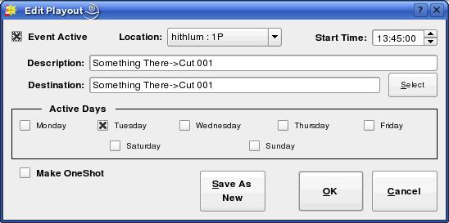Illustration 14: The Edit Playout Dialog
Section 4.5 – Automating Uploads/Downloads
It's possible to use RDCatch to automatically upload and download material from both local and Internet-based servers. Automated downloads are configured by means of the Edit Download dialog, which can be accessed either by clicking the Download button in the Add Event dialog (see Illustration 15) to create a new record event or by touching the Edit button to modify an existing event.

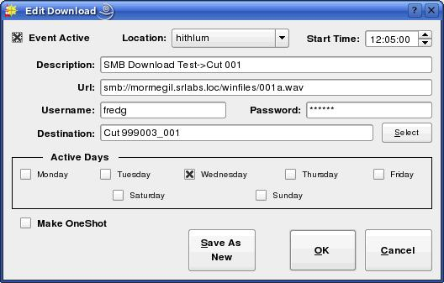Illustration 15: The Edit Download Dialog

With the exception of the Url, Username and Password controls, the process of configuring a download is very similar to that for configuring a recording – see the relevant part of Section 3.3, 'Automating Recordings' above for details.

The Url control is used to specify the Uniform Resource Locater for the material to be downloaded. The following download types are supported: http, ftp, smb and file. The URL field can also include wildcard characters that can be used to construct date-based URLs, as shown in Table 5.

The Username and Password fields are used to indicate the username and password required for access to the server referenced in the URL. For public web pages and anonymous FTP servers, these fields can be left blank.

Automated uploads are configured by means of the Edit Upload dialog (see Illustration 16), which can be accessed either by clicking the Upload button in the Add Event dialog to create a new record event or by touching the Edit button to modify an existing event. The following upload types are supported: ftp, smb and file. As with downloads, the URL field can also include wildcard characters that can be used to construct date-based URLs, as shown in Table 5.

Configuration of an upload event is very similar to that of a download, with the addition of the Export Format control. This is used to set what file format should be used for the upload. Depending upon what software encoders have been installed by the system administrator, the following export types may be available:

- PCM16 Linear (*.wav)
- Free Lossless Audio Codec [FLAC] (*.flac)
- MPEG Layer 2 (*.mp2)
- MPEG Layer 3 (*.mp3)
- OggVorbis (*.ogg)

The desired upload format and parameters are set by clicking the Set button.

WILDCARD | MEANING
%a | Abbreviated Weekday Name (e.g. mon, tue)
%A | Full Weekday Name (e.g. monday, tuesday)
%b | Abbreviated Month Name (e.g. jan, feb)
%B | Full Month Name (e.g. January, February)
%C | Century
%d | Day of the Month, range 01 – 31, with leading zero
%D | Numerical Date, in format mm-dd-yy
%F | Numerical Date in ISO 8601 Format (yyyy-mm-dd)
%g | Two Digit Year, as per ISO 8601
%G | Two Digit Year Number, as per ISO 8601
%H | Hour, range 00 – 23, with leading zero
%j | Julian Day, range 000 – 366, with leading zero
%m | Numerical Month, range 01 - 12, with leading zero
%M | Minute, range 00 – 59, with leading zero
%S | Second, range 00 – 60, with leading zero
%u | Numerical Day of the Week, range 1 – 7, 1 = Monday
%V | Week Number, as per ISO 8601
%W | Same as %V
%w | Numerical Day of the Week, range 1 – 7, 1 = Sunday
%y | Two-Digit Year, range 00 – 99
%Y | Four Digit Year, range 0000 – 9999
%% | Literal '%' character
Table 5: RDCatch Date/Time Wildcards
Section 4.6 – Automating Macro Execution
It's possible to configure the automatic execution of a Macro Cart by means of the Edit Cart Event dialog (see Illustration 17), which can be accessed either by clicking the Macro Cart button in the Add Event dialog to create a new Macro Cart event or by touching the Edit button to modify an existing event. The process of configuring a macro cart event is very similar to that for configuring a recording – see the relevant part of Section 3.3, 'Automating Recordings' above for details.

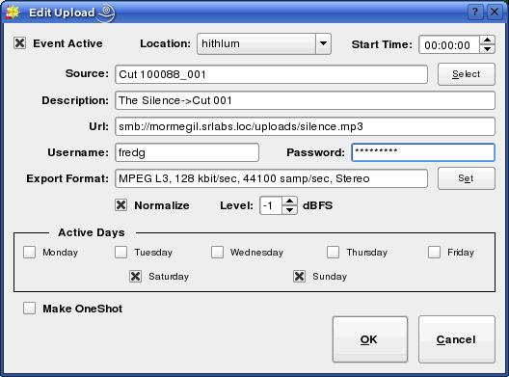Illustration 16: The Edit Upload Dialog

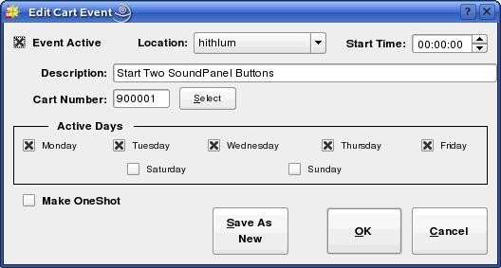Illustration 17: The Edit Cart Event Dialog

Section 4.7 – Automating Switcher Operations
It's possible to configure an automatic operation on a switcher device by means of the Edit Switcher Event dialog (see Illustration 18), which can be accessed either by clicking the Switch Event button in the Add Event dialog to create a new switch event or by touching the Edit button to modify an existing event.

In addition to the usual fields, a switch event has Switch Matrix (the name of one of the switch matrices associated with the selected Location), Switch Input and Switch Output controls. When executed, a switch events causes a take operation to be performed on the specified switcher device between the specified input and output. It is possible to specify the input and output either by their alphanumeric names (assigned in RDAdmin) or by their absolute numbers.

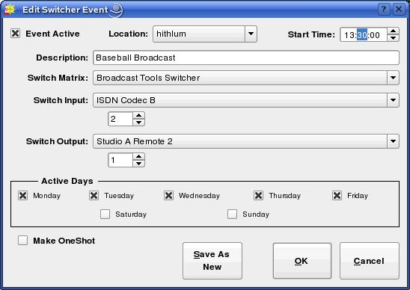Illustration 18: The Edit Switcher Event Dialog

Chapter Five
Generating and Maintaining Logs with RDLogEdit

Section 5.0 Logs and Log Events
A Rivendell log is a sequence of one or more events to be executed by the system, arranged in chronological order. (This functionality is sometimes referred to as a playlist in other automation systems). Several different types of events can be included in a log, along with parameters governing how and under what circumstances they will be executed.

Upon startup, RDLogEdit will show the current list of all logs on the system, as in Illustration 19. A number of important attributes of logs can be seen from this illustration, the first being the log name, with a summary status indicator next to it. The name is an alpha-numeric label that is used as a unique “handle” by the system to reference each log, and can be up to a maximum of 64 characters long. The status indicator is intended as a quick visual guide as to whether a particular log is ready for air (green check mark) or not (red ex).

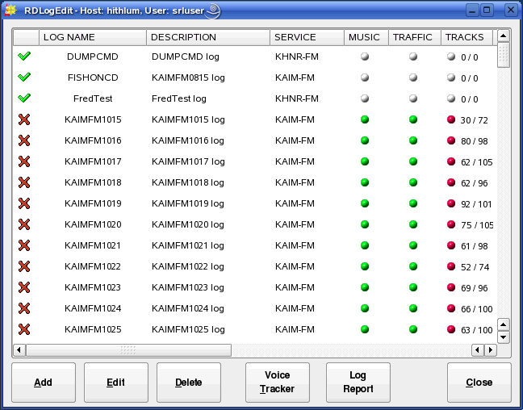Illustration 19: RDLogEdit Log List
Next comes the log's description. This is a free-form alpha-numeric label that can be used to record any information that might be useful to have appear on the log list (e.g. “This log for Sunday's show, don't modify!”).
Next comes a column showing the owning service. Each log is owned by exactly one service, which determines under what circumstances the log can be played and where electronic log reconciliation (ELR) data resulting from log playouts is sent (for an overview of Rivendell services, see section 1.1.3).

Next comes three “status indicator” columns (“MUSIC”, “TRAFFIC” and “TRACKS”) indicating the log's degree of readiness for air. A red indicator indicates that the particular data element is required but currently missing, a green indicator indicates an element is required and present, while a white indicator indicates that an element is not required. Additionally, the “TRACKS” column contains a pair of numbers indicating how many completed voice tracks exist in the log versus how many total track markers exist (the subject of voice tracks and track markers will be covered in more detail below).
When all three of these status indicators show either green or white, the summary status indicator (at the beginning of the log's entry in the list) will show as a green check mark, while a red indicator in any of these three fields will show a red ex. (NOTE: because a log sports a red ex does not indicate that the respective log cannot be played. It is merely a visual indicator to allow logs to be quickly “eyeballed” for completeness).

Next comes a pair of columns indicating the valid start date and end date for the log.

Finally, there is a column indicating the log's origin –i.e. the place, date and time it was originally created.

A report that lists the available logs on the system can be generated by touching the Log Report button.

A new log can be created by touching the Add button and entering a name, or an existing log inspected and modified by touching its entry on the log list and then touching the Edit button, resulting in the log being opened in the Edit Log dialog as shown in Illustration 20. The Edit Log dialog consists of three parts: the top section, where much of the information shown on the log list can be inspected and modified; the middle section, which shows the list of events comprising the log, and the bottom section, where buttons for modifying and saving the log are located. Each event in a log can be one of several different types, indicated by the icon displayed at the start of the line (see Table 6 for a breakdown of the various icons). The following types of events can be incorporated into a Rivendell log:

5.0.1 Audio Carts
The first, and usually most common type of log event is an audio cart. As the name implies, audio carts are Library entries that contain audio material intended for playout. Audio carts were covered in detail in Chapter Two in the discussion about RDLibrary.

5.0.2 Macro Carts
A macro cart is a cart from the Library that contains one or more system commands that can be used to cause the system to take various actions. They were touched upon in Chapter Two in the discussion about RDLibrary, and will be discussed in detail in Chapter Seven.

5.0.3 Note Markers
A note marker is an entry in the log that contains text intended to be seen by operators and used as a guide or reminder (program coders sometimes refer to this sort of functionality as a remark or comment, as seen in the REM command used by BASIC
programmers). Note markers belong to a class of log events known as meta events because (unlike carts, which exist in the Library independently of whether they are placed in a log or not), they have no independent existence outside of the specific log where they are placed. A note marker has absolutely no effect on the execution of a log other than to simply display some text at a specified point in a log, and as such can be useful as a mechanism for making notes or reminders to oneself or to others who may be executing the log.

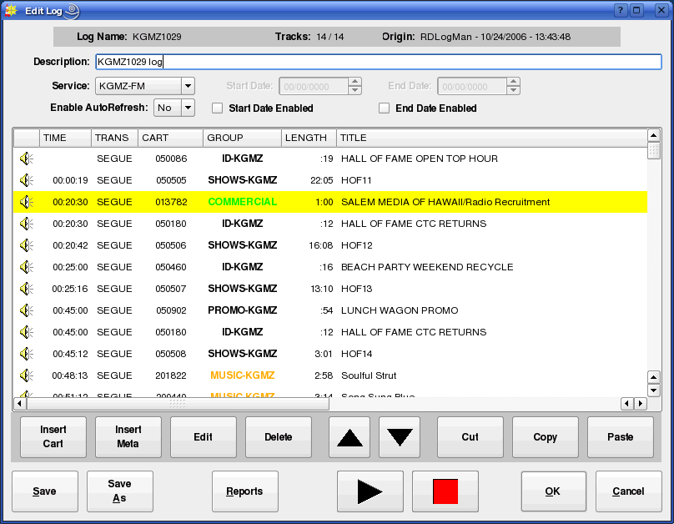Illustration 20: The Edit Log Dialog

5.0.4 Track Markers
A track marker is another meta event that is very similar in operation to note markers, with one key addition: track markers designate or “bookmark” a place in the log where a voice track is to be recorded. (The entire topic of voice tracks and tracking will be covered in detail in Chapter Eight). As with note markers, track markers have absolutely no effect on the execution of a log.

5.0.5 Chain Events
A third type of meta event is the chain event. Unlike markers, a chain event has a very definite effect when executed in a log: namely, causing a new log (whose name is specified as part of the event) to be loaded and executed. Chain events are often placed at the very end of a log, typically just before midnight so as to cause a new log to load for the next broadcast day.

5.0.6 Import Links
An import link is a placeholder event that shows where events imported from the external music or traffic scheduling system will eventually go. They will be covered in detail in the chapter on RDLogManager.

Each event in a Rivendell log can have its parameters modified by touching its entry in the Edit Log dialog and then clicking the Edit button, thus opening up the Edit Log Entry dialog, shown in Illustration 21 for a cart event, or Illustration 22 for a meta event.

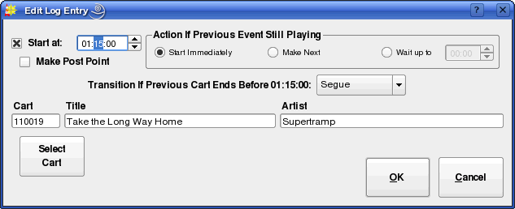Illustration 21: The Edit Log Entry Dialog for Cart Events
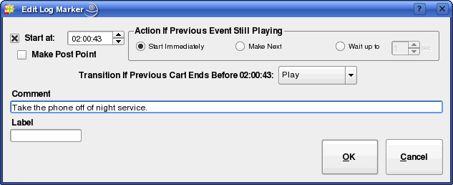Illustration 22: The Edit Log Entry Dialog for Meta Events

Section 5.1 Event Transitions
Each event in a log has a transition type, shown in the “TRANS” column of the Edit Log dialog. The transition type determines what happens when one event in a log ends and the next starts. Three basic transition types can exist in a Rivendell log: PLAY, SEGUE and STOP.

Audio Cart
Voice Track Audio Cart
Macro Cart
Note Marker
Track Marker
Chain Event
Music Import Link
Traffic Import Link
Table 6: Rivendell Log Event Type Icons
5.1.1 The PLAY Transition
If an event has a PLAY transition, then it will begin playing when the previous event has finished. PLAY transitions are used when automatic event sequencing is desired with no audio overlap (such as when playing two voice-only announcements back-to-back).
5.1.2 The SEGUE Transition
SEGUE transitions are similar to PLAY transitions, with one key difference: if the finishing event contains segue data (either from the Library or from a custom transition programmed in the voice tracker), then the event will start before the prior event is finished, causing the two pieces of audio to overlap and mix together. SEGUE transitions can be a very powerful tool for creating a variety of special effects, particularly when used in conjunction with musical material.

5.1.3 The STOP Transition
As the name implies, STOP transitions cause execution of the log to be suspended prior to execution of the event. This is often the desired behavior in situations where the log playout needs to be synchronized to one or more external audio sources (such as remote satellite feeds), and is commonly used in conjunction with Hard Timed events (see below).

Section 5.2 Time and Time Types
All Rivendell log events have an associated time type, which controls what effect (if any) the passage of time will have on the event. There are two basic time types: relative and hard. Additionally, the hard time type has several additional options that further modify its behavior.

5.2.1 The Relative Time Type
The default time type for log events, a relative time type simply means that the event is assumed to have a start time of whenever the previous event ends (if it has a PLAY or SEGUE transition) or whenever it is started (if it has a STOP transition).

5.2.2 The Hard Time Type
A hard time type causes the event to be executed or otherwise acted upon when the wall clock equals the time associated with the event. Hard times are a powerful feature that can be used to synchronize the log to various external events. An event can be assigned a hard time by clicking the Start at check box in the Edit Log Entry and filling in the desired time, and will show up with the letter 'T' appearing at the beginning of its listed time in the “TIME” column of the Edit Log dialog. An event which has been assigned a hard time can also be set to be a Post Point by checking the Make Post Point check box (the concept of post points will be discussed in detail in the chapter covering RDAirPlay).

The specific action that is performed when the time matches is determined by the option parameters supplied as part of the event. Three basic actions are possible:

- Start the event immediately
- Cue to the event (“Make Next”)
- Wait up to N Seconds, then start the event

5.2.2.1 Start Immediately
As implied by the name, if the event is set to start immediately, it will be started as soon as the hard time is reached. Any currently playing events in the log will be stopped down.

5.2.2.2 Cue to the Event (“Make Next”)
If set to 'Make Next', the event will be cued up to become the next event to be executed in the log, bypassing any intervening events in the log between the currently playing event and the hard timed one. Any currently playing events are unaffected.

5.2.2.3 Wait up to N Seconds, then start the event
Very similar to “start immediately”, with the difference that, if one or more events are currently playing, the log will wait up to the specified number of seconds before stopping them and starting the new event.

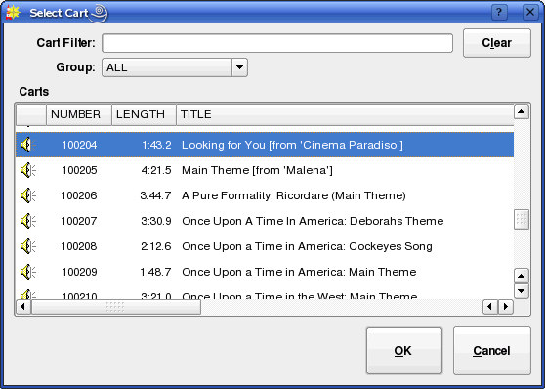Illustration 23: The Select Cart Dialog

Section 5.3 Editing Log Event Parameters
5.3.1 Specifying a Cart
The cart number to use for an event can be specified by touching the Select Cart button in the Edit Log Entry dialog, which will open up the Select Cart dialog, as shown in Illustration 23. Alternatively, it is possible to simply enter the cart number in the Cart field if the number is already known. The Title and Artist information will be automatically supplied by the system from the cart's label.

5.3.2 Specifying Meta Event Parameters
Note marker and track marker events each take only a single parameter: a Comment text that will show up on the log entry. In the case of a chain event, the name of the log to chain to must be supplied in the Log Name field, or the Select button can be touched to bring up the Select Log dialog to allow a name to picked from a list of all those available. Note that meta events are assigned transition and time types just the same as cart events.

5.3.3 Rearranging Log Events
Existing events in a log can be cut, copied, pasted or rearranged by touching the appropriate buttons in the Edit Log dialog. In addition, touch the Delete button will cause the selected log event(s) to be removed from the log.

5.3.4 Saving or Abandoning Changes to a Log
Any changes made to a log can be saved by touching either the Save or OK buttons in the Edit Log dialog. The current log can be saved under a different name by touching the Save As button, while touching Cancel will abandon any changes made since the last save.

5.3.5 Missing/Invalid Cart Events
If a given event has a problem (such as referencing a cart that does not exist in the Library, or that is not enabled for play on the log's owning service) its entry will be highlighted either RED (indicating a missing/invalid cart) or MAGENTA (indicating a cart without permission to run on the owning service). It's also possible to generate an exception report summarizing problem cart entries by touching the Check Log button.

Section 5.4 – Generating Log Reports
Various Log reports can be generated by touching the Reports button on the Edit Log dialog and then selecting the desired report and touching the Generate button. The following reports are available:

5.4.1 Log Listing
A chronological listing of all events in the log.

5.4.2 Log Exception Report
A list of missing/unplayable carts referenced in the log.

Section 5.5 – Auditioning Audio
The audio referenced by an audio event can be sampled in the Edit Audio dialog by highlighting the desired event and then touching the play button. No attempt to evaluate the rotation logic of the event is made – the audio played is intended solely as a 'sample' to help identify the type of material.

Chapter Six
Running Logs with RDAirPlay

Section 6.0 Overview
RDAirPlay is the Rivendell module used to run logs generated by the RDLogEdit or RDLogManager (for an overview of Rivendell logs, see Chapter Four). It contains a wide array of features for enabling playout of audio content in live assist as well as fully automated environments.

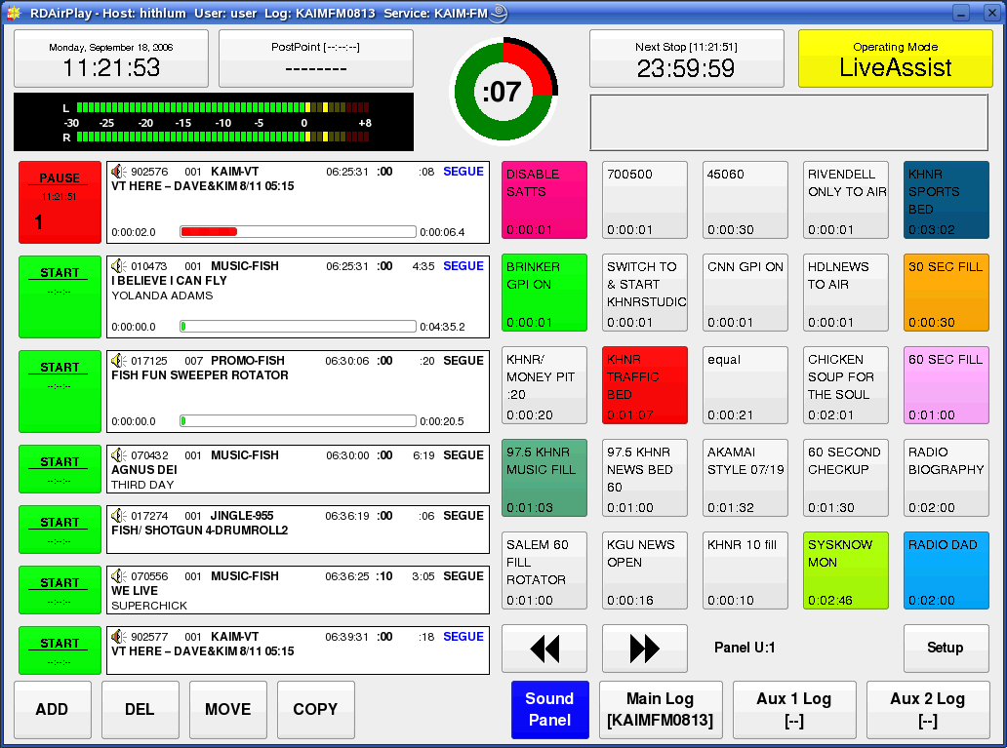Illustration 24: RDAirPlay Main Screen
Section 6.1 Log Machines
Fundamental to the operation of RDAirPlay is the concept of a log machine. A log machine is a virtual “device” into which a Rivendell log may be loaded and executed. RDAirPlay has three such log machines, called Main Log, Aux 1 Log and Aux 2 Log. Each of these log machines is completely independent of the others in the sense that different logs can be loaded and executed simultaneously in the respective machines.

Section 6.2 Layout
As shown in Illustration 24, the RDAirPlay main screen consists of four primary areas: the top area, which contains a variety of indicators for use in live assist situations as well as a set of audio meters; the button widget, which occupies the bulk of the left-hand side of the screen; the right-hand side, which displays either a SoundPanel array or a full log width; and the edit buttons in the lower left-hand corner of the screen.
The top area contains the following indicators:

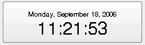Illustration 25: The Wall Clock

6.2.0 The Wall Clock
In the upper left-hand corner is wall clock indicator, which indicates the current system date and time. The style used for displaying times throughout RDAirPlay can be toggled between 24 hour “military” format and the traditional “AM/PM” presentation by clicking once on this display. If the system administrator has enabled it, this display will also flash RED to indicate possible clock inaccuracy due to loss of master clock synchronization.

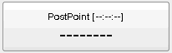Illustration 26: The Post Point Counter (Idle)

6.2.1 The Post Point Counter
Immediately to the right of the wall clock is the Post Point Counter. A post point is an attribute applied to a log event with a hard time type. The post point counter uses this information to display countdown and timing information.

The counter can be in one of four possible states: Idle, On Time, Under Time or Over Time. If the next upcoming hard timed event does not have its post point attribute set, then the counter will be in Idle mode (see Illustration 26). If the attribute is set however, then the counter will provide an estimate of how “on-time” the log currently is, on the basis of the current time and events still scheduled to be played.
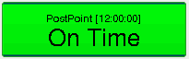Illustration 27: The Post Point Counter (On Time)

If the playout is such that the post point will be reached within one second of its programmed time, then the counter will be in On Time mode (see Illustration 27). The value shown in the square brackets is the scheduled time of the point point.
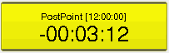Illustration 28: The Post Point Counter (Early)

If the playout is such that the post point will be reached one second or more before its programmed time, then the counter will be in Early mode (see Illustration 28). It will also give an indication of how much more material would need to be added to make the join on time.
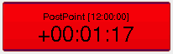Illustration 29: The Post Point Counter (Late)

If the playout is such that the post point will be reached one second or more after its programmed time, then the counter will be in Late mode (see Illustration 29). It will also give an indication of how much material would need to be removed to make the join on time.

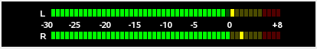Illustration 30: The Audio Meter

6.2.2 The Audio Meter
Immediately beneath the wall clock and post point counter is the audio meter. The meter shows the current peak levels of audio being played out of RDAirPlay, with '0' level referenced to -16 dBFS.

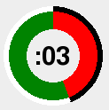Illustration 31: The Pie Wedge Widget

6.2.3 The Pie Wedge Widget
In the top center of the top area is the pie wedge widget. This widget counts down the final few seconds of each event. The length of time it counts down, along with whether it counts to the start of the next transition or the absolute end of the event are both configurable in RDADmin. The color of the band that grows as the countdown progresses (shown RED in Illustration 31) will change color to indicate if the currently playing event is the last event before a log stopdown. If it is the last, it will be RED, if not, GREEN. A BLUE band and countdown will also appear to indicate the event's talk time (if talk time markers have been set in the underlying cart).

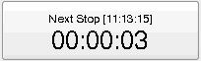Illustration 32: The Next Stop Counter

6.2.4 The Next Stop Counter
Immediately to the right of the pie wedge widget is the next stop counter. The large numerals indicate the predicted interval of time before the next stopdown of the Main Log machine, with the actual predicted time in the square brackets. If the Main Log is already stopped, then the counter simply displays 'Stopped'.

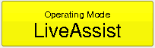Illustration 33: The Mode Indicator

6.2.5 The Mode Indicator
In the upper right-hand corner of the top area is the mode indicator, showing the current automation mode of the log machines. Three different modes are possible: Automatic, in which all log features, including PLAY and SEGUE transitions and hard times are fully enabled; LiveAssist, in which no automatic transitions or hard start times are executed but automatic crossfades are done between elements; and Manual, which is very similar to LiveAssist except that not even automatic crossfades are enabled (thus permitting fully manual crossfade control by means of an external console). To change RDAirPlay to a different mode, simply touch the mode indicator until the desired mode is indicated.

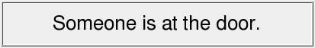Illustration 34: The Label Area

6.2.6 The Label Area
Immediately below the next stop counter and mode indicator is the label area. Text messages can be made to appear here (by means of RML commands) to signal the operator concerning the state of the system or need to take some kind of action.

6.2.7 The Right-Hand Side
Directly below the label area is the right-hand side. The right-hand side can display either a SoundPanel array or a full log widget for each of the three log machines, selected by clicking the appropriate button in the lower right-hand corner of the screen.
(NOTE: depending upon how the system administrator has configured the system, not all of the log machine buttons may be visible on your system).

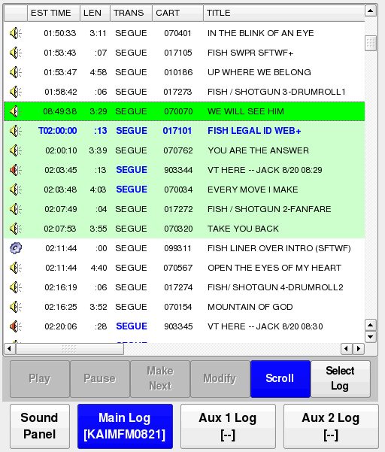Illustration 35: The Full Log Widget

6.2.8 The Full Log Widget
As the name implies, the full log widget can be used to view the contents of a log over its entire length. To load a log, touch the Select Log button to bring up the Select Log dialog, select the desired log from the list and then touch Load. The currently loaded log can also be saved by touching the Save or Save As buttons, or the current log unloaded by touching Unload. See Illustration 36.

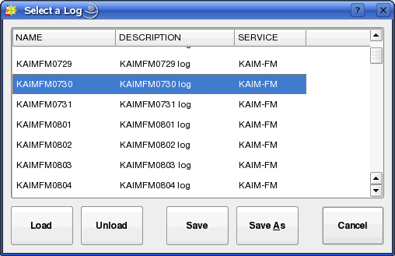Illustration 36: The Select Log Dialog
Once a log is loaded, it can be started at any point by touching an event and then pressing the Play button. Any playing event can likewise be stopped by touching in the event and then pressing the Stop button. To cue-up an event so that it is the next to play (indicated by the event being the first with a light green background), touch the event and then press the Make Next button. The play parameters of an event can be modified by touching the event, then pressing the Modify button, bringing up the Edit Event dialog (see Illustration 37).

In addition to having the ability to modify the event's time and transition parameters, the Edit Event dialog can be used to audition the event's audio in Cue or set the start position of the audio for on-air playback (so as to allow a program to be joined “in progress”, for example). To audition the audio, simply press the play button. The slider can be moved to adjust where in the audio to audition from. To set the start position, press the Start button and then position the slider where you wish the start to be. The red line on progress display indicates the current start position. Pressing the Start button again returns the dialog to Audition mode.
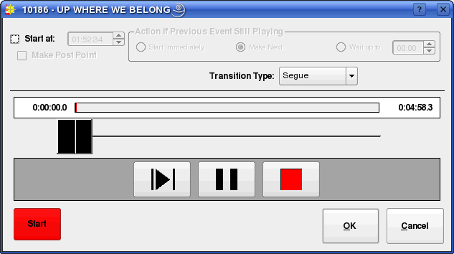Illustration 37: The Edit Event Dialog

When running a log, it is often desirable to have the currently playing event always in sight. To do this, toggle the Scroll button on (blue background).

6.2.9 The Button Log Widget
To the left of the full log widget is the button log widget, consisting of a column of seven large buttons adjacent to cart labels. This widget provides another, specialized “view” of the Main Log log machine. Specifically, the first seven currently playing and/or next events in that log machine will always be visible here. Events visible in the button log will be shown in the full log widget as having a green background. Unlike the full log widget, the button log is always visible, regardless of which display has been selected for the right-hand side.

To start an event from the button log, simply touch an event's corresponding Start button. Touching the button of a running event will either (depending upon how the system administrator has configured RDAirPlay) stop or pause it. To modify an event's parameters (via the Edit Event dialog), simply double-click the event's cart label.

Section 6.3 Editing a Log
It is possible to edit the log loaded into any of the three log log machines by means of the log edit buttons in the lower left-hand corner of the screen.

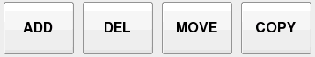Illustration 38: The Log Edit Buttons

6.2.10.1 Adding an Event
To add an event, touch the ADD button to open the Select Cart dialog, pick the desired cart and then touch OK. To place the selected cart using the button log widget, simply touch one of the yellow WHERE? buttons. To place it using the full log widget, click the event where you wish it to go and then touch the yellow WHERE? button. If, after selecting a cart from the Select Cart dialog, you decide you don't want to add it after all, simply touch the ADD button again to cancel the operation (see Illustration 39).

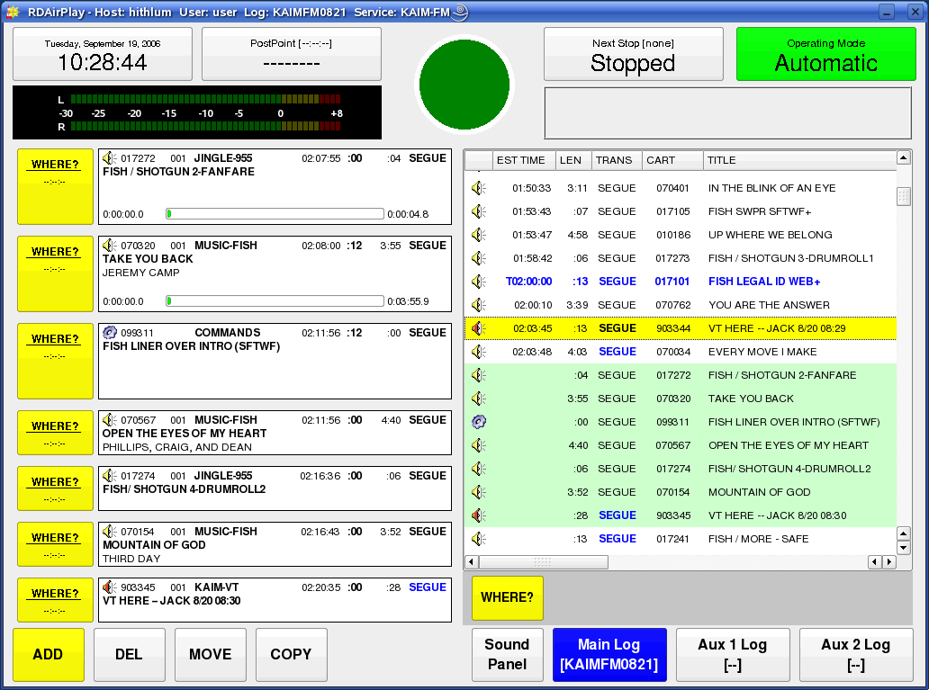Illustration 39: Adding an Event
6.3.0 Deleting an Event
To delete an event, touch the DEL button, then touch one of the violet DELETE buttons in the button log widget, or select an event and then touch the violet DELETE button. To cancel the operation, simply touch the DEL button again (see Illustration 40).

6.3.1 Moving an Event
To move an event, touch the Move button, then touch one of the violet MOVE buttons in the button log widget, or select an event and then touch the violet MOVE button, then touch one of the yellow TO buttons in the button log widget, or select an event and then touch the yellow TO button. To cancel the operation at any stage, simply touch the MOVE button again. It is perfectly permissible to move an event between two different log machines.
6.3.2 Copying an Event
To copy an event, touch the Copy button, then touch one of the violet COPY buttons in the button log widget, or select an event and then touch the violet COPY button, then touch one of the yellow TO buttons in the button log widget, or select an event and then touch the yellow TO button. To cancel the operation at any stage, simply touch the COPY button again. It is perfectly permissible to copy an event between two different log machines.

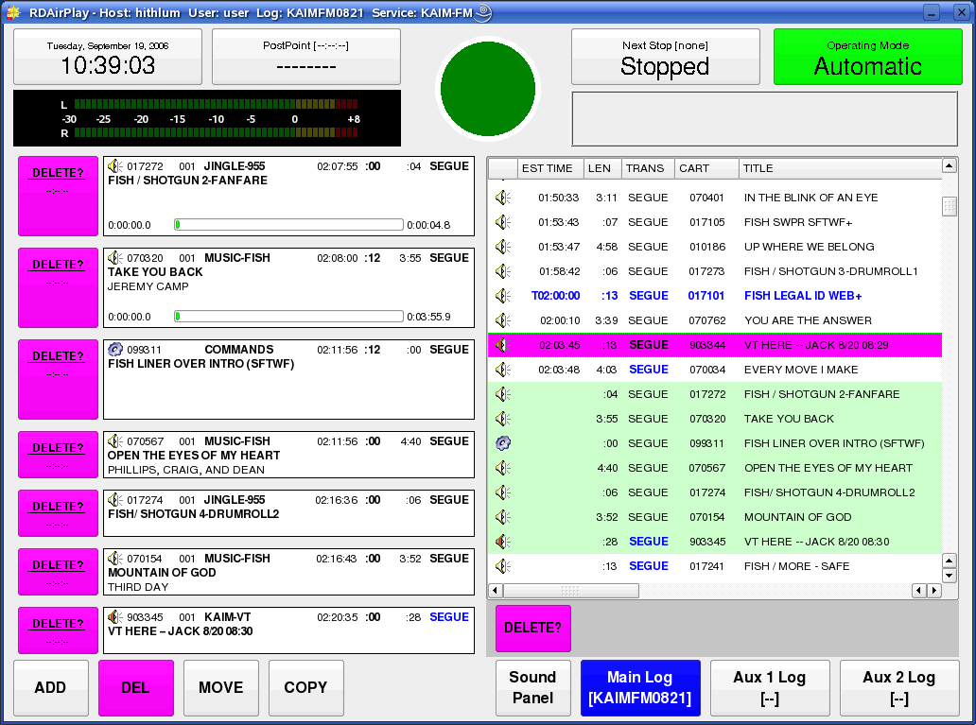Illustration 40: Deleting an Event

Section 6.4 The SoundPanel
The SoundPanel is an array of buttons that appears in the right-hand side of RDAirPlay when the Sound Panel button is selected (see Illustration 41). Each button can be associated with a particular cart in the Library (either Audio or Macro carts), which is then played each time the button is clicked. The soundpanel is particularly useful in live assist situations where it is desired to drop in some piece of audio on a live, improvised basis.

6.4.0 Panel Types
The SoundPanel has multiple panels or “panes” that can scrolled through by touching the double-left or double-right arrow buttons. Each panel has a designator, (displayed just to the right of the arrow keys), consisting of the letter 'U' or 'S' followed by a number. An 'S' indicates that the panel is a 'system' panel, meaning that its button assignments will show up in all RDAirPlay instances across a given site; while a 'U' indicates a 'user' panel, one which is associated with a particular user and that will “follow around” that user where ever he logs in in the site. (Depending upon how the system administrator has configured RDAirPlay, you may not have both of these panel types available to you).

6.4.1 Programming a SoundPanel Button
To associate a cart with a panel button, first touch the Setup button, which will begin to flash. (Depending upon how the system administrator has configured RDAirPlay, the Setup button may be disabled). Next, touch the button you wish to program, opening the Edit Button dialog (see Illustration 41).

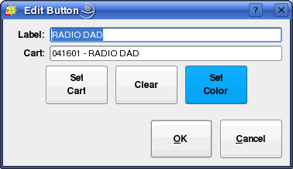Illustration 41: The Edit Button Dialog

Touch the Set Cart button to open the Select Cart dialog and pick a cart. To clear the button –i.e. have no cart associated with it – touch the Clear button. To assign a custom background color to the button, touch the Set Color button. A custom label can be entered in the Label field, or the name of the cart will be used by default. Touch the OK button when done. When done programming all the desired buttons, touch the Setup button again to toggle off Setup mode.

Chapter Seven
Generating Logs with RDLogManager

Section 7.0 Overview
RDLogManager is a tool for generating Rivendell logs. It is different from RDLogEdit in that, instead of building logs line-by-line, it allows log structures to be defined by a series of rules (called events and clocks) that are then plugged into a time framework (called a grid). This grid is then used to automatically generate logs on an as-needed basis. Each Rivendell service has its own, separately defined grid, thus allowing for separate log generation rules for each service. This system of rules allows for very powerful, modular features, including the ability to import and use scheduling data from various external third party systems, such as music schedulers and traffic and billing systems.

RDLogManager also includes facilities for generating reports. Reports are data outputs that detail whether certain events aired as scheduled, and under what circumstances. Reports are available in various formats. Some are intended to be read by humans, while others are intended for use by other, external software systems as a means of reconciling exported schedules.

When RDLogManager is started, it displays its main menu (see Illustration 42).

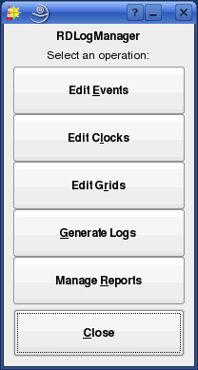Illustration 42: RDLogManager Main Menu

Section 7.1 Grids
Each Rivendell service has an RDLogManager grid. To see the list of available grids, touch the Edit Grids button to open the Log Grids dialog (see Illustration 43).

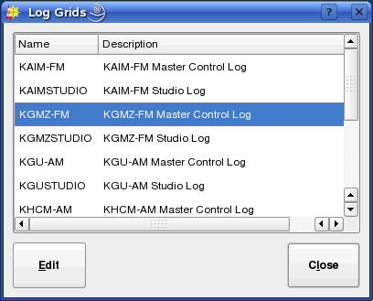Illustration 43: The Log Grids Dialog

To open a particular grid, select its service name and touch the Edit button (see Illustration 44).

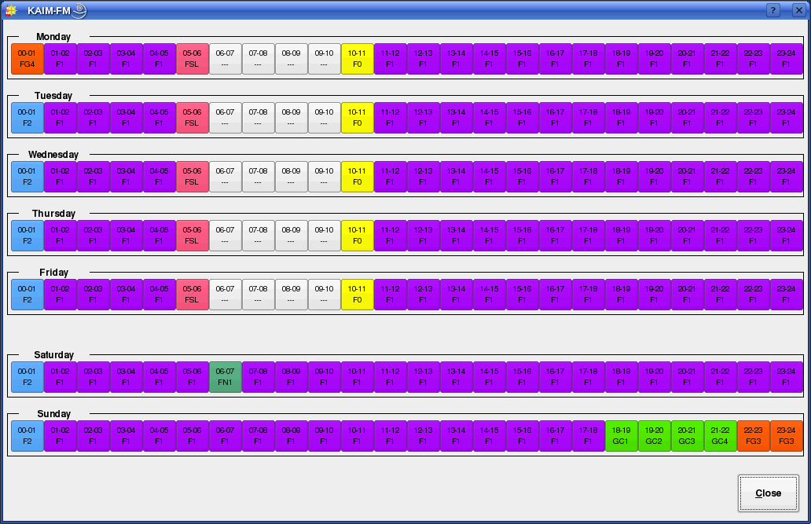Illustration 44: A Typical Service's Grid

Each grid has slots for every hour of every day of the broadcast week – 168 slots in all. By specifying a particular clock to go into each of these slots, a set of rules that RDLogManager can use to generate a log for any given day of the week is built up. To specify a clock, simply touch the particular hour of interest to open up the Select Log Clock dialog (see Illustration 45).

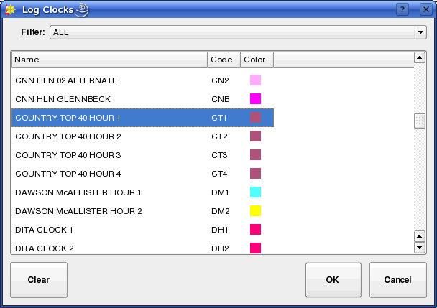Illustration 45: The Select Log Clock Dialog

Click the desired clock, then touch the OK button. To clear the assignment of any clock to the selected hour, touch the Clear button, then OK.

It is possible to 'drill down' directly to the underlying configuration of a clock (to be covered shortly) by right-clicking on the relevant hour in a grid and selecting Edit Clock.

Section 7.2 Clocks
An RDLogManager clock is a collection of RDLogManager events, arranged in terms of their start time (relative to the beginning of the hour) and length. It basically can be thought of as the “schedule” of an hour – any hour. Once defined, a clock can be plugged into any hour of a grid of any service, thus making for easy modularization and changes to a service's schedule.

To see the list of available clocks, touch the Edit Clocks button in RDLogManager's Main Menu to open the Log Clocks dialog (see Illustration 46). Each RDLogManager clock can be assigned a three-letter code and color, as an aid in identifying it when assigned to grids. To add a new clock, touch the Add button, or to edit a clock's parameters, click on it and touch the Edit button. In each case, the Edit Clock dialog (see Illustration 47) will open. Clocks can also be deleted by touching the Delete button or renamed by touching the Rename button.

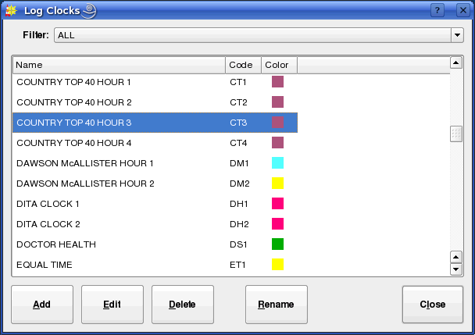Illustration 46: The Log Clocks Dialog
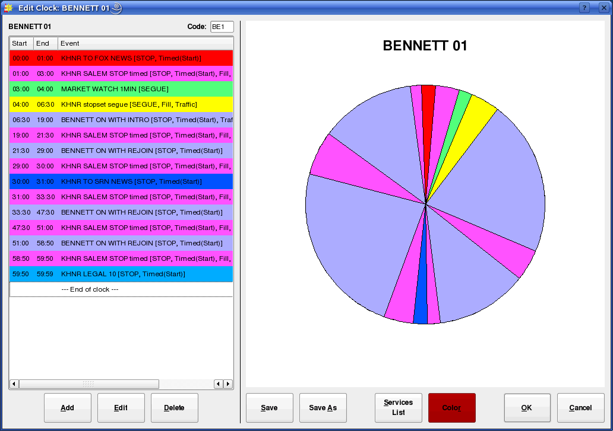Illustration 47: The Edit Clock Dialog
The Edit Clock dialog consists of three main sections: a tabular list of events in chronological order, a graphical depiction of the clock in the traditional “broadcast clock” format, and a series of action buttons across the bottom.
The clock's three-letter code is set by means of the Code: field in the upper right-hand corner of the table area. Its color can be set by touching the Color button. To save the clock without exiting the dialog, touch the Save or Save As buttons. To add a new event to the clock, touch the Add button, or to edit an existing entry touch the Edit button. In either case, the Edit Event Assignment dialog will open (see Illustration 48). To delete an entry, touch the Delete button. As in the case of grids, it is possible to 'drill down' into the underlying RDLogManager event by right-clicking on the respective entry in the clock event table and selecting Edit Event.

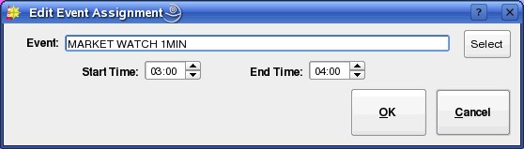Illustration 48: The Edit Event Assignment Dialog

The Edit Event Assignment dialog simply consists of an Event field for the name of the RDLogManager event and Start Time: and End Time: fields for the start and end times relative to the start of the hour. A list of available events can be brought up by touching the Select button to bring up the Log Events dialog.

Each clock can be designated as being associated with one or more services. This can make finding the correct clock for a given service much faster, as the Filter control on the List Clocks dialog can then be used. To program these associations, touch the Services List button in the Edit Clock dialog to bring up the Service Associations dialog (see Illustration 49).

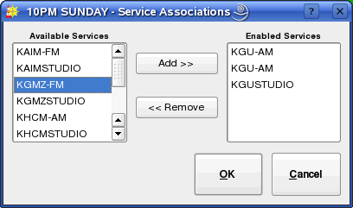Illustration 49: The Service Association Dialog

To designate a service as being valid for this clock, select the services name in the Available Services list and then touch the Add >> button. Likewise, to deselect a service, select its name in the Enabled Services list and then touch the << Remove button.

Section 7.3 Events
An RDLogManager event is a set of rules that define a series of log elements (audio carts, macro carts, markers, etc) that should be inserted into a log, along with the appropriate log event parameters (transition type, time type, etc) that should be associated with them. The actual elements to be inserted can be specified directly within the event itself, or imported from a data file generated by an external scheduling system. Up to two such external scheduling sources can be defined for each service. While for convenience sake these are designated as 'Traffic' and 'Music' within RDLogManager, they can each be used anywhere a means of importing external scheduling data into the system is needed, regardless of whether such data actually references commercial or musical material or not.

To see the list of available RDLogManager events, touch the Edit Events button on the RDLogManager Main Menu to open the Log Events dialog (see Illustration 50). It is possible to filter the list of available events to only those used for a particular service by selecting the service in the Filter: control. To add a new event, touch the Add button, or to edit an event's parameters, click on it and touch the Edit button. In each case, the Edit Event dialog (see Illustration 51) will open. Events can also be deleted by touching the Delete button or renamed by touching the Rename button.

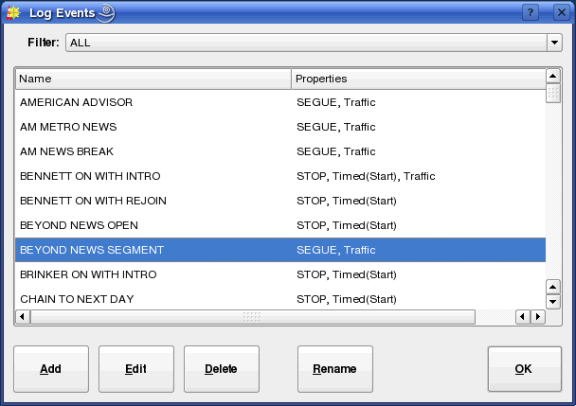Illustration 50: The Log Events Dialog

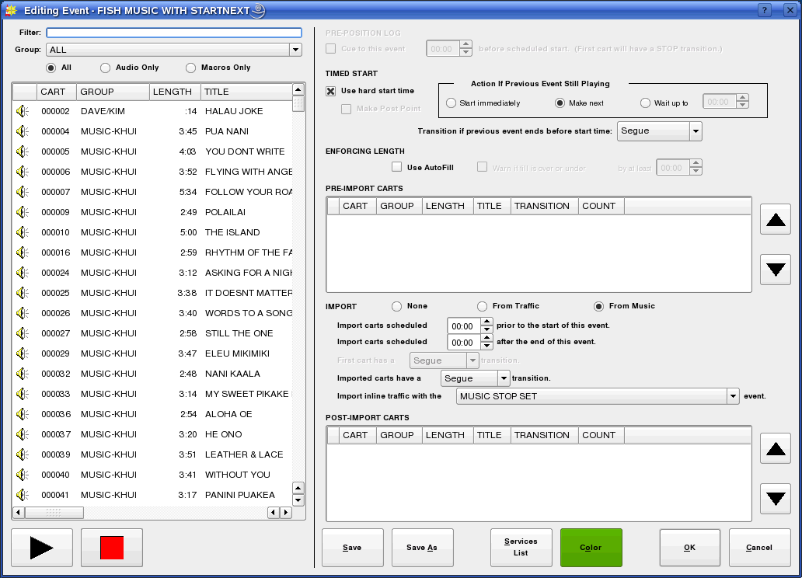Illustration 51: The Edit Event Dialog

The Edit Event dialog consists of two main parts: a Library cart picker widget on the left side, and an area showing the various event parameters on the right. Audio contained within audio carts can be sampled by selecting the desired cart and then touching the Play button. Programming an event basically consists of specifying four things: its log parameters (transition and time types), the list of pre-import events, the event import (if any) and the list of post-import events. The first matter to be decided is if the event should have a hard start time: if so, then the Use hard start time box in the TIMED START section should be checked. Checking this box will enable all of the usual hard start parameters to be specified. If an automatic timed start is not desired, then it is possible to check the Cue to this event box in the PREPOSITION LOG section. This will cause RDLogManager to place a hard time with a 'Make Next' attribute on the first item of the event – effectively, causing the event to be automatically “cued up” at the scheduled time – something that can be particularly handy for keeping spot breaks in sync when “overscheduling” music.

Next, if it is desired to have RDLogManager try to automatically insert material from the Autofill List to ensure that the event has the length indicated by its parent clock, the Use Autofill box in the ENFORCING LENGTH section should be checked. (Configuring the Autofill List is covered in detail in the Rivendell Technical and Administration Guide). If Autofill is enabled, it is also possible to check the Warn if fill is under or over box to have RDLogManager generate a warning if it was unable to properly fill the event when the log was generated.

Next, the list of log events (if any) to be inserted before the data import should be placed in the PRE-IMPORT CARTS list. For audio or macro carts, these can be simply dragged and dropped from the Library cart list on the left-hand side of the dialog. Meta events can be inserted by right-clicking on the list and selecting the desired element. It is also possible to edit or delete elements and set the transition type of each element through the right-click menu.

The IMPORT section then defines which (if any) source will be used for importing external scheduling events into the log. Either Music, Traffic or None can be selected. If Music or Traffic is selected, then RDLogManager will import any events from those sources that fall within the start and end times of the event (as supplied by the parent clock). These start and end times can be further broadened by means of 'slop factors' entered into the Import carts scheduled controls (this is sometimes necessary to get the import to work properly with certain external scheduler systems). The transition types to be used for the first and subsequent imported elements can be specified with the First cart has a and Imported carts have a controls. If Music has been selected as the import source, it is also possible to specify the event to use to import traffic breaks embedded in the music log with the Import inline traffic with the control. (Configuration of the actual parser parameters for data importation is covered in the Rivendell Technical and Administration Guide).

Finally, the list of log events (if any) to be inserted after the data import should be placed in the POST-IMPORT CARTS list. Configuration of the events work very similarly to that of the PRE-IMPORT CARTS list.

The color of the event (as seen in the Edit Clock dialog) can be set by touching the Color button. The list of services for which this event is valid can be edited by touching the Services List button. To save the event without exiting the dialog, touch the Save or Save As buttons.

Section 8.4 Generating Logs
After all of the appropriate hours have been populated in a service's grid, it's time to start generating logs. To do this, touch the Generate Logs button in RDLogManager's Main Menu to open the Generate Log dialog (see Illustration 52).

Depending upon how many external scheduling sources are involved, generating a log involves one, two or three steps. Before performing any of the steps, it is first necessary to select the relevant service for which to generate the log (using the Service: control) and the log date (either by entering the date in the Date: control or by touching the Select button and picking it off of the calendar).

In all cases, a new log is initially generated by touching the Create New Log button. If the log for the selected date and service does not already exist, it will be created at this point

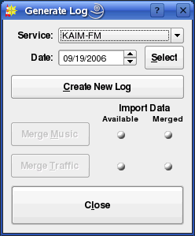Illustration 52: The Generate Log Dialog

(becoming visible in RDLogEdit). It the log already exists, it will be overwritten. (NOTE: if completed voicetracks exist in the old log, they will be deleted when the log is overwritten!)

When generating a log, RDLogManager will look for possible problems (such as scheduled carts that are missing in the Library) and generate an exception report if it finds any.

Once generated, the status lights in the Generate Log dialog indicate which (if any) additional import data are needed to complete the log. Two types of status light exist: Available, which indicates if the required data file is available to RDLogManager, and Merged, indicating whether the data has been merged into the log as yet. Each light can show one of three different colors: GREEN, meaning “yes”, RED, meaning “no” and WHITE, meaning “not required”.

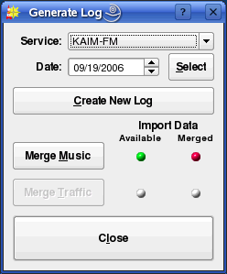Illustration 53: The Generate Log Dialog -- Music Merge Required

For an example, see Illustration 53. This is showing a log that has been generated and has music data available but not yet merged. To perform the merge, touch the Merge Music button. The dialog now changes to that shown in Illustration 54, indicating that Music data has been merged but that traffic data is still needed. Once a log has reached this state – that of having any necessary music data merged – it can be voicetracked without having to wait for traffic data to become available. Traffic data can be merged at any time before, during or after the generation of voicetracks. The actual traffic merge is performed by touching the Merge Traffic button, resulting in a dialog like that shown in Illustration 55. (NOTE: the configuration of the various data file names and parser

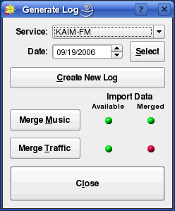Illustration 54: The Generate Log Dialog -- Traffic Merge Required

parameters needed for data import is done in the RDAdmin module and is covered in the Rivendell Technical and Administration Guide).

It is important to note that the sequence of operations from the example above is typical, but may vary depending upon how the system administrator has configured RDLogManager at each site. Some services, for example, will have no music data, only traffic, so the music indicator lights will be “whited out” accordingly.

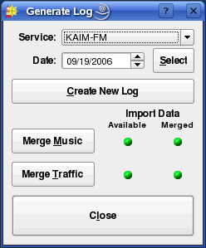Illustration 55: The Generate Log Dialog -- Completely Merged

Section 7.5 Generating Reports
A Rivendell report is a data output that details whether certain events aired as scheduled, and under what circumstances. Reports are available in various formats. Some are intended to be directly read by humans, while others are intended for use by other, external software systems as a means of reconciling exported schedules.

Rivendell has the ability to filter the data that go into any particular report on the basis of the type of material played (traffic spots, music or all), the playing service(s) and the originating host(s). The configuration of reports is done in the RDAdmin module and is covered in the Rivendell Technical and Administration Guide. Once configured however, reports are actually generated by the RDLogManager module.

To generate a report, touch the Manage Reports button on the RDLogManager Main Menu to open the Select Service dialog (see Illustration 56). The dialog will show each service on the system, along with the date of the oldest data available for generating reports. Touch the Generate Reports button to open the Select Report Dates dialog (see Illustration 57). The desired report can be selected with the Report: control, and the start and end dates of the report specified with the Start Date: and End Date: controls, respectively (NOTE: not all reports are capable of being generated so as to span more than one day).
Once the parameters are set, touch the Generate Report button to write out the report.

7.5.1 Purging Old Report Data
Rivendell keeps the raw data used to generate reports indefinitely, until manually purged out of the system. Periodic purging of old data is a good idea from the standpoint of minimizing the amount of system resources utilized, and can be done by selecting the desired service and then touching the Purge Data button in the Select Service dialog, opening up a calendar dialog (see Illustration 58). Each date that has data eligible for purging will be shown in bold. To purge a particular day, select it and the touch the Purge Data button. (NOTE: once purged, no reports can be generated for that particular service/date, so be sure that all required reports have been produced before purging!)

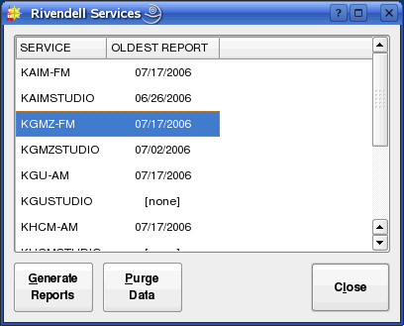Illustration 56: The Select Service Dialog

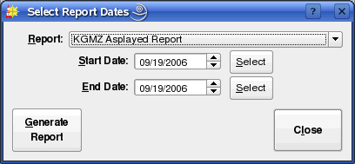Illustration 57: The Select Report Dates Dialog

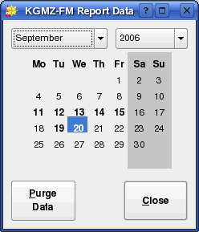Illustration 58: The Purge Calendar Dialog

Chapter Eight
VoiceTracking

Section 8.0 Voicetracking in Rivendell
Voicetracking is a capability wherein custom “one-off” content is created and inserted into logs, making it possible to create programming that sounds very spontaneous and “live”. In Rivendell, such voicetracks are placed into a special type of audio cart known as a voicetrack cart. These carts are automatically created, deleted and managed by the voicetracker interface (part of the RDLogEdit module), with no manual user intervention required. The voicetracker module also includes extensive capabilities for allowing customization of the transitions between log elements.

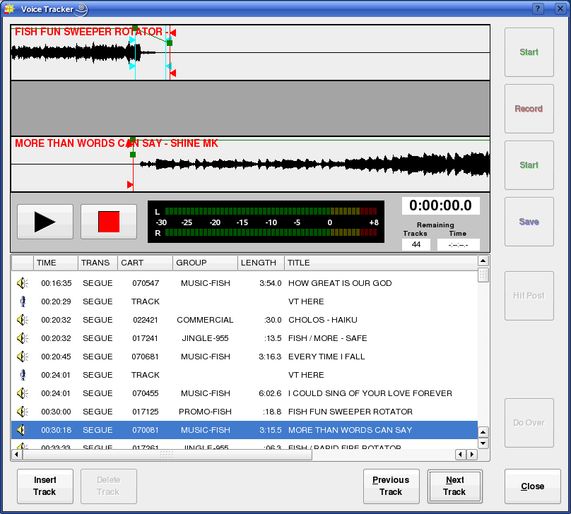Illustration 59: The Voicetracker Dialog, Showing a Simple Transition
8.0.1 Prerequisites
Before beginning voicetracking for a particular service, a voicetracker group and pool of available cart numbers must be configured in the RDAdmin module. These procedures are detailed in the Rivendell Technical and Administration Guide.

9.0.2 VoiceTrack Markers
A voicetrack marker is a meta event that can be inserted into a log as a “placeholder” to others to indicate where a voicetrack is to be recorded. Track markers can be inserted by RDLogEdit, RDLogManager events or even “embedded” in data generated by external schedulers such as RCS Selector_{TM.}

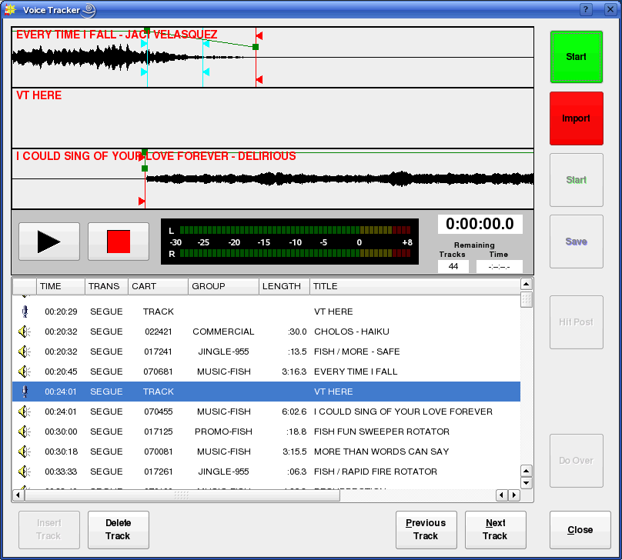Illustration 60: Ready to Record a Voicetrack
Section 8.1 Using the Voicetrack Interface
8.1.0 The VoiceTracker Dialog
To voicetrack a log, start the RDLogEdit module (see Illustration 19), highlight the desired log and touch the VoiceTracker button, opening the VoiceTracker dialog (see Illustration 59). This dialog consists of three major parts: the waveform area, the log list and the control buttons.

The waveform area is in the upper center part of the dialog, and consists of four “panes”. The upper three display waveform depictions while the fourth contains audition control buttons, an audio meter and various counters. Directly below this is the log list, showing a copy of the currently loaded log. The control buttons occupy the bottom and right-hand edges of the dialog.

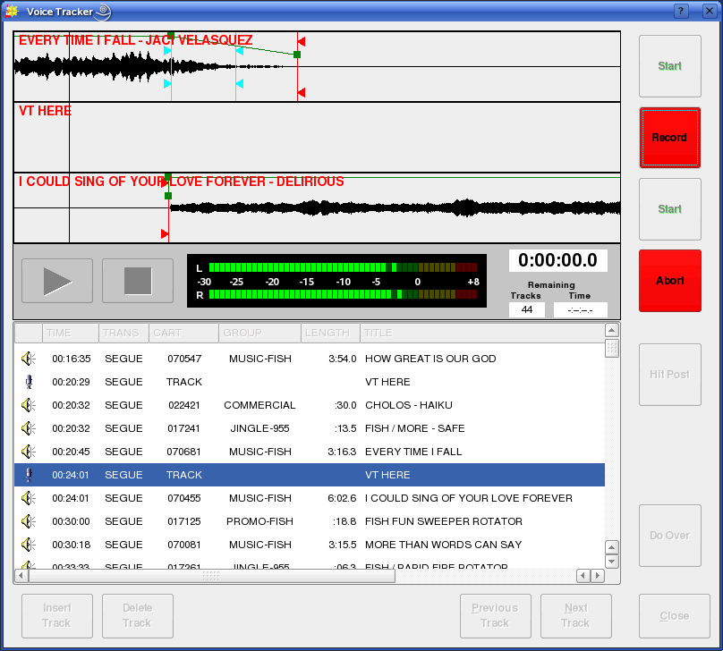Illustration 61: Track One Playing
8.1.1 Editing Transitions
When an event is selected in the log list, a graphical depiction of the transition into that event is loaded into the waveform area. If the selected event and its prior event in the log is not a voicetrack or track marker, then the selected event will be displayed in the third pane of the waveform area and the previous event displayed in the first pane. If the selected event or its prior event is a voicetrack or track marker, then voicetrack or marker will be displayed in the second pane of the waveform area.

Once selected, a transition can be auditioned by touching the play button in the fourth pane of the waveform area. Play will start from the left-hand edge of the topmost waveform. This start location can be adjusted by dragging the topmost waveform to the left or right by means of the mouse or touchscreen. If the transition type of the selected event is SEGUE, it is also possible to adjust the degree of audio overlap by dragging the second or third waveform as well. It's possible to “undo” changes made in the segue overlap by right-clicking on the waveform and selecting Undo Segue Changes from the menu. To make the overlap permanent, touch the Save button. To restore the transition to its default state (calculated on the basis of segue markers from the Library) touch the Do Over button. The transition type can be changed by right-clicking on an event and selecting the desired transition type from the menu.

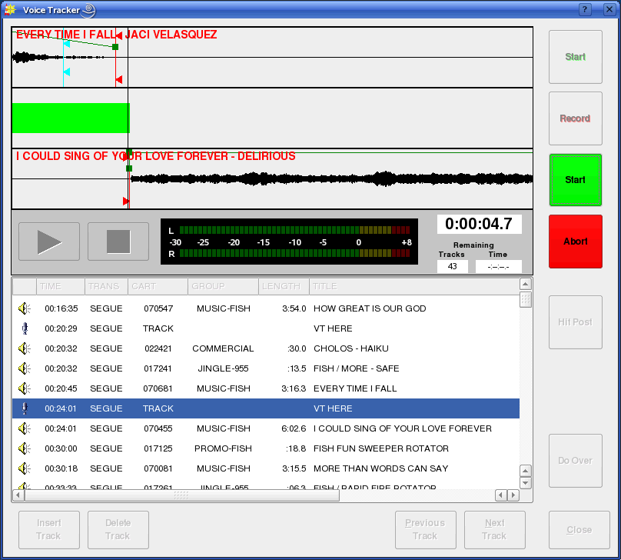Illustration 62: Recording
8.1.2 Inserting and Deleting Track Markers
It is possible to insert a new voicetrack marker by selecting the desired location in the log list and touching the Insert Track button. An existing voicetrack marker can likewise by deleted by selecting it in the log list and touching the Delete Track button.

8.1.3 Moving Between Track Markers
It is possible to move directly to the next or previous voicetrack marker simply by touching the Next Track or Previous Track buttons, respectively.

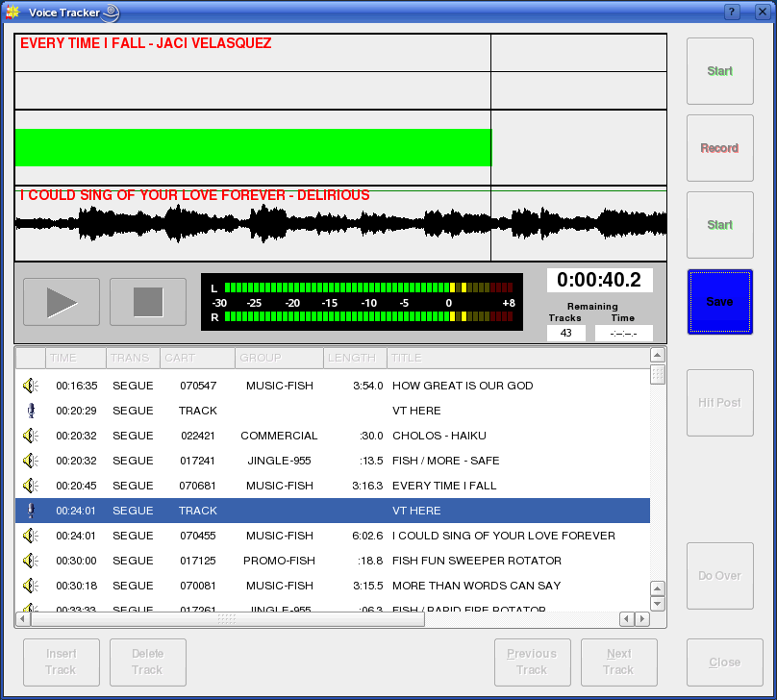Illustration 63: Track Two Started

8.1.4 Recording a Voicetrack
Once the desired voicetrack marker has been selected, the process of recording a voicetrack consists of four steps, each initiated by one of the four square control buttons in the upper right-hand corner of the dialog. (See Illustration 50).

To begin, touch the topmost Start button. This will cause the audio in the topmost pane to begin playing, with a cursor to show playback position (see Illustration 61). To begin the actual recording, touch the Record button (see Illustration 62). To start the following event (in the third pane), touch the second Start button (see Illustration 63). Finally, to stop recording, touch the Save button (see Illustration 64). The record process can be canceled at any time by touching the Abort button, restoring the transition to its default
state. It is also possible to undo a completed voicetrack by touching the Do Over button.

Once completed, the segue overlaps into and out of a voicetrack can be adjusted in the same manner as for simple transitions –i.e. by dragging the appropriate waveforms with the mouse.

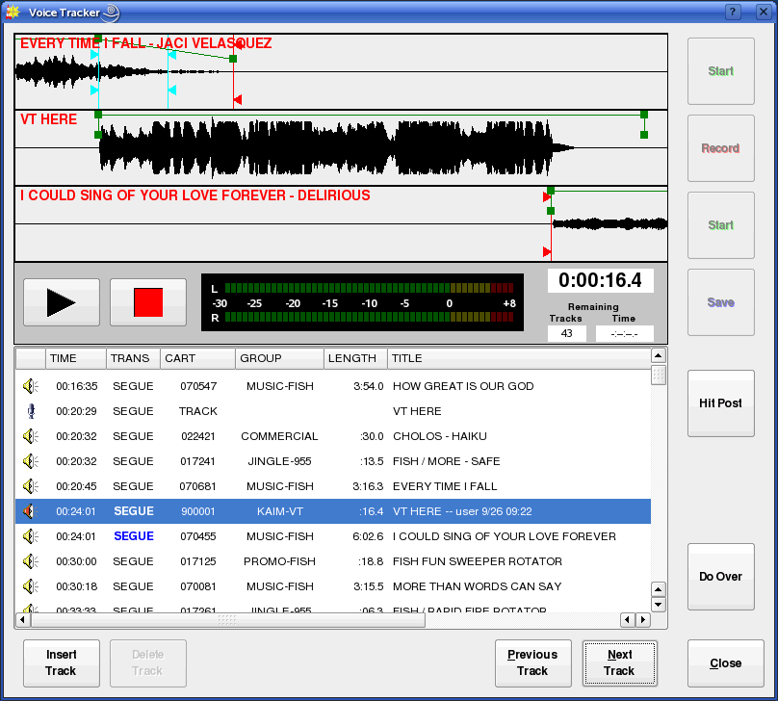Illustration 64: Completed VoiceTrack
8.1.5 Adjusting Transition Levels
It is possible to adjust the audio fade levels applied during transitions by means of rubber bands on the waveform displays. These are green lines with small square targets. To adjust a rubber band, use the mouse to grab one of the targets and drag it to the desired location.

8.1.6 Importing Voicetracks
In addition to recording in realtime, it's possible to import a voicetrack directly from an audio file. To do so, select the desired voicetrack marker and then touch the Import button to open the Import/Export Audio dialog (see Illustration 5). (For more information on using the Import/Export Audio dialog, see Section 3.1.0 Importing Audio from a File). Once imported, the voicetrack can be manipulated in the same manner as those that were directly recorded.

8.1.7 Hitting the Post
If the event following a voicetrack has its Talk Time markers set, it is possible to set the transition so that the end of the voicetrack automatically aligns with the end of the Talk Time (commonly referred to as hitting the post). To do this, simply touch the Hit Post button.

Chapter Nine
Rivendell Macro Langauge

Section 9.0 Overview
Rivendell Macro Language (or RML for short) is a set of commands implemented within Rivendell that can be used to program the system to take various actions. A wide variety of commands exist, ranging from control of outboard gear (such as switchers and GPIO devices) to control of various aspects of log playout in RDAirPlay, to Rivendell user management.

Section 9.1 Command Structure
Each RML command in its native form consists of a two-letter code, followed by zero or more arguments (separated by spaces) and terminated with a '!' character. For example, the 'Play Next' RML looks like this:

PN 1!

This command would cause the Main Log machine in RDAirPlay to start the next event in the log. A full list of all available RMLs can be found in the section 9.3.

Section 9.2 Specifying Color
Some RMLs take a color value as one of their arguments. The following colors are available:

white black
red darkRed
green darkGreen
blue darkBlue
cyan darkCyan
magenta darkMagenta
yellow darkYellow
gray darkGray
lightGray

Section 9.3 Available Commands
NOTE: not all commands shown will be available for all types of hardware (this is particularly true of the GPIO and Switcher commands). For an up-to-date listing of hardware devices supported by Rivendell, along with supported RML functionality for each, consult the 'SWITCHERS.txt' and 'GPIO.txt' files in the Rivendell documentation directory.

ADD NEXT
Code: PX
Syntax:
PX <mach> <cart>!

Insert cart <cart> in the next to play position on RDAirPlay log machine <mach>. Values for <mach> are: 1 = Main Log, 2 = Aux 1 Log, 3 = Aux 2 Log.

BINARY SERIAL OUT
Code: BO
Syntax:
BO <port-num> <hex-code> <...>!

Output a string of binary codes represented by <hex-code> <...> on serial port <port-num>!

APPEND LOG
Mneumonic: AL
Syntax:
AL <mach> <log>!

Append the log <log> to the log currently loaded in log machine <mach>.

CLEAR SERIAL TRAP
Code: SC
Syntax:
SC <port> <cart> <string>!
SC <port> <cart>!
SC <port>!
Clear a serial trap. The three argument form will clear all traps on <port> that reference <cart> and <string>. The two argument form will clear all traps on <port> that reference <cart>, while the one argument form will clear all traps on <port>.

COMMAND SEND
Code: CC
Syntax:
CC <dest> <rml>!
Send the RML command <rml> to <dest>. <dest> may be either a Rivendell host name or an IP address.

CONNECT JACK PORTS
Mnemonic: JC
Syntax:
JC <output-port> <input-port>!
Attempt to connect JACK input port <input-port> to <output-port>.

DISCONNECT JACK PORTS
Mnemonic: JD
Syntax:
JD <output-port> <input-port>!
Attempt to disconnect JACK input port <input-port> to <output-port>.

CONSOLE LABEL
Code: CL
Syntax:
CL <matrix> <surface> <chan> <label>!
On matrix <matrix>, set the input <chan> module label of control surface <surface> to <label>.

DATABASE BACKUP
Code: DB
Syntax:
DB <path-name>!
Create a backup copy of the active Rivendell database in <pathname>.
(WARNING: use of this RML is deprecated, as generating backups from a live Rivendell database can cause system pauses).

EXECUTE CART
Code: EX
Syntax:
EX <cart>!
Execute macro cart <cart> on the local host.

FIRE SALVO
Code: FS
Syntax:
FS <matrix> <salvo-num>!
Fire salvo number <salvo-num> on matrix <matrix>.

GPI ENABLE
Mnemonic: GE
Syntax:
GE <matrix> <type> <gpi-num> <state>!
Enable or disable the GPI line of type <type> indicated by <gpi-num> on matrix <matrix>. Possible types are I=Input, O=Output.

GPI ENABLE (old format, deprecated)
Code: GE
Syntax:
GE <matrix> <gpi-num> <state>!
Enable or disable the GPI line indicated by <gpi-num> on matrix <matrix>.

GPI SET
Mnemonic: GI
Syntax:
GI <matrix> <type> <gpi-num> <state> <cart>!

Issue the macro cart <cart> upon transition of the GPIO of type <type> and line <gpi-num> on matrix <matrix> to <state>. Possible types are I=Input, O=Output.

GPI SET (old format, deprecated)
Code: GI
Syntax:
GI <matrix> <gpi-num> <state> <cart>!

Issue the macro cart <cart> upon transition of the GPI line <gpi-num> on matrix <matrix> to <state>.

GPO SET
Mnemonic: GO
Syntax:
GO <matrix> <type> <gpo-num> <state> <length>!

Command GPIO line <gpo-num> of type <type> on matrix <matrix> to <state> for <length> mS. A length of '0' indicates to hold the state indefinitely. Possible types are I=Input, O=Output. Possible states are 0=OFF, 1=ON, -1=passthrough hardware input. The 'passthrough' state is valid only for the Input type –i.e. <type>=I.

GPO SET (old format, deprecated)
Code: GO
Syntax:
GO <matrix> <gpo-num> <state> <length>!

Command GPO line <gpo-num> on matrix <matrix> to <state> for <length> mS. A length of '0' indicates to hold the state indefinetly.

INSERT SERIAL TRAP
Code: SI
Syntax:
SI <port> <cart> <string>!

Insert a serial trap to execute the macro cart <cart> upon receipt of <string> on serial port <port>.

LABEL PANEL
Mneumonic: PC
Syntax:
PC <panel> <column> <row> <label> <color>!

Set the button at <column>,<row> of panel <panel> to have a text label of <label> and a background color of <color>. Panel: S1...50 or U1...50; C for <panel> means currently selected panel.

LOAD LOG
Code: LL
Syntax:
LL <mach> <log> [<start-line>]!

Load the log <log> in RDAirPlay log machine <mach>. After loading, start the log at line <start-line> if it is >=0. Default <start-line>=-1. Values for <mach> are: 1 = Main Log, 2 = Aux 1 Log, 3 = Aux 2 Log.

LOAD PANEL
Code: PE
Syntax:
PE <panel> <column> <row> <cart>!

Load cart <cart> into the RDAirPlay SoundPanel button at <column>,<row> of panel <panel>. <panel> should be specified with a type identifier to indicate “system” or “user”, e.g. 's1' or 'u2'

LOGIN
Code: LO
Syntax:
LO!
LO <user> <password>!

Set the current Rivendell user to <user>. If no arguments are supplied, log out the host –i.e. Revert to the default user.

MAKE NEXT
Code: MN
Syntax:
MN <mach> <line>!

Set the next event for RDAirPlay log machine <mach> to line <line>. Values for <mach> are: 1 = Main Log, 2 = Aux 1 Log, 3 = Aux 2 Log.

MESSAGE BOX
Code: MB
Syntax:
MB <display> <severity> <msg>!
Display the text <msg> in a popup window on X display <display>, with an icon to indicate <severity>. Valid values of <severity> are:

1 – Information
2 – Warning
3 - Critical

PLAY PANEL
Code: PP
Syntax:
PP <panel> <column> <row>!

Play the RDAirPlay button at <column>,<row> of panel <panel>. <panel> should be specified with a type identifier to indicate “system” or “user”. For example, to start a button in the second column, third row of panel U:1, one would send: PP U1 2 3!

RUN SHELL COMMAND
Code: RN
Syntax:
RN <shell-cmd>!

Run the shell command <shell-cmd>. The command will run with the permissions of the Rivendell user as configured in rd.conf(5).

REFRESH LOG
Code: RL
Syntax:
RL <mach>!
Refresh a log. Values for <mach> are: 1 = Main Log, 2 = Aux 1 Log, 3 = Aux 2 Log.

SELECT WIDGET
Code: PW
Syntax:
PW <mach>|0!

Select the RDAirPlay right-hand widget to log-machine <mach> or '0' for sound panel. Values for <mach> are: 1 = Main Log, 2 = Aux 1 Log, 3 = Aux 2 Log.

SERIAL OUT
Code: SO
Syntax:
SO <port-num> <string>!

Output <string> on serial port <port-num>!

SERIAL RELOAD
Code: SY
Syntax:
SY <port-num>!

Reload the configuration for the indicated serial port. Normally, this should only be issued by RDAdmin following a configuration change.
SET COLOR LABEL
Code: LC
Syntax:
LC <color> <string>!

Display <string> in color <color> in the label area of RDAirPlay.

SET DISPLAY
Code: SD
Syntax:
SD <matrix> <display> <line> <col> <attr> <label>!
On matrix <matrix>, set the console display <display> to <label>, starting at position <line>,<col> and using message attributes <attr>.

The message attributes value is constructed as follows:
Bit 7 – Display mode
Bit 6,5 – Video attribute
Bits 2,1,0 – Message Text Color

Display Mode: 0 – overwrite text
1 – insert text

Video Attribute: 00 – normally
01 – flash
02 – reverse

Text Color: 000 - White
001 - Red
010 - Yellow
011 - Green
100 - Cyan
101 – Magenta

SET LABEL
Code: LB
Syntax:
LB <string>!

Display <string> in the label area of RDAirPlay.

SET MODE
Code: PM
Syntax:
PM <mode>!

Set the RDAirPlay mode <mode>. 1 = LiveAssist, 2 = Auto, 3 = Manual.

SLEEP
Code: SP
Syntax:
SP <msecs>!
Wait for <msecs> milliseconds.

START
Code: PL
Syntax:
PL <mach> <line>!

Start RDAirPlay log machine <mach> at line <line> if stopped, otherwise do nothing. Values for <mach> are: 1 = Main Log, 2 = Aux 1 Log, 3 = Aux 2 Log.

START BUTTON
Code: PB
Syntax:
PB <button>!

Push button number <button> on RDAirPlay's button widget.

START NEXT
Code: PN
Syntax:
PN <mach> [<mport>] [<skip-meta>]!

Start RDAirPlay log machine <mach> if stopped, or start next event if already running. If specified, start the playout on machine port <mport>. Values for <mach> are: 1 = Main Log, 2 = Aux 1 Log, 3 = Aux 2 Log. If <skip-meta> is supplied, equal to '1' and the log machine is in Manual or Live Assist mode, then any intervening meta-events in the log between the current 'next' event and the next cart will be skipped over.

START RECORD DECK
Mneumonic: RS
Syntax:
RS <deck-num> <cart-num> <cut-num> <max_len>!

Start recording to cut <cut-num> of cart <cart-num>, using RDCatch record deck <deck-num> for a maximum time of <max-len> mS. The record parameters used (format, sample rate, channels, etc) will be those configured for the selected deck in RDAdmin->ManageHosts->RDCatch. The selected cart and cut must already exist. Any audio previously residing in the selected cart and cut will be overwritten.

STOP
Code: PS
Syntax:
PS <mach>|0!

Stop log machine <mach>. Values for <mach> are: 1 = Main Log, 2 = Aux 1 Log, 3 = Aux 2 Log, 0 = ALL.

STOP PANEL
Code: PT
Syntax:
PT <panel> <column> <row>!

Stop the RDAirPlay SoundPanel button button at <column>,<row> of panel <panel>. <panel> should be specified with a type identifier to indicate “system” or “user”, e.g. 's1' or 'u2'

STOP RECORD DECK
Mneumonic: RR
Syntax:
RR <deck-num>!

Stop any active recording on RDCatch deck <deck-num>.

SWITCH ADD
Code: SA
Syntax:
SA <matrix> <source> <dest>!

Command switch matrix number <matrix> to add input number <source> to output number <dest>. Unlike SWITCH TAKE, this command leaves any other previously assigned inputs unchanged.

SWITCH ADD WITH GAIN
Code: SG
Syntax:
SG <matrix> <source> <dest> <gain>!

Command switch matrix number <matrix> to add input number <source> to output number <dest> at gain <gain>. The gain is specified in 1/10 of a dB, with 0 = unity gain. Unlike SWITCH TAKE, this command leaves any other previously assigned inputs unchanged.

SWITCH LEVEL
Code: SL
Syntax:
SL <matrix> <source> <level>!

Command switch matrix number <matrix> to adjust the gain of input number <source> to <level> dB.

SWITCH CROSSPOINT GAIN
Code: SX
Syntax:
SX <matrix> <source> <dest> <level>!

Command switch matrix number <matrix> to adjust the gain of the crosspoint connecting input <source> to output <dest> to <level> dB.

SWITCH RELOAD
Code: SZ
Syntax:
SZ <matrix>!

Reload the configuration for the indicated matrix. Normally, this should only be issued by RDAdmin following a configuration change.

SWITCH REMOVE
Code: SR
Syntax:
SR <matrix> <source> <dest>!

Command switch matrix number <matrix> to remove input number <source> from output number <dest>. Unlike SWITCH TAKE, this command leaves any other previous assigned inputs unchanged.

SWITCH TAKE
Code: ST
Syntax:
ST <matrix> <source> <dest>!

Command switch matrix number <matrix> to take input number <source> to output number <dest>. “Take” in this context implies removing any previously assigned inputs from the referenced output.

TOGGLE ON AIR FLAG
Code: TA
Syntax:
TA 0|1!

Set the On-Air flag in RDAirPlay to ON [1] or OFF [0].

UDP OUT
Code: UO
Syntax:
UO <ip-addr> <udp-port> <string>!

Send <string> in a UDP packet to port <udp-port> at <ip-addr>.

Section 9.4 RML Command Index
AL – Append Log | NN – Null Command | MN – Make Next
BO – Binary Serial Out | PB – Start Button | SA – Switch Add
CL – Console Label | PC – Label Button | SC – Clear Serial Trap
DB – Database Backup | PE – Load Panel | SD – Set Display
EX – Execute Cart | PL – Start | SG – Switch Add with Gain
FS – Fire Salvo | PM – Set Mode | SI – Insert Serial Trap
GE – GPI Enable | PN – Start Next | SL – Switch Level
GI – GPI Set | PP – Play Panel | SO – Serial Out
GO – GPO Set | PS – Stop | SP – Sleep
JC – Connect JACK Port | PT – Stop Panel | SR – Switch Remove
JD – Disconnect JACK Port | PW – Select Widget | ST – Switch Take
LB – Set Label | PX – Add Next | SX – Switch Xpoint Gain
LC – Set Color Label | RL – Refresh Log | SY – Serial Reload
LL – Load Log | RN – Run Shell Command | SZ – Switch Reload
LO – Login | RS – Start Record Deck | TA – Toggle On Air Flag
MB – Message Box | RR – Stop Record Deck | UO – UDP Out

Chapter Ten
Interfacing with the Linux Ecosystem: RMLSend and RDImport

Section 10.0 RMLSend
RMLSend is a small utility that can be used to send RML commands to a local or remote Rivendell host. It can operate in two modes: GUI or a command line interface (CLI).

If started with no arguments, RMLSend will come up in GUI mode (see Illustration 65).

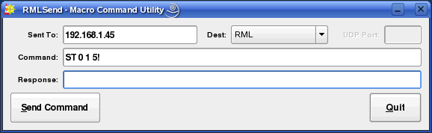Illustration 65: RMLSend in GUI Mode
The Sent To: should have the name or IP address of the system to which to send the RML. Dest: controls the method by which the command will be sent. 'RML' is standard RML transmission that returns an echo code to indicate success/failure. 'RML (No echo)' does not return an echo code, while 'Set Port' allows the destination UDP port to be set (useful for controlling Rivendell from outside firewalls). Command: is the RML command to be sent, and Response: will show any echo code returned from the remote system (or 'No response' if no reply is received). Touching the Send Command button actually sends the command.

RMLSend also has a full-featured command-line facility that allows Rivendell commands to be sent using the standard Linux CLI utilities. The command-line syntax is:

rmlsend [--to-host=<hostname>] [--to-port=<port>] [<rml>|--from-file=<file>]

Where:
<hostname> name or IP address of the host to send the command to

<port> UDP port to to send the message to

<rml> any valid RML code

<file> name of a file containing valid RML code. If '-' is specified as <file>, then
rmlsend will read the list of RML commands to be sent from standard
input.

When specifying RML code on the command line, it will likely be necessary to escape any special characters (such as spaces or bang [!] characters) to protect them from the shell.

Examples:
rmlsend LL\ TestLog\!
Send the RML command 'LL 1 TestLog!' to the local host.

rmlsend --to-host=host.example.com --to-port=5858 --from-file=test.rml
Send the RML commands in 'test.rml' to the system at 'host.example.com' at
port 5858.

The above information can also be displayed on the command line by doing:
rmlsend –help

Section 10.1 RDImport
RDImport is a command-line interface (CLI) program that can be used to import audio material into the Rivendell Library. It is particularly useful in situations where a large number of audio files need to be imported in an automated fashion, and is capable of importing thousands of files with a single command-line invocation.

The syntax for invoking RDImport is:

rdimport [options] <group> <filespec> [,<filespec>]*

Where:
<group> The name of a Rivendell group

<filespec> A file name or specification. All of the usual regex tricks work. A
<filespec> of '-' will cause RDImport to read the list of filespecs from
standard input.

The following options are available:

--verbose
Print progress messages during processing.

--normalization-level=<level>
Specify the level to use for normalizing the audio, in dBFS.
Specifying '0' will turn off normalization. By default, RDImport will use the
normalization level specified in RDAdmin->ManageHosts->RDLibrary.

--autotrim-level=<level>
Specify the threshold level to use for autotrimming the audio, in dBFS. Specifying '0'
will turn off autotrimming. By default, RDImport will use the autotrim level specified
in RDAdmin->ManageHosts->RDLibrary.
--single-cart
If more than one file is imported, place them within multiple cuts within a single cart,
rather than creating separate carts for each file.

--to-cart=<cartnum>
Specify the cart to import the audio into, rather than using the next available cart
number for the group. If the cart does not exist, it will be created. Each file will be
imported into a separate new cut within the cart. Use of this option implies the
--single-cart option as well.

--delete-source
Delete each source file after successful import. Use with caution!

--delete-cuts
Delete all cuts within the destination cart before importing. Use with caution!

--drop-box
Operate in DropBox mode. RDImport will run continuously, periodically scanning
for the specified files, importing and then deleting them when found. WARNING:
use of this option also implies the --delete-source option!

--metadata-pattern=<pattern>
Attempt to read metadata parameters from the source filename, using
the pattern <pattern>. Patterns consist of a sequence of macros and
regular characters to indicate boundaries between metadata fields.
The available macros are:

%a - Artist
%b - Record Label
%c - Client
%e - Agency
%g - Rivendell Group
%l - Album
%m - Composer
%n - Rivendell Cart Number
%p - Publisher
%t - Title
%u - User Defined
%% - A literal '%'

Detection of either the Rivendell Group [%g] or Rivendell Cart [%n]
will cause RDImport to attempt to import the file to the specified Group
and/or Cart, overriding whatever values were specified elsewhere on the
command line.

Boundaries between metadata fields are indicated by placing regular
characters between macros. For example, the pattern '%t_%a_%g_%n.',
when processing a filename of 'My Song_My Artist_TEMP_123456.mp3',
would extract 'My Song' as the title and 'My Artist' as the artist,
while importing it into cart 123456 in the TEMP group.

It may be necessary to enclose individual <filespec> clauses in quotes in order to protect wildcard characters from expansion by the shell. A typical indicator that this is necessary is the failure of RDImport to process newly added files when running in DropBox mode.

The above information can also be displayed on the command line by doing:
rdimport –help

Appendix A
The GNU General Public License, Version Two

GNU GENERAL PUBLIC LICENSE
Version 2, June 1991

Copyright (C) 1989, 1991 Free Software Foundation, Inc. 59 Temple Place, Suite 330, Boston, MA 02111-1307 USA.
Everyone is permitted to copy and distribute verbatim copies of this license document, but changing it is not allowed.

Preamble

The licenses for most software are designed to take away your freedom to share and change it. By contrast, the GNU General Public License is intended to guarantee your freedom to share and change free software--to make sure the software is free for all its users. This General Public License applies to most of the Free Software Foundation's software and to any other program whose authors commit to using it. (Some other Free Software Foundation software is covered by the GNU Library General Public License instead.) You can apply it to your programs, too.

When we speak of free software, we are referring to freedom, not price. Our General Public Licenses are designed to make sure that you have the freedom to distribute copies of free software (and charge for this service if you wish), that you receive source code or can get it if you want it, that you can change the software or use pieces of it in new free programs; and that you know you can do these things.

To protect your rights, we need to make restrictions that forbid anyone to deny you these rights or to ask you to surrender the rights. These restrictions translate to certain responsibilities for you if you distribute copies of the software, or if you modify it.

For example, if you distribute copies of such a program, whether gratis or for a fee, you must give the recipients all the rights that you have. You must make sure that they, too, receive or can get the source code. And you must show them these terms so they know their rights.

We protect your rights with two steps: (1) copyright the software, and (2) offer you this license which gives you legal permission to copy, distribute and/or modify the software.

Also, for each author's protection and ours, we want to make certain that everyone understands that there is no warranty for this free software. If the software is modified by someone else and passed on, we want its recipients to know that what they have is not the original, so that any problems introduced by others will not reflect on the original
authors' reputations.
Finally, any free program is threatened constantly by software patents. We wish to avoid the danger that redistributors of a free program will individually obtain patent licenses, in effect making the program proprietary. To prevent this, we have made it clear that any patent must be licensed for everyone's free use or not licensed at all.

The precise terms and conditions for copying, distribution and modification follow.

GNU GENERAL PUBLIC LICENSE
TERMS AND CONDITIONS FOR COPYING, DISTRIBUTION AND MODIFICATION

0. This License applies to any program or other work which contains a notice placed by the copyright holder saying it may be distributed under the terms of this General Public License. The "Program", below, refers to any such program or work, and a "work based on the Program" means either the Program or any derivative work under copyright law: that is to say, a work containing the Program or a portion of it, either verbatim or with modifications and/or translated into another language. (Hereinafter, translation is included without limitation in the term "modification".) Each licensee is addressed as "you".

Activities other than copying, distribution and modification are not covered by this License; they are outside its scope. The act of running the Program is not restricted, and the output from the Program is covered only if its contents constitute a work based on the Program (independent of having been made by running the Program). Whether that is true depends on what the Program does.

1. You may copy and distribute verbatim copies of the Program's source code as you receive it, in any medium, provided that you conspicuously and appropriately publish on each copy an appropriate copyright notice and disclaimer of warranty; keep intact all the notices that refer to this License and to the absence of any warranty; and give any other recipients of the Program a copy of this License along with the Program.

You may charge a fee for the physical act of transferring a copy, and you may at your option offer warranty protection in exchange for a fee.

2. You may modify your copy or copies of the Program or any portion of it, thus forming a work based on the Program, and copy and distribute such modifications or work under the terms of Section 1 above, provided that you also meet all of these conditions:

a) You must cause the modified files to carry prominent notices
stating that you changed the files and the date of any change.

b) You must cause any work that you distribute or publish, that in
whole or in part contains or is derived from the Program or any
part thereof, to be licensed as a whole at no charge to all third
parties under the terms of this License.

c) If the modified program normally reads commands interactively
when run, you must cause it, when started running for such
interactive use in the most ordinary way, to print or display an
announcement including an appropriate copyright notice and a
notice that there is no warranty (or else, saying that you provide
a warranty) and that users may redistribute the program under
these conditions, and telling the user how to view a copy of this
License. (Exception: if the Program itself is interactive but
does not normally print such an announcement, your work based on
the Program is not required to print an announcement.)

These requirements apply to the modified work as a whole. If identifiable sections of that work are not derived from the Program, and can be reasonably considered independent and separate works in themselves, then this License, and its terms, do not apply to those
sections when you distribute them as separate works. But when you distribute the same sections as part of a whole which is a work based on the Program, the distribution of the whole must be on the terms of this License, whose permissions for other licensees extend to the entire whole, and thus to each and every part regardless of who wrote it.

Thus, it is not the intent of this section to claim rights or contest your rights to work written entirely by you; rather, the intent is to exercise the right to control the distribution of derivative or collective works based on the Program.

In addition, mere aggregation of another work not based on the Program with the Program (or with a work based on the Program) on a volume of a storage or distribution medium does not bring the other work under the scope of this License.

3. You may copy and distribute the Program (or a work based on it, under Section 2) in object code or executable form under the terms of Sections 1 and 2 above provided that you also do one of the following:

a) Accompany it with the complete corresponding machine-readable
source code, which must be distributed under the terms of Sections
1 and 2 above on a medium customarily used for software interchange; or,

b) Accompany it with a written offer, valid for at least three
years, to give any third party, for a charge no more than your
cost of physically performing source distribution, a complete
machine-readable copy of the corresponding source code, to be
distributed under the terms of Sections 1 and 2 above on a medium
customarily used for software interchange; or,

c) Accompany it with the information you received as to the offer
to distribute corresponding source code. (This alternative is
allowed only for noncommercial distribution and only if you
received the program in object code or executable form with such
an offer, in accord with Subsection b above.)

The source code for a work means the preferred form of the work for making modifications to it. For an executable work, complete source code means all the source code for all modules it contains, plus any associated interface definition files, plus the scripts used to control compilation and installation of the executable. However, as a
special exception, the source code distributed need not include anything that is normally distributed (in either source or binary form) with the major components (compiler, kernel, and so on) of the operating system on which the executable runs, unless that component
itself accompanies the executable.

If distribution of executable or object code is made by offering access to copy from a designated place, then offering equivalent access to copy the source code from the same place counts as distribution of the source code, even though third parties are not
compelled to copy the source along with the object code.

4. You may not copy, modify, sublicense, or distribute the Program except as expressly provided under this License. Any attempt otherwise to copy, modify, sublicense or distribute the Program is void, and will automatically terminate your rights under this License. However, parties who have received copies, or rights, from you under
this License will not have their licenses terminated so long as such parties remain in full compliance.

5. You are not required to accept this License, since you have not signed it. However, nothing else grants you permission to modify or distribute the Program or its derivative works. These actions are prohibited by law if you do not accept this License. Therefore, by modifying or distributing the Program (or any work based on the Program), you indicate your acceptance of this License to do so, and all its terms and conditions for copying, distributing or modifying the Program or works based on it.

6. Each time you redistribute the Program (or any work based on the Program), the recipient automatically receives a license from the original licensor to copy, distribute or modify the Program subject to these terms and conditions. You may not impose any further restrictions on the recipients' exercise of the rights granted herein. You are not responsible for enforcing compliance by third parties to this License.

7. If, as a consequence of a court judgment or allegation of patent infringement or for any other reason (not limited to patent issues), conditions are imposed on you (whether by court order, agreement or otherwise) that contradict the conditions of this License, they do not excuse you from the conditions of this License. If you cannot distribute so as to satisfy simultaneously your obligations under this License and any other pertinent obligations, then as a consequence you may not distribute the Program at all. For example, if a patent license would not permit royalty-free redistribution of the Program by all those who receive copies directly or indirectly through you, then the only way you could satisfy both it and this License would be to refrain entirely from distribution of the Program.

If any portion of this section is held invalid or unenforceable under any particular circumstance, the balance of the section is intended to apply and the section as a whole is intended to apply in other circumstances.

It is not the purpose of this section to induce you to infringe any patents or other property right claims or to contest validity of any such claims; this section has the sole purpose of protecting the integrity of the free software distribution system, which is implemented by public license practices. Many people have made generous contributions to the wide range of software distributed through that system in reliance on consistent application of that system; it is up to the author/donor to decide if he or she is willing to distribute software through any other system and a licensee cannot impose that choice.

This section is intended to make thoroughly clear what is believed to be a consequence of the rest of this License.

8. If the distribution and/or use of the Program is restricted in certain countries either by patents or by copyrighted interfaces, the original copyright holder who places the Program under this License may add an explicit geographical distribution limitation excluding those countries, so that distribution is permitted only in or among countries not thus excluded. In such case, this License incorporates the limitation as if written in the body of this License.

9. The Free Software Foundation may publish revised and/or new versions of the General Public License from time to time. Such new versions will be similar in spirit to the present version, but may differ in detail to address new problems or concerns.

Each version is given a distinguishing version number. If the Program specifies a version number of this License which applies to it and "any later version", you have the option of following the terms and conditions either of that version or of any later version published by the Free Software Foundation. If the Program does not specify a version number of
this License, you may choose any version ever published by the Free Software Foundation.

10. If you wish to incorporate parts of the Program into other free programs whose distribution conditions are different, write to the author to ask for permission. For software which is copyrighted by the Free Software Foundation, write to the Free Software Foundation; we sometimes make exceptions for this. Our decision will be guided by the two goals of preserving the free status of all derivatives of our free software and of promoting the sharing and reuse of software generally.

NO WARRANTY

11. BECAUSE THE PROGRAM IS LICENSED FREE OF CHARGE, THERE IS NO WARRANTY FOR THE PROGRAM, TO THE EXTENT PERMITTED BY APPLICABLE LAW. EXCEPT WHEN OTHERWISE STATED IN WRITING THE COPYRIGHT HOLDERS AND/OR OTHER PARTIES PROVIDE THE PROGRAM "AS IS" WITHOUT WARRANTY OF ANY KIND, EITHER EXPRESSED OR IMPLIED, INCLUDING, BUT NOT LIMITED TO, THE IMPLIED WARRANTIES OF
MERCHANTABILITY AND FITNESS FOR A PARTICULAR PURPOSE. THE ENTIRE RISK AS TO THE QUALITY AND PERFORMANCE OF THE PROGRAM IS WITH YOU. SHOULD THE PROGRAM PROVE DEFECTIVE, YOU ASSUME THE COST OF ALL NECESSARY SERVICING, REPAIR OR CORRECTION.

12. IN NO EVENT UNLESS REQUIRED BY APPLICABLE LAW OR AGREED TO IN WRITING WILL ANY COPYRIGHT HOLDER, OR ANY OTHER PARTY WHO MAY MODIFY AND/OR REDISTRIBUTE THE PROGRAM AS PERMITTED ABOVE, BE LIABLE TO YOU FOR DAMAGES, INCLUDING ANY GENERAL, SPECIAL, INCIDENTAL OR CONSEQUENTIAL DAMAGES ARISING OUT OF THE USE OR INABILITY TO USE THE PROGRAM (INCLUDING BUT NOT LIMITED TO LOSS OF DATA OR DATA BEING RENDERED INACCURATE OR LOSSES SUSTAINED BY YOU OR THIRD PARTIES OR A FAILURE OF THE PROGRAM TO OPERATE WITH ANY OTHER PROGRAMS), EVEN IF SUCH HOLDER OR OTHER PARTY HAS BEEN ADVISED OF THE POSSIBILITY OF SUCH DAMAGES.

END OF TERMS AND CONDITIONS

How to Apply These Terms to Your New Programs

If you develop a new program, and you want it to be of the greatest possible use to the public, the best way to achieve this is to make it free software which everyone can redistribute and change under these terms.

To do so, attach the following notices to the program. It is safest to attach them to the start of each source file to most effectively convey the exclusion of warranty; and each file should have at least the "copyright" line and a pointer to where the full notice is found.

<one line to give the program's name and a brief idea of what it does.>
Copyright (C) <year> <name of author>

This program is free software; you can redistribute it and/or modify
it under the terms of the GNU General Public License as published by
the Free Software Foundation; either version 2 of the License, or
(at your option) any later version.

This program is distributed in the hope that it will be useful,
but WITHOUT ANY WARRANTY; without even the implied warranty of
MERCHANTABILITY or FITNESS FOR A PARTICULAR PURPOSE. See the
GNU General Public License for more details.

You should have received a copy of the GNU General Public License
along with this program; if not, write to the Free Software
Foundation, Inc., 59 Temple Place, Suite 330, Boston, MA 02111-1307 USA

Also add information on how to contact you by electronic and paper mail.

If the program is interactive, make it output a short notice like this when it starts in an interactive mode:

Gnomovision version 69, Copyright (C) year name of author
Gnomovision comes with ABSOLUTELY NO WARRANTY; for details type `show w'.
This is free software, and you are welcome to redistribute it
under certain conditions; type `show c' for details.

The hypothetical commands `show w' and `show c' should show the appropriate parts of the General Public License. Of course, the commands you use may be called something other than `show w' and `show c'; they could even be mouse-clicks or menu items--whatever suits your program.

You should also get your employer (if you work as a programmer) or your school, if any, to sign a "copyright disclaimer" for the program, if necessary. Here is a sample; alter the names:

Yoyodyne, Inc., hereby disclaims all copyright interest in the program
`Gnomovision' (which makes passes at compilers) written by James Hacker.

<signature of Ty Coon>, 1 April 1989
Ty Coon, President of Vice

This General Public License does not permit incorporating your program into proprietary programs. If your program is a subroutine library, you may consider it more useful to permit linking proprietary applications with the library. If this is what you want to do, use the GNU Library General Public License instead of this License.

Appendix B
The Creative Commons Attribution-Noncommercial-ShareAlike License 2.5

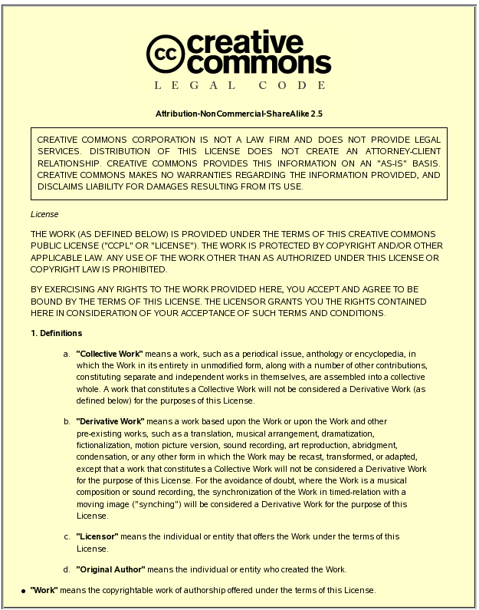

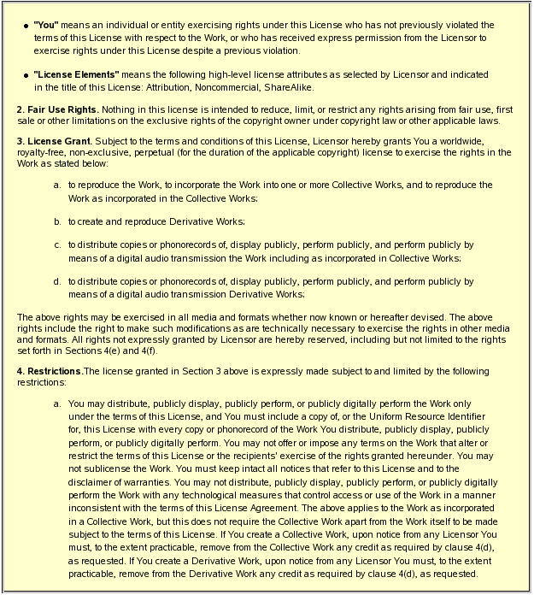

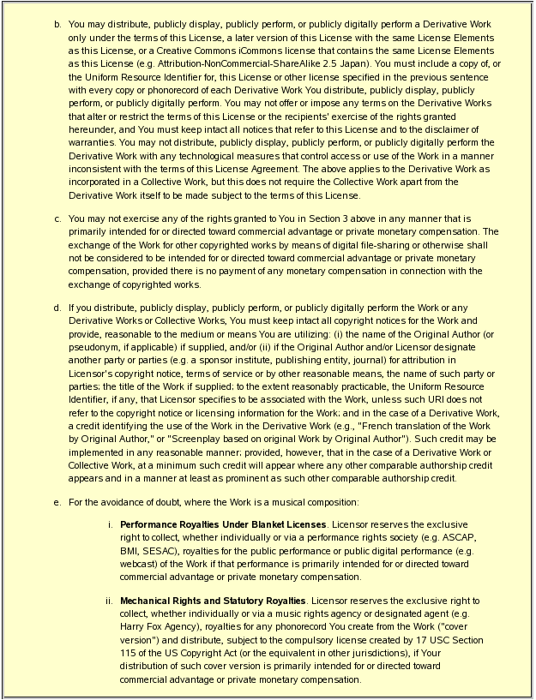

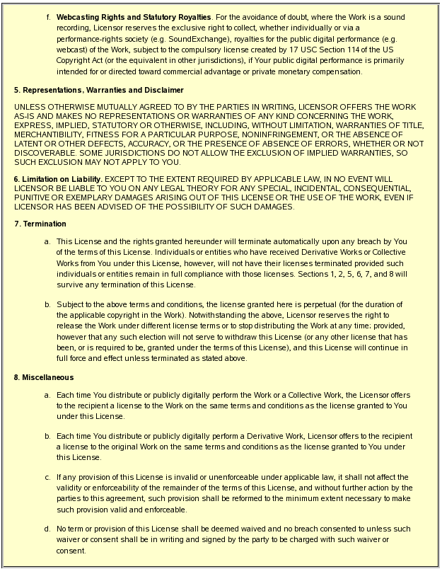

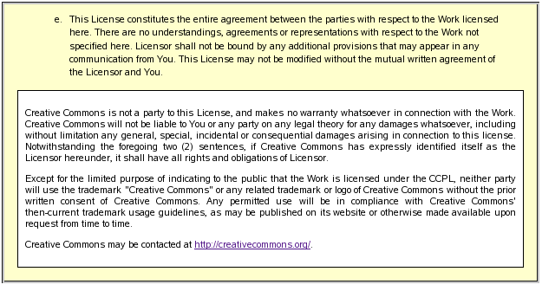

Document Change History

2005-11-28 Fred Gleason <fredg@salemradiolabs.com>
Initial document release, Chapters 1 -3

2006-09-27 Fred Gleason <fredg@salemradiolabs.com>
Released full document as version 0.9.

2006-10-10 Robert Orr <orrrobert@gmail.com>
Fixed various typos.

2006-10-10 Fred Gleason <fredg@salemradiolabs.com>
Added a title page.
Added a Change History page.
Released as version 0.9.1

2006-10-10 Fred Gleason <fredg@salemradiolabs.com>
Added the '<skip-meta>' parameter to the Start Next [PN] RML.

2006-10-18 Fred Gleason <fredg@salemradiolabs.com>
Added the Refresh Log [RL] RML.

2006-10-20 Fred Gleason <fredg@salemradiolabs.com>
Added the Toggle On Air Flag [TA] RML.

2006-11-28 Fred Gleason <fredg@salemradiolabs.com>
Updated for Rivendell v0.9.76.

2008-10-23 Fred Gleason <fredg@paravelsystems.com>
Updated for Rivendell v1.1.0.
Added 'Start Record Deck' [RS] and 'Stop Record Deck' [RR] RMLs.
Added the '--metadata-pattern' switch and wildcard for RDImport.

2009-03-18 Fred Gleason <fredg@paravelsystems.com>
Added 'Message Box; ['MB'] RML.

2011-11-01 Fred Gleason <fredg@paravelsystems.com>
Added 'Connect JACK Ports' ['JC'] and 'Disconnect JACK Ports' RMLs.

2012-07-27 Fred Gleason <fredg@paravelsystems.com>
Added 'Label Button' ['PC'] RMLs.

2014-05-22 Fred Gleason <fredg@paravelsystems.com>
Added 'Append Log' ['AL'] RML.

2015-08-29 Fred Gleason <fredg@paravelsystems.com>
Reverted RDCartSlots chapter.

Linux is a registered trademark of Linus Torvalds
Windows is a registered trademark of Microsoft Corporation

