***Crypto Portfolio Tracker App***

**Description:**

The crypto portfolio app is a web system that allows users to track their portfolio crypto investments.

**Technologies to use:**

* Backend: Laravel
* Frontend: Vue, Axios, Bootstrap (Only CSS) or Tailwind, D3.js
* External APIs: CoinGecko, Google, Facebook, Github

**Functionalities:**

1. Login and Registration through social media networks

* Facebook
* Google
* Github

1. Show crypto Rankings (Ordered by market cap)
2. Show a crypto details (Symbol, logo, current price, lowest price, highest price, owned amount, owned amount in USD, market cap, increase owned amount, decrease owned amount, enter owned amount, graph in 7 days)
3. Manage portfolio

* Show daily portfolio worth
* Show total worth of portfolio in USD
* Show portfolio diversification in pie chart with percentage for each crypto
* Show each crypto´s details (Symbol, logo, price in USD, market cap, price in USD according to owned amount)
* Increase, decrease and edit amount of each crypto in portfolio
* Save portfolio snapshot with date

**Views:**

**Login**

- Email

- Password

- Link to Google

- Link to Facebook

**Registration**

- Email

- Password

- Password Confirmation

- Link to Google

- Link to Facebook

**Cryptos – Index view (10 per page)**

- Rank: (api)

- Image: (api)

- Symbol: (api)

- Price: (api)

- Market capitalization: (api)

- hasCrypto: (backend)

- Add crypto to portfolio

- Remove crypto from portfolio

**Crypto – Show view**

- Rank: (api)

- Synbol: (api)

- Image: (api)

- Price: (api)

- Graph in 7 days: (api)

- hasCrypto: (backend)

- Amount: (backend)

- Total owned worth in USD

- Add crypto to portfolio

- Remove crypto from portfolio

- Increase owned amount

- Decrease owned amount

- Edit owned amount

**Portfolio show view**

- List of all the cryptos in portfolio (symbols and amount): (Backend)

- Show rank, image and price for each crypto in USD: (api)

- Total worth of portfolio in USD

- Add crypto to portfolio

- Update crypto amount

- Remove crypto from portfolio

- Crypto diversification pie chart with percentages

- Portfolio percentage Growth since creation date

**-** Portfolio creation date: (backend)

- Portfolio Growth in USD since creation date

**Snapshots index**

- List of all snapshots in descending order: (backend)

- For each snapshot show the date, count of cryptos and total worth: (backend)

**Snapshot show**

- Date: (backend)

- List of cryptos with symbol, image and price: (backend)

- Total worth in USD: (backend)

**Http Methods, Routes, Controllers and Data type**

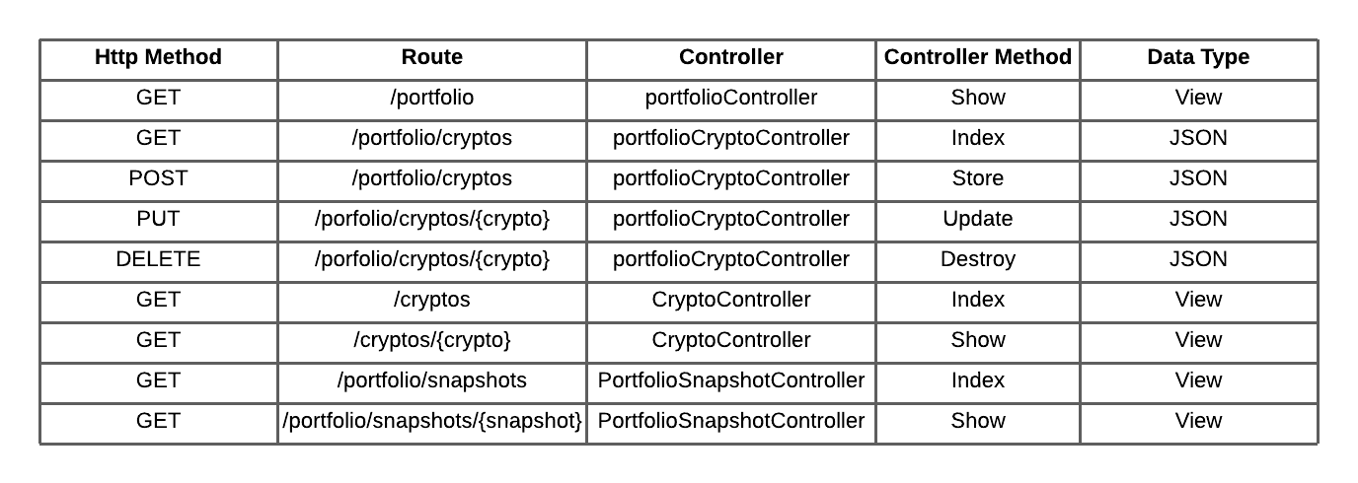

**Main Entities:**

* Portfolio
* User
* Snapshot
* Crypto

**Entities Description:**

- Portfolio

* id: (int) pk
* user_id: (int) fk, unique
* created_at: (date)
* updated_at: (date)

-Crypto_Portfolio

* id: (int) pk
* portfolio_id: (int) fk
* crypto_id: (int) fk
* amount:(decimal)

-User

* id: (int) pk
* name: (varchar, min: 3, max: 12)
* email: (varchar, max: 30)
* password: (varchar, min: 6, max: 15)
* created_at: (date)
* updated_at: (date)

-Snapshot

* id: (int) pk
* portfolio_id: (int) fk
* created_at: (date)
* updated_at:(date)

-Crypto_snapshot

* id: (int) pk
* crypto_id: (int) fk
* amount: (decimal)
* price: (decimal)

-Crypto:

* id: (int) pk
* symbol: (varchar, max: 8)
* name: (varchar max: 15)

**Relationships:**

* A User has only one Portfolio
* A Portfolio has many Snapshots
* A Portfolio has many Cryptos
* A Crypto belongs to many Portfolios
* A Snapshot has many Cryptos

**Entity-Relationship Diagram**

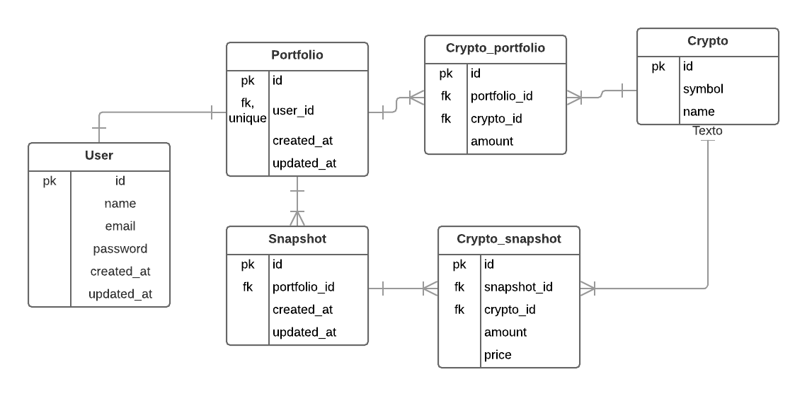

**Main Classes (Laravel Models)**

* **User**
* **Crypto**
* **Portfolio**
* **Snapshot**