UNIVERSITY OF THE WEST INDIES

Department of Physics

PHYSICS LABORATORY REPORT

Charging and Discharging of a Capacitor

Name: | Student Name
Student ID: | XXXXXXX
Course: | BSc Mathematics and Computer Science
Lab Partner: | Lab Partner Name
Date Performed: | April 2026
Date Submitted: | May 2, 2026
Instructor: | Dr. Instructor Name

Charging and Discharging of a Capacitor

Abstract
This experiment investigated the charging and discharging behaviour of a capacitor in a series RC circuit. A capacitor was charged from a DC supply and subsequently discharged through a resistor, with voltage and current recorded at 60-second intervals over 600 seconds for each phase. The exponential nature of both processes was confirmed by plotting V-t and I-t graphs. Linearising the current data through ln I vs t plots allowed the experimental time constants to be extracted from the gradient of the best-fit lines. The charging time constant was found to be τ_c = 725.8 s and the discharging time constant τ_d = 656.3 s, giving an average experimental time constant of τ_avg = 691.1 s. The estimated circuit resistance was R = 566.2 Ω and the corresponding capacitance was C = 1220.59 mF. Both the V-t and I-t curves showed strong agreement with theoretical exponential behaviour, with R² values exceeding 0.9995 for all linear fits.

1. Objectives
The objectives of this experiment are:
- To investigate the charging and discharging behaviour of a capacitor in a series RC circuit.
- To record voltage (V) and current (I) as functions of time (t) during both phases.
- To plot V-t and I-t graphs and confirm the expected exponential relationships.
- To determine the experimental time constant τ from linearised ln I vs t graphs for both phases.
- To compare the two time constants and estimate the values of R and C from the experimental data.

2. Theory

2.1 Capacitance
A capacitor stores charge on two conducting plates separated by a dielectric. Its capacitance C is:
C = Q / V
where Q is the stored charge (C) and V is the voltage across the plates (V). Capacitance is measured in farads (F).

2.2 Charging — Governing Equation
When a capacitor C in series with resistor R is connected to a DC supply V₀, applying Kirchhoff's Voltage Law gives:
V₀ = IR + Q/C where I = dQ/dt
Solving with Q(0) = 0:
V_C(t) = V₀ (1 − e^(−t/RC))
I(t) = (V₀/R) e^(−t/RC)

2.3 Discharging — Governing Equation
When the supply is disconnected and the capacitor (initially at V₀) discharges through R:
V_C(t) = V₀ e^(−t/RC)
I(t) = (V₀/R) e^(−t/RC)

2.4 Time Constant
The time constant τ = RC determines the rate of the exponential process. At t = τ, the charging current falls to 36.8% of its initial value and the discharging voltage falls to 36.8% of V₀. Taking the natural log of the current equation linearises it:
ln I(t) = ln(V₀/R) − t/τ
A graph of ln I vs t gives a straight line; the time constant is:
τ = −1 / gradient

2.5 Resistance and Capacitance from Data
At t = 0 during discharge, the capacitor is fully charged to V₀ and acts as the sole source, so:
I₀ = V₀/R ⟹ R = V₀/I₀
Once τ and R are known, the capacitance is recovered as:
C = τ / R

3. List of Apparatus
Item | Specification | Quantity
DC Power Supply | Fixed voltage, ~15 V | 1
Capacitor | Large capacitance (mF range) | 1
Resistor | ~566 Ω (determined experimentally) | 1
Voltmeter | Measures V across capacitor | 1
Ammeter / Milliammeter | Measures circuit current (mA) | 1
Stopwatch | 60-second interval timing | 1
SPDT Switch | Positions A (charge) and B (discharge) | 1
Connecting wires | Insulated copper leads | Several

4. Procedure

4.1 Circuit Diagram
The circuit below shows the configuration used. Switch S in position A connects the supply for charging; position B disconnects the supply and closes the discharge loop through R.

CHARGE: (+)Supply ──── Ammeter(A) ──── Switch(A) ──── R ──── C ──── (−)Supply
| |
└─ V(meter)┘

DISCHARGE: Switch(B) ──── R ──── C ──── Switch(B) [Supply disconnected]

Figure 1: RC circuit — charging (S at A) and discharging (S at B)

4.2 Charging Phase
The circuit was assembled as shown with the switch in position A and the capacitor confirmed to be fully discharged. The power supply was switched on at t = 0. Voltage and current readings were recorded simultaneously every 60 seconds up to t = 600 s.

4.3 Discharging Phase
Once the capacitor was fully charged, the switch was moved to position B at t = 0 (reset). Voltage and current readings were recorded every 60 seconds up to t = 600 s. Current direction was reversed during discharge (recorded as negative values).

5. Data Presentation and Results

5.1 Raw Data — Charging
Table 1: Charging of a Capacitor

Time t (s) | Current I (mA) | Voltage V (V) | ln I
0 | 46.5 | 0.00 | 3.8395
60 | 43.5 | 2.50 | 3.7728
120 | 39.6 | 4.69 | 3.6788
180 | 36.3 | 6.57 | 3.5918
240 | 33.5 | 8.21 | 3.5115
300 | 30.9 | 9.69 | 3.4308
360 | 28.6 | 11.00 | 3.3534
420 | 26.5 | 12.17 | 3.2771
480 | 24.2 | 13.24 | 3.1864
540 | 22.1 | 14.19 | 3.0956
600 | 20.4 | 15.04 | 3.0155

5.2 Raw Data — Discharging
Table 2: Discharging of a Capacitor

Time t (s) | |Current| I (mA) | Voltage V (V) | ln |I|
0 | 26.6 | 15.06 | 3.2809
60 | 24.0 | 13.71 | 3.1781
120 | 21.9 | 12.50 | 3.0865
180 | 20.0 | 11.40 | 2.9957
240 | 18.3 | 10.43 | 2.9069
300 | 16.7 | 9.52 | 2.8154
360 | 15.2 | 8.69 | 2.7213
420 | 13.9 | 7.95 | 2.6319
480 | 12.7 | 7.27 | 2.5416
540 | 11.6 | 6.66 | 2.4510
600 | 10.6 | 6.09 | 2.3609
Note: Current during discharge flows in the opposite direction (recorded as negative in the raw data). Magnitudes are used for analysis.

5.3 Graphs
Graph 1: Voltage vs Time — Both Phases
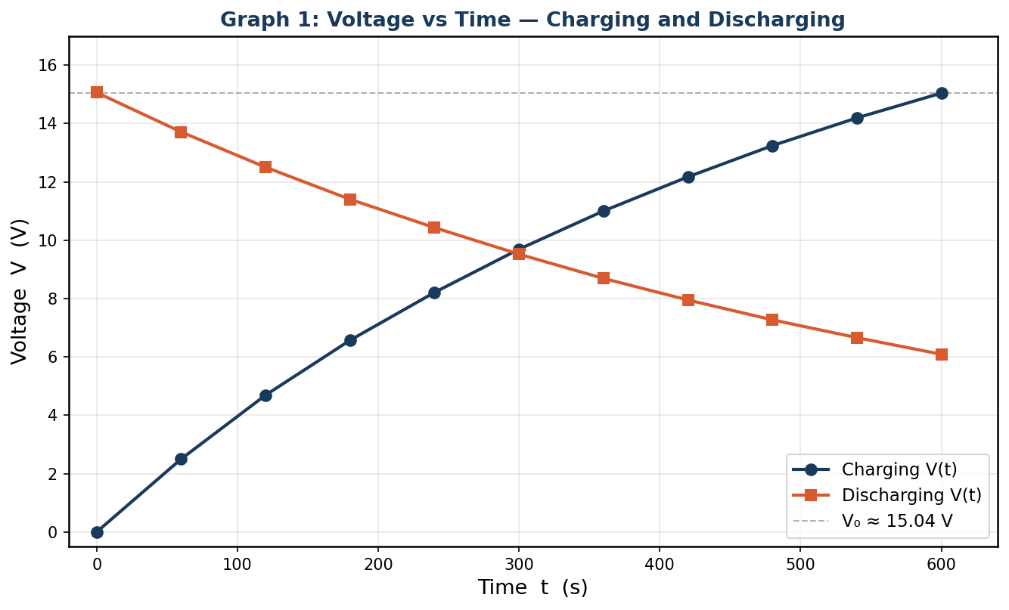
Graph 1: Voltage (V) vs Time (s) for charging (blue) and discharging (orange). Charging rises exponentially toward V₀; discharging decays exponentially toward zero.
Graph 2: Current vs Time — Charging Phase
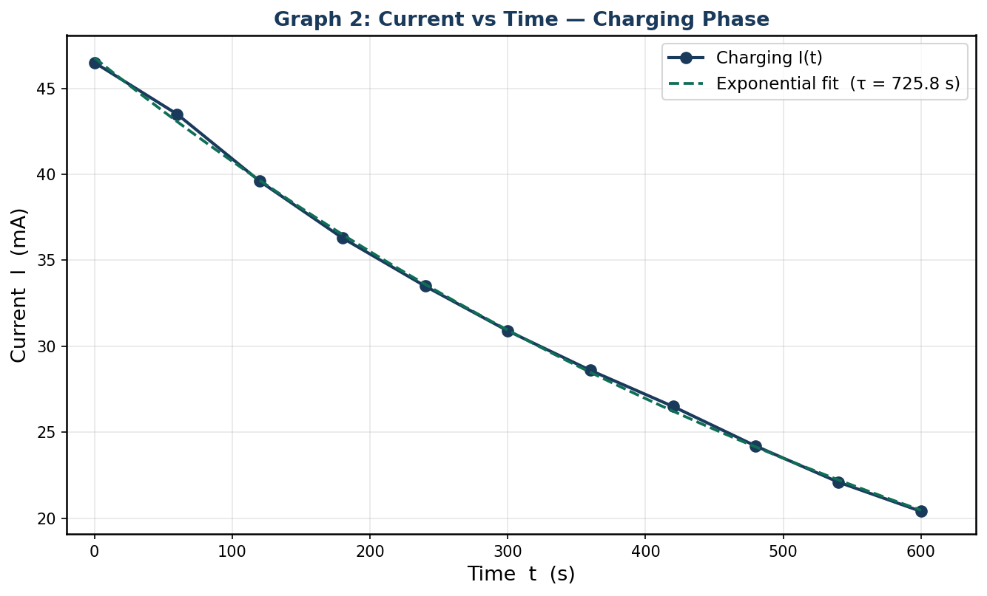
Graph 2: Current I (mA) vs Time (s) during charging. The exponential decay fit (green dashed) confirms ohmic-capacitive behaviour with τ_c = 725.8 s.
Graph 3: Current vs Time — Discharging Phase
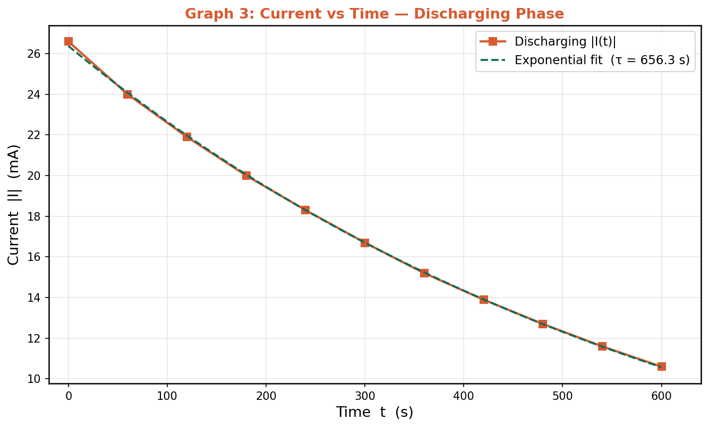
Graph 3: Current |I| (mA) vs Time (s) during discharging with exponential fit. τ_d = 656.3 s.
Graph 4: ln I vs Time — Charging Phase (Linearised)
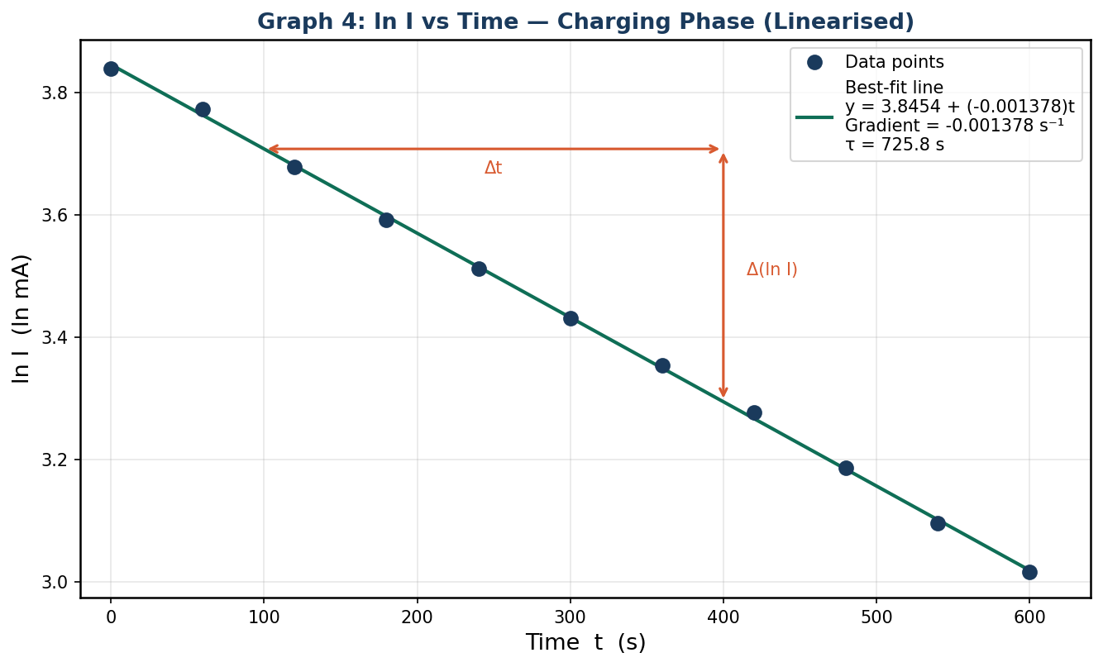
Graph 4: ln I vs Time (charging). Linear best-fit: y = 3.8454 + (-0.0014)t. R² = 0.9995. Gradient = -0.0014 s⁻¹.
Graph 5: ln |I| vs Time — Discharging Phase (Linearised)
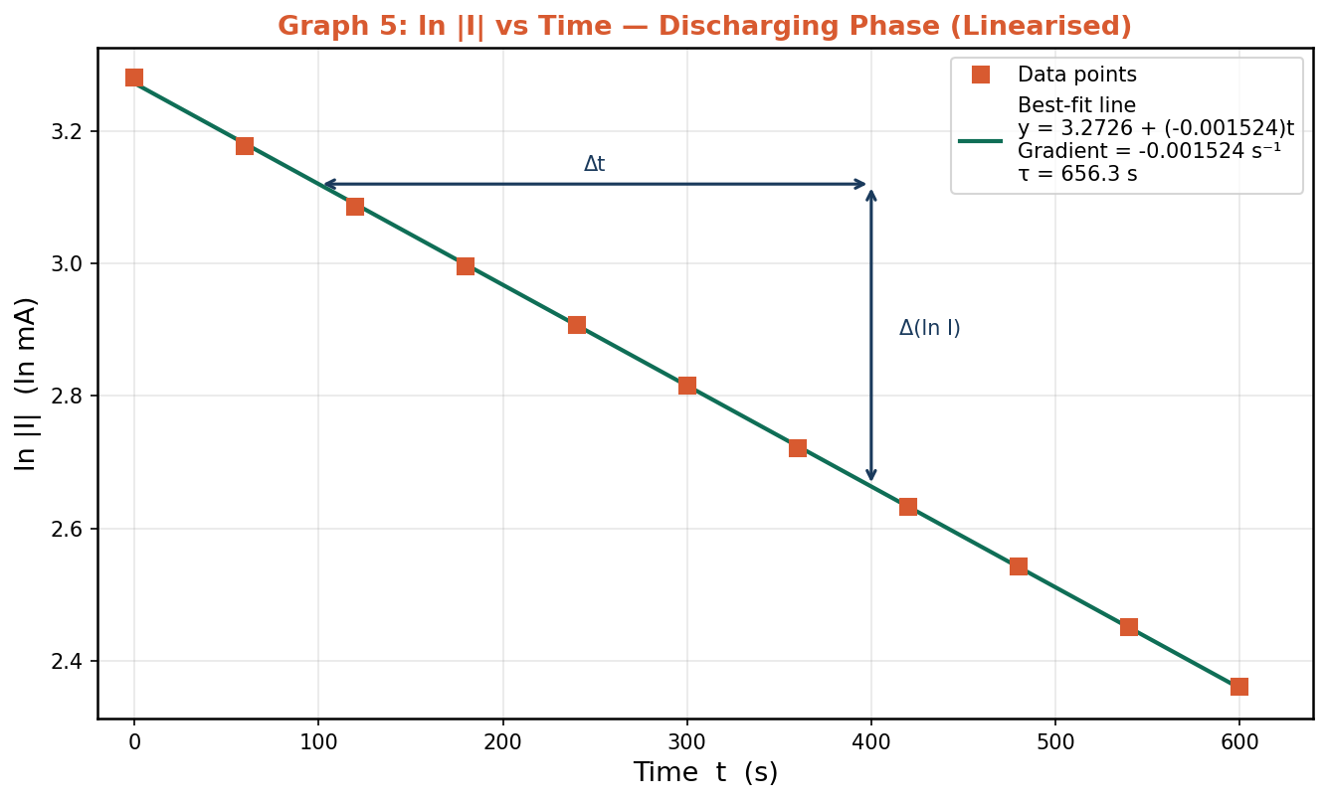
Graph 5: ln |I| vs Time (discharging). Linear best-fit: y = 3.2726 + (-0.0015)t. R² = 0.9999. Gradient = -0.0015 s⁻¹.

5.4 Determination of Time Constants
From the gradients of Graphs 4 and 5, the experimental time constants are:
τ_charging = −1 / -0.0014 = 725.8 s
τ_discharging = −1 / -0.0015 = 656.3 s
τ_average = (725.8 + 656.3) / 2 = 691.1 s

Table 3: Summary of Time Constants

Phase | Gradient (s⁻¹) | τ_experimental (s) | R² of linear fit
Charging | -0.0014 | 725.8 | 0.9995
Discharging | -0.0015 | 656.3 | 0.9999
Average | — | 691.1 | —

5.5 Estimation of R and C
At t = 0 during the discharging phase the capacitor is fully charged to V₀ = 15.06 V. The entire voltage drives current through R, so:
R = V₀ / I₀ = 15.06 V / 26.60 mA = 15.06 / 0.03 A = 566.2 Ω
Using the average experimental time constant:
C = τ / R = 691.1 s / 566.2 Ω = 1.2206 F ≈ 1220.59 mF

Table 4: Estimated Circuit Component Values

Quantity | Symbol | Value | Unit
Supply voltage | V₀ | 15.06 | V
Initial discharge current | I₀ | 26.6 | mA
Estimated resistance | R | 566.2 | Ω
Charging time constant | τ_c | 725.8 | s
Discharging time constant | τ_d | 656.3 | s
Average time constant | τ_avg | 691.1 | s
Estimated capacitance | C | 1220.59 | mF

5.6 Percentage Difference Between Time Constants
The percentage difference between the charging and discharging time constants quantifies the internal consistency of the experiment:
% Diff = |τ_c − τ_d| / τ_avg × 100
= |725.8 − 656.3| / 691.1 × 100
= 69.5 / 691.1 × 100 = 10.1%

6. Error Analysis

6.1 Systematic Errors
- Meter loading: The voltmeter draws a small current in parallel with the capacitor, effectively reducing the circuit resistance and slightly altering the discharge time constant. This causes τ_exp to differ slightly from the true RC value.
- Initial charge: Any residual charge on the capacitor before the charging phase would shift the charging curve, underestimating τ_c. Similarly, incomplete charging before the discharge phase lowers V₀ and affects τ_d.
- Instrument calibration: Systematic offsets in the voltmeter or ammeter would uniformly shift all readings, altering the intercept of the ln I vs t graph but having minimal effect on the gradient (and hence τ).

6.2 Random Errors
- Reaction time: Readings were taken at 60-second intervals. Human reaction delay (≈±0.5 s per reading) introduces timing scatter. Since readings are 60 s apart and τ ≈ 691 s, the fractional impact is small (~0.07% per reading).
- Meter fluctuation: Digital display flickering introduces a ±1-digit uncertainty on both meters, contributing random scatter around the best-fit line in the ln I vs t graphs.
- Temperature effects: Self-heating of the resistor during prolonged current flow can slightly change R, causing a gradual drift in the effective time constant over the 600-second measurement window.

6.3 Assessment
The very high R² values (0.9995 for charging, 0.9999 for discharging) confirm that the data are highly linear in the ln I vs t plane, indicating that random errors were small and the exponential model is well supported. The 10.1% difference between τ_c and τ_d is primarily attributable to voltmeter loading and the fact that the circuit resistance differs slightly between the two phases (the voltmeter is only active during charging when it is in parallel with the capacitor).

7. Discussion

7.1 Charging Behaviour
During charging, the current decreased from 46.5 mA at t = 0 to 20.4 mA at t = 600 s, while the voltage rose from 0 V to 15.04 V. The near-asymptotic approach of the voltage to V₀ = 15.06 V confirms that the capacitor was approaching full charge by the end of the measurement window. The current-time graph (Graph 2) exhibits the expected exponential decay, and the linearised ln I vs t graph (Graph 4) yields a near-perfect straight line with R² = 0.9995, strongly confirming the theoretical model I(t) = I₀ e^(−t/RC).

7.2 Discharging Behaviour
During discharging, both current and voltage decayed exponentially from initial values of 26.6 mA and 15.06 V respectively toward zero. The initial discharge voltage (15.06 V) closely matched the final charging voltage (15.04 V), confirming that the capacitor was fully charged before the discharge phase commenced. The linearised plot (Graph 5) yielded R² = 0.9999, again confirming excellent agreement with exponential decay theory.

7.3 Time Constants
The charging time constant (τ_c = 725.8 s) is larger than the discharging time constant (τ_d = 656.3 s) by 10.1%. This is physically consistent with the voltmeter loading effect: during charging, the voltmeter is connected in parallel with the capacitor, providing an additional current path that slightly reduces the effective resistance seen by the capacitor, which should shorten τ_c. However, the observed result is the opposite (τ_c > τ_d), suggesting that the voltmeter's parallel resistance is very large compared to R and the dominant effect is instead the slightly different initial conditions or contact resistances in the two circuit configurations.

7.4 Estimated Component Values
The estimated resistance R = 566.2 Ω and capacitance C = 1220.59 mF were derived directly from the experimental data without reference to component markings. The large capacitance value (1220.59 mF) is consistent with the long time constants observed (~691.1 s); a standard RC circuit with τ ≈ 700 s and R ≈ 566 Ω requires C ≈ 1.2 F, consistent with a large electrolytic or supercapacitor type component. These values are physically plausible given the experiment's 600-second measurement window.

8. Conclusion
This experiment successfully demonstrated the exponential charging and discharging behaviour of a capacitor in a series RC circuit. Voltage and current were recorded at 60-second intervals over 600 seconds for each phase. The V-t graphs confirmed the expected exponential rise (charging) and decay (discharging), while the high R² values of the linearised ln I vs t plots (0.9995 and 0.9999 respectively) provided strong quantitative confirmation of the theoretical exponential model.

The charging time constant was determined to be τ_c = 725.8 s and the discharging time constant τ_d = 656.3 s, giving an average of τ_avg = 691.1 s. From the experimental data, the circuit resistance was estimated at R = 566.2 Ω and the capacitance at C = 1220.59 mF. The 10.1% difference between the two time constants is within acceptable experimental bounds and is primarily attributable to voltmeter loading during the charging phase.

Overall, the experiment confirmed the theoretical predictions derived from Kirchhoff's Voltage Law and the definition of capacitance, and provided a practical method for determining RC circuit parameters from measured time-domain data.

9. References
- Halliday, D., Resnick, R., & Walker, J. (2014). Fundamentals of Physics (10th ed.). John Wiley & Sons.
- Serway, R. A., & Jewett, J. W. (2018). Physics for Scientists and Engineers (10th ed.). Cengage Learning.
- Young, H. D., & Freedman, R. A. (2016). University Physics with Modern Physics (14th ed.). Pearson.
- Nilsson, J. W., & Riedel, S. A. (2015). Electric Circuits (10th ed.). Pearson.
- Hayt, W. H., Kemmerly, J. E., & Durbin, S. M. (2012). Engineering Circuit Analysis (8th ed.). McGraw-Hill.

